REDI-GRO

CORPORATION

8909 Elder Creek Road, Sacramento CA 95828

Phone (916) 381-6063 1 (800) 654-4358 Fax (916) 381-1838

WALK ON BARK

Walk on Bark is a mixture or Fir Bark nuggets and wood particles. It is considered a shredded bark but it’s not as fibrous as cedar or redwood and may not be the best choice for steep slopes. Walk on Bark is most popular for landscape construction especially streetscapes and new installations. It is highly efficient for mulching purposes and will retard weed growth and help to conserve soil moisture.

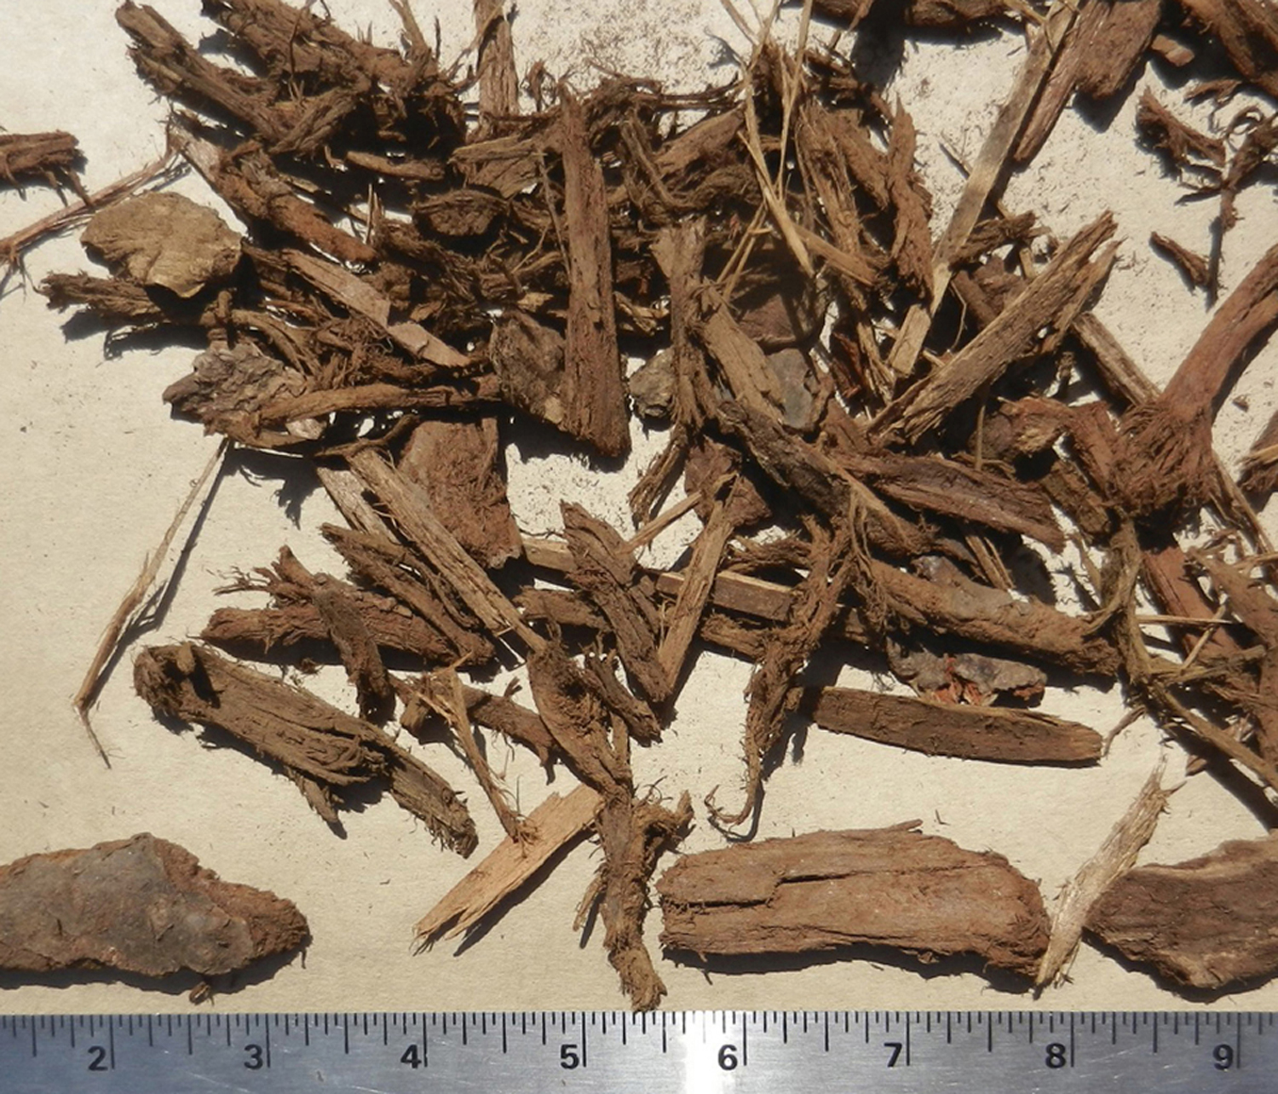

SPECIFICATION GUIDELINES

Walk on Bark is derived from Douglas Fir, Red Fir or and or White Fir and shall consist of a woody bark mixture with an average particle size of 1-1/2 inches.

Suggested minimum application rate is 6 cubic yards per 1000 square feet to provide a 2 inch layer of mulch.

