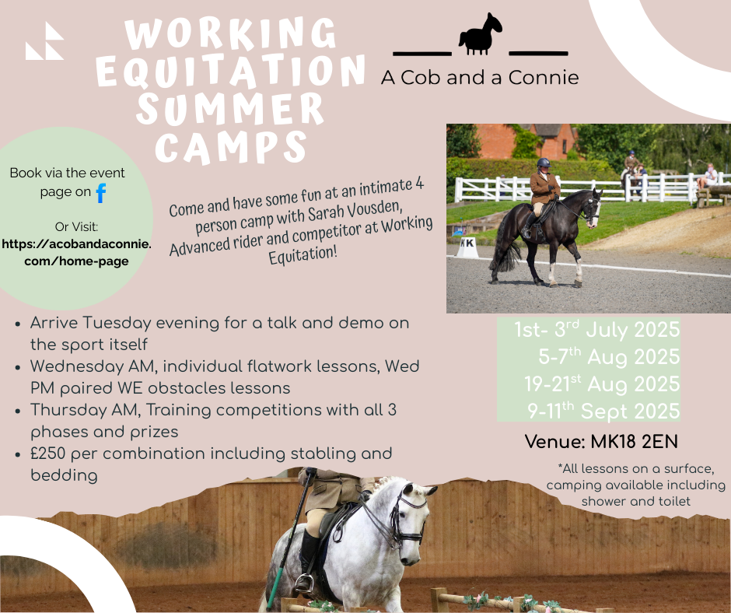

Come and enjoy a few days of pony time at one of my Summer Working Equitation camps!

These camps are for anyone wanting to start or improve their Working Equitation skills in a friendly environment whilst spending time with other like minded people in small groups of just 4 per camp. You will get the opportunity to learn from watching others lessons as well as completing your own.

*Stabling details*

The price includes stabling with rubber matting and bedding for 2 nights. Hay will be available to purchase on site if required. All training sessions and the training competition are included. Camping in vehicles or tents is available and there will be a communal tea room with toilet and shower also available to use.

*Payment details*

The Cost is £250 per horse and rider with everything detailed above included except food for you and the horse. To book on, Please visit: <https://www.myridinglife.com/RemoteLocationEventList.aspx?SecretaryID=605713>

*(Start times)* Itinerary overview is as follows:

**Arrive Tuesday PM between 4-6pm**

7pm Demo / Talk from Sarah of WE / Groundwork / whatever takes your fancy!

**Wednesday**

9 - 12pm 45 min individual lessons on the flat with the option to run through a WE dressage test

BYO lunch

2 - 4pm Paired 1hr, obstacles lessons

6pm Group BBQ or Pizza (weather dependant – will be communicated the week before)

**Thursday AM**

Full Working Equitation training competition

* Dressage test judged with feedback on sheet
* Ease of Handling course with feedback
* Fun speed !
* Prize giving

Depart Thursday lunchtime

*Withdrawals*

  If you need to withdraw or cancel, you may be offered the option of transferring your entry to a different date.  No refunds will be issued unless your slot can be filled.

Venue is 9 Claydon Hill Farm Barns, Steeple Claydon, Padbury, MK18 2EN