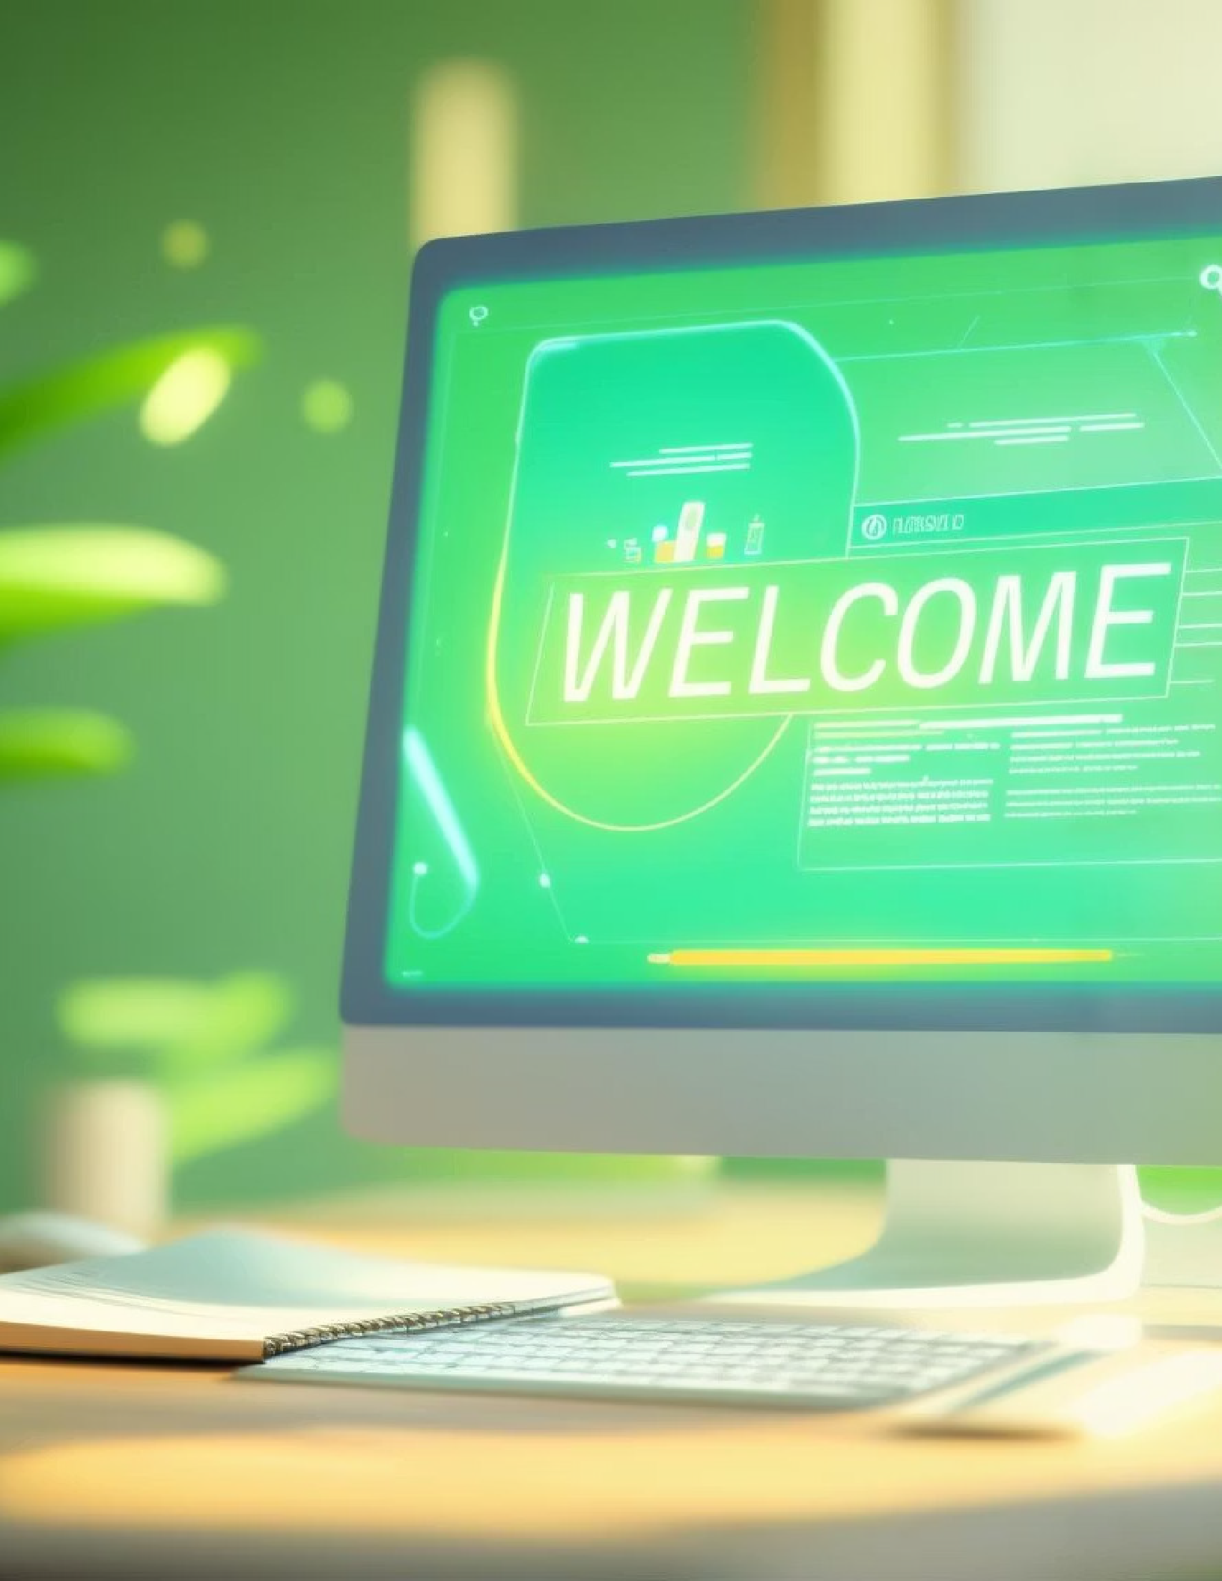
Client Onboarding Guide
Welcome to our comprehensive onboarding process! This guide outlines your 4-week journey from initial setup to successful launch. We've designed a structured approach to ensure your transition is smooth and productive. Let's begin your path to success.

Welcome to the Team!
We're thrilled to welcome you as our newest client! This guide will walk you through what to expect during the onboarding process, how to access your essential tools, and where to find support when you need it.
Our onboarding process is carefully designed to get you up and running efficiently while ensuring you have a clear understanding of all the systems we'll be implementing together. We've broken everything down into manageable weekly stages to keep the process organized and stress-free.

Week 1: Setup & Access

Complete Client Intake Form
1
Check your email for your personalized intake form. This helps us understand your specific needs and goals.

Access Your Dashboard
Your account credentials will arrive separately. This dashboard will be your central hub for all project activities.
2

Review Onboarding Call Recording
3
If we've already had our initial call, the recording is available for your reference.

Upload Required Assets
Please add your logos, brand guidelines, and relevant links to your shared folder.
4

Week 2: Systems & Strategy
During your second week, we'll focus on establishing your custom workflows and refining your strategic approach. This week is crucial for building the foundation of your automated systems.

Review Custom Workflows
Explore your personalized workflows, forms, and automation sequences that we've designed based on your business needs.

Strategy Call
We'll meet to finalize your funnel layout and automation logic, ensuring everything aligns with your business objectives.

Provide Initial Feedback
Share your thoughts through the client feedback form so we can make necessary adjustments early in the process.

This stage is all about refinement. Your input is essential as we work together to create systems that perfectly match your business requirements. Be prepared to dive deep into the strategy behind your automations.

Week 3: Launch Preparation


As we approach launch, this week focuses on testing and finalizing all client-facing elements. This careful preparation ensures a smooth launch experience for both you and your customers.
Review your landing pages and booking flows for brand consistency and user experience
Test all email and SMS automation sequences to ensure proper triggering and delivery
Finalize and approve your funnel or lead capture system before it goes live
We'll work closely with you to make any final adjustments needed before your systems go live. This thorough testing phase helps identify and address any potential issues before they impact your customers.

Week 4: Go Live + Support





Launch Your Systems
We'll activate your lead magnet, service funnel, or booking system according to our implementation plan.

Monitor Performance
We'll closely track lead flow and form completions to ensure everything is functioning as expected.

Optimization Call
We'll meet to review initial performance and make any necessary adjustments for optimal results.

The final week marks an exciting milestone as your new systems go live! Our team will be monitoring everything closely to ensure a successful launch. We'll remain highly responsive during this critical phase to address any issues that might arise and make real-time adjustments as needed.
This isn't the end of our journey together, but rather the beginning of an optimized workflow that will continue to evolve with your business needs.

Essential Tools & Resources

CRM
Dashboard
Your central hub for managing leads, visualizing your pipeline, and monitoring automated workflows.

Booking Calendar
Streamlined scheduling system for client calls, consultations, and appointments.

Email/SMS Automation
Powerful communication tools to nurture leads and maintain client relationships.

Forms & Funnels
Lead capture systems and content delivery mechanisms to grow your client base.

These integrated tools work together to create a seamless experience for both you and your clients. During onboarding, you'll receive detailed training on each platform, with ongoing support as you become more familiar with their capabilities.
We've carefully selected these tools based on their reliability, user-friendliness, and powerful features that will help streamline your business operations.

Communication & Support

Our Communication Promise
Weekly email updates every Monday to keep you informed
24-48 business hour response time for all inquiries
Dedicated shared workspace for all deliverables
Regular check-in calls included in your service package
Need help? Contact your onboarding coordinator or support team anytime for assistance. We're committed to your success!



Our support doesn't end after onboarding. We're here to ensure your ongoing success with our systems. Whether you have questions, need additional training, or want to explore advanced features, our team is just a message away.

