# Wheel of Life Assessment Date:

Conduct your own Wheel of Life Assessment to get an overview of the balance that currently exists between each of the key areas in your life.

The key areas considered include:

1. Career/Business (what you do with your time to make money)
2. Finances and Wealth (managing your money)
3. Friends and Family (important platonic relationships)
4. Fun, Recreation and Entertainment (guiltless, earned pleasure)
5. Health and Fitness (exercise and nutrition)
6. Love Life (significant other)
7. Personal/Spiritual Development (things you want to develop just for you)
8. Physical Environment (your physical location – house, city, state, country)

## Instructions

1. Rank your level of satisfaction within each area of your life by drawing a single point in each of the 8 segments of the circle displayed on the next page. When plotting your point consider that the centre of the wheel = POOR and the outer edge = EXCELLENT.
2. Once you have ranked each segment, draw a line connecting each of the points. The new perimeter represents your Wheel of Life.

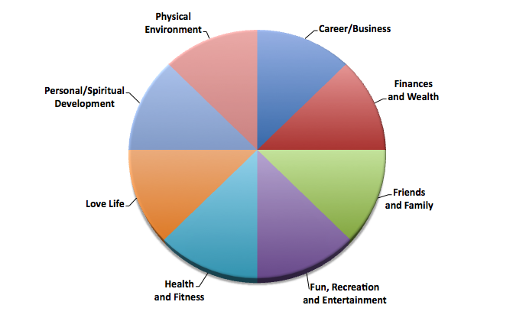

|  |  |
| --- | --- |
| 1. | Describe what kind of ride be if this were a real wheel… |
|  | |
| **2.** | **List any life areas that you think you need to work on.** |
|  | |

|  |  |
| --- | --- |
| 3. | What would you need to do to improve each life area? |
| Career/Business | |
| Finances and Wealth | |
| Friends and Family | |
| Fun, Recreation and Entertainment | |
| Health and Fitness | |
| Love Life | |
| Personal/Spiritual Development | |
| Physical Environment | |

|  |
| --- |
| Dear Coach,  **I hope you enjoy the Wheel of Life Assessment. It is a useful tool to  use to kick-start a meaningful conversation with a new prospect.**  **We have a ton of similar tools in our NEW product,** [**The Coaching Tool Kit**](http://thecoachingtoolkit.com)**. Out now!**  **As always, happy coaching!**  **::::Corporate Services:Marketing:Images:Benay:Benay_SignatureWeb.gif**  *Benay Wettle*  ***Director, Benay Wettle and Associates*** |