**STAGE IT! SHOW IT! SELL IT!**

**HOME STAGING SERVICES**

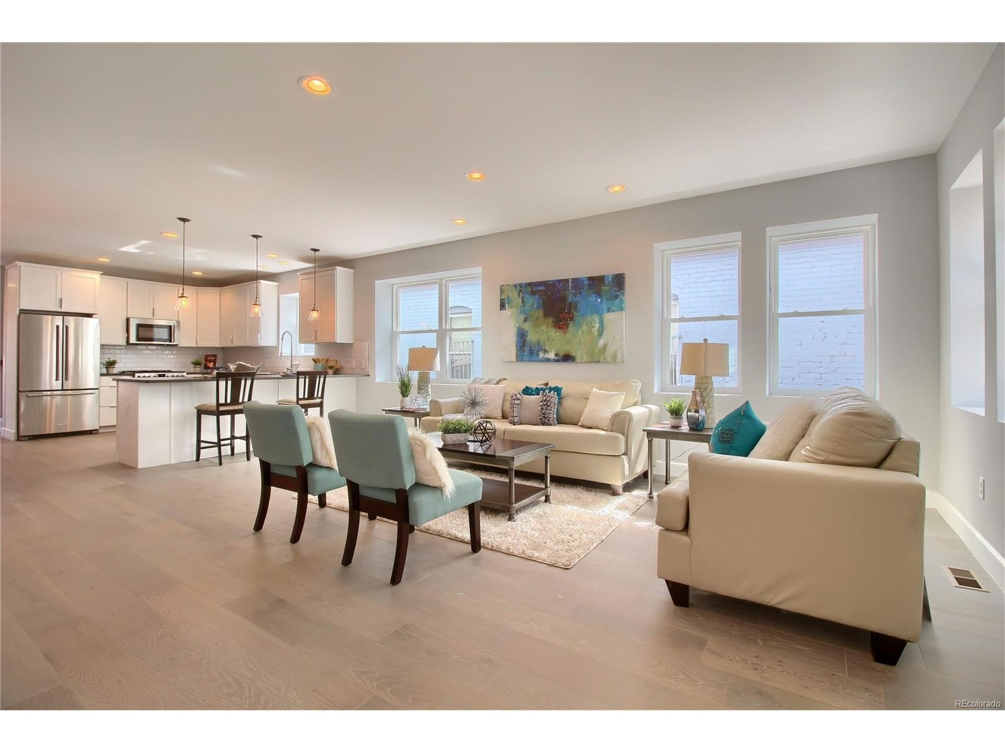

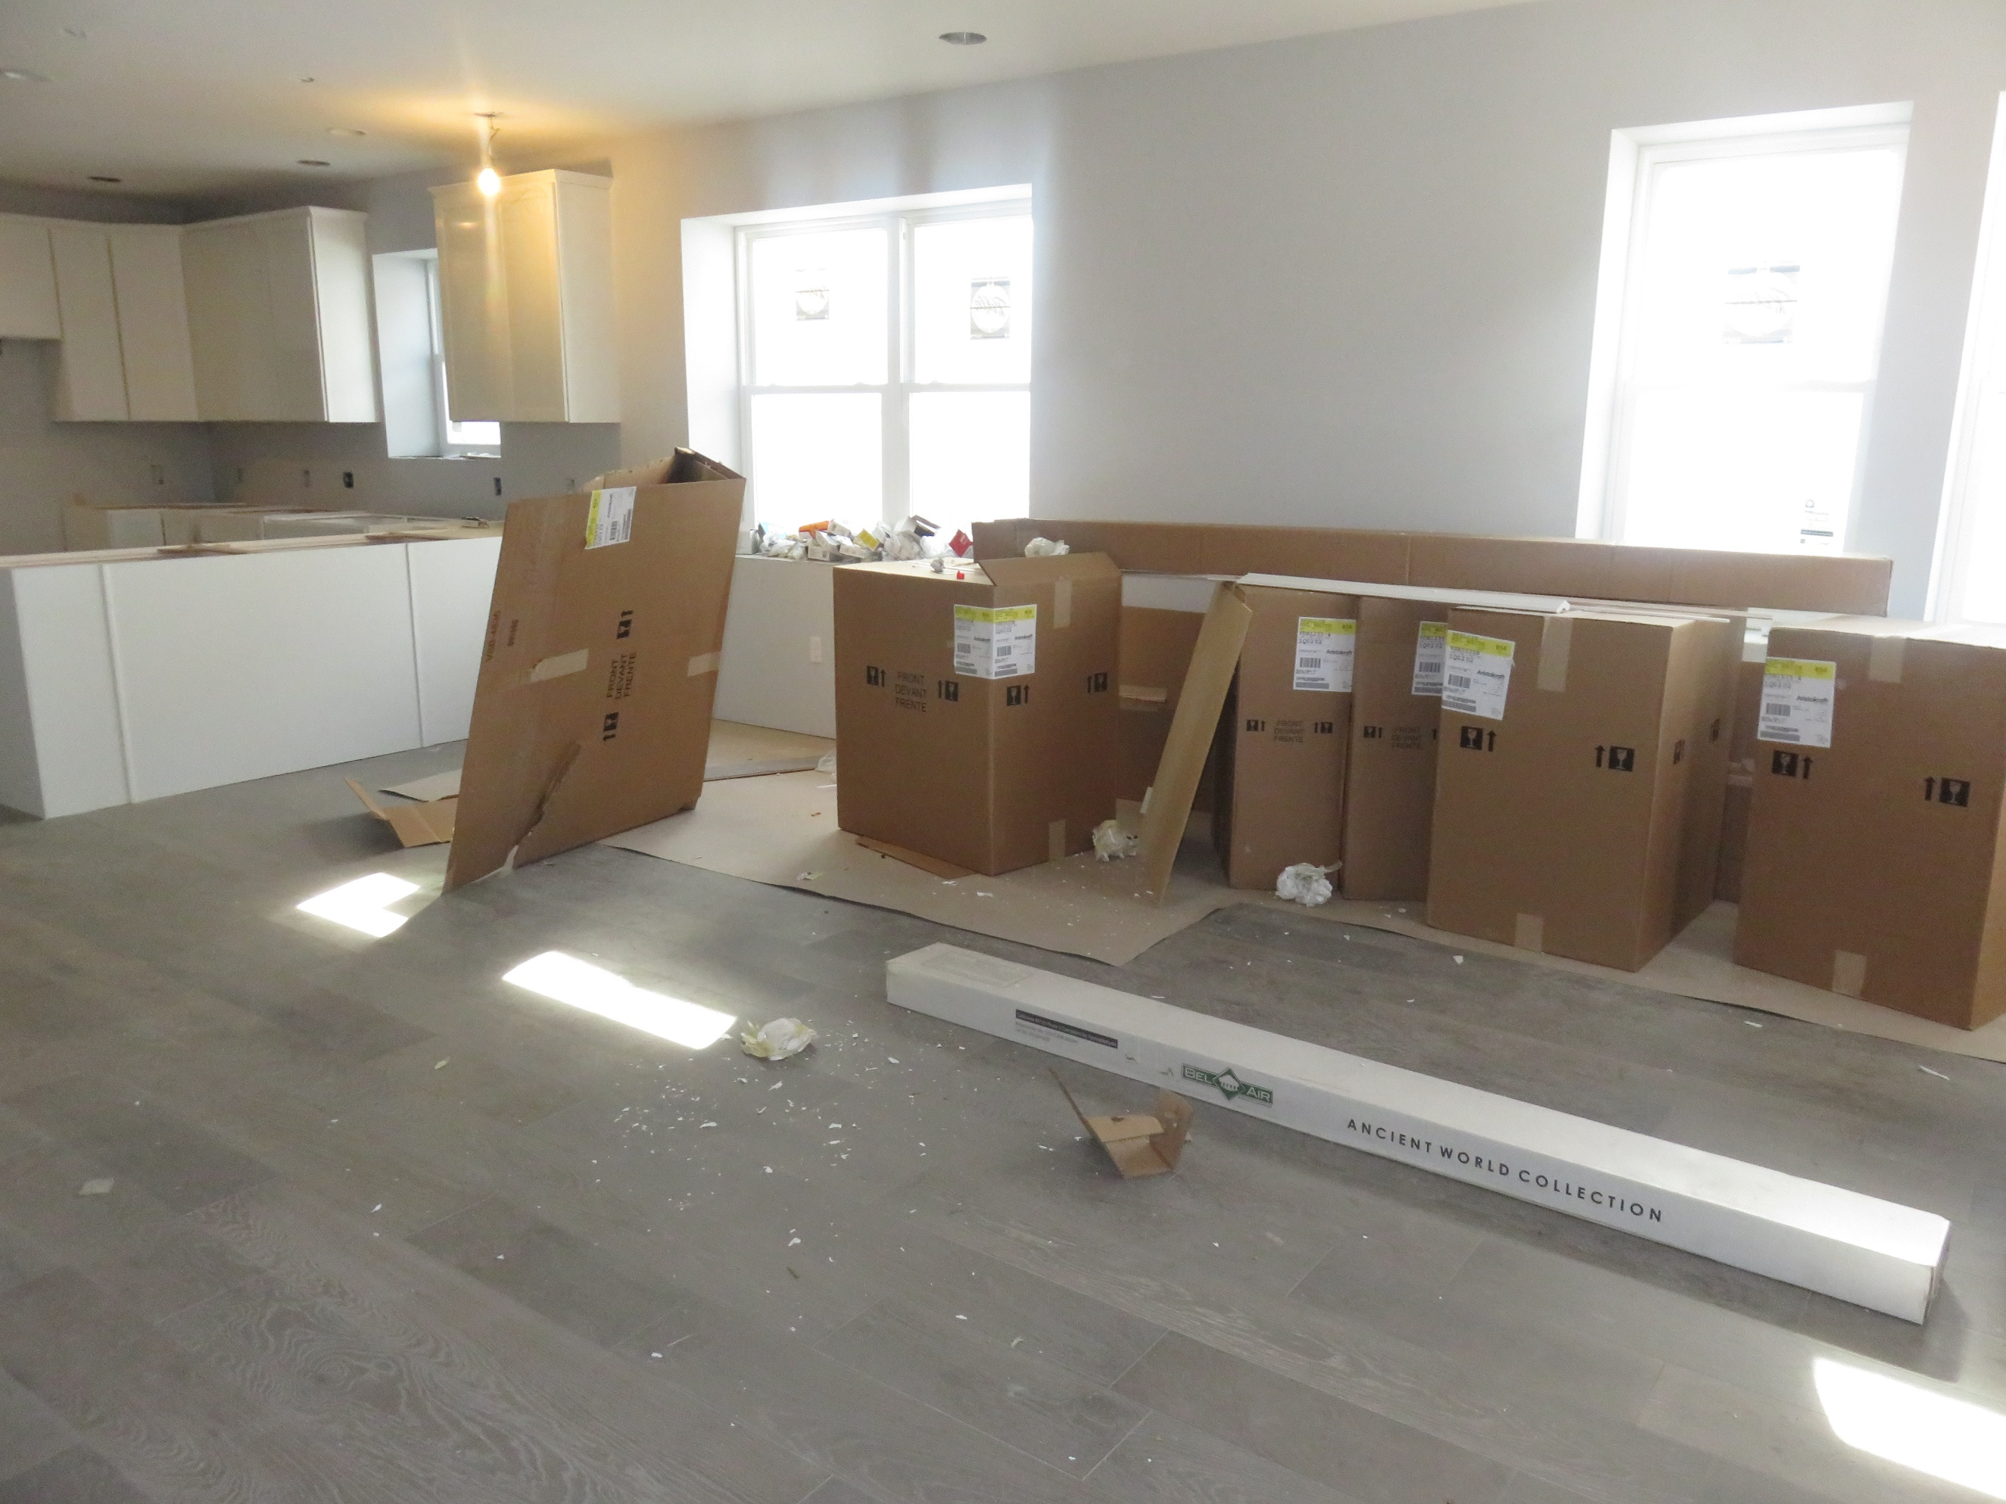

(Your Company) offers Home Staging Services to help prepare properties for sale. We partner with our clients for their success, and have the same goals: **To get the property SOLD quickly and at the very BEST PRICE based on market conditions.**

***“I can do as little or as much as you would like.”***

Before and after example of Vacant Home Staging.

* **Home Staging Consultations**: I prepare a detailed summary of recommendations room by room, including the front and back yards.
* **Hands-on Staging**: I can complete the hands-on Staging of your property saving you time and energy. I can use your things or supplement as needed with my tasteful inventory.

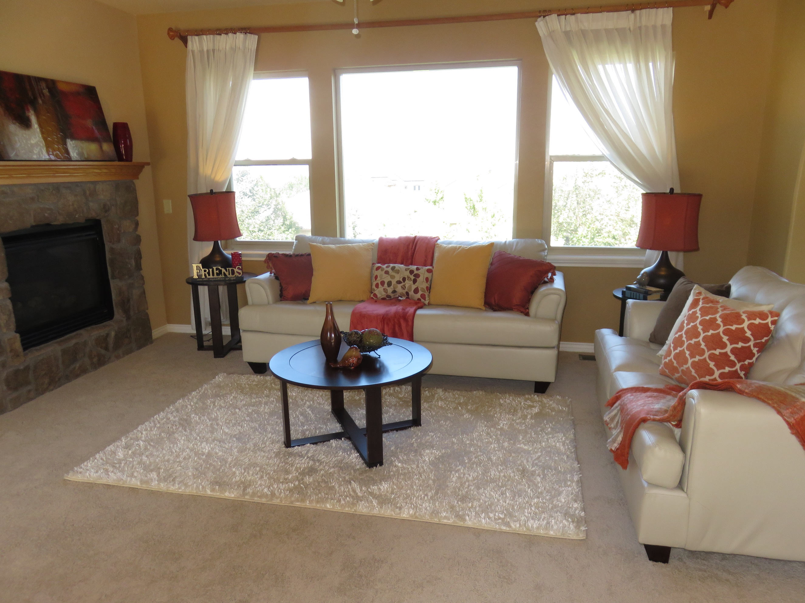

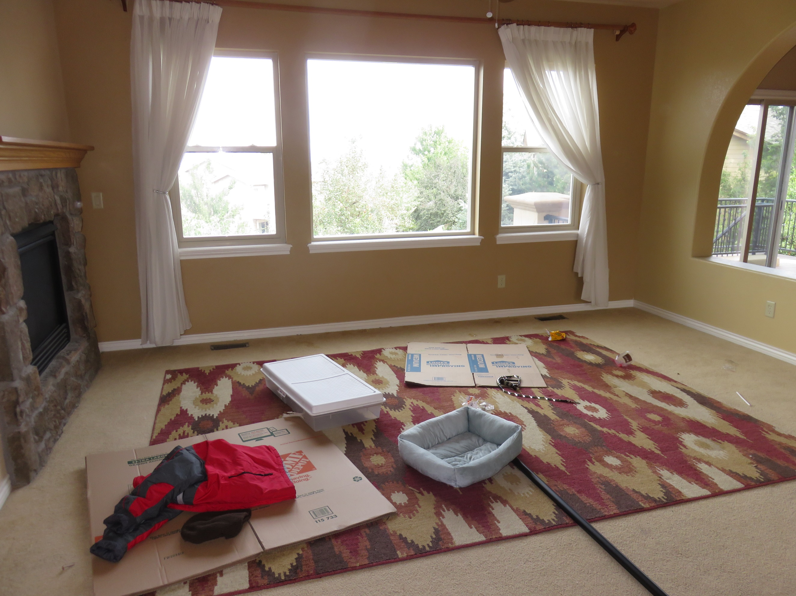

* **Vacant Staging**: I will Stage the recommended areas of the property with tasteful furniture and décor. I start with a complimentary preview followed by a pricing proposal detailing our scope of work and fees associated with getting your property Staged.



50% of Buyers

**DID YOU KNOW**

are willing to **pay** **MORE** for a property that is Staged!*

*NAR Profile of Home Staging

*Your phone number, email and website*



***“THE INVESTMENT IN STAGING IS ALWAYS LESS THAN A PRICE REDUCTION.” ‐ Barb Schwarz***

Before and after example of Occupied Home Staging.

*I am an Accredited Staging Professional® (ASP®) Home Stager and a member of The International Association of Home Staging Professionals® (IAHSP®).*

Information about you – your background and credentials, whatever you would want your potential client to know about you. What makes you different, or your mission statement, how you want to serve clients, etc.

*Your phone number, email and website*

Stage® is a Federally Registered Trademark of Stagedhomes.com. ASP®, IAHSP®, Accredited Staging Professional®, and The International Association of Home Staging Professionals® are Federally Registered Trademarks of Stagedhomes.com/Barb Inc. All rights reserved.

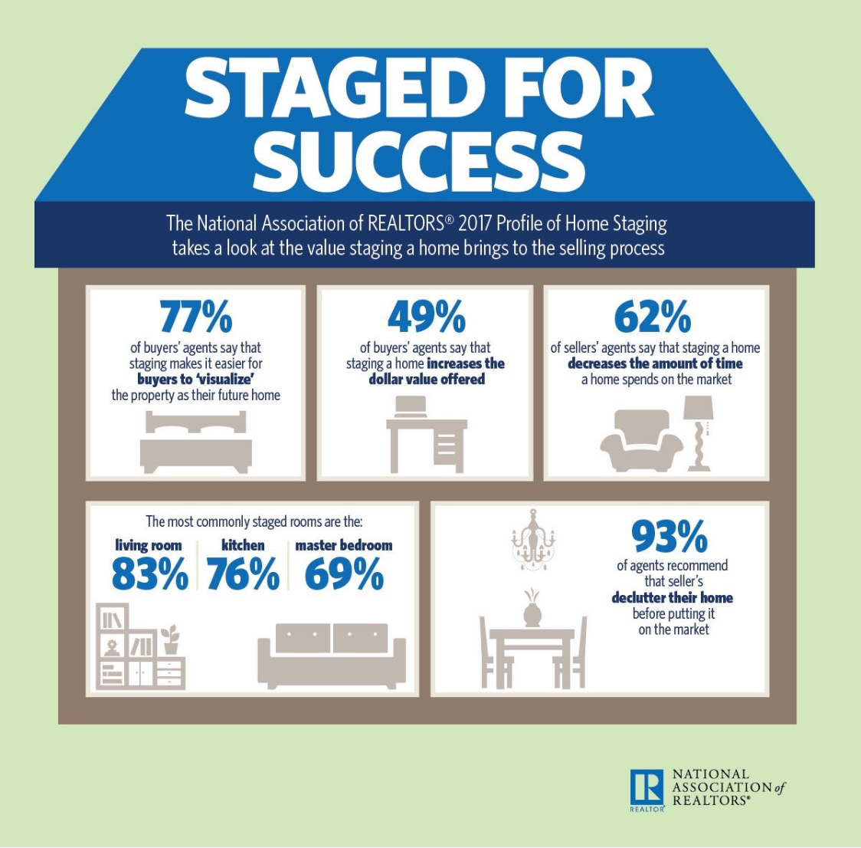

***Staging for the Best First Impression!***

***Front Door***

***Home Staging***

