The 41st Green Room Awards Ceremony

**8th April 2024,7pm**

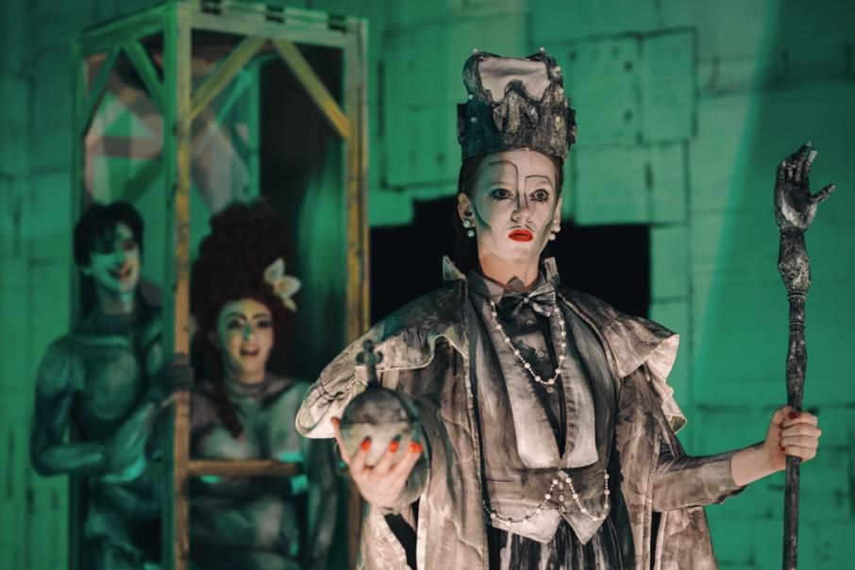

*IMAGE DESCRIPTION: A photo from the production of “The Crocodile”, image by Jack Dixon-Gunn*

Comedy Theatre Accessibility Information

**Current at 5/12/2023**

The Comedy Theatre welcomes everyone to the venue, and we work hard to make live performances accessible to all. We’ve put together the below information about the venue, but if there is anything missing or if you have any questions, please don’t hesitate to contact us.

## Accessibility & Ticketing contacts

Phone: 1300 11 10 11

Email: [access@marrinergroup.com.au](mailto:access@marrinergroup.com.au)

Website: [www.marrinergroup.com.au/comedy-theatre-accessibility](http://www.marrinergroup.com.au/comedy-theatre-accessibility)

## Green Room Awards Accessibility Assistance

Weng Yi Wong (Secretary): 0424 672 868

## Ticketing

[ticketing@greenroom.org.au](mailto:ticketing@greenroom.org.au)

# How To Get Here

The Comedy Theatre is located on the corner of Exhibition & Lonsdale Streets, Melbourne.

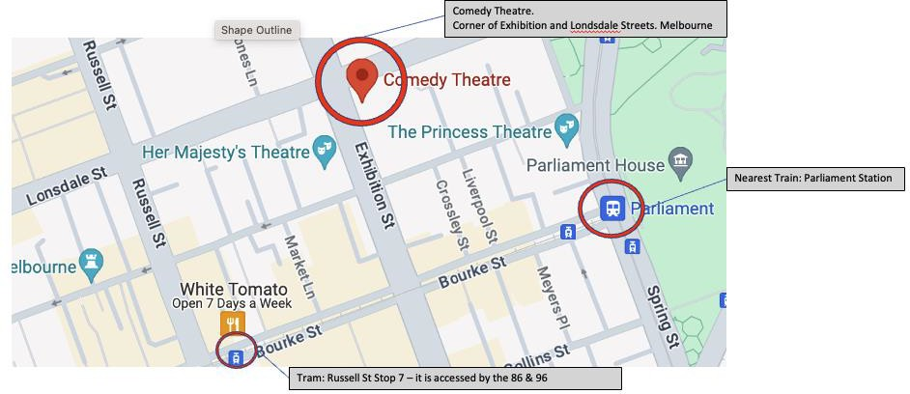

*IMAGE DESCRIPTION: A map identifying, in red circles, the location of the Comedy Theatre, the nearest train and the nearest tram.*

**Parking:** There is limited parking in the city, but patrons can access special rates at select Wilson Car Parks. This offer must be booked on their website before arrival. Click here for more information – marrinergroup.com.au/offers/discount-parking

**Drop Off/Pick Up:** The best spot for drop off and pick up is on Exhibition Street, outside the Woolworths next to the theatre. These street spots are designated loading zone or five-minute parking dependant on time of day.

**Taxi:** The nearest taxi rank is outside the Melbourne Marriott Hotel, corner Exhibition and Lonsdale Streets.

**Tram:** The closest tram stop is Russell St Stop 7 – it is accessed by the 86 & 96 trams and is a level access stop.

**Train:** Parliament Train station is approximately 260m from the Comedy Theatre. This is a City Loop station. There is an accessible entrance and exit located on Spring Street. Please click here for more information and timetables – [www.ptv.vic.gov.au](http://www.ptv.vic.gov.au/)

# Booking Tickets

Accessible tickets for the Comedy Theatre can be purchased by calling us on 1300 11 10 11 (option 2), Monday to Friday 10am to 5pm or by emailing [access@marrinergroup.com.au](mailto:access@marrinergroup.com.au).

Tickets are also available from the Comedy Box Office (two steps, no ramp available) 90 minutes before performances, or from the Princess Theatre Box Office located at 163 Spring Street, Melbourne, open 10am-5pm Monday – Friday.

To arrange a companion card ticket or wheelchair seat please contact us on the details below before the show.

Booking wheelchair positions is available online for some shows.

If you are an invited guest of the Green Room Awards Association, on a complimentary ticket, please ensure you have notified the Association of any accessibility requirements PRIOR to the event via [ticketing@greenroom.org.au](mailto:ticketing@greenroom.org.au) or by contacting the secretary, Weng Yi Wong, on 0424 672 868.

# Companion Card Tickets

Companion Cards are accepted for all performances at the Comedy Theatre and can be booked directly with the Box Office on 1300 11 10 11 (option 2). Companion Card tickets can only be collected from the Box Office from an hour prior to the performance. The Companion Card must be presented before tickets can be handed to the patron.

# Arriving at the Venue

Entry to the Comedy Theatre is via Exhibition Street. There are several glass doors that remain open pre-show and during interval. There is a small step to access these doors, which as you move away from Lonsdale Street is reduced to a small lip.

Uniformed Green Room Awards Event Staff will be positioned throughout the venue and are available to assist you at any time.

Ramp access can be provided by Event Staff, Front of House or Security upon request. A member of staff will be able to assist you upon arrival at the theatre.

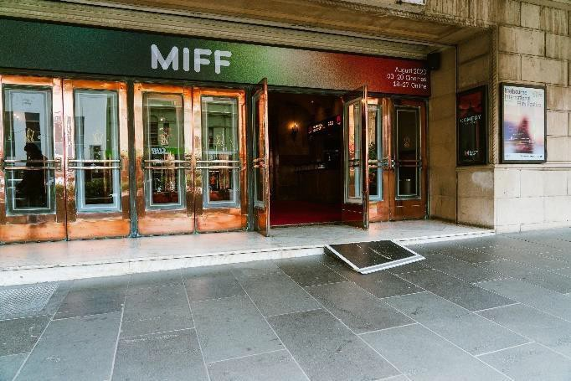

***IMAGE DESCRIPTION: The Exhibition Street entrance to the Comedy Theatre showing the glass doors, with the second-to-right double glass doors open and a ramp from the street level, to the theatre foyer level.***

A Front of House staff member will scan your ticket at the inner glass doors of the theatre.

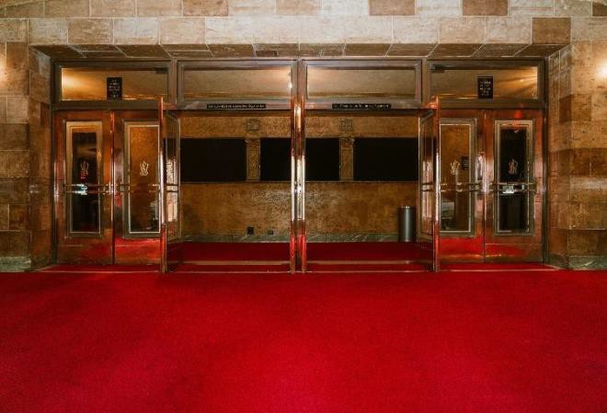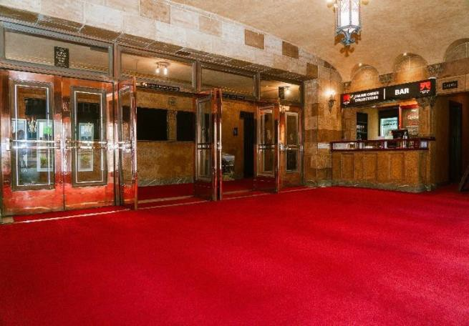

*IMAGE DESCRIPTION: A photo of the Comedy Theatre foyer, red carpets and bronze and glass doors.*

The Box Office is located to the left of the front doors on Exhibition Street and can also be accessed once inside the foyers via the left-hand Stalls bar. It is visibly signed and has a counter 1m high.

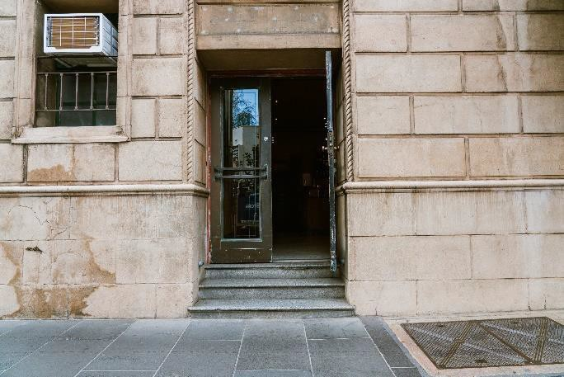

*IMAGE DESCRIPTION: The Exhibition Street entrance to the Comedy Theatre Box Office.*

*Light brown stone, three steps up to glass doors.*

# Foyers

**Stalls:** The Stalls foyer is carpeted all the way through to the auditorium. There is limited seating available at Stalls level.

Toilets and bars are available on this level. Merchandise is typically available on this level; however availability may vary with each production.

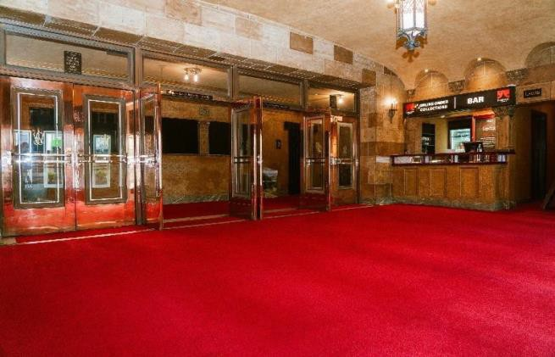

*IMAGE DESCRIPTION: A photo of the Comedy Theatre foyer, red carpets and bronze and glass doors.*

**Dress Circle:** The Dress Circle foyer is large and carpeted. **Please note there is no lift access to the Dress Circle**. Access is via two large staircases with handrails, with 19 stairs each. There is limited seating available in the Dress Circle foyer.

A bar and toilets are available at this level.

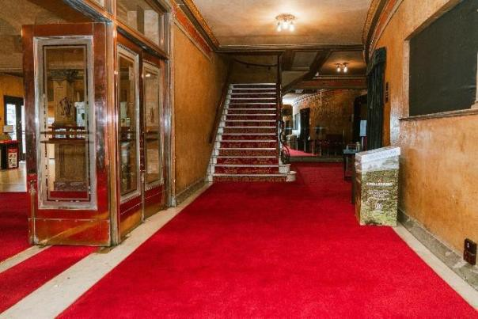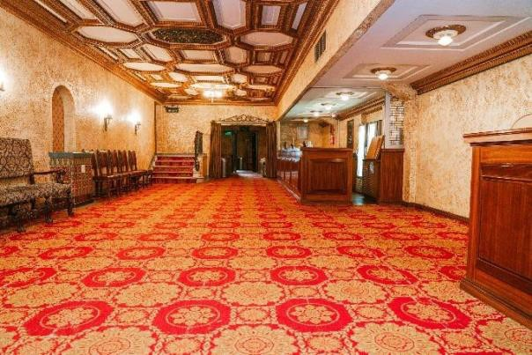

*IMAGE DESCRIPTION: Two photos of the downstairs and upstairs foyers, with stairs leading from downstairs to upstairs in the left-hand-side photo*

The Comedy Theatre is a fully seated venue over two levels. All seats fold down and forward, leaving more room between rows when seats are unoccupied.

**Stalls:** There are no steps from the foyer into the Stalls auditorium. Seating is mildly raked. There are two central aisles and two outside aisles until Row F, providing plenty of aisle seats. Rows A – E have outside aisles only. There are no handrails within the Stalls aisles. Stalls seating is staggered to provide the best possible sightline.

Although the aisles themselves are slightly raked, the back seating Rows P – R have two small steps into them, and Rows O – N have one small step into them, providing a level footing surface for patrons.

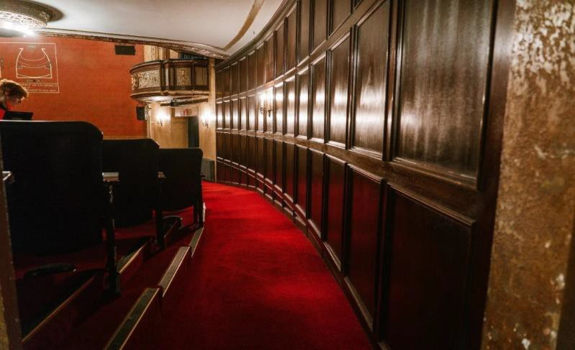

***IMAGE DESCRIPTION: Photo of the far right-hand-side of the Stalls Seating, four back rows with steps.***

From the back four rows (Row O – Row R), view of the stage may be affected by the Dress Circle overhang. The Dress Circle overhang is less pronounced in the Comedy Theatre than in other venues.

**Dress Circle:** On the right and left of the Dress Circle foyer, a set of stairs with 14 stairs and handrails lead into the auditorium.

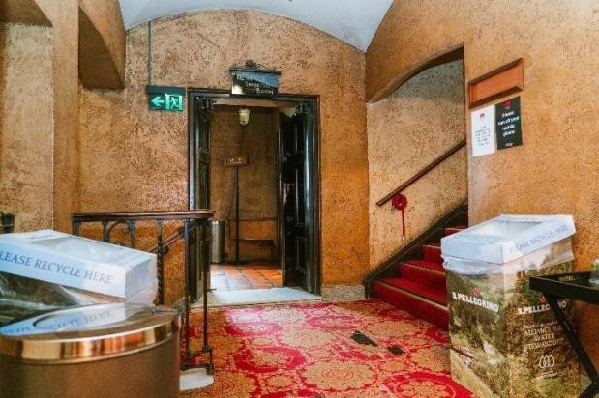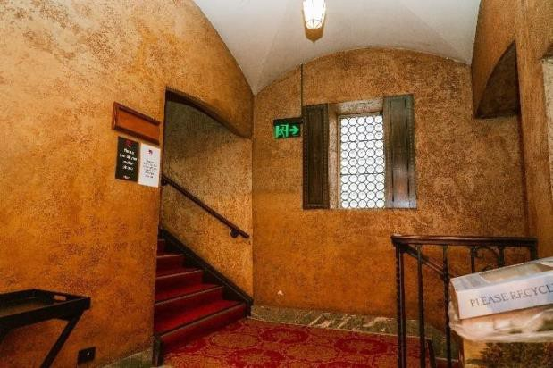

***IMAGE DESCRIPTION: Two photographs of the Dress Circle foyer with stairs leading to the auditorium.***

These steps come out onto a landing that becomes Row E. Rows A – D are accessible via an outside aisle, with up to 12 stairs down to Row A, a handrail and a segmented handrail. Rows E – M are accessible via two stepped central aisles with segmented handrails. There are 24 stairs to the back row (Row M).

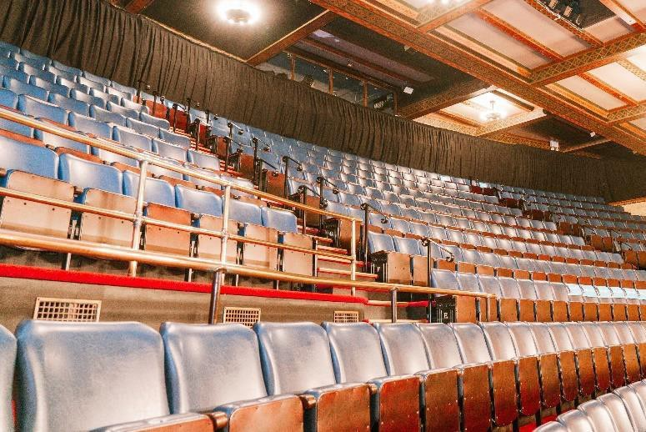

***IMAGE DESCRIPTION:A photo of the blue leatherette seating in the Dress Circle auditorium***

Seating within the Dress Circle is quite steeply tiered, and Rows E – M may not be suitable for patrons with vertigo. *There is no lift access to the Dress Circle.*

# Toilets

**Stalls:** The Female toilets are located on the right-hand side upon entry to the foyer, down a hallway next to the smaller bar.

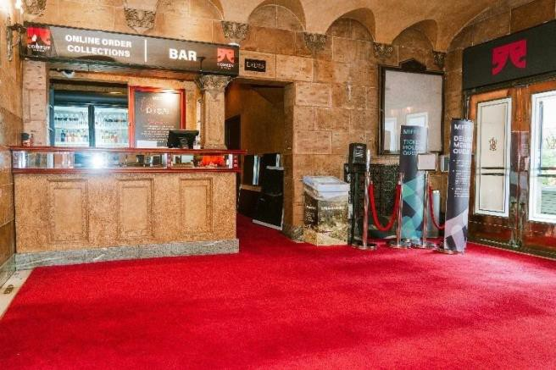

***IMAGE DESCRIPTION: A photo of the Female toilets on Stalls level, adjacent to the smaller bar on the Right-hand-side***

The Male toilets are located to the left, past the larger bar and through a doorway. The toilets on this level don’t require any stairs to access.

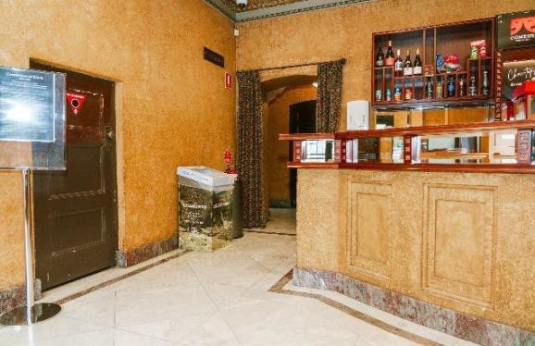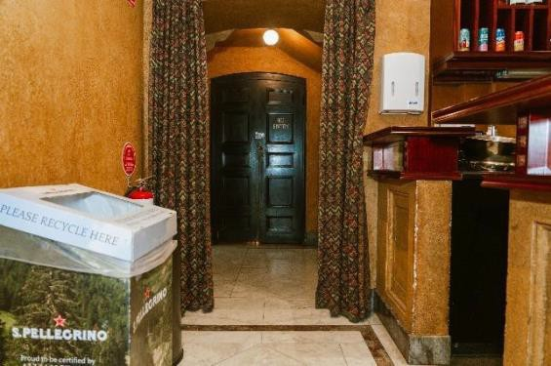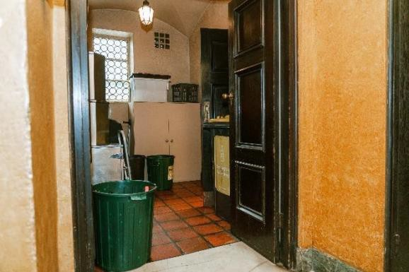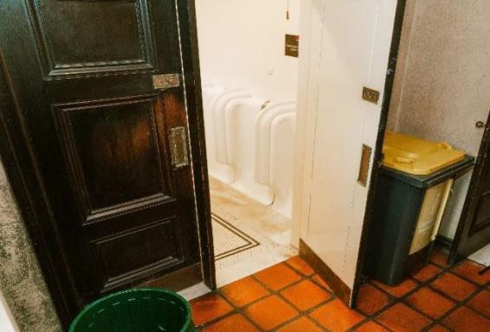

***IMAGE DESCRIPTION: Photos of the male toilets on Stalls level, adjacent to the larger bar on the Left-hand-side***

**Dress Circle:** The Female toilets are located toward the right-hand side of the Dress Circle foyer, indicated by a sign which says ‘Ladies Cloak Room’. There are five stairs with a handrail to access

the toilets. There are a large number of Female toilet stalls available in the Dress Circle.

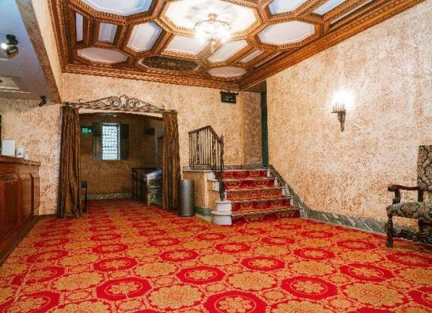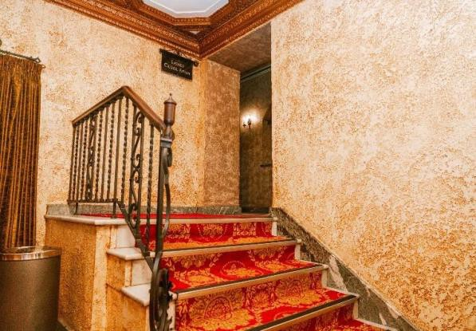

***IMAGE DESCRIPTION: Photos of the Dress Circle Female Toilets, up a flight of stairs without accessible entrance***

The Male toilets are located on the left-hand side of the Dress Circle foyer, through a doorway with a sign above that says “Gentlemen’s Smoking Room”. There are urinals and stalls available.

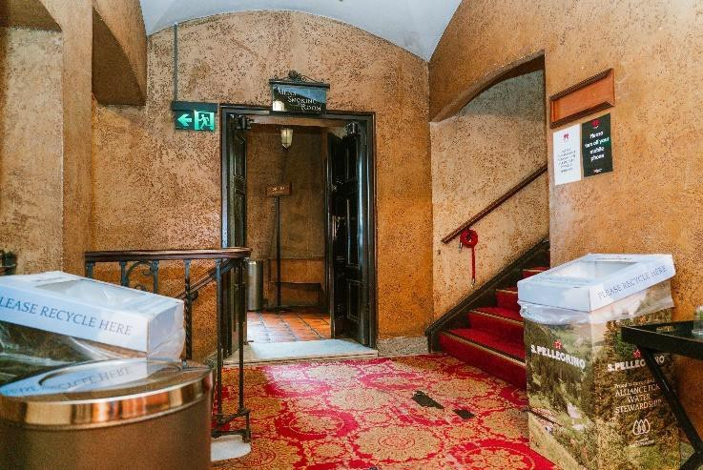

***IMAGE DESCRIPTION: Photos of the Dress Circle Male Toilets, inside room signed “Gentleman’s Smoking Room”***

**Accessible & Gender Neutral:** There is a unisex accessible toilet located in the Stalls inner foyer. It is located through the Stalls foyer on the far-right hand side, opposite the Door 4 entry to the auditorium. There is a clearly visible sign above the door. It is a Left-Hand Side accessible toilet.

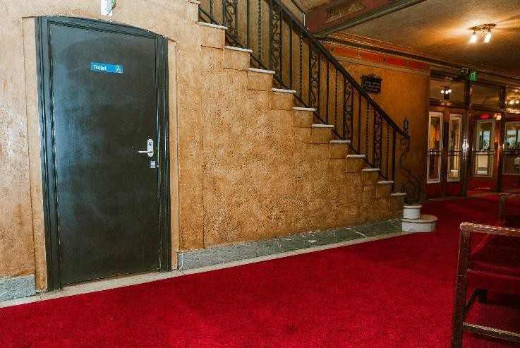

***IMAGE DESCRIPTION: Photos of the Gender Neutral, accessible toilets on stalls level.***

**Infant change facilities:** The Comedy Theatre does not have infant change facilities.

**Adult change facilities:** The Comedy Theatre does not have an accessible adult change facility within the venue. Please visit [https://changingplaces.org.au/find-a-](https://changingplaces.org.au/find-a-toilet/find-changing-places-toilet/) [toilet/find-changing-places-](https://changingplaces.org.au/find-a-toilet/find-changing-places-toilet/) [toilet/](https://changingplaces.org.au/find-a-toilet/find-changing-places-toilet/) for information on the nearest public adult change facility.

# Bars

**Stalls:** There are two bars on the Stalls level – one to the left of the entry doors, and a smaller bar located to the right. Both bars have quite high counters.

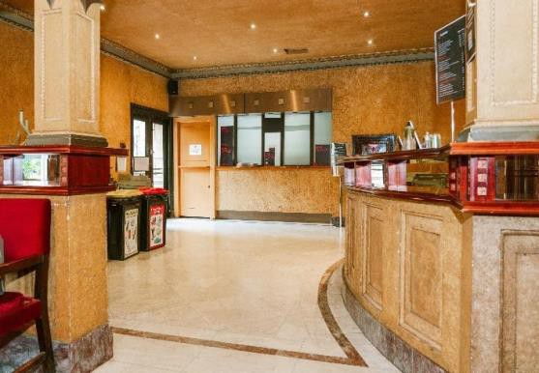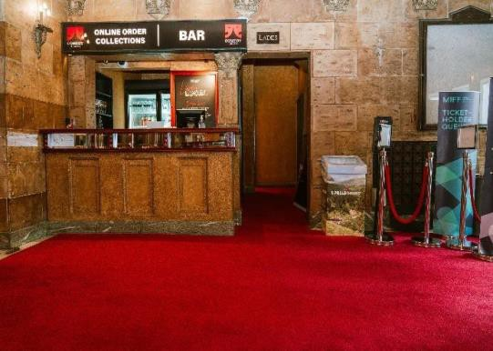

***IMAGE DESCRIPTION: Photos of the Bars in the Stalls level foyer.***

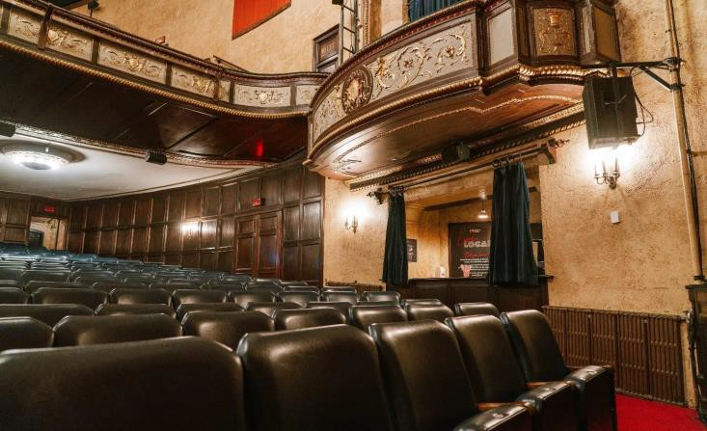There is also a bar located inside the Stalls auditorium, on the far left- hand side, inside Door 1.

***IMAGE DESCRIPTION: A photo of the Bar on Stalls level, on the left-hand-side of the auditorium***

**Dress Circle:** There is a bar available on the Dress Circle level. The counter is around

1.1m high.

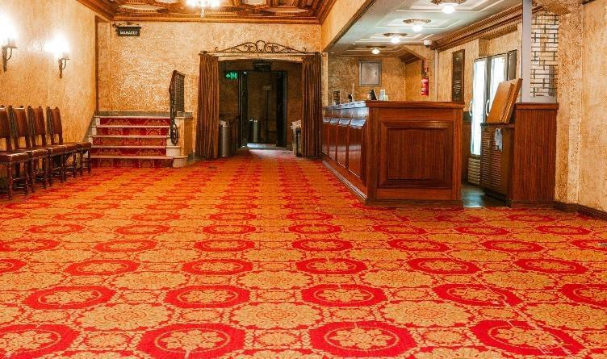

## Merchandise

***IMAGE DESCRIPTION: A photo of the Bar on the Dress Circle level***

The location of merchandise stalls may vary between shows. The standard location is within the inner Stalls foyer, immediately beyond the internal glass doors.

## Cloakroom

There are limited cloaking facilities available at the Comedy Theatre. To cloak items, please visit the Box Office, or speak to a Front of House staff member for assistance. Patrons are advised against bringing bulky items or prams to the theatre. The cloakroom is located to the left of the Box Office.

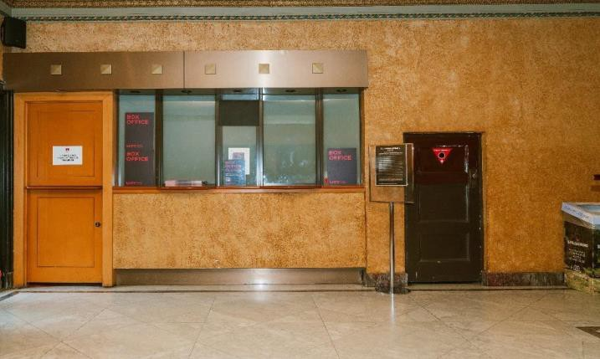

***IMAGE DESCRIPTION: A photo of the Cloakroom at the Exhibition Street, Box Office entrance.***

12

# Lighting

There is low lighting in the venue as needed for shows. All walkways and aisles are clearly marked, however if you have low vision and need assistance, please let us know, our staff will be happy to help.

We will always try and make sure there is signage for any shows with strobe lighting, however this may not always be possible. If you have any concerns about strobe or flash lighting for any show you are attending, please contact us or speak to a Front of House staff member within the venue, and we will do our best to give you as much information as we can.

## Facilities for people with Low Vision or Blindness

Seats close to the stage can be requested when booking tickets. Please book through Box Office on 1300 11 10 11 (option 2) or by emailing [access@marrinergroup.com.au](mailto:access@marrinergroup.com.au).

Some shows have audio described performances – please check the show information page for a booking link. For further information, direct enquiries to Vision Australia.

## Support Animals & Guide Dogs

Support and assistance animals are welcome at the Comedy Theatre. We encourage you to contact the Box Office on 1300 11 10 11 prior to the show so we can arrange assistance with entry if required.

Please be aware that the venue can be a noisy and busy environment, so you may want to consider the use of an alternative aid when attending a show.

Water bowls can be provided for Guide Dogs upon request.

# Facilities for hard of hearing or d/Deaf patrons

**Assistive Listening Devices:** The Comedy Theatre provides personal induction neck loops free of charge from the cloakroom, located at the Box Office. Patrons with hearing aids can utilise neckloops by switching the “T” Switch, or Telecoil position.

We can also provide headsets for those without compatible hearing aids or who may prefer headsets.

Our Assistive Listening Devices are compatible with standard 3.5mm headphone jacks if patrons wish to bring their own headsets.

We aim to do our best and ensure patrons using Assistive Listening Devices can fully experience the show. If there are any issues with a device, please see a Front of House staff member for assistance.

13

## Auslan Interpreted and Captioned Performances:

The Green Room Awards will be Auslan interpreted.

To book seats with the best view of the interpreter or captioning monitor, a unique ticketing link will often be available via Auslan Stage Left’s webpage or can be booked by emailing [ticketing@greenroom.org.au](mailto:ticketing@greenroom.org.au)

# Facilities for People with Mobility Impairments

Patrons with mobility impairments are strongly advised to book Stalls seating. **There is no lift access to the Dress Circle.** Frames and crutches are stored in the foyer or in the cloakroom and returned at interval and conclusion of performances.

Patrons are advised of the storage area, and all items are marked with the patron’s row and seat number.

## Facilities for Wheelchair Users

There are two wheelchair positions at the Comedy Theatre, each with associated companion seats. These seats allocated for the wheelchair position are removable if a patron prefers to remain in a wheelchair or can remain in situ if they prefer to transfer to a theatre seat. Please indicate preference when booking.

Patrons should direct booking enquiries for wheelchair positions to Box Office on 1300 11 10 11 (option 2) or email us at [access@marrinergroup.com.au](mailto:access@marrinergroup.com.au).

Wheelchair entry to the theatre is via ramp that is placed toward the right of the frontage, away from Lonsdale Street. Once inside the foyer, there are no stairs through to the auditorium.

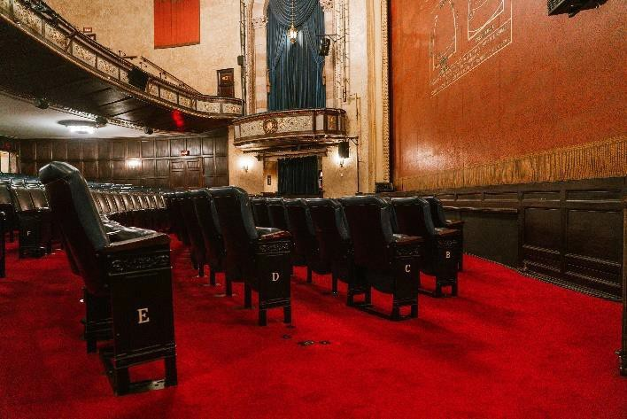

***IMAGE DESCRIPTION: A photo of the wheelchair position/s on the right-hand-side of the Stalls***

14

# Quiet Spaces

The Comedy Theatre does not have a dedicated quiet space. During the show, the foyers are quiet, well-lit and have seating available. Patrons with sensory sensitivities may find the theatrical experience overwhelming. There are aisle seats available for booking in case a quick exit is required. Please email [ticketing@greenroom.org.au](mailto:ticketing@greenroom.org.au) to make these requests.

Uniformed Green Room Awards event staff will be positioned throughout the venue and are available to assist you at any time.

Please note that once exiting the auditorium, patrons may have to wait until a suitable break in the performance to be re-admitted to their seats.

The Comedy Theatre currently has soft, in-ear earplugs available for patrons upon request. Ask a Front of House staff member for assistance.

The Comedy Theatre does not have a stage view monitor available in the foyer.

## General Information and Service

If you have any questions or specific needs, please let us know.

**Need something else?** Please visit marrinergroup.com.au, call our friendly Customer Service team on 1300 11 10 11, or speak to any of the venue staff who are always happy to assist. You may also seek assistance from the Green Room Awards Secretary, Weng Yi Wong on 0424 672 868

## Feedback & Suggestions

Have you got any suggestions for what we can do better or a general enquiry? Please send them through to [**access@marrinergroup.com.au**](mailto:access@marrinergroup.com.au)

15