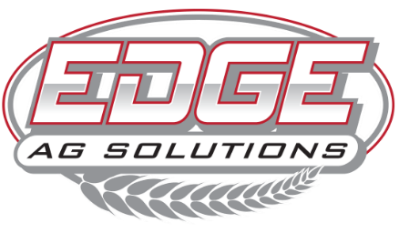

2168 US Hwy 34 | Corning, Iowa | 50841

(641)322-EDGE | www.edgeagsolutions.com

**POSITION:**

Custom Applicator

**JOB SUMMARY:**

The Custom Applicator is responsible for the safe and accurate application of crop protection products and fertilizers to customers' fields. This role involves operating and maintaining sprayers, spreaders, and other agricultural equipment, ensuring proper calibration and application. The applicator must maintain detailed records, communicate with customers, and assist with warehouse, delivery, and general maintenance duties as needed.

At EDGE Ag Solutions, we are committed to innovation, precision, and customer service. We offer CDL training assistance and continued education to help applicators stay current with licensing requirements and industry advancements. This position offers competitive pay, seasonal overtime opportunities, and a performance-based bonus structure tied to accuracy and acres covered.

**JOB DUTIES:**

**Application & Equipment Operation**

* Operate and maintain application equipment, including sprayers, spreaders, and tender trucks.
* Mix, load, and apply crop protection products and fertilizers at prescribed rates.
* Calibrate equipment to ensure accurate application.
* Follow all OSHA, EPA, DOT, and state regulations for chemical handling and application.
* Maintain up-to-date spray records and required application logs.

**Customer Service & Communication**

* Educate customers on the products being applied, their benefits, and how the company can continue to support their operation.
* Maintain a professional and customer-focused attitude.

**Maintenance & Safety**

* Perform routine preventative maintenance on equipment.
* Ensure all personal protective equipment (PPE) is used properly and consistently.
* Maintain the cleanliness and organization of work areas, vehicles, and storage facilities.
* Understand and comply with Worker Protection Standards (WPS).

**General Support Duties**

* Assist in warehouse operations, including handling and delivering bulk and packaged products.
* Help with seasonal operational needs such as fertilizer and chemical deliveries.
* Participate in general facility and equipment maintenance.
* Adapt to changing workloads and complete additional tasks as assigned.

**Work Schedule & Seasonal Expectations:**

* **Standard Hours:** Monday – Friday, 8:00 AM – 5:00 PM.
* **Peak Season (Spring & Fall):** Overtime required, including extended weekday and weekend hours.
* Flexibility is **required** to accommodate seasonal workload demands.

**Qualifications:**

**Required:**

* Valid Class A CDL with tanker and hazmat endorsements (or ability to obtain; CDL training assistance provided).
* Commercial Pesticide Applicator’s License (or ability to obtain; continuing education support provided).
* Minimum of 3 years of experience in spraying or equipment operation.
* Clean driving record.
* Ability to lift 75+ pounds.
* Basic mechanical and maintenance skills.
* Strong ability to work independently and as part of a team.
* Willingness to work long hours during peak seasons.

**Preferred:**

* Experience with precision ag technology and application equipment.
* Familiarity with agricultural chemicals, fertilizers, and seed products.
* Knowledge of agronomic principles related to chemical application.

**Compensation & Benefits:**

* Competitive Base Pay with seasonal overtime opportunities.
* Performance-Based Bonuses tied to accuracy and acres covered.
* CDL Training Assistance and Continuing Education Support for license requirements.
* Paid Time Off (PTO).
* 401(k) Retirement Plan with 3% match (following 6 months employment).
* Health Insurance available.
* Career Growth Opportunities within EDGE Ag Solutions.