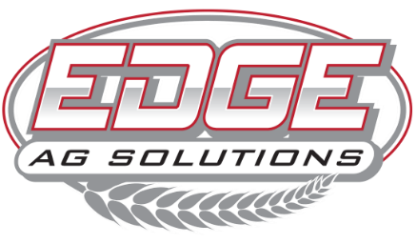

2168 US Hwy 34 | Corning, Iowa | 50841

(641)322-EDGE | www.edgeagsolutions.com

**ABOUT US**

At EDGE Ag Solutions, we provide precision agriculture services that help growers achieve their goals. Our team values attention to detail, excellent customer service, and operational efficiency. We’re looking for a dependable and highly organized Office/Billing Specialist to manage daily office operations and handle critical billing and accounting support tasks with accuracy.

**POSITION OVERVIEW**

The Office/Billing Specialist will oversee front office activities and perform essential accounting tasks with a strong focus on accuracy. You will manage invoicing, accounts payable and receivable, and inventory billing, while also serving as the first point of contact for customers and vendors.

**KEY RESPONSIBILITIES**

**ACCOUNTING & BILLING TASKS**

* Prepare and send customer invoices for products and services.
* Process accounts receivable: track payments, apply payments to customer accounts, and follow up on outstanding balances.
* Process accounts payable: enter vendor invoices, match with purchase orders, and prepare for payment approval.
* Generate and send out monthly customer account statements.
* Maintain accurate records of sales, purchases, inventory movements, and billing details.
* Assist in inventory tracking and reconciliation to ensure correct billing.
* Perform routine data entry and electronic filing of accounting documents.

**OFFICE ADMINISTRATION**

* Answer and direct incoming phone calls professionally.
* Greet and assist visitors and vendors at the front office.
* Manage daily office tasks such as mail handling, ordering office supplies, and keeping the front office organized.
* Schedule deliveries, service calls, and internal meetings.
* Support internal team members with administrative tasks and document preparation.

**OTHER DUTIES**

* Maintain confidentiality and handle sensitive information responsibly.
* Collaborate with team members to ensure smooth workflow and customer satisfaction.
* Assist with preparing reports and documents for leadership as needed.

**QUALIFICATIONS**

* Previous experience in billing, invoicing, accounts payable/receivable, or office administration is strongly preferred.
* Proficiency in QuickBooks, Excel, and other Microsoft Office products is required.
* High attention to detail and accuracy is essential.
* Strong organizational and time-management skills.
* Excellent communication skills, both verbal and written.
* Friendly, professional demeanor with a team-oriented mindset.
* Ability to manage multiple responsibilities in a fast-paced environment.
* Agricultural experience is a plus, but not required — we will train the right candidate!

**Compensation & Benefits**

* Full-time, hourly pay.
* Holiday Pay and Paid Time Off (PTO).
* 401(k) Retirement Plan with 3% match (following 6 months employment).
* Health Insurance available.
* Career Growth Opportunities within EDGE Ag Solutions.