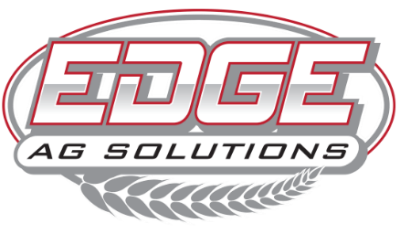

2168 US Hwy 34 | Corning, Iowa | 50841
(641)322-EDGE | www.edgeagsolutions.com

POSITION:
Sales Consultant

JOB SUMMARY:
As a Sales Consultant, you will be the face of EDGE Ag Solutions to our grower clients. Your role is to help clients maximize their return on investment by delivering agronomic advice, product recommendations, and precision solutions tailored to their operations. You'll serve as a partner in their success, backed by a team that values integrity, results, and rural roots.

At EDGE Ag Solutions, we are committed to helping producers grow stronger operations through agronomic expertise, reliable service, and proven products. We provide top-tier solutions in seed, fertilizer, crop protection, and biologicals. Our team is focused on delivering value beyond the acre and building long-term relationships rooted in trust and performance. This person must thrive in a fast-paced environment, enjoy problem-solving, and want to be an essential part of a high-performance ag retail team.

Key Responsibilities
- Build trust and develop relationships with new leads and existing clients
- Convert prospects to customers through strong communication and follow-through
- Explain EDGE’s proven process, capabilities, and value in a clear and effective way
- Recommend agronomic solutions including seed, fertilizer, crop protection, and biologicals tailored to each operation
- Provide field scouting, crop planning, and precision agriculture support (as needed)
- Stay up to date with current agronomic trends, industry advancements, and product knowledge
- Work closely with the operations team to ensure timely product delivery and customer satisfaction
- Input client data and maintain CRM records using tools like Monday and Stannect
- Map fields and gather product needs to communicate with internal team members
- Ensure accurate post-sale service: follow-up, account support, and customer satisfaction
- Coordinate with merchandising, operations, and billing to fulfill and close orders
- Track margins and oversee billing for your own clients to ensure profitability
- Participate in local ag events and maintain a visible presence in your territory
- Identify and prioritize your top 10–15 prospects quarterly
Success Measures
- New customer acquisition, client retention, and revenue growth
- Conversion % from lead to sale
- Margin on sales and billing accuracy
- Number of soil samples acquired
- Overall growth in customer accounts after first sale
- Progression of leads through the sales process
- Agronomic knowledge advancement and training participation

Qualifications:
- 2+ years of ag-related sales, customer service, or relationship-based sales experience
- Strong understanding of crop production systems, agronomy, and local farming practices
- Excellent communication, follow-up, and problem-solving skills
- Proficient in Microsoft Office and comfortable learning CRM or ag technology platforms
- Self-starter who takes ownership of outcomes and able to work independently while being a strong team player
- Clear and effective communicator—both written and verbal

Compensation & Benefits:
- Competitive base salary + commission structure
- Access and training on platform tools and CRM
- Professional development and training
- Continuing Education Support for license requirements
- Paid Time Off (PTO)
- 401(k) Retirement Plan with 3% match (following 6 months employment).
- Health Insurance available
- Career Growth Opportunities within EDGE Ag Solutions and a voice in how we do business—we don’t just hire salespeople, we build leaders

