Summary
This is a course designed for high school students on how to identify themes in literature. It is comprised of 3 modules. You will be developing the intro slides and module 1 only which defines what a theme is.

Authoring Technology: Articulate Storyline 360
Navigation: The user must view the slides in order. They may navigate to previous screens with the “back” button. Delete preset side menu so user cannot see it. Delete preset navigation buttons.

Style Guide
- Fonts: Use only “Articulate” (for text) and “Articulate Extrabold” (for headings)
  - Colors: Use HEX #1156AB for headings
- Navigation buttons:
  - Color: Use HEX #1070C4 for button and it will change to HEX #5A91E8 for “hover” feature
  - Font: “Articulate Extrabold” size 24
  - Button outline color: HEX #143966

Lesson Title: How to Find Themes in Literature | Screen Title: Title Slide | # l | Navigation Info
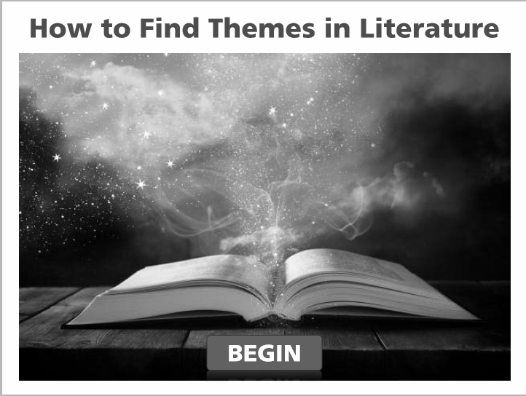 |  |  | “BEGIN” button will allow user to go to next slide upon click. Also, it changes color on “hover” (see summary)
 |  |  | Visual Info/Media
Font: Articulate Extrabold (size 28)
Font Color: HEX #1156AB
Photo: Open Book Title
Background color: white
(see summary for navigation button specs)
 |  |  | Additional Comments:

Lesson Title: How to Find Themes in Literature | Screen Title: Lesson Objectives | # 2 | Navigation Info
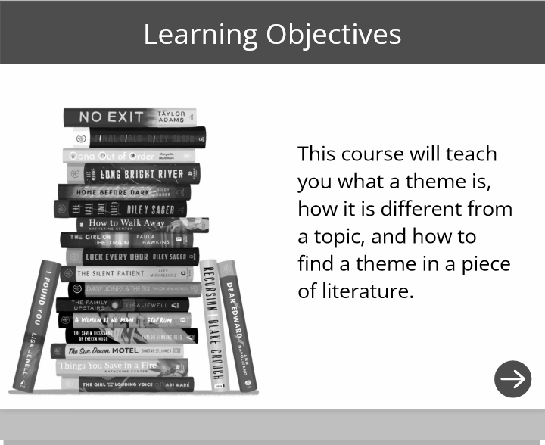 |  |  | Icon arrow (bottom right) will allow user to navigate to next slide upon click. Icon should be same color as background behind “Learning Objectives”
 |  |  | Visual Info/Media
Font (heading): Articulate Extrabold size 28, color white, centered on slide
Font (text): Articulate size 20, color black
Picture: Book-Stack
Background behind “Learning Objectives”: #1156AB
Background: white

 |  |  | Additional Comments:

Lesson Title: How to Find Themes in Literature | Screen Title: Course Overview | # 3 | Navigation Info
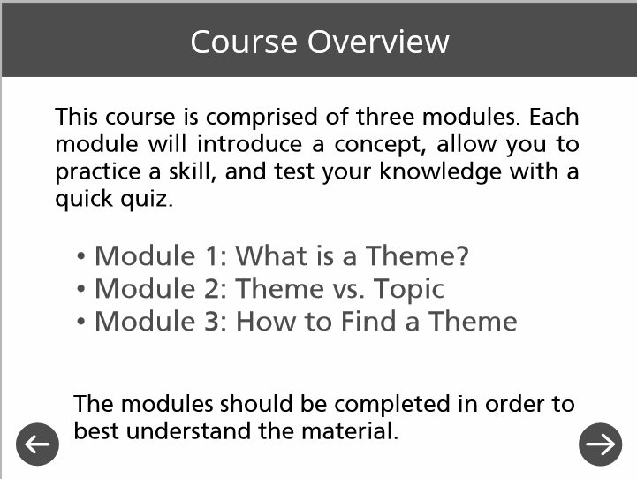 |  |  | Icon arrow (bottom right) will allow user to navigate to next slide upon click. Icon arrow (bottom left) will navigate to previous slide. Icons should be same color as header background.
 |  |  | Visual Info/Media
Font (heading): Articulate Extrabold size 28, color white, centered on slide
Font (text): Articulate size 20, color black
Font (3 modules): Articulate size 24 BOLD, color #1156AB
Background behind “Course Overview”: #1156AB
Background: white

 |  |  | Additional Comments:

Lesson Title: How to Find Themes in Literature | Screen Title: Main Menu | # 4 | Navigation Info
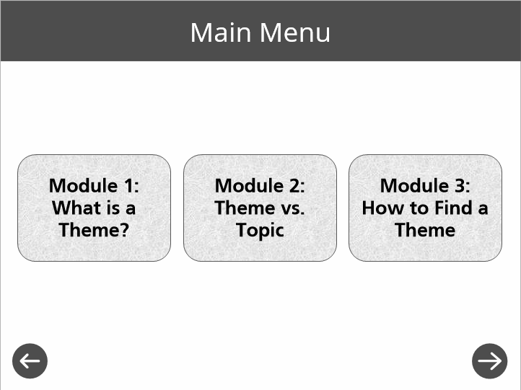 |  |  | Module 1 button: leads to next slide #5  Module 2 and 3 buttons are inactive  Icon arrow (bottom right) will allow user to navigate to next slide upon click. Icon arrow (bottom left) will navigate to previous slide. Icons should be same color as header background.
 |  |  | Visual Info/Media
Font (heading): Articulate Extrabold size 28, color white, centered on slide
Font (text): Articulate size 20, color black
Background behind header: #1156AB
Background: white

Additional Comments:

Buttons should turn gray after user has clicked on them

Lesson Title: How to Find Themes in Literature | Screen Title: Module 1: What is a Theme? | # 5 | Navigation Info
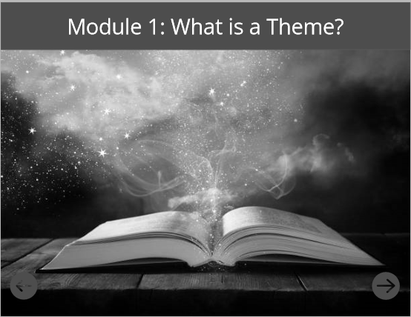 |  |  | Icon arrow (bottom right) will allow user to navigate to next slide upon click. Icon arrow (bottom left) will navigate to previous slide. Icons should be same color as header background.
 |  |  | Visual Info/Media
Font (heading): Articulate Extrabold size 28, color white, centered on slide
Background behind heading: #1156AB
Background Photo: same as title slide (fill in to take up background)

 |  |  | Additional Comments:

Lesson Title: How to Find Themes in Literature | Screen Title: Module 1: Definition of Theme | # 6 | Navigation Info
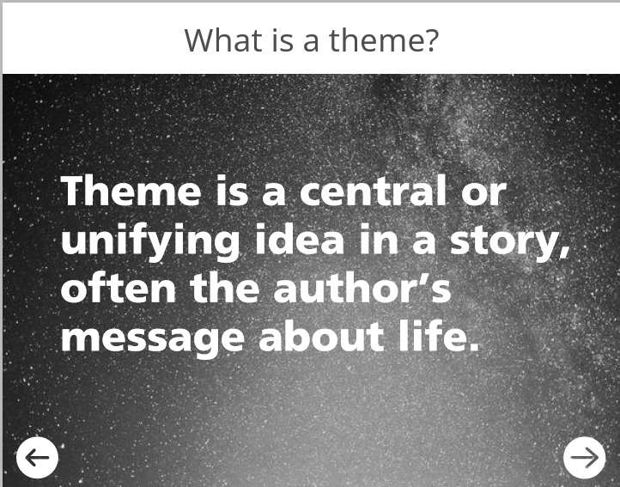 |  |  | Icon arrow (bottom right) will allow user to navigate to next slide upon click. Icon arrow (bottom left) will navigate to previous slide.
 |  |  | Visual Info/Media
Font (heading): Articulate Extrabold size 28, color blue, centered on slide
Font (text): Articulate Extrabold size 36, white
Background behind heading: white
Background Photo: vibrant-night-sky (fill in to take up background)

Additional Comments:
- Change navigation buttons’ color to white so it is visible to user

Lesson Title: How to Find Themes in Literature | Screen Title: Module 1: Definition of Theme | # 7 | Navigation Info
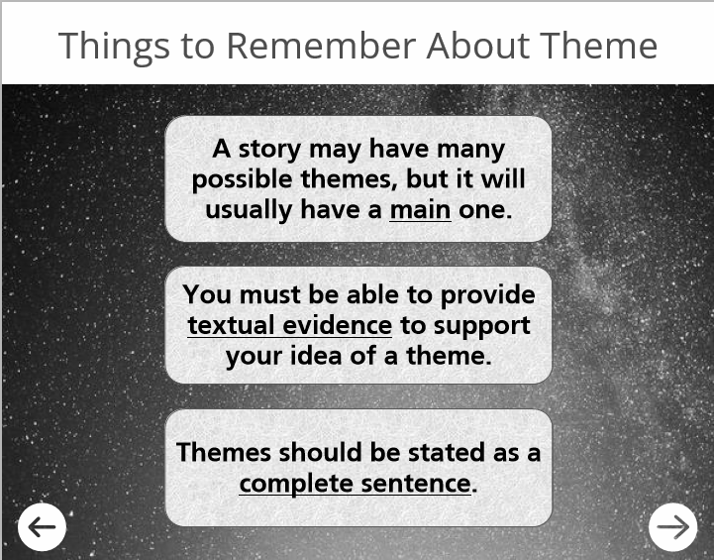 |  |  | Icon arrow (bottom right) will allow user to navigate to next slide upon click. Icon arrow (bottom left) will navigate to previous slide.
 |  |  | Visual Info/Media
Font (heading): Articulate Extrabold size 28, color blue, centered on slide
Font (text): Articulate Extrabold size 36, white
Background behind heading: white
Background Photo: vibrant-night-sky (fill in to take up background)

Additional Comments:
- Change navigation buttons’ color to white so it is visible to user
- Use same text boxes from slide 3 with the blue tissue paper background for text boxes.
- Add entrance animations to each of the 3 boxes (float in from bottom). Each should have a duration of 1 second and float in one after the other, with top box floating in first.

Lesson Title: How to Find Themes in Literature | Screen Title: Module 1: Examples of Theme | # 8 | Navigation Info
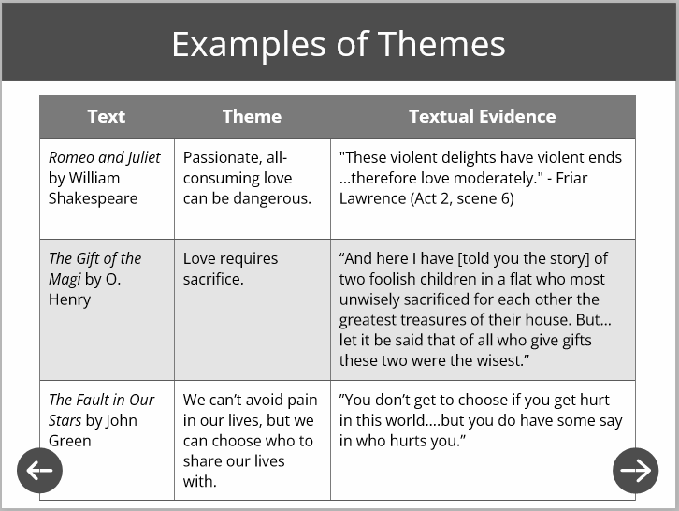 |  |  | Icon arrow (bottom right) will allow user to navigate to next slide upon click. Icon arrow (bottom left) will navigate to previous slide. Icons should be same color as header background.
 |  |  | Visual Info/Media
Font (heading): Articulate Extrabold size 28, color white, centered on slide
Font (text): Articulate size 12, black
Background behind heading: #1156AB
Table color (defaults to blue, you don’t need to change it)

Additional Comments:
- Change navigation buttons back to blue #1156AB

Lesson Title: How to Find Themes in Literature | Screen Title: Practice | # 9 | Navigation Info
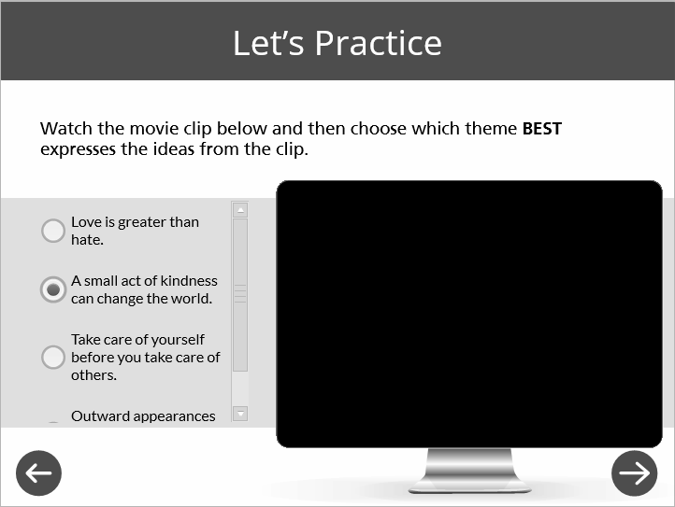 |  |  | Icon arrow (bottom right) will allow user to navigate to next slide upon click. Icon arrow (bottom left) will navigate to previous slide. Icons should be same color as header background.
 |  |  | Visual Info/Media
Font (heading): Articulate Extrabold size 28, color white, centered on slide
Font (text for instructions): Articulate size 14, black
Font (text for answer choices): Articulate size 12, black
Background behind heading: #1156AB
Additional Comments:
- Video is being conceptualized here, but you do not need to include it, per project instructions

SEE NEXT PAGE FOR DETAILED QUESTION/ANSWER INFORMATION.

Screen # 7 | 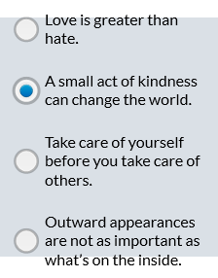  Question Type  Multiple Choice | Text on Screen  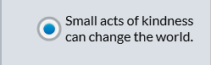 | Answer  Option 2 is the correct answer | Feedback  Option 1: While this answer is true, it is not the BEST option for the theme of this movie. Try again.  Option 2: Correct! This is the main theme of the movie.  Option 3: This option is not demonstrated in the movie clip. Try again.  Option 4: While this may be a minor theme in the movie, it is not the main theme. Try again.

1 of 1

Lesson Title: How to Find Themes in Literature | Screen Title:  Quiz #1 (Drag-and-drop or matching) | # 10 | Navigation Info  When user clicks “submit” button, they will go to the results slide (next slide).
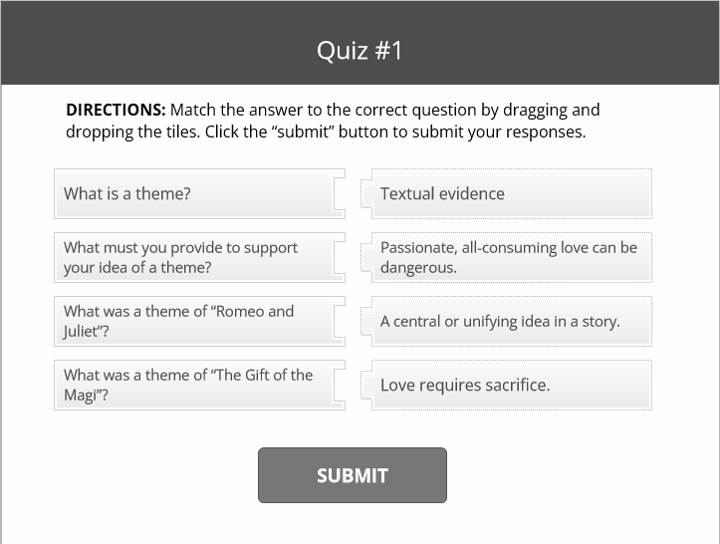 |  |  | Answer 1  What is a theme? Answer: A central or unifying idea in a story
Answer 2
What must you provide to support your idea of a theme? Answer: Textual evidence
Answer 3
What was a theme of “Romeo and Juliet”? Answer: Passionate, all-consuming love can be dangerous.
Answer 4
What was a theme of “The Gift of the Magi”? Answer: Love requires sacrifice.
 |  |  | Visual Info/Media
Same font and color for heading as previous slides.
Use Articulate font size 12 for directions (black).
Use Articulate font size 14 for questions and answers (black).
Button should be formatted same as button on first slide.
Reviewer Comments
Set the number of attempts to unlimited.

Lesson Title: How to Find Themes in Literature | Screen Title:  Quiz #1 Results | # 10A | Navigation Info  When user gets all answers correct, then can move on to the next module by clicking the “Continue” button. If user does not select correct answers, they will be directed to retry with the “try again” button.
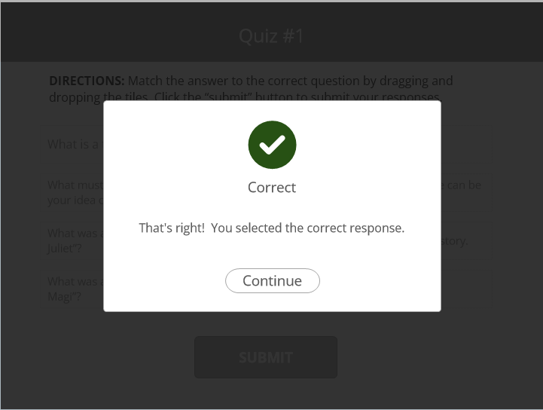  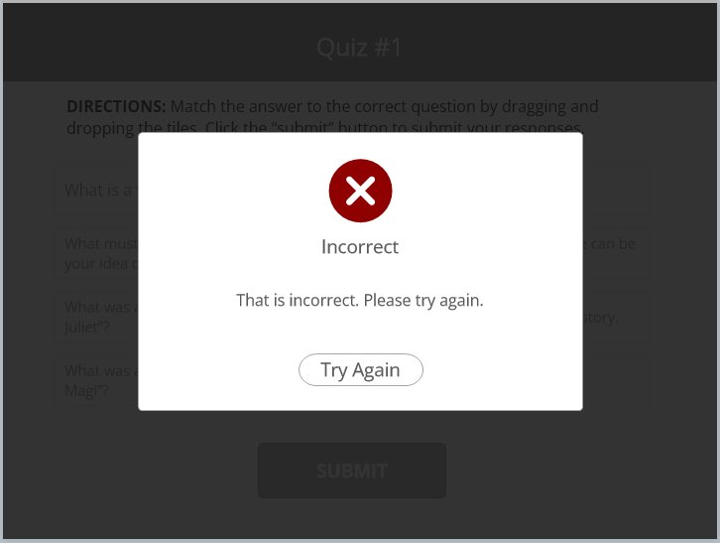 |  |  | Visual Info/Media
 |  |  | Reviewer Comments

