13th NARECOM – NAnoEnviCz REsearch COmmunity Meeting
19th January 2022 from 2:30 p.m.
Nano zero-valent iron in wastewater treatment
Daniele Silvestri
Institute for Nanomaterials, Advanced Technologies and Innovation, Technical University in Liberec, Czech Republic

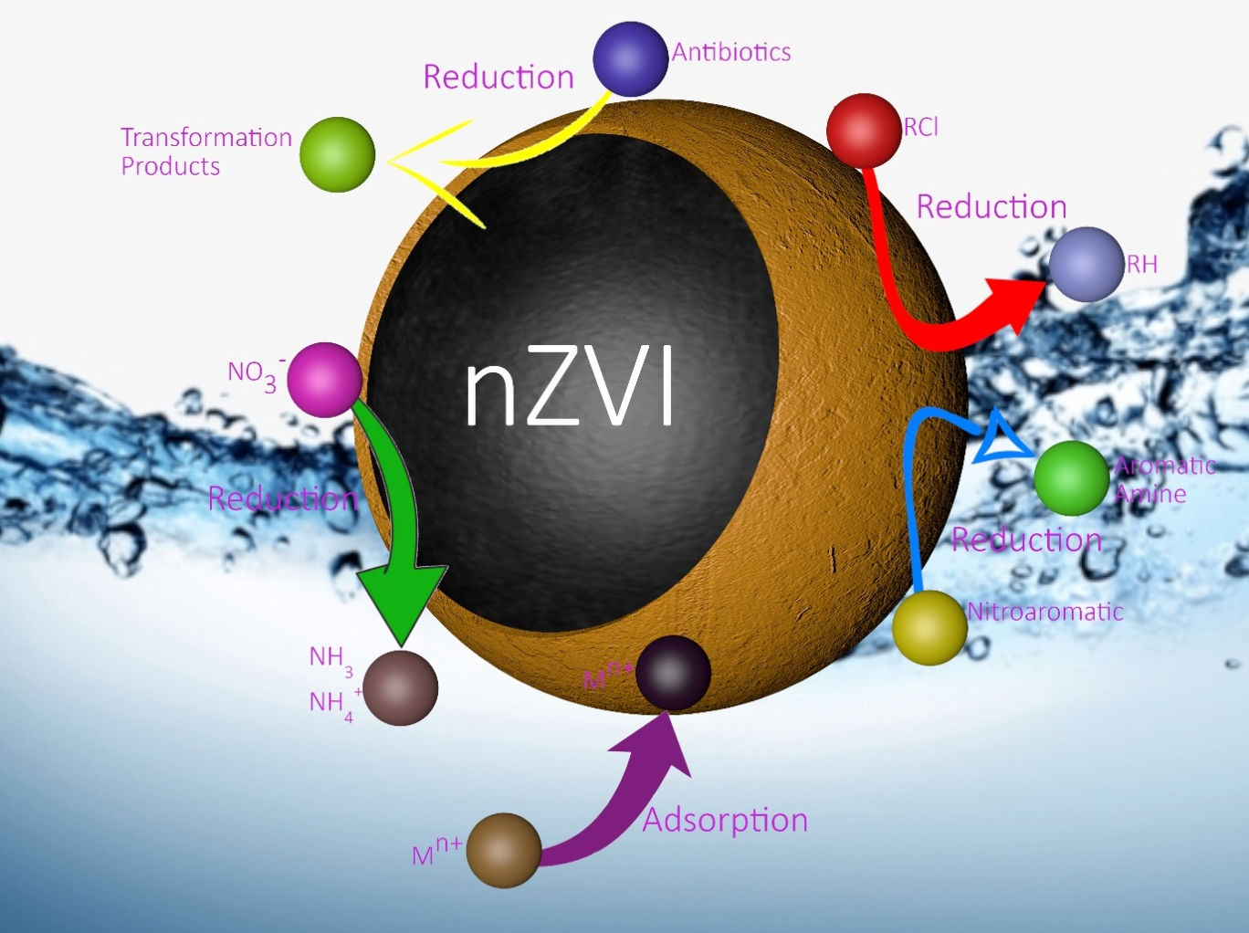
ABSTRACT: Due to the relentless growth of the world population and the rapid development of industry, water is becoming a precious commodity. The scarcity of drinking water arouses interest in the development of new strategies for water and wastewater treatment, as common methods (e.g. adsorption, coagulation-flocculation) are insufficient. One of such strategies is remediation using specifically designed nanomaterials. Nanoscale zero-valent iron (nZVI) has been found effective against a wide range of pollutants, such as halogenated aliphatic compounds, nitrates, heavy metals, pesticides and pharmaceuticals, and could therefore be considered one of the most promising materials for environmental remediation. The use of nZVI for the degradation of contaminants is related to many advantages, such as high specific surface area, high reducing ability and ability to migrate in groundwater. Moreover, modification of nZVI could improve its stability, dispersibility and mobility, and thus enhance the degradation of pollutants. The first part of the presentation will show an overview on the ZVI and its use for water decontamination, while the second part will be focused on surface modification of nZVI and its use for different pollutants degradation.

