

41st NARECOM – NAnoEnviCz REsearch COmmunity Meeting

-60

-40

-20

0

20

-2

-1

0

1

2

0

200

400

600

**

H

(x10

3

ps/m)

200 K

**Z** (film#2)

*T*

= 10 K

100 K

200 K



P (

❍

C/m

2

)

*H*

(T)

*T*

= 10 K

100 K

scheme of ME (transverse)

poling geometry:

[0001]Z

**± HP //**

**± EP //**

11th December 2024 at 2:30 p.m.

**Targeting Drug Delivery: Why It's Easier Said Than Done**

**Dr. Dominika Wróbel**

*Centre for Nanomaterials and Biotechnology (CENAB), Jan E. Purkyne University*

**Abstract:**

The development of therapeutic agents remains inherently challenging due to significant technical and regulatory barriers across drug design and drug delivery platform engineering. This presentation outlines key challenges in drug construction, including molecular targeting complexities, synthesis scalability, and chemical stability, as well as obstacles in optimizing efficacy and safety. These issues not only affect therapeutic performance but also complicate manufacturing processes and drive up production costs. We investigated novel amphiphilic structures designed as potential drug delivery systems specifically targeting mitochondria, providing insights into common challenges encountered during foundational research and characterization. The insights gained highlight both the potential and the limitations of these advanced delivery systems for mitochondrial-targeted therapies.

**Graphical Abstract:**

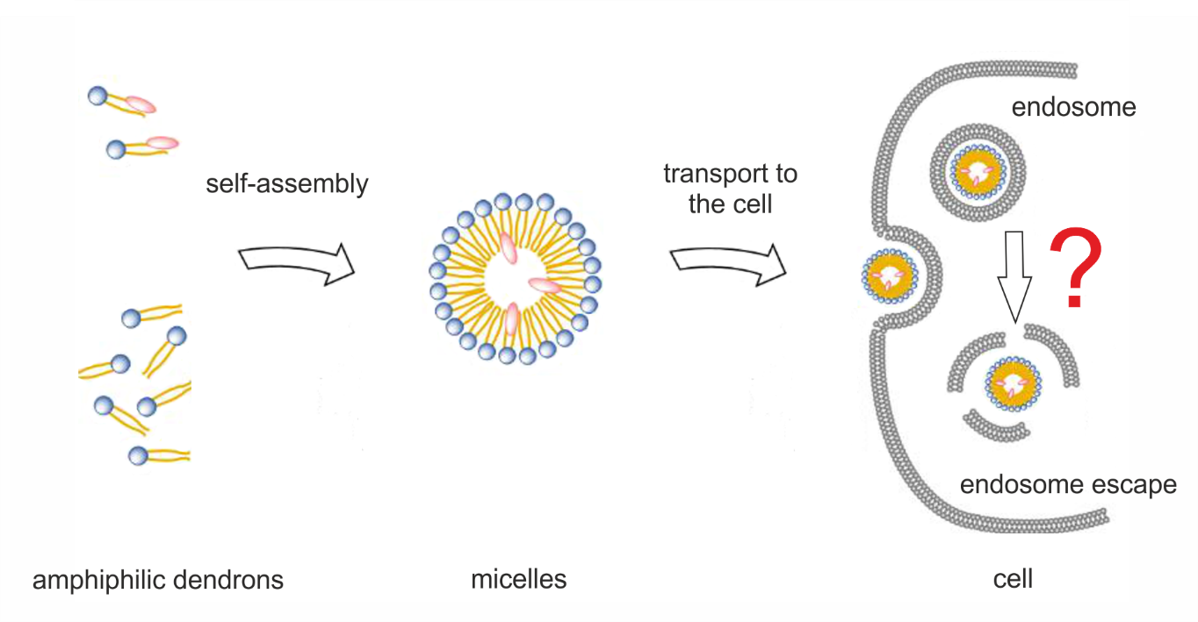

**1 µm**