

37th NARECOM – NAnoEnviCz REsearch COmmunity Meeting

-60

-40

-20

0

20

-2

-1

0

1

2

0

200

400

600

**

H

(x10

3

ps/m)

200 K

**Z** (film#2)

*T*

= 10 K

100 K

200 K



P (

❍

C/m

2

)

*H*

(T)

*T*

= 10 K

100 K

scheme of ME (transverse)

poling geometry:

[0001]Z

**± HP //**

**± EP //**

19th June 2024 from 2:30 p.m.

**Chemical solution deposition route to highly oriented hexaferrite thin films**

**Josef Buršík**

*Institute of Inorganic Chemistry of the CAS*

**Abstract:**

During past two decades, hexaferrites, compounds belonging to a large family of magnetic oxides, have been found to exhibit gigantic magnetoelectric (ME) effects near room temperature and at low magnetic fields. However, large ME coupling has been realized mainly in single-crystal or polycrystalline forms so far. Despite such great application potentials and timely needs, the synthesis of hexaferrite films of complex structures has not been realized,

It will be reported a successful growth of X-, Y- and Z-type hexaferrite thin films on SrTiO3 single crystal substrates using chemical solution deposition method. Use of three-dimensional texture analysis and high-resolution X-ray diffraction allow us to study real structure effects and orientation relations between film and substrate, respectively, and their consequences for to the magnetic or ME properties of films. The magnetization process, magnetic domain structure, and anisotropy behavior were investigated using magnetic measurements, Lorentz transmission electron microscopy, and ferromagnetic resonance, respectively. For some cases (Z-type), the results of ME coupling measurements will be mentioned.

**Graphical Abstract:**

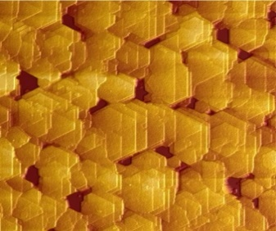

**1 µm**

