Fluorescence inverted confocal spinning disk microscope Olympus SpinSR10
Equipment: Olympus SpinSR10
No. of Equipment: IEM12
Responsible coordinator: Dr. Pavel Rossner, PhD.
Name of Institution: Institute of Experimental Medicine, CAS
Address of Institution: Vídeňská 1083, 142 20 Prague 4, Czech Republic
E-mail: pavel.rossner@iem.cas.cz
Telephone: +420 241062763
Homepage: http://www.iem.cas.cz/
Contact person: Mgr. Tereza Červená
E-mail: tereza.cervena@iem.cas.cz
Telephone: +420 241062663

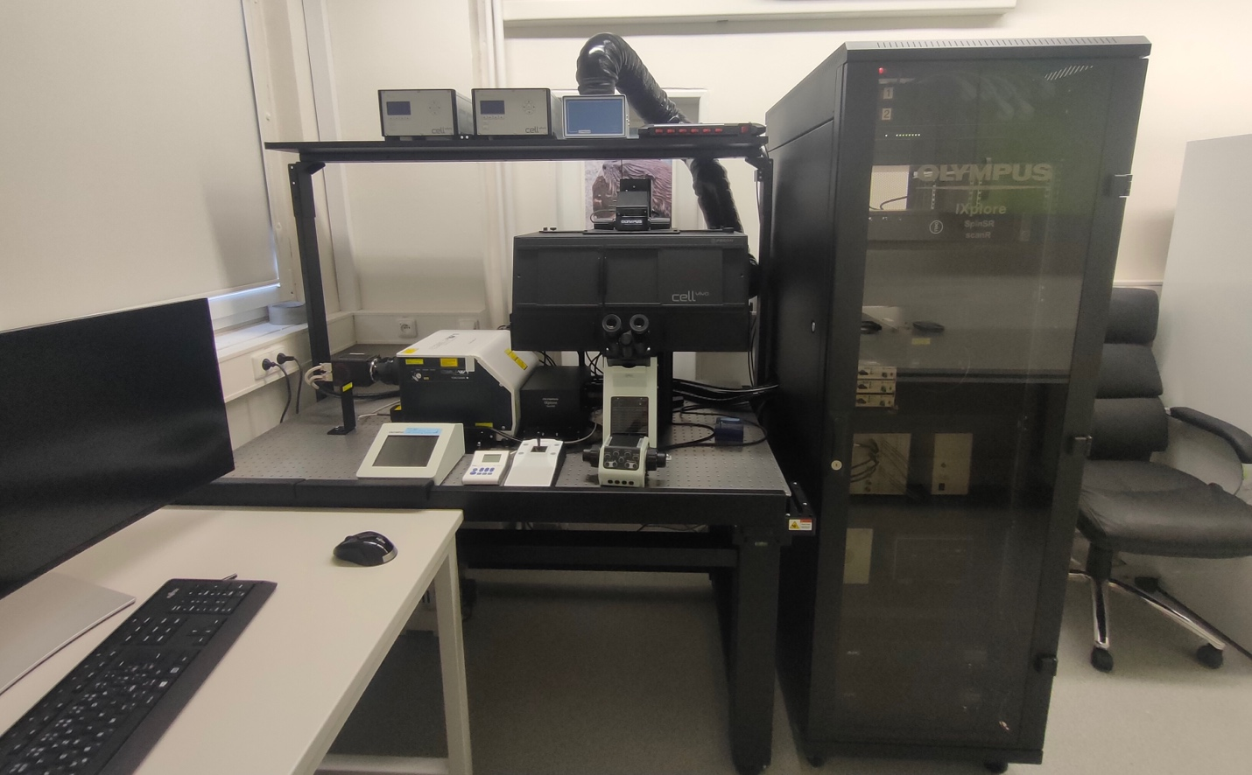

Equipment Description
The Olympus SpinSR10 is a fluorescence inverted confocal spinning disk microscope with super-resolution mode. It is designed for fast 3D super resolution imaging and prolonged cell viability in time-lapse experiments, the IXplore SpinSR microscope system offers XY resolution down to 120 nm without the need for dedicated labeling procedures.

Specifications and technical features:
Illumination | Halogen lamp for transmission light illumination  CoolLED pE-300ultra fluorescence light source (3x LED: 405, 488, 561 nm)  Solid-state laser 405 nm (50 mW)  Solid-state laser 488 nm (100 mW)  Solid-state laser 561 nm (100 mW)  Solid-state laser 640 nm (100 mW)
Objectives | UPLXAPO 10X, dry, NA 0.4, WD 3.1 mm  UPLXAPO 20X, dry, NA 0.8, WD 0.6 mm  UPLXAPO 40X, dry, NA 0.95, WD 0.18 mm  UPLXAPO 60 X, oil, NA 1.42, WD 0.15 mm
Filter sets | DAPI: ex. 330 – 385 nm, em. LP 420 nm, DM: 400 nm  FITC: ex. 470 – 490 nm, em. LP 520 nm, DM: 500 nm  TRITC: ex. 510 – 550 nm, em. LP 590 nm, DM: 570 nm  CY5:
Detectors | 2x Hamamatsu ORCA-Flash4.0 CMOS camera for two – channel imaging.  Resolution: 2048 x 2048 px  Pixel size: 6.5 µm x 6.5 µm  Live frame rates: 100 fps (2048 x 2048), binning 2 x 2 and 4 x 4
Scanning module | Yokogawa CSU-W1 confocal scanner unit with spinning disk  Pinhole diameter: 50 µm  Tunable rotation speed >4000 rpm.,  Scan speed >100 fps  Effective view field number 18mm.  Motorized magnification lens for super-resolution mode. XY resolution max 120 nm.
Stage | PC-controlled motorized stage
Software | cellSens Dimension, ScanR Acquisition, ScanR Analysis
Additional equipment | PECON cellVivo incubator with adjustable temperature and CO₂/O₂ concentration

Location:
- building La, 1st floor, room 1.17

Applications:
- Fast and multi-colour
- Super-resolution imaging
Various measurement options: multi-channel imaging, z-stack, time series, mosaic, smart experiment design
- Long term live-cell imaging available
- Transmission light microscopy, DIC

Specification of expertise relevant to NanoEnviCz workpackage
WP3a,d,f,g,h, WP4a,b, WP6a,d, WP7a,c,e,h,i, WP9a,b,c,d
Detailed description of expertise
Please, specify the main research topics connected with equipment:
Olympus SpinSR10 is a system used in nanotoxicology. It allows super-resolution confocal imaging, Long term live-cell imaging or transmission light microscopy.

Please, specify the secondary research topics connected with equipment:
The system may be used in toxicology in general, or in any application that requires analyzes and monitoring live-cells.
Keywords describing research area:
Live-cell imaging, nanotoxicity, biological effects of nanomaterials, nanoparticles

Competence
Relevance for applied and industrial research:
Analyzes of effects of xenobiotics, including nanomaterials, with the aim to identify possible negative response of the organism to the exposure to these compounds.
Relevance for fundamental studies:
The Olympus SpinSR10 is a fluorescence inverted confocal spinning disk microscope with super-resolution mode. It is designed for fast 3D super resolution imaging and prolonged cell viability in time-lapse experiments.

