**Equipment:** MPT-2 Multipurpose titrator (Malvern) + Bugbox Plus (BAKER RUSKINN) + Laminar flow cabinet (HERASAFE KS) + CO2 incubator (HERACELL VIOS 250i) + Thermo Scientific Barnstead Smart2Pure 3 UV/UFWater Purification System

**No. of Equipment: IEM9**

**Responsible coordinator:** JanTopinka, DSc.

**Name of Institution:** Institute of Experimental Medicine of the Czech Academy of Sciences

**Address of Institution:** Vídeňská 1083, 142 20 Prague 4, Czech Republic

**E-mail:** jtopinka@biomed.cas.cz

**Telephone:** +420 24106 2675

**Homepage:**  http://www.iem.cas.cz/en/

**Contact person:** Táňa Brzicová, Msc.

**E-mail:** tana.brzicova@biomed.cas.cz

**Telephone:** +420 24106 2663

**Equipment Description**

**Description of equipment:**

*Bugbox Plus (BAKER RUSKINN)*

Description of principle and use:

Bug box is an anaerobic workstation and is designed specifically to help microbiologists cope with rising workloads and provide the best primary isolation rates. Bugbox is easy to use. Its compact size meets the needs of even the smallest laboratory spaces. Adjustable temperature and humidity provides a precisely controlled anaerobic environment.

The acrylic airtight chamber is flooded with anaerobic gas mix (H2 in N2) and O2 is displaced. If any O2 remains or is allowed to enter, it is “scavenged” by a palladium catalyst situated under the floor tray - the O2 reacts with the H2 to form water. Interlock uses an N2 purge, so when a user brings in plates through the interlock, no O2 enters the main chamber - inner and outer interlock doors cannot be opened simultaneously. Gloveless Ezee Sleeves™ are purged using N2 gas via foot pedals, so no O2 enters the main chamber when the glove ports are opened. Ezee Sleeve™ Direct Hand entry system allows access without disrupting the atmosphere within the chamber.

**MODEL BUGBOX/ BUGBOX M BUGBOX PLUS**

Specifications and technical features:

Maximum Capacity: 90 mm Plates 234

Working Capacity: 90 mm Plates 180

Interlock Capacity: 90 mm Plates 18

Interlock Time Cycle: 35 sec

Ultimate control for optimum cell environment:

Accurate temperature control from ambient + 5˚C to 45˚C

Accurate and automated humidity control

Palladium catalyst maintains anaerobic environment, plus anaerobic colorindicator strips verify anoxic conditions

**Description of equipment:**

*Laminar flow cabinet (HERASAFE KS)*

Description of principle and use:

The safety cabinet Herasafe KS is a laboratory device for installation and operation in microbiological and biotechnical laboratories of safety levels 1, 2, and 3. Depending on the hazard level of the agents involved, the operator must prepare in writing appropriate decontamination procedures for the device and the accessories used in the sample chamber.

A vacuum-sealed air system in combination with two HEPA filters (= High Efficiency Particulate Air Filter) for downflow (the air circulating within the device) and exhaust air (air that is released to the exterior) forms the basis of the safety system for personal and material protection.

Specifications and technical features:

**Personal protection:** Air aspired from the exterior along the entire working opening at a constant high velocity prevents that agents may leak through the working opening of the chamber. As the exterior air pressure around the unit exceeds the pressure of the internal air system (vacuum sealing), it is ensured that agents cannot be released to the exterior in the case of a leak in the cabinet housing.

**Material protection:** A steady airflow within the air system ensures that a constant downflow allows the HEPA filters to remove contaminants so that the samples are always surrounded by ultrapure air; harmful particles are not carried over through the sample chamber (protection from cross-contamination).

**Safety lockout**

To protect from UV radiation, the optional UV disinfection routine can be run only if the front opening is closed. During UV disinfection, the front opening safety lockout is activated and prevents harmful UV radiation from being emitted from the sample chamber.

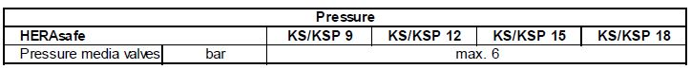

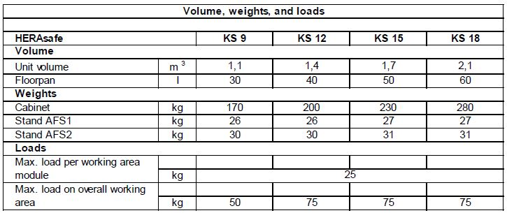

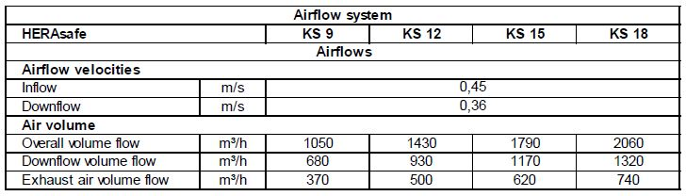

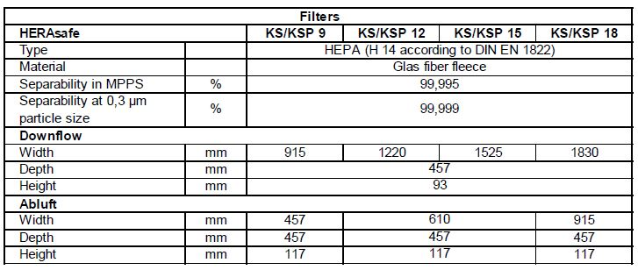

**Description of equipment:**

*CO2 incubator (HERACELL VIOS 250i)*

Description of principle and use:

Many cell types thrive best in CO2 incubators with reduced oxygen. Culturing cells at lower oxygen concentration will better simulate physiological conditions, resulting in cell behaviors that are more predictive of the in vivo environment. Heracell Vios 250i incubator has unique covered integrated humidity reservoir that maximizes relative humidity without condensation ensuring a dry inner chamber, preventing a breeding ground for contaminants. Providing stable, high relative humidity levels, the integrated 3 liter reservoir allows more space for samples than standard pan designs. The reservoir cover eliminates standing water in the culture area while limiting particles and spilled media from settling into the reservoir. Water level is continuously monitored and displayed on the Thermo Scientific™ iCAN™ touchscreen with advanced refill reminder. Humidity reservoir may be filled without removing shelves or cultures and is easily drained through built-in copper drain. CO2 and optional N2 /O2 gases are pre-humidified before entering the chamber, providing a more constant, uniform environment.

Specifications and technical features:

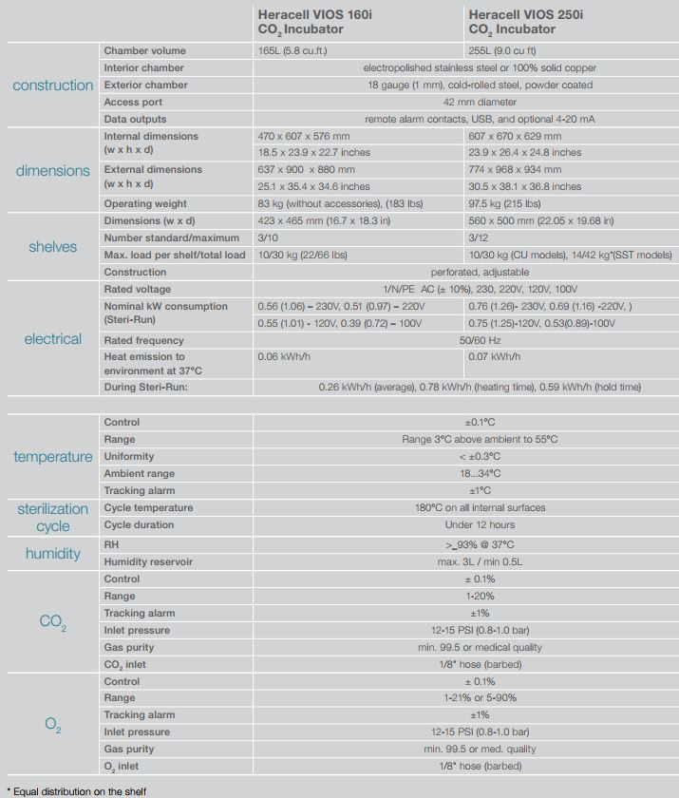

**Description of equipment:**

*Barnstead Smart2Pure Water 3 UV/UF Purification System (Thermo Scientific)*

Description of principle and use:

In normal operation, tap water at a maximum pressure of 6 bar flows into the system and is pumped by pressure booster pump P1 through the subsequent pretreatment F1 and reverse osmosis membrane F2. The latter retains all salts dissolved in the incoming water to the extent of the given retention quota and, because of the molecular size of the membrane pores, also retains up to Ø 99% of bacteria, pyrogens and particles.

The reverse osmosis permeate flows on through the downstream purification stages, such as UV-photooxidation UV1, the 185 nm and 254 nm wavelengths of which reduce organic compounds, filter cartridge F3 and ultrafilter F6 with automatic rinsing to the tank. The water constituents which were retained by the reverse osmosis membrane flow away in the concentrate that remains.

The special conductivity measuring probe QISA 300 (with temperature compensation) and temperature probe TISA 500 permanently monitor the conductivity and temperature of the ultra pure water and the values of these are shown in the display. The water in the storage tank is re-circulated at regular intervals by recirculation pump P2 to ensure the constant high water quality. Float switch LIS 100 monitors the water level inside the tank.

Specifications and technical features: Ultra pure water system

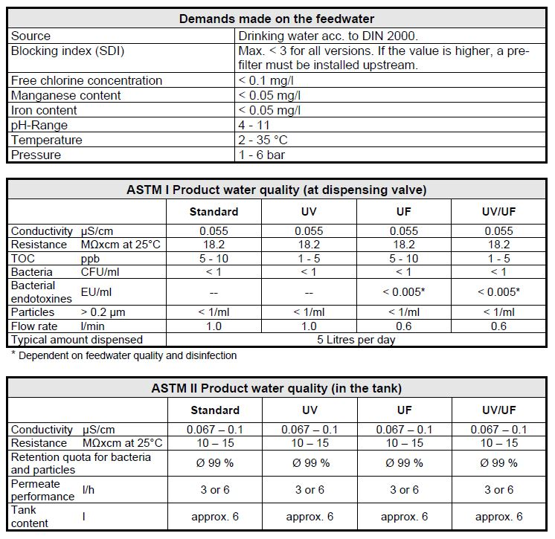

**Specification of expertise relevant to NanoEnviCz workpackages:**

**WP3**a,d,f,g,h, **WP4**a,b, **WP6**a,d, **WP7**a,c,e,h,i, **WP9**a,b,c,d

**Detailed description of expertise**

**Please, specify the main research topics connected with equipment**:

Characterization of size and surface properties of different nanoparticles

Genotoxicity assessment of manufactured nanoparticles in model human cell lines

**Please, specify the secondary research topics connected with equipment**:

Nanomaterials for biomedical research

**Keywords describing research area:**

zeta-potential, dynamic light scattering, nanoparticles, genotoxicity

**Competence**

**Relevance for applied and industrial research:**

The increasing number of applications of nanomaterials (NMs) and rate of their production lead to growing exposure to NMs – from products or from the environment.

NM is a specific group of substances, and their toxic effects may differ. Assessment of toxicity of nanomaterials belong to an important part of ensuring a safe working environment in companies processing of NMs. Exposure of workers to new materials is often long-term and the doses could be high if the exposure was not controlled adequately.

**Relevance for fundamental studies:**

The ideal NMs used in biomedicine should exhibit low toxicity while maintaining desirable technical properties. The biological impacts of NMs can be modified by surface variation and alteration of their size. NM dimension determines cellular uptake mechanism and efficiency, intracellular localization and specifically affects NM size-related properties. Surface properties determine binding biomacromolecules both *in vivo* and *in vitro*, interactions with cell membranes as well as interparticulate interaction and dynamic changes in particle behavior (e.g. dissolution rate, stability).