Rheometer
(completed by the responsible coordinator of equipment)
Equipment: equipment Rheometer, (Pro-NanoEnviCz III)
No. of Equipment: UPOL18
Responsible coordinator: Mgr. Petr Jakubec, Ph.D.
Name of Institution: Palacký University in Olomouc
Address of Institution: RCPTM-CATRIN, Šlechtitelů 27, 779 00 Olomouc
E-mail: p.jakubec@upol.cz
Telephone: +420 585 634 474
Homepage: www.rcptm.com/cs/business/analytic-services/

Contact person: Ing. Vojtěch Kupka, Ph.D.
E-mail: vojtech.kupka@upol.cz
Telephone: +420 585 634 474

Equipment Description
A rheometer HR 20 Discovery Hybrid Rheometer, TA Instruments, is capable of measuring rheological measurements in rotation and oscillation. In addition to rheological measurements, the rheometer also allows for dynamic mechanical analysis (DMA) of solid materials.
The device allows to measure in controlled stress or controlled strain mode. The geometries for rheology include plate-plate and cone-plate geometries of various radius. The temperature range is from -25 to 200 °C. The geometries for DMA measurement allow measurement of fiber/film testing, solid bars via cantilever bending and torsion bending. The air chiller allows the measurement in DMA mode from -85 °C to 400 °C.

Specification of expertise relevant to NanoEnviCz workpackages:
WP3 SYNTHESIS AND DESIGN OF NEW MULTIFUNCTIONAL NANOMATERIALS FOR ENVIRONMENT PROTECTION

Conceptually new nanostructured materials with the potential for application in innovative technologies | yes
Computer aided nanomaterials design | no
Low dimensional materials and their composites (carbon dots, nanotubes, graphene derivatives) | yes
Nanofibers | yes
Magnetic hybrids | no
Metal and metal oxide NPs | no
Redox active nanomaterials | no
Nanomaterials for biomedical applications | yes
WP4 HETEROGENEOUS CATALYSIS FOR ENVIRONMENTAL PROTECTION
Nanomaterials for catalytic degradation of pollutants in water, soil and air | yes
Nanostructured heterogeneous catalysts for abatement of pollutants from industrial processes and automotive transport | no
New “clean” catalytic processes for chemical production | no
WP5 NOVEL NANOMATERIALS AND TECHNOLOGIES FOR SUSTAINABLE PRODUCTION
Processes and technology for sustainable energy and chemical production | no
Catalytic processes for transformation of natural gas to liquids | no
Nanomaterials for utilization of renewables; Magnetically separable green catalysts | yes
WP6 EFFECTIVE PHOTOCATALYTIC TECHNOLOGIES
Mastering nanomaterials for photocatalysis | no
Effective photocatalytic processes | no
Photovoltaic paints | yes
Functional surfaces for environmental protection | yes
Hybrid materials combining photocatalysts and heterogeneous catalysts | yes
Thin photocatalytic films for direct solar splitting of water | no
WP7 NANOTECHNOLOGY FOR TRAPPING AND CHEMICAL DEGRADATION OF POLLUTANTS
Nanomaterials for sorption | yes
Natural based nanomaterials produced by “green” technology | yes
Reactive sorbents for degradation of pesticides and highly toxic agents | no
Degradation of chemical warfare agents | no
Analysis of filtering capabilities of nanomaterials | yes
Elimination of radionuclides contamination | no
Modified nanofiber filters; Advanced antimicrobial filters/membranes | yes
Nanoiron for groundwater and waste water treatment | no
Nano-trapping of heavy metals | no
WP8 SENSING AND MONITORING OF POLLUTANTS
Efficient sensing of pollutants | no
Biosensing by new devises | yes
Application of new sensors in monitoring of pollutants | yes
Magnetic sensors; Magnetically assisted SERS sensors | no
Advanced electrochemical sensors | no
Graphene based nanosensors | yes
WP9 TOXICITY AND RISKS OF NANOMATERIALS
Health risks | no
Environmental risks | no
„In vitro“ and „in vivo“ toxicity tests – cytotoxicity, genotoxicity, interactions with membrane | no
RNA gene expression changes and protein expression changes | no
Complete eco/aquatoxicity ecotoxicity evaluation | no
Toxicity against bacteria and fungi | no

  - V oblasti WP5 (Nové nanomateriály a technologie pro udržitelnou produkci) – nové kompozitní materiály
  - Budoucí uživatelé
    - UPOL (P. Jakubec, V. Kupka)
    - VŠB-TUO (A. Slíva)
    - Forvia Hella (P. Tuček)
    - CEITEC VUT (M. Pumera)

  - V oblasti WP8 (Detekce a monitorování polutantů) – vývoj elektrochemických sensorů
  - Budoucí uživatelé
    - UPOL (P. Jakubec, V. Kupka)
    - Effetec s.r.o. (M. Frantík)
    - ICN2 (Catalan Institute of Nanoscience and Nanotechnology, A. Merkoci)
    - Department of Chemistry, Faculty of Natural Sciences, University of Tirana, Albania (M. Vasjari)
Detailed description of expertise
Please, specify the main research topics connected with equipment:
inkjet printing, paste printing, materials printing, energy storage (slurries characterization)
Please, specify the secondary research topics connected with equipment:
Thermal properties of polymers/plastics (glass transition temperature, temperature of melting), hydrogels characterization, curing of thermosets, solid polymer rheology
Keywords describing research area:
polymer analysis, rheology, viscosity, dynamic-mechanical analysis
Competence
Relevance for applied and industrial research:
Rheological characteristics is crucial for characterization of viscosity and flow behavior. This is key in industries like paints, coatings, cosmetics, food, and plastics, where the material's ease of application or consumption is critical.
Rheological tests also help in understanding the elastic and plastic behavior of materials, which is important for applications like rubber and plastics in the automotive industry.
Many industrial processes such as extrusion, injection molding, 3D printing, and coating depend on the flow behavior of materials. Measuring rheology helps optimize these processes by tailoring material properties for specific processing conditions.
Relevance for fundamental studies:
Rheology is essential in basic research because it provides critical insights into how materials flow and deform, linking their molecular structure to macroscopic properties. It is particularly relevant in fields like materials science, chemistry, and physics, where understanding the behavior of complex fluids and soft solids such as polymers, gels, inks, slurries, and suspensions is crucial. Rheology is also used in areas such as food science, biomaterials, pharmacy, and 3D printing.
Comments
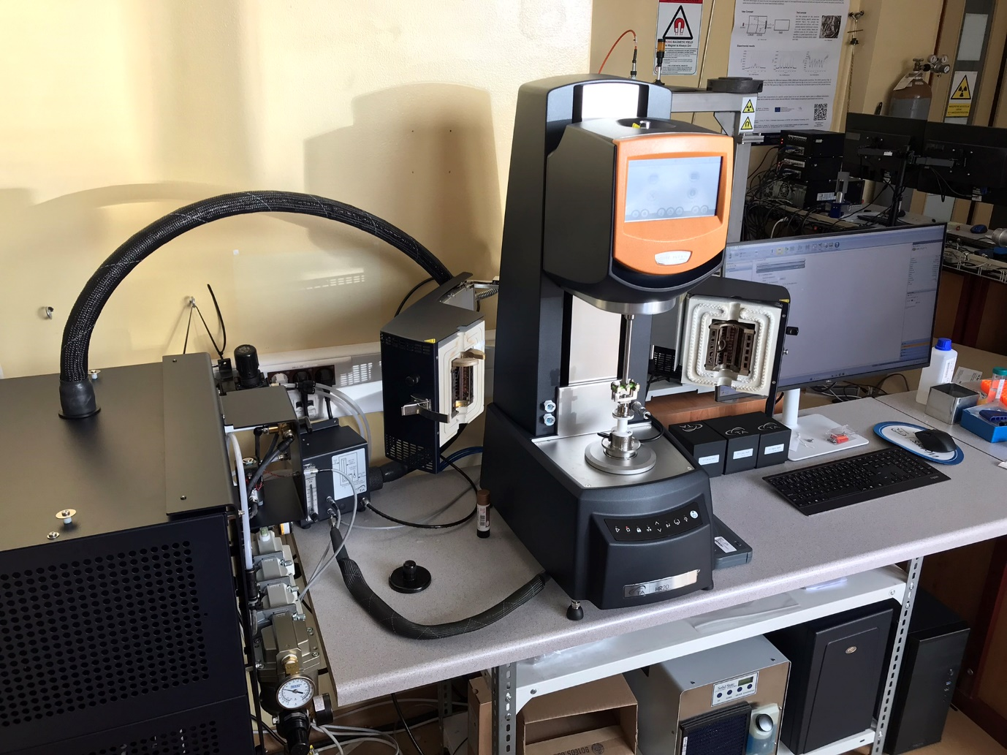
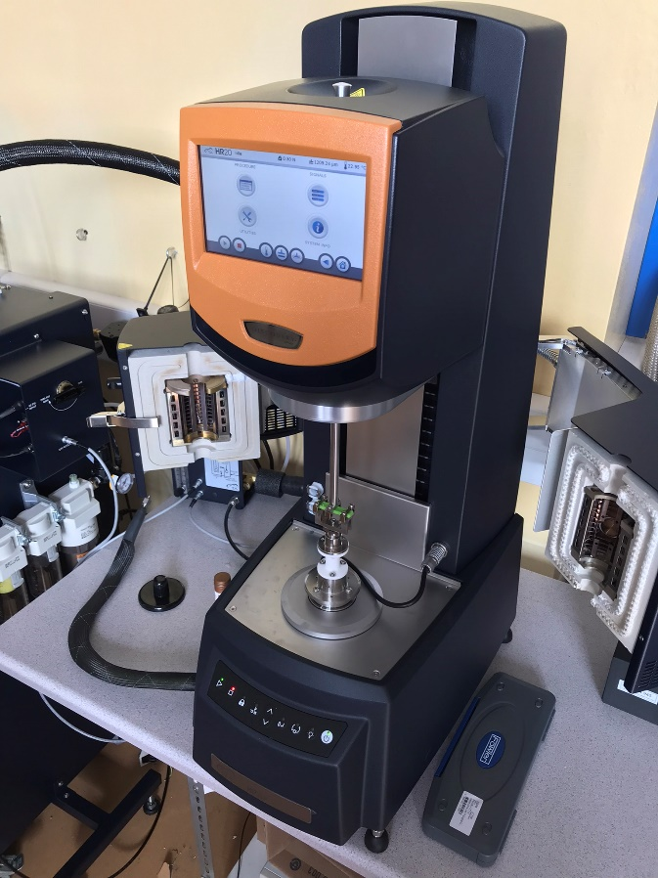 | 