

46th NARECOM – NAnoEnviCz REsearch COmmunity Meeting

11th June 2025 at 2:30 p.m.

**Studies of Oxygen Electrochemistry on Perovskite Oxides**

**Dr.** **Lalita Sharma**

*J. Heyrovsky Institute of Physical Chemistry of the Czech Academy of Sciences, Dolejškova 3, Libeň, 18223 Prague 8, Czech Republic*

**Abstract:**

The development of the fuel cells and electrolyzers faces one hindrance due to the lack of the oxygen electrodes, which suffer from high overpotential and slow kinetics. Perovskite oxides (ABO3) are considered promising oxygen electrode catalysts because of their low cost, flexibility and tailored properties.1 The bridging of the perovskite electronic structure with catalysis has allowed fundamental understanding of the catalytic processes and improved catalyst design for technologically relevant reactions. Here, in this talk, we will highlight how understanding of LaCoO3 perovskite electronic structure can rationalize surface energetics, catalytic activity towards oxygen evolution reaction (OER) and oxygen reduction reaction (ORR).2 Nanocrystalline LaCoO3 materials prepared by *sprayfreeze freeze-drying* approach in presence of gelatine in the reaction mixture affects the distribution of the oxygen vacancies as well as formation of Ruddlesen–Popper (RP) defects within nanocrystals. The materials prepared at low gelatine concentration (c ≅ 1.5g/L) tend to locate the oxygen vacancies

*Fig: CV curves of LaCoO3 synthesized with 0.0 g/L and 7.5 g/L gelatine;where the effect of exfoliation (ink 2 – red curve) is co-*

*-mpared with no exfoliation (ink 1 – black curve) with respective HRTEM images in inset*

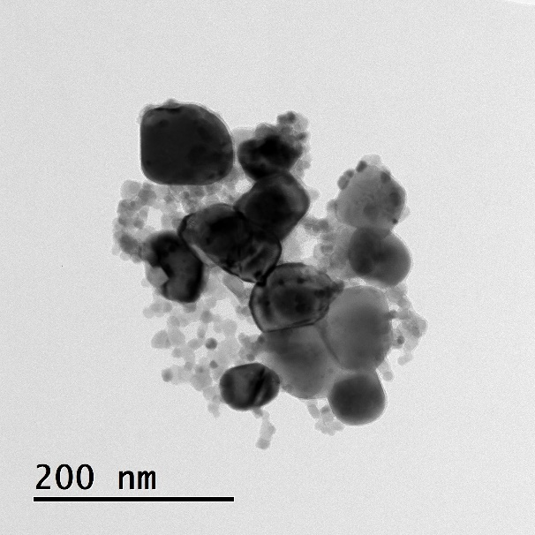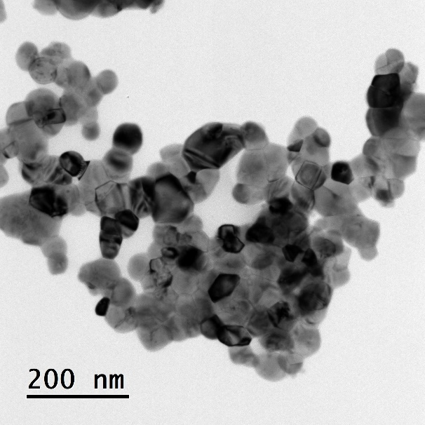

at the domain boundaries while increasing

gelatine concentration promotes a larger formation of superstructure where the oxygen vacancies get ordered along the (100) pseudocubic direction in the crystal. The exfoliated material revealed that RP faults as well as ordered vacancies are the primary sites of exfoliation in acid media. As a result, it promotes the OER activity via a new surface formation increasing the presence of Co (III) - Co (IV) species at the surface which are responsible for oxygen evolution. The exfoliation, on the other hand, leads to a change of the ORR mechanism promoting four-electron reduction over the two-electron peroxide formation. The engineering of the defects and their ordering can be used as an additional instrument in advanced oxide catalyst design.

**References**

1. Hwang, J.; Rao, R. R.; Giordano, L.; Katayama, Y.; Yu, Y.; Shao-Horn, Y., Perovskites in catalysis and electrocatalysis. Science 2017, 358 (6364), 751-756.

2. Sharma, L.; Klementova, M.; Minhova Macounova, K.; Krtil, P., Gelatine-Assisted Defect Engineering in LaCoO3 and Its Impact on Oxygen Electrocatalysis. Journal of The Electrochemical Society 2025.

**1 µm**