Empyrean, series 3, multipurpose X-ray powder diffractometer, Co tube
Equipment: Empyrean, series 3, multipurpose X-ray powder diffractometer, Co tube
No. of Equipment: UACH17
Responsible coordinator: Dr. Petr Bezdička
Name of Institution: Institute of Inorganic Chemistry of the Czech Academy of Sciences
Address of Institution: č.p. 1001, 250 68 Husinec - Řež
E-mail: petrb@iic.cas.cz
Telephone: +420 311 23 69 34
Homepage:

Contact person: Dr. Petr Bezdička
E-mail: petrb@iic.cas.cz
Telephone: +420 311 23 69 34

Equipment Description
Description of equipment:
Empyrean, series 3, multipurpose X-ray powder diffractometer, Co tube
More detailed specifications and features:
- Co radiation
- iCore – dCore multipurpose primary and secondary optics
- programmable sample changer up to 45 samples
- Bragg – Brentano reflection geometry
- transmission geometry alternatively with the focusing mirror
- micro-diffraction (poly-capillary exit diameter of 50 microns, spot size of about 60 microns on the surface of sample)

Specification of expertise relevant to NanoEnviCz workpackages:
WP3 SYNTHESIS AND DESIGN OF NEW MULTIFUNCTIONAL NANOMATERIALS FOR ENVIRONMENT PROTECTION

Conceptually new nanostructured materials with the potential for application in innovative technologies
Computer aided nanomaterials design
Low dimensional materials and their composites (carbon dots, nanotubes, graphene derivatives)
Nanofibers
Magnetic hybrids
Metal and metal oxide NPs
Redox active nanomaterials
Nanomaterials for biomedical applications
WP4 HETEROGENEOUS CATALYSIS FOR ENVIRONMENTAL PROTECTION
Nanomaterials for catalytic degradation of pollutants in water, soil and air
Nanostructured heterogeneous catalysts for abatement of pollutants from industrial processes and automotive transport
New “clean” catalytic processes for chemical production
WP5 NOVEL NANOMATERIALS AND TECHNOLOGIES FOR SUSTAINABLE PRODUCTION
Processes and technology for sustainable energy and chemical production
Catalytic processes for transformation of natural gas to liquids
Nanomaterials for utilization of renewables; Magnetically separable green catalysts
WP6 EFFECTIVE PHOTOCATALYTIC TECHNOLOGIES
Mastering nanomaterials for photocatalysis
Effective photocatalytic processes
Photovoltaic paints
Functional surfaces for environmental protection
Hybrid materials combining photocatalysts and heterogeneous catalysts
Thin photocatalytic films for direct solar splitting of water
WP7 NANOTECHNOLOGY FOR TRAPPING AND CHEMICAL DEGRADATION OF POLLUTANTS
Nanomaterials for sorption
Natural based nanomaterials produced by “green” technology
Reactive sorbents for degradation of pesticides and highly toxic agents
Degradation of chemical warfare agents
Analysis of filtering capabilities of nanomaterials
Elimination of radionuclides contamination
Modified nanofiber filters; Advanced antimicrobial filters/membranes
Nanoiron for groundwater and waste water treatment
Nano-trapping of heavy metals

WP8 SENSING AND MONITORING OF POLLUTANTS
Efficient sensing of pollutants
Biosensing by new devises
Application of new sensors in monitoring of pollutants
Magnetic sensors; Magnetically assisted SERS sensors
Advanced electrochemical sensors
Graphene based nanosensors
WP9 TOXICITY AND RISKS OF NANOMATERIALS
Health risks
Environmental risks
„In vitro“ and „in vivo“ toxicity tests – cytotoxicity, genotoxicity, interactions with membrane
RNA gene expression changes and protein expression changes
Complete eco/aquatoxicity ecotoxicity evaluation
Toxicity against bacteria and fungi

Detailed description of expertise
Please, specify the main research topics connected with equipment:
Qualitative and quantitative phase analysis of crystalline phases
Ex-situ structural transformations at elevated temperature
Micro-diffraction of small heterogeneous solid samples with complicated stratigraphy
Please, specify the secondary research topics connected with equipment:
Analysis and quantification of clay-based materials, of various clinker or concrete materials.
Keywords describing research area:
X-ray powder diffraction, X-ray powder micro-diffraction, quantitative phase analysis, qualitative phase analysis

Competence
Relevance for applied and industrial research:
Non-destructive analysis, qualitative and quantitative phase analysis of crystalline solids, determination of amorphous content by indirect method using an internal standard addition.
Studies of changes in materials connected with their applications, usage, functionality.
Studies of changes in materials caused by ageing, fatigue at operation conditions.
Relevance for fundamental studies:
Studies of phase transformations at elevated temperatures that could lead to elucidation of their mechanisms. Direct comparison with methods of thermal analysis (could be complementary each other)
Studies of changes of physical and structural properties of materials connected to doping, reaction pathways etc..

Comments

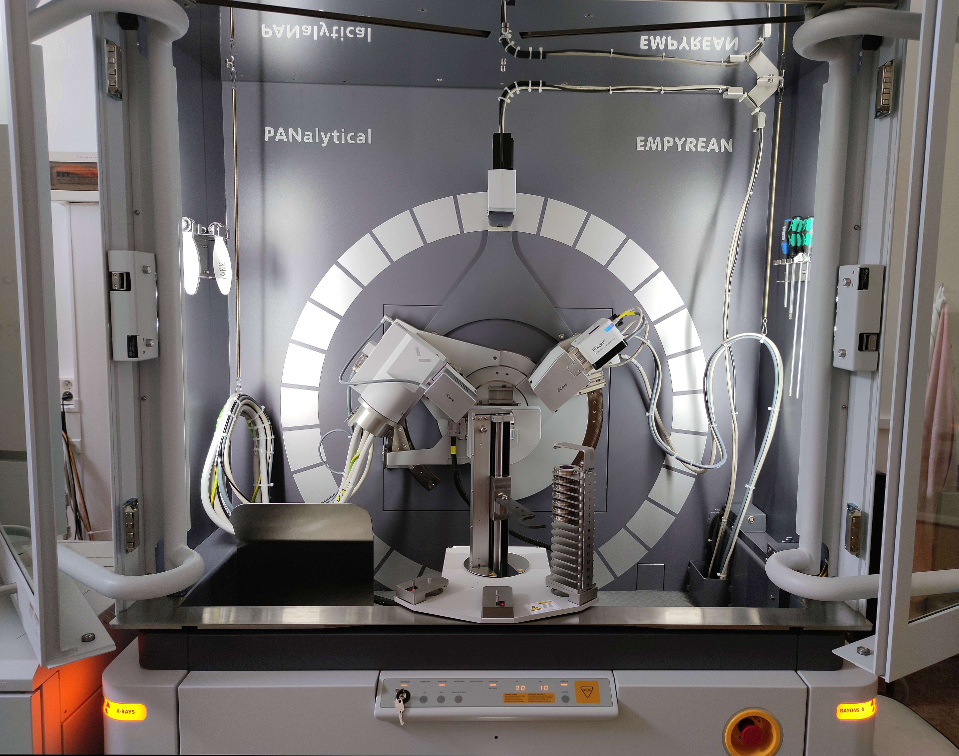 | 