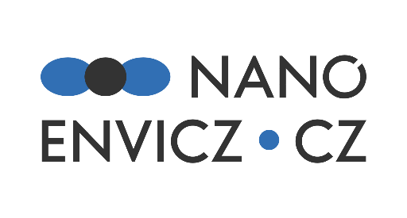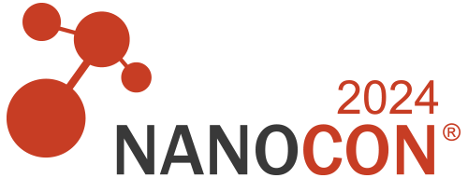

**PROGRAM of NanoEnviCz workshop**

Date: October 17, 2024

14:00 - 14:10 **TOPINKA Jan,** *Institute of Experimental Medicine of the CAS, Prague, Czech Republic*: **Introduction of the Project NanoEnviCz**

14:10 - 14:30 **ŘEZANKA Michal**, *Technical University of Liberec, Liberec, Czech Republic:* **Advanced Instrumentation in NanoEnviCz at TUL: Nuclear Magnetic Resonance for Nanomaterials Characterization**

14:30 - 14:55 **SAZAMA Petr, SÁDOVSKÁ Galina,** *J. Heyrovský Institute of Physical Chemistry of the CAS, Prague, Czech Republic*: **Effects of Nanoconfinement on Catalysis**

14:55 - 15:20 **ECORCHARD Petra**, *Institute of Inorganic Chemistry of the CAS, Rez, Czech Republic,* **Innovation of Instrumental Techniques and Practical Example of Using of Support of NanoEnviCz Project**

15:20 - 15:40 **ORAVA Jiří**, *Jan Evangelista Purkyně University in Ústí nad Labem, Ústí nad Labem, Czech Republic*: **Sustainable Solutions for Safer Lithium-ion Batteries: From Advanced Materials Development to Comprehensive Critical Raw Materials Recovery**

15:40 - 16:00 **TOPINKA Jan**, *Institute of Experimental Medicine of the CAS, Prague, Czech Republic*, NanoEnviCz: **New Instrumentation for Single Cell Toxicogenomics available at IEM**

The authors acknowledge the assistance provided by the Research Infrastructure NanoEnviCz, supported by the Ministry of Education, Youth, and Sports of the Czech Republic under Project No. LM2023066.

