

47th NARECOM – NAnoEnviCz REsearch COmmunity Meeting

24th September 2025 at 2:30 p.m.

**Molecular modelling and design of functional nanostructures**

**doc. RNDr. Marek Malý, Ph.D**

*J. E. Purkyně Univerzity in Ústí nad Labem, Faculty of Science, Department of Physics*

**Abstract:**

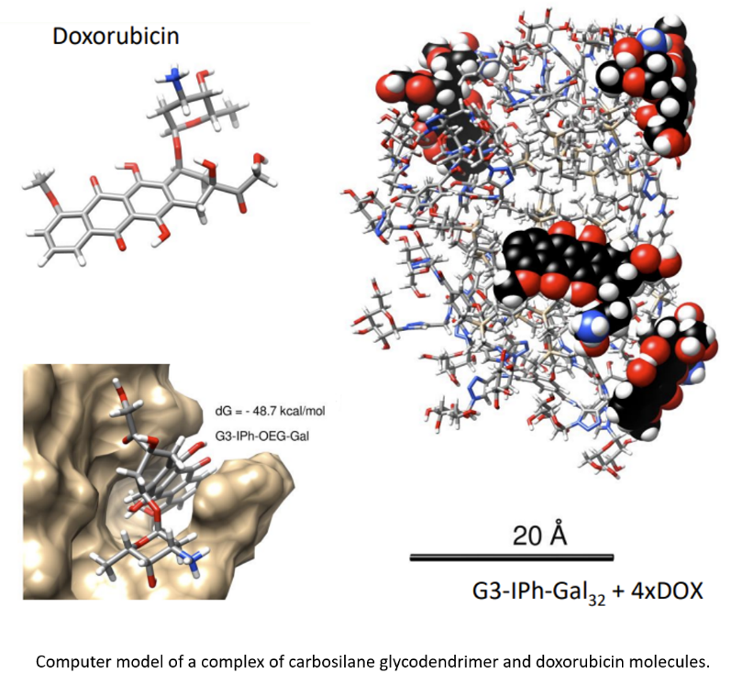Computer modelling complements experimental methods and serves as a useful analytical tool that is commonly used today in various fields of science and research. One of the main methods in the area of particle simulations is molecular dynamics, which is based on the numerical solution of system of equations of motion that describe the movement of particles under forces (e.g. mutual interaction forces). This method provides the ability to study molecular systems with a resolution that is difficult to achieve with experimental techniques, thereby helping to better understand processes driven by molecular interactions. For this reason, this “virtual” tool is currently widely used, for instance, in biomedical research, where it helps to streamline the development of relevant therapies, particularly in the context of drug design or drug delivery. Another broad area of application for this simulation method is the development of new materials, such as nanocomposites, for industrial applications. In the indicated contexts, hyperbranched polymer molecules called dendrimers are also being studied and utilized. The presentation will introduce some specific applications of these polymer molecules, with a primary focus on the biomedical field, as well as the use of molecular simulations to study relevant molecular systems.