

38th NARECOM – NAnoEnviCz REsearch COmmunity Meeting

-60

-40

-20

0

20

-2

-1

0

1

2

0

200

400

600

**

H

(x10

3

ps/m)

200 K

**Z** (film#2)

*T*

= 10 K

100 K

200 K



P (

❍

C/m

2

)

*H*

(T)

*T*

= 10 K

100 K

scheme of ME (transverse)

poling geometry:

[0001]Z

**± HP //**

**± EP //**

11th September 2024 from 2:30 p.m.

**Application of LC/MS system in the analysis of organic compounds**

**Dr. Stanislava Vrchovecká**

*Technical University of Liberec, Department of Environmental Chemistry*

**Abstract:**

Liquid chromatography coupled with mass spectrometry (LC/MS) is one of the most widely used techniques for the separation, identification, and quantification of organic compounds. The Department of Environmental Chemistry (OECH) has a system consisting of an ExionLC high-performance liquid chromatography and an X500R QTOF high-resolution mass spectrometer with a Turbo V ion source from AB Sciex. The basic principle of the LC/MS method is the separation of compounds based on their physicochemical properties, ionization in the ion source, separation of the ions in the vacuum based on their mass‑to‑charge (m/z) ratio, and their subsequent detection. Analyses using our LC/MS system can be performed in a targeted analysis mode, where the optimal conditions for identification and highly sensitive quantification of selected compounds are found using available standards. The second option is non-targeted analysis, where all compounds present in the sample are detected.

OECH provides analytical services for internal research groups and students from TUL, as well as for external scientists and industrial customers. OECH focuses on the analysis of a wide spectrum of samples. These include the determination of pharmaceuticals or perfluorinated compounds in surface, groundwater or wastewater, the monitoring of degradation products of pharmaceuticals resulting from new elimination technologies using non-targeted analysis, the determination of pesticides and their monitoring in the construction and operation of wetland systems. In addition, we are following new trends and responding to the needs of research groups by introducing new methods - the introduction of a method for the determination of 12 micropollutants identified by the European Union Directive (ST-7108-2024-INIT) for research groups involved in urban wastewater treatment. Furthemore, we perform the monitoring of organic degradation products of tires (6-PPD quinone, 1,3-diphenylguanidine, 2-hydroxybenzothiazole) in cooperation with the University of Zittau. We cooperate with groups dealing with biodegradation of plastic materials - here monitoring of terephtalic or furandicarboxylic acid in aqueous samples is conducted. In the case of pharmaceuticals, disinfectants and personal care products, we cooperate with bioengineers and the Faculty of Textile Engineering(TUL), who perform the incorporation of these compounds into nanofibre formulations and monitor the concentration, stability and release of these compounds. We also collaborate with commercial companies such as Benteler and Preciosa to anlyze coupling materials or cleaning solutions containing surfactants.

**Graphical Abstract:**

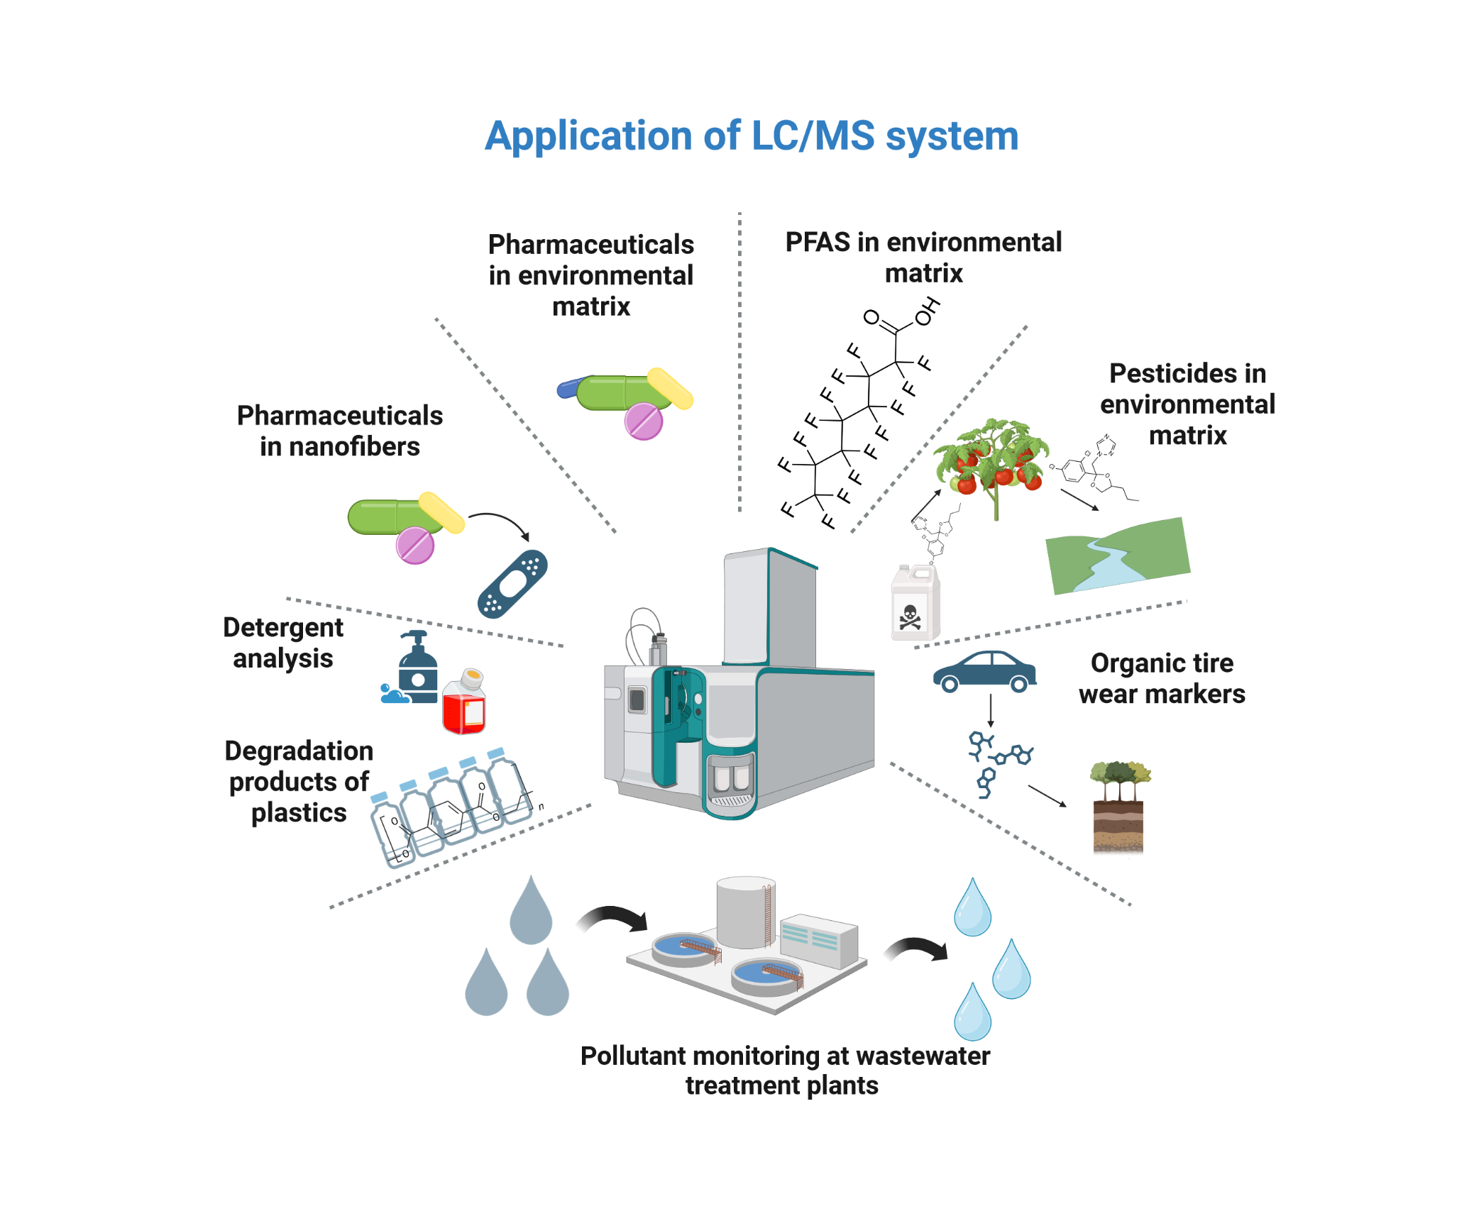

**1 µm**