

44th NARECOM – NAnoEnviCz REsearch COmmunity Meeting

-60

-40

-20

0

20

-2

-1

0

1

2

0

200

400

600

**

H

(x10

3

ps/m)

200 K

**Z** (film#2)

*T*

= 10 K

100 K

200 K



P (

❍

C/m

2

)

*H*

(T)

*T*

= 10 K

100 K

scheme of ME (transverse)

poling geometry:

[0001]Z

**± HP //**

**± EP //**

16th APRIL 2025 at 2:30 p.m.

**Shaping Microbial Diversity: The Impact of Mine Water Treatment on Autochthonous Communities at Former Mining Site in Zlaté Hory**

Vira Velianyk1, Martin Palusak1, Nhung Nguyen1, Jakub Riha1, Alena Sevcu1,2, Miroslav Cernik1, Veronika Hlavackova1,2

*1Technical University of Liberec, Institute for Nanomaterials, Advanced Technologies and Innovation, Czech Republic, Department of Applied Biology, Liberec, 460 01*

*2Technical University of Liberec, Faculty of Science, Humanities and Education, Czech Republic Liberec, 460 01*

**Abstract:**

The Zlaté Hory mining site, located in the southern and southwestern parts of the Jeseník district in Northern Moravia, is well-known for its historic polymetallic copper and gold deposits. Past mining activities, including sulfide leaching with the use of aggressive methods, have caused significant chemical and physical changes to the environment, disrupting biological processes in nearby natural habitats. As part of the SURRI project (Horizon Europe Twinning) and in collaboration with DIAMO, a state enterprise managing former mining sites in the Czech Republic, we conducted a microbiological survey of the underground mine area, key points of the treatment station and the tailing site. Modern molecular methods have been increasingly applied to detect, quantify, and study microbial populations in the selected area. Among these methods, PCR-based techniques have received considerable attention, particularly real-time quantitative PCR (qPCR), which is considered highly sensitive, specific, and capable of simultaneous detection and quantification of microorganisms in water and sinter samples. Analysis of the 16S rRNA library (p > 0.01) revealed notable differences in microbial communities across three major groups of microorganisms. Acid-tolerant microbes were primarily found in the acidic mine shaft discharge. After pH neutralization, metal-tolerant neutrophilic bacteria were identified in the flocculation tank, despite elevated concentrations of heavy metals. The highest microbial diversity was observed in drainage water from the tailing site. These findings emphasize the crucial role of factors such as pH and metal concentrations in shaping microbial communities. These communities are characterized by their adaptability and ability to thrive in toxic environmental conditions.

**Graphical Abstract:**

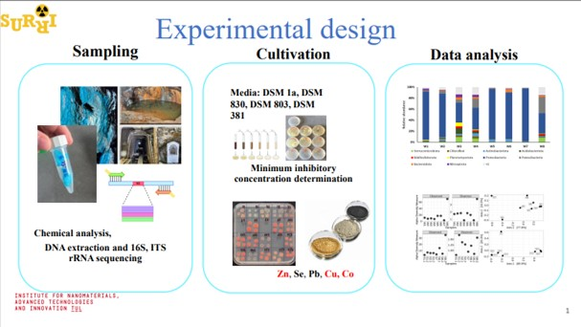

**1 µm**