

43rd NARECOM – NAnoEnviCz REsearch COmmunity Meeting

-60

-40

-20

0

20

-2

-1

0

1

2

0

200

400

600

**

H

(x10

3

ps/m)

200 K

**Z** (film#2)

*T*

= 10 K

100 K

200 K



P (

❍

C/m

2

)

*H*

(T)

*T*

= 10 K

100 K

scheme of ME (transverse)

poling geometry:

[0001]Z

**± HP //**

**± EP //**

19th March 2025 at 2:30 p.m.

**Metal-organic frameworks: Environmental application vs chemical stability**

**Daniel Bůžek**

*Institute of Inorganic Chemistry of the CAS, Faculty of Environment, J. E. Purkyně University in Ústí nad Labem*

**Abstract:**

Metal-organic frameworks (MOFs) are porous coordination polymers that consist of inorganic nodes interconnected by organic ligands called linkers. Typical linkers used for the construction of MOFs are polytopic carboxylic aromatic acids. The connection of inorganic and organic building blocks usually results in 3D crystalline structures with high specific surface area and pore volume. Today, there are countless different MOF structures and topologies with variable and tuneable properties, which depend mainly on the choice of building blocks. Due to high variability, tuneability and the possibility of functionalization, MOFs are tested for a number of potential applications such as sorption, separation and storage of gases, sensing, heterogeneous catalysis, biomedicine and drug delivery.

Environmental applications of MOFs (for example, adsorption removal, (photo)catalytical degradation and sensing of pollutants) are one of the frequently studied directions. A typical feature of these applications is the aqueous environment in which the MOF occurs. However, this is not always pure water; it contains other components that lead to different salinity, pH, etc. Although MOFs often excel in their adsorption capacities for pollutants in comparison with standard adsorbents such as activated charcoal, on the other hand, a limiting factor of MOFs is their weaker stability. In this presentation, we will talk about which parameters are important for MOF stability from a theoretical point of view. However, the results of our team focusing on MOF stability will also be unveiled.

**Graphical Abstract:**

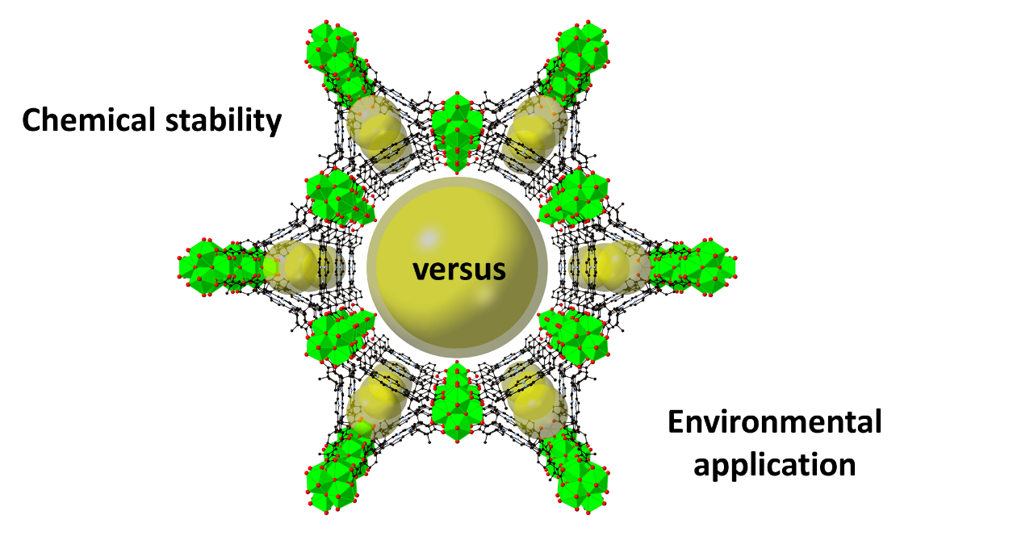

**1 µm**