


2
49th NARECOM – NAnoEnviCz REsearch COmmunity Meeting
12th November 2025 at 2:30 p.m.
Photo-induced Degradation of Microplastics and Hydrogen Production using Metal Oxide Nanostructures
Guru Karthikeyan Thirunavukkarasu, Ph.D.
Institute of Inorganic Chemistry of the Czech Academy of Sciences, Husinec-Řež 250 68, Czech Republic
Abstract:
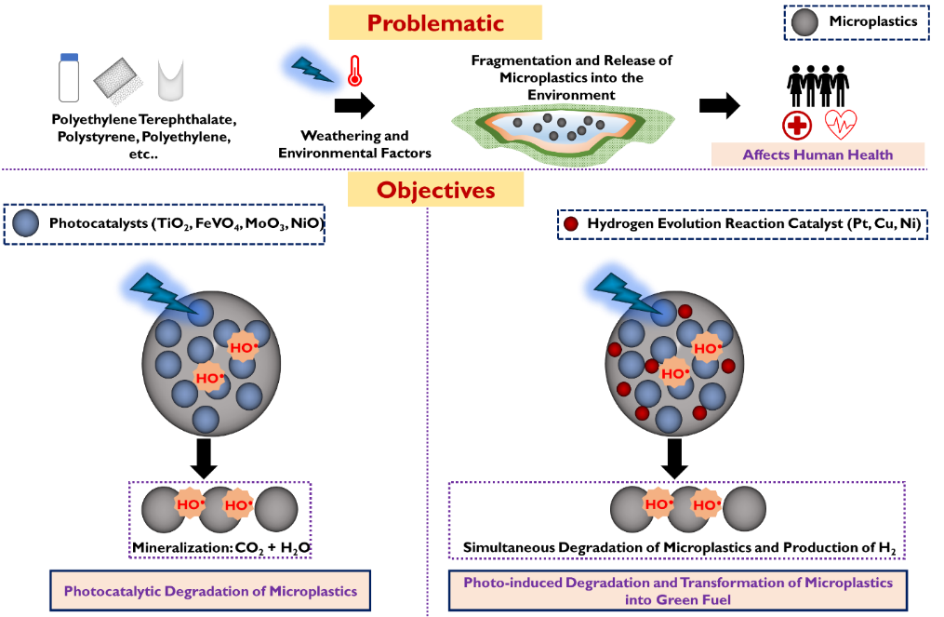
Microplastic (MP) pollution has seriously affected the environment globally. Currently, wastewater treatment plants are not favorable for treating MPs. Hence, it is a necessity to investigate different methodologies to treat MPs in water efficiently. Photocatalytic (PC) and photo-Fenton (PF) processes are among the promising treatment methodologies that utilize reactive oxygen species (ROS) to degrade MPs. Here in this talk, we explore the processes for the degradation of MPs using metal oxide nanostructures and the production of clean energy H₂ via the degradation of MPs. We evaluated the degradation of MPs using attenuated total reflection infrared (ATR-IR) spectroscopy, total organic carbon (TOC) analysis, thermogravimetric analysis coupled with differential scanning calorimetry and mass spectrometry (TGA-DSC/MS), nuclear magnetic resonance (NMR) spectroscopy, and high-performance liquid chromatography with high-resolution mass spectrometry (HPLC-HRMS). Photo-induced degradation of the MPs was evaluated by monitoring the changes in the carbonyl/peroxyl index (CI/PI) recorded by ATR-IR spectroscopy and the mass loss measured by TGA-DSC/MS techniques. Further, NMR spectroscopy and HPLC-HRMS techniques were used to confirm the formation of degradation by-products. The production of H₂ was monitored by gas chromatography (GC). The contribution of ROS responsible for the MPs' degradation was monitored by electron paramagnetic resonance (EPR) spectroscopy. Therefore, our work has the potential to significantly influence future research and environmental policies by providing better insights into preparing efficient nanostructures for photo-induced degradation of MPs and for simultaneous production of H₂.

