**Equipment:** Fragment Analyzer (Advanced Analytical)

**No. of Equipment: IEM10**

**Responsible coordinator:** JanTopinka, DSc.

**Name of Institution:** Institute of Experimental Medicine of the Czech Academy of Sciences

**Address of Institution:** Vídeňská 1083, 142 20 Prague 4, Czech Republic

**E-mail:** jtopinka@biomed.cas.cz

**Telephone:** +420 24106 2675

**Homepage:**  http://www.iem.cas.cz/en/

**Contact person:** mgr. Andrea Rössnerová, PhD.

**E-mail:** andrearo@biomed.cas.cz

**Telephone:** +420 24106 2612

**Equipment Description**

**Description of equipment:**

*Fragment analyzer (Advanced Analytical)*

Description of principle and use:

The Fragment Analyzer is a parallel capillary electrophoresis instrument designed to eliminate laboratory bottlenecks caused by slow and unreliable QC analysis of nucleic acids. These bottlenecks are resolved by the automation of key steps such as gel loading and sample injection. After separations are complete, nucleic acid fragment analysis is simplified with *[PROSize](https://www.aati-us.com/instruments/fragment-analyzer/prosize-data-analysis-software/)*® Data Analysis Software. Together, the Fragment Analyzer and PROSize offer researchers the ability to quickly and reliably QC their samples and move on to downstream applications sooner.

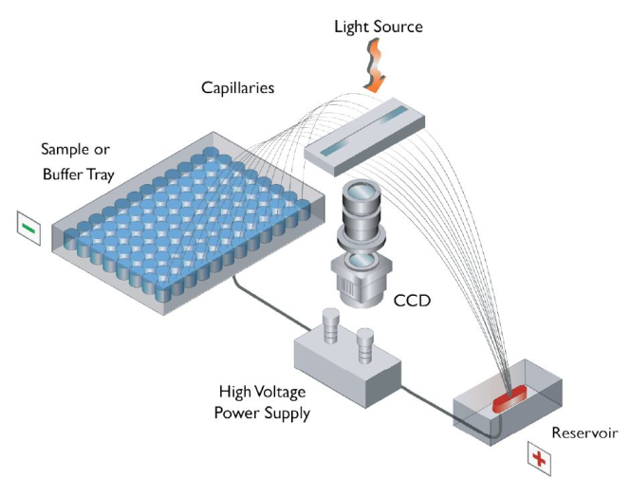

Specifications and technical features:

Maximum Sample Throughput: Array dependent, either 12, 48, or 96 samples

Maximum Unattended Sample Capacity: Up to 288 samples

Minimum Sample Volume: 20 μL of liquid for injection; as little as 1 μL of actual sample required

Resolution: Gel dependent; to as low as 3 bp

Sizing Accuracy: Typically 5% or better

Detection Sensitivity: As low as 5 pg/μL for fragments and 50 pg/μL for a smear

Light Source: 700 mA, 10 W LED, 470 nm excitation wavelength

Detector: High sensitivity CCD; 500-600 nm emission wavelength

Software: Fragment Analyzer Instrument Control, *PROSize*® Data Analysis Software

Data Export Format: CSV, PDF, flexible numerical or binary output options

Environmental Conditions: Indoor use, normal laboratory environment 20-23°C

Relative Humidity Range: < 80% (non-condensing)

Electrical: 100-200 VAC; 50-60 Hz; 15 A (alternate configurations available)

**Specification of expertise relevant to NanoEnviCz workpackages:**

**WP3**a,d,f,g,h, **WP4**a,b, **WP6**a,d, **WP7**a,c,e,h,i, **WP9**a,b,c,d

**Detailed description of expertise**

**Please, specify the main research topics connected with equipment**:

Genomics in the study of biological effects of manufactured nanoparticles

**Please, specify the secondary research topics connected with equipment**:

Impact of nanoparticles from air pollution on genome of model human cell lines

**Keywords describing research area:**

DNA analysis, RNA analysis, biological effects of nanomaterials, nanoparticles

**Competence**

**Relevance for applied and industrial research:**

NMs represent a specific group of substances, and their toxic effects may differ. Toxicological data related to the real concentrations present in the working environment will be applicable in promoting the safe working environment.

**Relevance for fundamental studies:**

The genotoxic assessment will contribute to our understanding how nanomaterial properties affect their potential toxicity. Toxicological data related to the physico-chemical characteristics will be applicable in developing both more efficient and safer nano-based products for biomedical applications.