

**15th NARECOM – NAnoEnviCz REsearch COmmunity Meeting**

16th March 2022 from 2:30 p.m.

**In vivo toxicity study of metal oxides NMs in mice**

**RNDr. Pavel Rossner, Ph.D.**

Institute *of Experimental medicine of the CAS*

**Graphical Abstract**

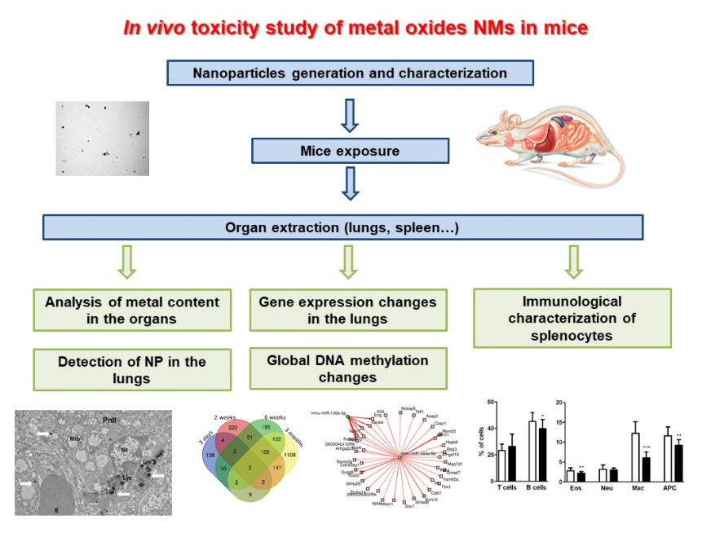

**Abstract**

Zinc oxide nanoparticles (ZnO NP) and copper oxide nanoparticles (CuO NP) are commonly used as antimicrobial agents, in various industrial applications, chemistry, or in electronic devices. Although *in vitro* tests indicate their high potency to induce oxidative stress, apoptosis, cell cycle arrest or DNA damage, exact mechanisms of biological impacts are not well understood.

In the first study, adult female ICR mice inhaled ZnO NP for three days and three months, respectively. Analysis of differential expression and alternative splicing (AS) events in genes involved in oxidative stress, immune response, inflammation, apoptosis, DNA damage and repair, and cell cycle regulation was conducted using next-generation sequencing. The potential immunotoxic and immunomodulatory effects of ZnO NP were analyzed by phenotyping and cytokine production by splenocytes after three months exposure. Three days exposure resulted in the up-regulation of *IL-6* and down-regulation of *BID*, *GSR*, *NF-kB2*, *PTGS2*, *SLC11A2*, and *TXNRD1* mRNA expression; three months exposure increased the expression of *ALDH3A1, APAF1, BID, CASP3, DHCR7, GCLC, GCLM, GSR, GSS, EHHADH, FAS, HMOX-1, IFN, NF-kB1, NQO-1, PTGS1, PTGS2, RAD51, RIPK2, SRXN1, TRAF6* and *TXNRD1* mRNA. AS of *TRAF6* and *TXNRD1* genes was induced after three days exposure. Three months exposure caused a significant decrease in the percentage of granulocytes in the spleen cells, and affected the production of IL-10 and IL-6 by lipopolysaccharide-stimulated leukocytes. In summary, our study revealed changes in the expression of genes involved in the oxidative stress response, apoptosis, immune response, inflammation and DNA repair, as well as induction of AS in genes associated with oxidative stress and inflammation following ZnO NP exposure. Subchronic ZnO NP exposure induced immunomodulatory effects in the spleen.

In the second study, female ICR mice were exposed by inhalation to CuO NP for 3 days, 2 weeks, 6 weeks and 3 months. The exposure resulted in deregulation of a number of transcripts that tended to increase with the exposure time. We detected 170 (100 upregulated, 70 downregulated), 590 (432 upregulated, 158 downregulated), 534 (409 upregulated, 125 downregulated) and 1551 (898 upregulated, 653 downregulated) deregulated transcripts after 3 days, 2 weeks, 6 weeks and 3 months of inhalation, respectively. Biological processes and pathways affected by the inhalation differed between 3 days exposure (collagen formation) and longer treatments (immune response). Two weeks exposure further induced apoptotic processes, 6 weeks inhalation affected cell cycle and 3 months treatment impacted processes related to cell adhesion. In summary, inhalation of CuO NP induced significant transcriptomic response already after 3 days exposure. Longer treatment affected a greater number of transcripts and processes mostly related to immunity.