

42nd NARECOM – NAnoEnviCz REsearch COmmunity Meeting

-60

-40

-20

0

20

-2

-1

0

1

2

0

200

400

600

**

H

(x10

3

ps/m)

200 K

**Z** (film#2)

*T*

= 10 K

100 K

200 K



P (

❍

C/m

2

)

*H*

(T)

*T*

= 10 K

100 K

scheme of ME (transverse)

poling geometry:

[0001]Z

**± HP //**

**± EP //**

5th February 2024 at 2:30 p.m.

**The impact of environmental pollution to oxidative stress in mothers/newborns**

**Dr. Antonín Ambrož**

*Institute of Experimental Medicine AS CR, v.v.i.*

**Abstract:**

The project “Healthy Aging in Industrial Environment” (HAIE) was carried out in 2018-2022. The partial aim of the study was to analyze contaminants that affect oxidative DNA damage and lipid peroxidation in non-smoking mothers and their newborns. 147 pairs of mothers/newborns originated from Ceske Budejovice (CB; an agricultural region) and 201 pairs were recruited from Karvina (an industrial region). Personal and medical data, external (PM2.5, B[a]P) and internal (PCBs, OCPs, BFRs, PFASs and OH-PAHs) exposures, antioxidant mechanisms (SOD, CAT, GPx and ORAC), and cytokines concentrations (IL-1β, IL-6) were investigated as parameters potentially affecting the markers of DNA oxidation (8-oxo-7,8-dihydro-2’-deoxyguanosine) and lipid peroxidation (15-F2t-isoprostane).

**Graphical Abstract:**

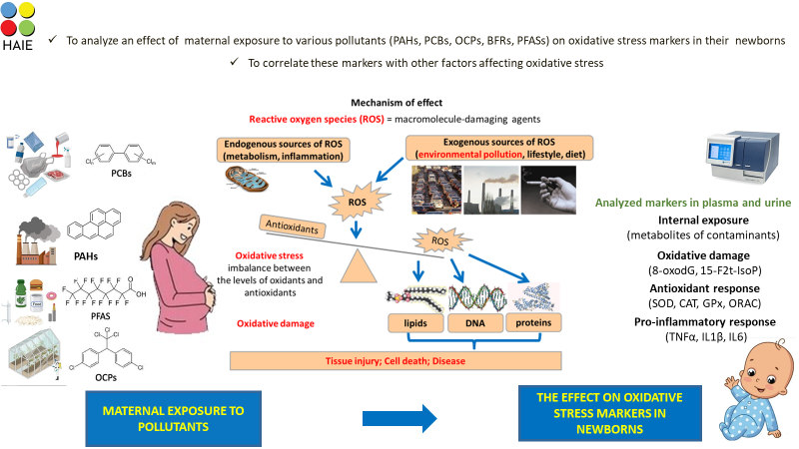

**1 µm**