|  |  |
| --- | --- |
| Jr. Mechanical Engineering  Paddle Boat Design Challenge | |
| **Activity** | **Supplies Needed** |
| Discuss Potential and Kinetic Energy – See diagram below. | None |
| Make a Paddle Boat  <https://www.sciencebuddies.org/stem-activities/rubber-band-paddle-boat> | 1. Cardboard  2. Duct Tape  3. Scissors/Box Knifes  4. Rubber Bands |
| Test the Paddle Boats | Body of Water |
| Discuss the Results |  |
| Brainstorm ways to make the paddle boat better. |  |

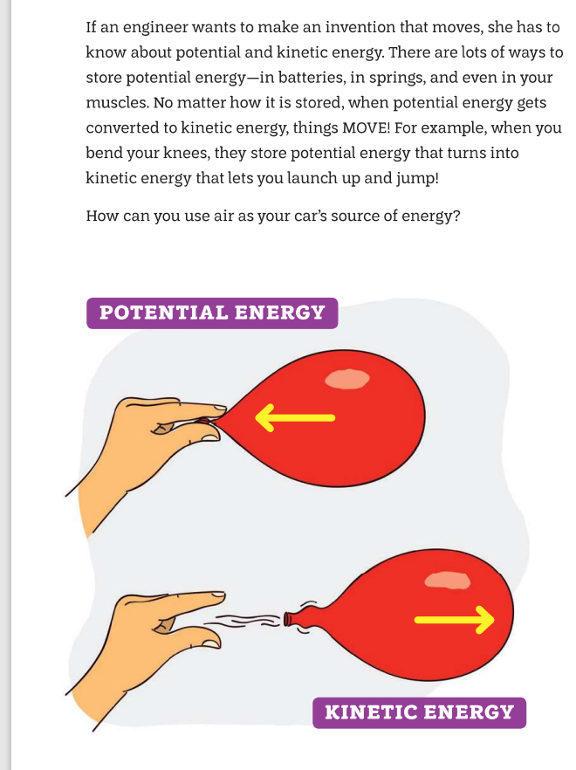

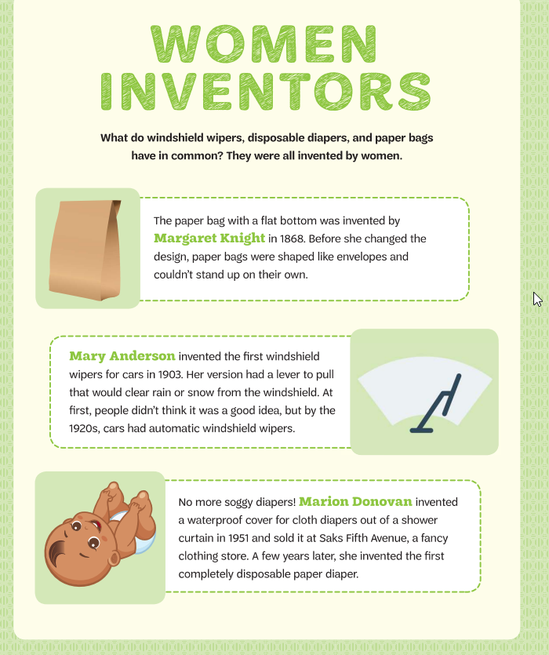

Women Inventors?

Answer Sheet

|  |  |
| --- | --- |
| Disposable Diapers | Marion Donavan |
| Windshield Wipers | Mary Anderson |
| Flat Bottom Grocery Bag | Margaret Knight |
| Circular Saw | Tabitha Babbitt |
| Dishwasher | Josephine Cochrane |
| Monopoly | Elizabeth Magie |
| Invisible Glass | Katharine Burr Blodgett |
| Solar Powered Heating System | Maria Telkes |
| Computer Software | Grace Hopper |
| Closed Circuit Television | Marie Van Brittan Brown |
| Bullet Proof Vest | Stephanie Kwolek |
| Aquascope | Stephanie Kwolek |
| Hand Cranked Ice Cream Freezer | Nancy Johnson |
| Barbie Doll | Ruth Handler |
| Bra | Mary Phelps Jacob |

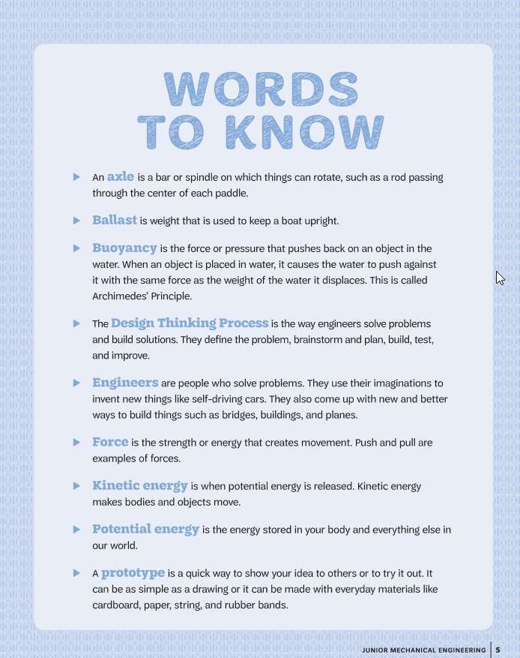

Build a Rubber Band Paddle Boat

**Summary**

**Active Time**

20-30 minutes

**Total Project Time**

20-30 minutes

**Key Concepts**

Buoyancy, energy

**Credits**

[Ben Finio, PhD, Science Buddies](https://www.sciencebuddies.org/about/author/ben_finio)

*Science Buddies is committed to creating content authored by scientists and educators.*[*Learn more about our process and how we use AI.*](https://www.sciencebuddies.org/about/artificial-intelligence-usage-statement)

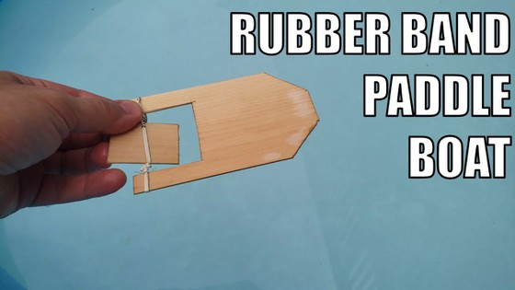

**Introduction**

Build your own bathtub or pool toy from simple craft materials in this fun activity! You will build a rubber-band-powered boat that can zip across the surface of the water after you wind up the rubber band.

**Materials**

* Rubber band
* Materials for the boat, such as:
  + Cardboard (requires duct tape for waterproofing)
  + Balsa wood
  + Popsicle sticks (requires hot glue gun for assembly)
* Optional: Small pieces of foam to make the boat float better
* Pencil
* Ruler
* Hobby knife or scissors
* Bathtub or kiddie pool

**Prep Work**

1. Fill your kiddie pool or bathtub so you are ready to test your boat!
2. Depending on which materials you are using, you can watch video instructions on how to build your boat, or keep scrolling for written instructions.



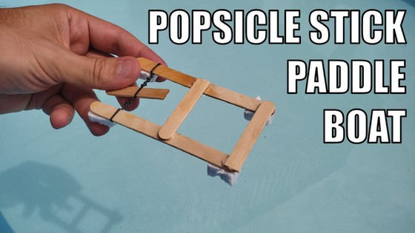

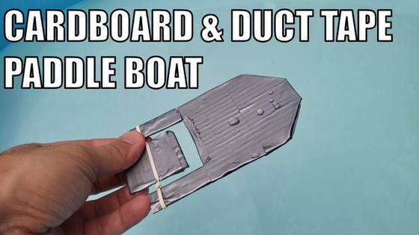

**Instructions**

1. Make the hull of your boat.
   1. If you are using balsa wood or cardboard, start with a rectangular piece that is about 3 by 5 inches. Cut corners or round off one end of the boat. This will be the front.
   2. If you are using popsicle sticks, first score one by etching a line with the end of the scissors so you can more easily snap it in half, then glue the sticks together to make a frame, like the one pictured.

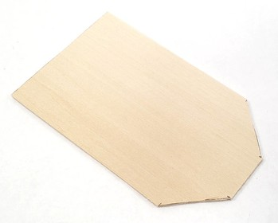Image Credit: [Ben Finio, Science Buddies / Science Buddies](https://www.sciencebuddies.org/image-credit?id=17749) 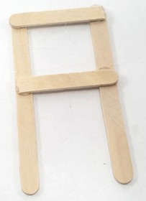Image Credit: [Ben Finio, Science Buddies / Science Buddies](https://www.sciencebuddies.org/image-credit?id=17750)

1. Cut out a section for the paddle, approximately a 2-by-2-inch square (this step is not necessary if you built your frame from popsicle sticks).

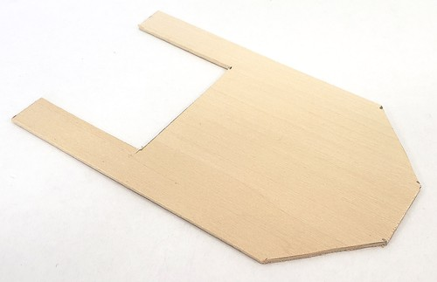Image Credit: [Ben Finio, Science Buddies / Science Buddies](https://www.sciencebuddies.org/image-credit?id=17751)

1. Make the paddle.
   1. If you are using cardboard or balsa wood, cut the piece you removed from the hull so it is *narrower* than the gap. This will ensure it has room to spin without getting stuck.
   2. If you are using popsicle sticks, cut another popsicle stick in half.

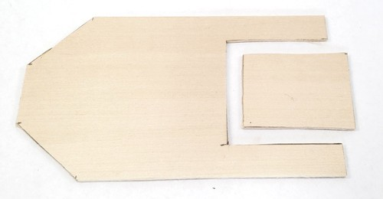Image Credit: [Ben Finio, Science Buddies / Science Buddies](https://www.sciencebuddies.org/image-credit?id=17752)

1. If you are using cardboard, completely cover and seal both the hull and the paddle with duct tape to prevent them from getting wet.

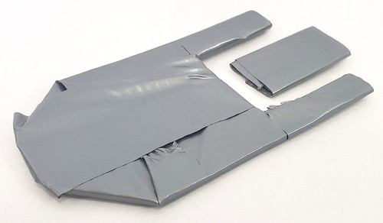Image Credit: [Ben Finio, Science Buddies / Science Buddies](https://www.sciencebuddies.org/image-credit?id=17753)

1. Stretch a rubber band across the gap in the hull. Slide the paddle through the rubber band, and twist it at least 20 times to wind it up. Hold the paddle in place so it does not unwind.

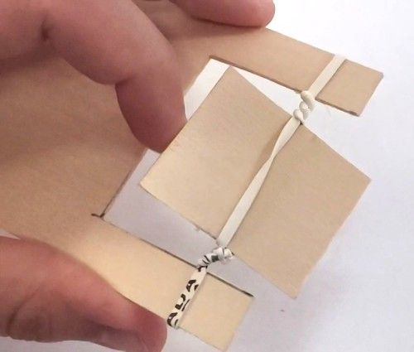Image Credit: [Ben Finio, Science Buddies / Science Buddies](https://www.sciencebuddies.org/image-credit?id=17754)

1. Put your boat down in the water, release the paddle, and watch it go!

|  |  |
| --- | --- |
| **Think about:** | How far does your boat go before it stops? If you wind the paddle up more, does the boat go farther? |

1. 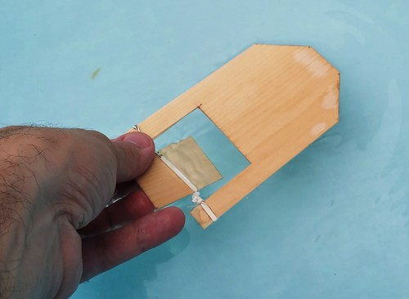Image Credit: [Ben Finio, Science Buddies / Science Buddies](https://www.sciencebuddies.org/image-credit?id=17756)
2. Optional: Glue some small pieces of foam to the bottom of your boat to make it float better. This is especially useful for boats made from popsicle sticks.

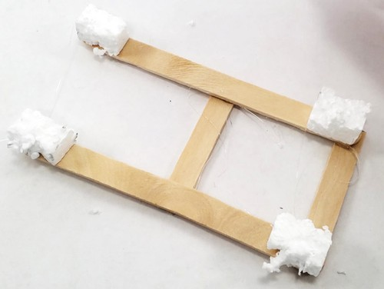Image Credit: [Ben Finio, Science Buddies / Science Buddies](https://www.sciencebuddies.org/image-credit?id=17755)

**Cleanup**

Do not leave your boat in the water for long periods of time or it may start to fall apart. Remove the boat from the water when not in use so it can dry.

**What Happened?**

When you put the boat down in the water and released the paddle, the paddle should have spun, propelling the boat forward! The more times you wound up the paddle, the farther the boat should have gone.

**Digging Deeper**

In this project you built a miniature version of a paddle boat. In the 1800s, large steam-powered boats that could carry lots of people were propelled by large paddles. Today, smaller recreational boats are powered by people, who sit and use *pedals* to turn the *paddles*, just like riding a bike.

The paddle boat is a good way to demonstrate two different laws of physics. First, it demonstrates conservation of energy. When you twist up the rubber band, it stores elastic potential energy (the energy stored in a stretched material). When you release the rubber band, this potential energy is converted to kinetic energy (the energy of motion), and the boat moves forward.

Second, when the paddle spins, it pushes on the water, pushing the water backward. According to Newton's third law of motion, for every action there is an equal and opposite reaction. This means that the water pushes back on the paddle, pushing the entire boat forward.