Reset PLAY Clock to (40) seconds for most situations:

- RESET the PLAY CLOCK to (40) seconds after the ball is snapped

- START the (40) second PLAY CLOCK when the covering official indicates the ball is dead, by one of the following signals:

- One hand above head [S1]
- Stop Clock signal [S3]
- Incomplete pass signal [S10]
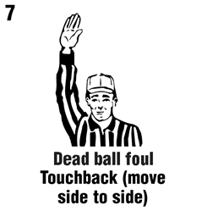
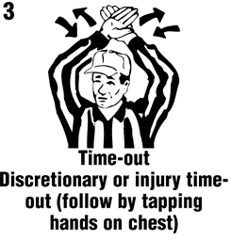
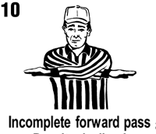
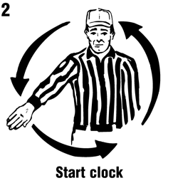
- Wind signal near sideline [S2]

- Reset to (40) if GC stopped for DEFENSIVE Injury, Equip or Foul
- Reset to (25) when a DOUBLE “Change of Possession” occurs
(original OFFENSE has the ball at the end of the down)
- See the covering official’s Dead Ball Signal, take a breath, count one-thousand-one, then start the PLAY Clock → BE CONSISTENT

Reset to (25) seconds AFTER or FOR the following:

1. FOUL – OFFENSIVE Foul or DOUBLE Foul (Both Teams Foul)
2. INJURY – play is stopped for INJURED OFFENSIVE Player
3. SCORE – any down that involves a score
4. TIME-OUT – either team is granted a time-out
5. HELMET COMES OFF – OFFENSIVE player’s helmet comes off
6. KICK – any down that includes a legal kick (Kickoff, Punt, Field Goal attempt, or Kick after a Safety)
7. MEASUREMENT – a measurement for a first down;
8. CHANGE OF POSSESSION – and the DEFENSE has the
ball at the end of the down
9. START OF A QUARTER – the beginning of any period;
10. INADVERTENT WHISTLE – an inadvertent whistle;
11. UNTIMED DOWN
12. If Game Clock is STOPPED to “DIG for a FUMBLE”
This list includes most 25-second PLAY Clock situations

The “R” will give the ready-for-play signal [S1] & the PLAY Clock will begin the 25-second count (‘chop’ signal or ‘wind’ signal).

If the (40)-Second PLAY Clock is running with less than (25) seconds remaining and the ball has not been placed on the ground:

- “R” will STOP the Play & Game Clocks
- Re-Set the PLAY Clock to (25)
- “R” will Mark the Ball Ready-for-Play with a “Whistle & Chop” and the (25) PLAY Clock will start

Signal to Reset to (25) → By “R” or “BJ”:

- ONE palm open in an over-the-head pumping motion

Signal to Reset to (40) → By “R” or “BJ”:

- BOTH palms open in an over-the-head pumping motion

If (40) / (25) Second Clock hits “0” – Delay of Game:

- If BJ has a FLAG for Delay of Game – leave PC showing “0”

- If no flag – reset PC to (40)

- Mechanics: BJ will see “0” on the clock, and then look to the ball – If the ball is moving, then the play will continue; if the ball is not moving, then the BJ will Whistle & Flag for Delay of Game

If GAME Clock is running with less than the (40) / (25):

- Do not start the PLAY Clock

- But pay attention → The PLAY Clock may run for the next play depending on what occurs during the play

Example: Incomplete Pass, Out of Bounds, Time-Out

