- Have Game Clock (GC) run out (1) minute before KO
- Start GC (30) minutes before KO time
- Any official can signal to stop the game clock – typically (1) signal:
- Timeout, Incomplete Pass, Any Score, or Touchback Signal
- If GC is stopped → Watch “R” (White Hat) → “R” will signal:
- For (25) second Play Clock
  - If R “chops” (does not wind) – GC starts on the SNAP
  - R will wind GC when the GC is to start on RFP
- If (40) second Play Clock is Running
  - “R” may “silent” wind the GC after the ball is placed on
the ground & the Umpire is “in position” → NO Whistle
  - If “R” does NOT wind when the ball is placed on the ground & U is in position, then Start the GC on the SNAP
- GC may be stopped for a pile-up, fumble, etc., by any official – IF the GC is stopped → “R” may wind GC as soon as pile is cleared
- On KO’s – GC starts when ball is legally touched in the field of play → covering official (s) will wind GC
- GC does NOT run on Try, period extensions, etc.
- R will give the Untimed Down signal
- When a run, pass or fumble ends in End Zone
- Stop GC even if no signal from official(s) → especially if officials conference
- With LESS than 2 minutes in either half – If Penalty occurs:
  - GC may not start until SNAP – Watch the “R” (Rule 3-4-7)
- Officials do not run a separate watch on the field – if GC malfunctions – let us know time remaining, and we will pick it up
- When the GC is operating again, officials will start using the Field GC at next convenient game stoppage
- (20) minute halftime → wait for R’s signal to start
- After Halftime - ( 3) minute warm-up – put it on the GC & run it
- Turn GC OFF after 3rd time if: (3 Strikes)
  - Operator must be corrected or GC malfunctions
- Come in at half time in case of any problems/adjustments
- During the 2nd Half → If score differential reaches 30 points
  - Or during 1st Half → IF BOTH Head Coaches Agree
- R (White Hat) will point to the timer, tap his wrist, and give the wind signal with his Index FINGER
- All game officials will still use normal timing signals
  - CLOCK OPERATOR must know when to stop the GC
- GC will ONLY be stopped for:
- Injured Player
- Charged Team TO
- End of a Quarter
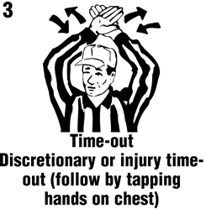
- After a Scored or attempted Try, FG, or Safety (NOT a TD) → “R” will wind GC on the RFP for the KO
- An Extended Delay
  - R will face the clock operator
and signal STOP THE CLOCK

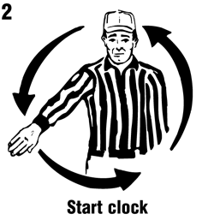
- When GC is stopped for any reason in #4, GC will start on Ready For Play – R will face the GCO and give the WIND Signal
- GC will run during the following:
- A Try following a TD
- Incomplete Pass
  - Runner goes OOB
  - Penalty Enforcement
  - A 1st Down is made
  - COP
- If point differential becomes LESS than 30 points, then use REGULAR NFHS Timing Rules
- Rule 3-4-7 is NOT Applicable ( Penalty < 2 minutes in 2nd & 4th Q)

