Certificate of Conformance
DATE: | July 31, 2023
CUSTOMER: | LC Industries
NSN NUMBER / PRODUCT: | 7510-00-074-5100, 60mm (2.5”) x 60 YD OD Waterproof Tape / 3-50-5100
DESCRIPTION: | Pressure-sensitive tape for packaging, box closure, and sealing; Water resistant woven cloth backed

CERTIFICATION: | ASTM D 5486/D 5486M-06 (2020) Type IV

SHELF LIFE: | This product has a shelf life of twelve (12) months after date of manufacture. After twelve (12) months, the Government reserves the right to extend the shelf life at its discretion.  The month/year of manufacture is listed on each carton label and in the core of each roll of tape, along with the reinspect date.

Sincerely,

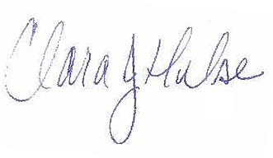
Clara Hulse
Quality Assurance Manager
Phone: 513-487-4536
Fax: 513-221-1084

