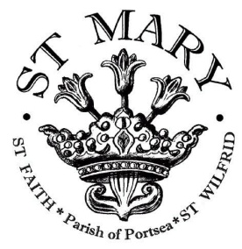

The Parish of St Mary, Portsea

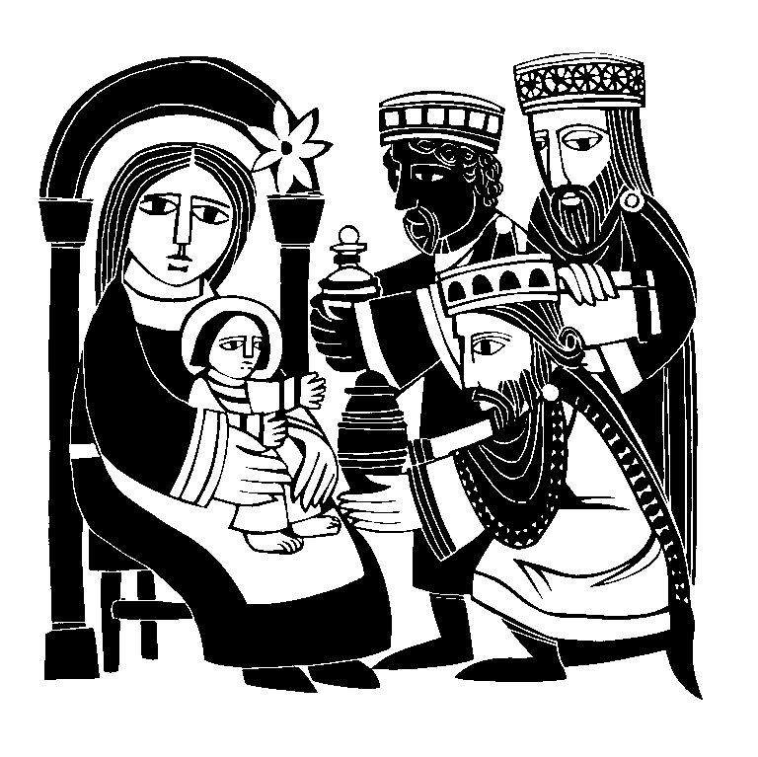

**A Service of   
Readings & Music for Epiphanytide**



**Welcome to St Mary’s**

Welcome to St Mary’s for this service of Readings and Carols for Epiphany.

For the early Church, three ‘wonders’ traditionally marked the feast and season of Epiphany, when Christians celebrated God manifest in their midst. Each of these wonders shows how Christ is revealed to the nations. Firstly, the pilgrimage of the Magi (the wise men) represents the homage of the Gentile (non-Jewish) world at the manger of the Christ Child, and shows how the child of Bethlehem is God-with-us, the One who will gather all the nations into the Covenant of salvation. Secondly, the Baptism of Christ reveals Jesus as the Beloved Son of the Father, the One to whom we should listen for the message of redemption, and whose life and divinity we share through the waters of our own baptism. Thirdly, the sign of the Wedding at Cana reveals Christ as the Bridegroom of the New Creation, as the abundance of new wine overflows at the wedding feast between Heaven and Earth, ushering in God’s final reign of truth, reconciliation and healing.

All of these themes are explored tonight as we listen to the Scriptures, reflect on the Epiphany in music and symbols, and towards the end of the service allow our hearts to be turned towards Candlemas and the coming season of Lent when we celebrate Jesus’ death and resurrection

*The service begins with an Organ Prelude*

*Minister* Three wonders mark this holy season,  
as the Church is joined to her heavenly Bridegroom.  
This day a star leads the wise men to the manger.

**All** **Alleluia!**  
  
This day water is made wine at the wedding feast.  
**Alleluia!**  
  
This day Jesus is revealed as the Christ  
in the waters of baptism.  
**Alleluia! Praise to you, Lord Jesus Christ!**

Grace and peace from God our Father  
and the Lord Jesus Christ be with you.  
**And also with you.**

*A prayer is said*

*The anthem ‘The Three Kings by Cornelius ’is sung*

**THE KING OF ALL THE WORLD IS**

**REVEALED TO THE MAGI**

This day a star leads the wise men to the manger.  
Arise, shine; for your light has come  
**And the glory of the Lord has risen upon you.**  
  
Nations shall come to your light  
**And kings to the brightness of your rising.**  
  
They shall bring gold and frankincense  
**And proclaim the praise of the Lord.**  
  
Your gates will lie open continually  
**Shut neither by day nor by night.**  
  
No more will the sun give you daylight  
**Nor moonlight shine upon you.**  
  
But the Lord will be your everlasting light  
**Your God will be your splendour.**

Incense is placed on the charcoal:

Blessed are you, Lord our God, King of the universe:  
you receive our sacrifice of praise and thanksgiving.  
May our prayer be set forth in your sight as incense,  
And the lifting up of our hands be an evening sacrifice.  
**Blessed be God for ever.**

A reading from the Gospel according to Matthew.( 2.1-2,8-11)  
**Glory to you, O Lord.**

*At the end*

This is the Gospel of the Lord.  
**Praise to you, O Christ.**

*The Incense is placed at the Altar as a prayer is said*

*The anthem ‘O Taste and see’ by Moles is sung*

**THE NEW CREATION IS REVEALED**

**IN THE WATER MADE WINE**

This day water is made wine at the wedding feast.  
I saw the holy city, New Jerusalem, coming down

out of heaven from God  
**Prepared as a bride adorned for her husband.**  
  
And I heard a great voice from the Throne, saying:  
**Behold, the dwelling of God is with his people.**  
  
He will dwell with them and they shall be his own:  
**And God himself shall be with them.**  
  
Behold, I make all things new:  
**I am Alpha and Omega,**

**the beginning and the end.**

To the thirsty I will give water without price:  
**From the fountain of the water of life.**

*The Flagon of wine is held*

Blessed are you, Lord our God, King of the universe:  
for the marriage of the Lamb has come.  
Make your Church ready, and clothe her  
with the righteous deeds of the saints,  
to join the praises of your new creation.  
**Blessed be God for ever.**

A reading from the Gospel according to John. (2.1 – 11)  
**Glory to you, O Lord**

At the end

This is the Gospel of the Lord.  
**Praise to you, O Christ.**

*The flagon of wine is placed on the Altar and a prayer is said*

*The anthem Litany to the Holy Spirit by Hurford is sung*

**THE CHRIST IS REVEALED**

**IN THE WATERS OF BAPTISM**

This day Jesus is revealed as the Christ

in the waters of baptism.

I will take you from the nations:

**and gather you from all countries.**

I will sprinkle clean water upon you:

**and purify you from all defilement.**

A new heart I will give you:

**and put a new spirit within you.**

You shall be my people:

**and I shall be your God.** *from Ezekiel 36*

*The jug of water is held*

Blessed are you,   
Lord our God, King of the universe:  
you bring waters out of the stony rock.  
For with you is the well of life,  
and in your light shall we see light.  
**Blessed be God for ever.**

A reading from the Gospel according to Mark*. ( 1.1 – 11)***Glory to you, O Lord.**

*At the end*

This is the Gospel of the Lord.  
**Praise to you, O Christ.**

*A prayer is said and the jug of water is placed on the altar*

**RENEWAL OF THE COVENANT**

At our baptisms we turned to Christ, repented of our sins, and renounced evil. And so I ask all those baptized:

Do you now renew your allegiance to Christ?  
**I do, and with God's grace**

**I will follow him as my Saviour and Lord.**  
  
Will you continue in the apostles' teaching and fellowship, in the breaking of bread, and in the prayers?  
**With the help of God, I will.**  
  
Will you persevere in resisting evil, and whenever you fall into sin, repent and return to the Lord?  
**With the help of God, I will.**  
  
Will you proclaim by word and example the Good News of God in Christ?  
**With the help of God, I will.**  
  
Will you seek and serve Christ in all people, loving your neighbour as yourself?  
**With the help of God, I will.**

Will you recognise Christ's authority over human society,

by prayer for the world and its leaders, by defending the weak, and by seeking peace and justice?  
**With the help of God, I will.**

May God the Creator, the rock of our salvation,  
who has given us new birth by water

and the Holy Spirit   
and forgiven all our sins  
through our Lord Jesus Christ,  
keep us faithful to our calling, now and for ever. **Amen.**

*As the water is poured out*

Remember your baptism into Christ Jesus.  
**Thanks be to God.**

**PRAYERS**

*For the Ministry and Mission of the Church using the response*

Father, by your Spirit  
**bring in your kingdom.**

*and concludes*  
  
Lord of the Church  
**hear our prayer,**  
**and make us one in heart and mind**  
**to serve you with joy for ever. Amen.**

As we look for the coming of the kingdom, let us pray together in the words our Saviour has taught us:

**Our Father, who art in heaven,**  
**hallowed be thy name; thy kingdom come;**  
**thy will be done; on earth as it is in heaven.**  
**Give us this day our daily bread.**  
**And forgive us our trespasses,**  
**as we forgive those who trespass against us.**  
**And lead us not into temptation;**  
**but deliver us from evil.**  
**For thine is the kingdom,**

**the power and the glory, for ever and ever. Amen.**

*As we look forward to Candelmas (Feb 2nd) the Lumen (Chant for Candlemas) is sung*

**BLESSING AND DISMISSAL**

*After the blessing*

Live in peace, love and serve the Lord.  
**In the name of Christ. Amen.**

The service ends with an Organ Voluntary