****[](https://www.uco.ac.uk/)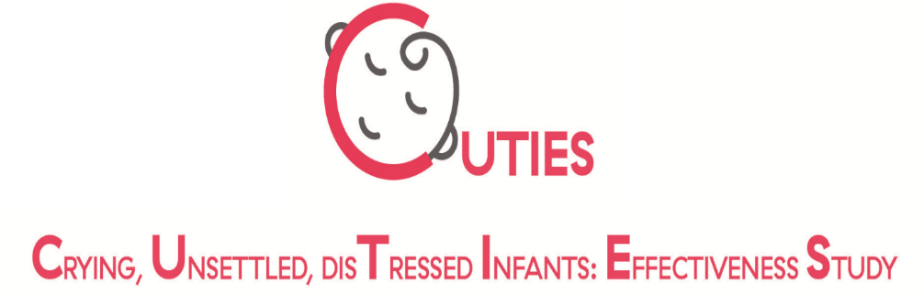

V1.2 30.10.19A IRAS:268925

Is your baby crying excessively?

(more than 3 hours of crying a day for 3 days or more in a week)

Is your baby less than 10 weeks old?

If you have answered YES to the above then please get in touch with the CUTIES team.



are investigating whether osteopathic care is effective in helping babies cry less. CUTIES researchers would like to test whether an osteopathic approach using gentle ‘hands-on’ techniques works.

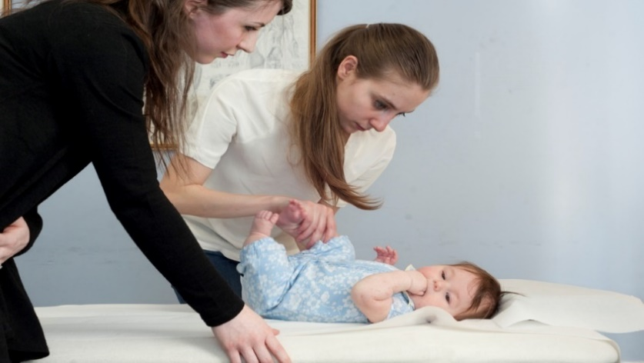

The results will help parents in the future decide what treatments are best for their babies.

Taking part would mean that your baby would have an initial consultation to check that they are eligible to be in the study and then they would be given one of two different approaches being studied (non-specific light touch or light osteopathic touch). Your baby would receive up to 4 treatments over a 2 week period with an experienced, registered and specifically trained osteopath.

All treatment will be free but we will ask you (the parent or guardian) to monitor the amount of time your baby cries, and to fill in a crying diary (5-10 minutes per day) for 14 days. You will also be asked to fill in 2 short questionnaires at the beginning and end of the study (each taking 5 minutes to complete).

**If you are interested in taking part please contact a member of the CUTIES team:**

Osteopath/Receptionist: XXX

Or sandra.grace@scu.edu.au