Constructive Aloneness
Make Solitude Work for You

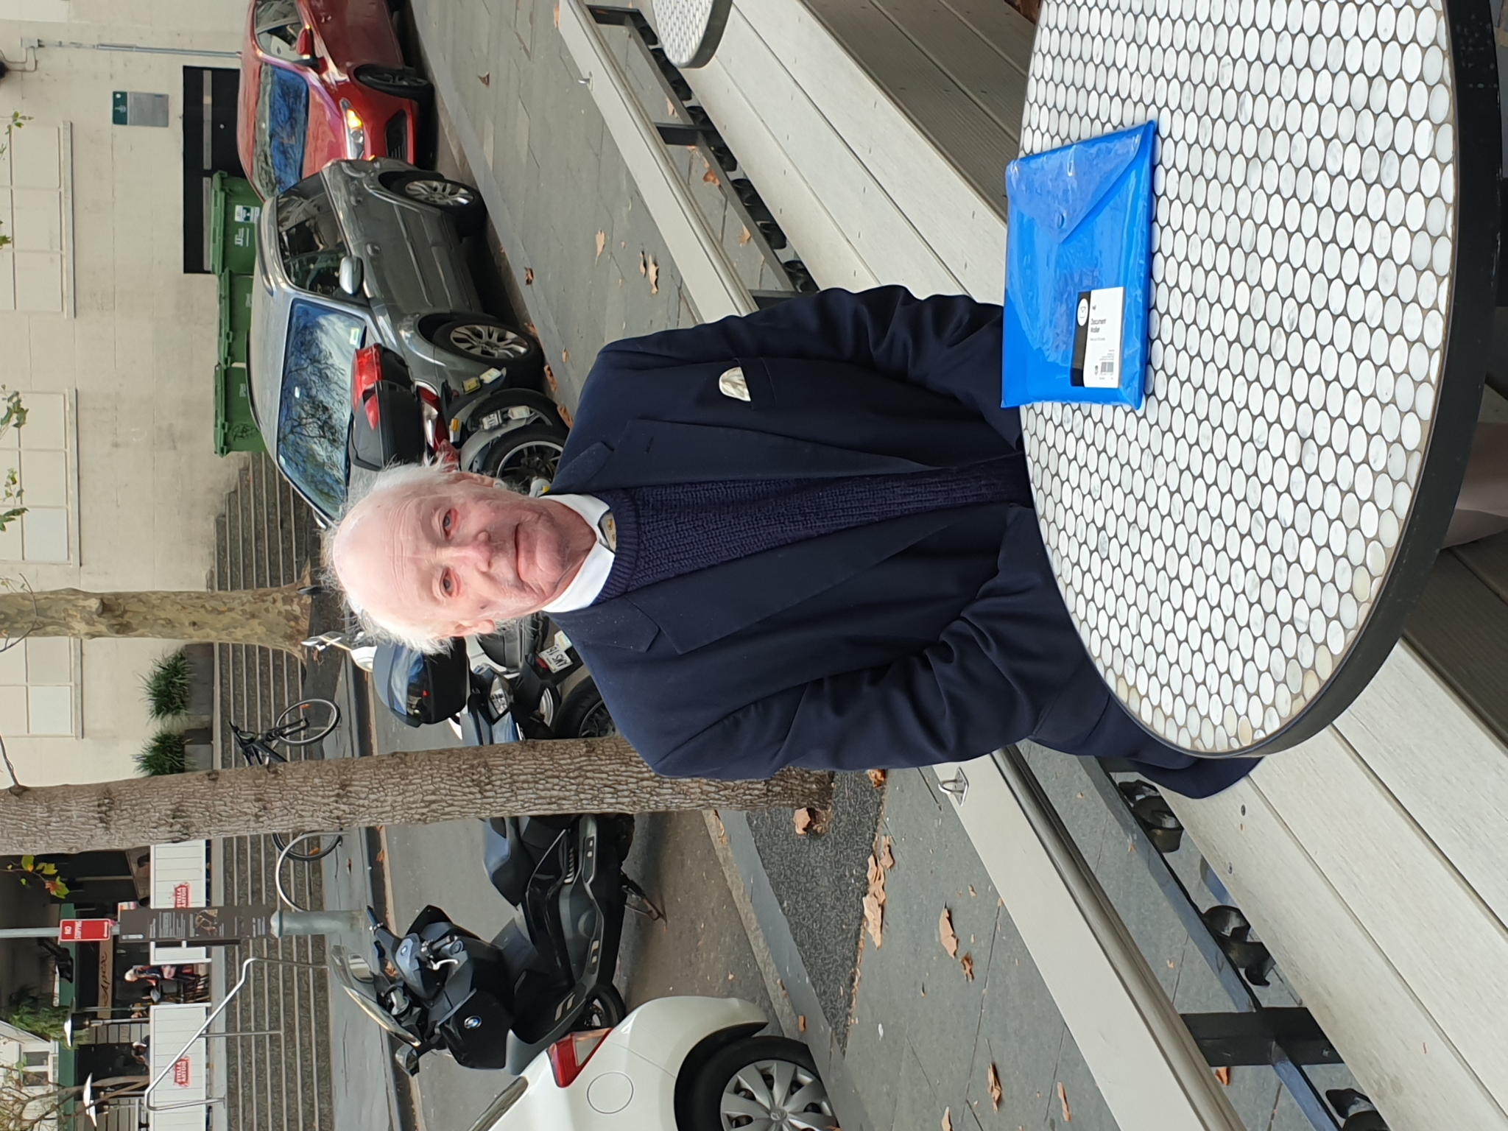

Maxwell Dodd
Constructive Aloneness
Make Solitude Work for You

Constructive Aloneness
Make Solitude Work for You

Maxwell Dodd

A GIFT OF ENCOURAGEMENT
Spooner Dodd Consulting Services
Post Office Box 462
EDGECLIFF NEW SOUTH WALES 2027

Telephone (+61) (0) 410 940 183

maxwelldodd2021@gmail.com

© M.J.R. Dodd, 2021
Introduction

Covid 19 has brought many of us into totally new demands of solitude and for some of us the experience is far from one of comfort.

This is a small work of guidance on coping with the problems of isolation put together in order to assist you to deal with the challenges of the new experience. That this new experience has been thrown at us unexpectedly has limited our preparedness for it and we find ourselves perhaps more burdened accordingly.

Read on. All that is set out here is intended to help you to come out of this time refreshed and enlarged. That you have been compelled to go into lockdown and be alone in a confined space for days on end with seemingly little comfort can be turned to very positive advantage. You will discover more of yourself and be able more and more to support those around you to deal with their own dilemmas of whatever shape.

The essential thrust of the guidance being offered is the immensity of all that you are and how complete is the being reading this small work of guidance. You are a very special statement of life in all its diversity, the man or woman of extraordinary gifts and capacities, many of which are awaiting discovery. Perhaps the moment of isolation is the moment of a major discovery and a much larger awakening.

My deepest good wishes go out to you as you launch into a new and exciting challenge of immense reward.

What follows is a guidance on meditation that others have found of benefit over many years. It is the perfect means of filling the otherwise empty hours and the benefits are not merely immediate but lifelong.

I am sure that an active response to all that is offered will bring substantial and perhaps unexpected blessings to the point where the enquirer will decide that far from disliking lockdown, he or she saw it as a great opportunity for personal development.

Maxwell Dodd
Edgecliff, New South Wales, 2027, Australia
Tuesday 29 June 2021

As we begin...

This is a simple guidebook to the richest of all experience. It is a source of support in the journey of meditation, the voyage of enormous inward self-discovery and the rewards to accompany that enquiry.

We are born with the most remarkable capacity to develop the potential that lies within us. We seem, however, to do so little to stretch those frontiers and our lives become statements of pain and frustration as a result. There is in all of us, whatever we have done with our time, so much more to discover and so much more to celebrate. The remarkable American poet, Walt Whitman, (1819-1892) wrote in Leaves of Grass (1855) “I celebrate myself” – what a wonderful choice of words to describe so abundant and satisfying an adventure. You are invited to share in that celebration and to find so much more of yourself.

What is recommended, whether or not you have ever tried it, is that you explore yourself by the ancient yogic practice of meditation. Those who discovered in the plain of the Ganges so long ago the virtues of deep self-searching did so with no religious thought; they were seeking the most complete knowledge of the underlying force of the Universe (they called it Brahman) and they found it within themselves – Atman. That Brahman and Atman (the Transcendent and the Immanent) were the same was a major discovery in the history of mankind’s search for himself and his identity. The route of that discovery was however totally natural and lay open to an enquiry that was given to all men and women and whose denial was costly to individual wellbeing. That pursuit was the journey of meditation, the long and gentle travelling within oneself to the greatness that is one’s own essence and richest capacity.

The journey of meditation is offered to you as something that can touch and heal as nothing else. The route is entirely personal and idiosyncratic. It will touch individual lives in ways that will reflect both its eclecticism and the extraordinary diversity of people and the measure of their potential. We shall each meditate and find expressions of it that differ so widely and yet so helpfully.

The first question of meditation will always be procedural: how do I meditate? The answer is indeed imprecise – the practice of meditation is as diverse as the experiences of more complete living to which it will guide us. The Buddha took as his starting point so long ago the question of pain and suffering and the turbulence of the activities of the mind which he saw to be their cause. We all know that our minds are possessed of qualities of almost uncontrollable tempestuousness – we are all aware how extraordinary and transient are the ideas and impressions that circulate with such fury in our heads. There is a veritable maelstrom in there. If you have any doubt of the truth of that last remark, simply sit and allow your mind free rein for a mere 60 seconds and look back on the many feelings and places to which the mind took you in those 60 seconds. The American phrase “bucking bronco” seems singularly relevant.

And yet that very restless activity and, dare I say it, “wildness,” is an indication of vigour and energy; we are alive. Our minds have enormous power and creativity deep within them, awaiting release for all the turbulence and the oscillations. Meditation is the journey, long and gentle, of taking charge of those mental, emotional and psychic energies and using them to our greater development and satisfaction. The Buddha witnessed all that was happening within himself and instead of seeing it neurotically, he saw opportunity and growth. His final “enlightenment” under the bodhi tree perhaps in May 528 B.C., (modern scholarship is suggesting a date closer to 360 B.C.) was a release and a startling empowerment. That he had attained Nirvana was not an escape: it was the discovery of so singular a natural experience of total living of such serenity and calm and, simultaneously, empowerment, that the only word to describe it was the word usually translated “nothingness.” To use such a term is to do a major disservice to his “enlightenment” as it suggests something negative. Its only negative quality is its lack of an equal and the impossibility of its exact repetition. There is a final, enormously positive and constructive - and, yet, ineffable - “something,” to be known to adepts, which allows us freedom from the pain and dislocation to which our minds and our limited sense of egoistic importance will lead us. The journey there is long and gentle and time-consuming but honestly and consistently undertaken, it will reward with a vividness of living second to none.

No-one can “teach” meditation. The practice itself and the wonders of living which it will suggest to us are so personal that the best that anyone can do is to make the broadest recommendations (and to do so with a certain reticence). Meditation requires inner solitude (even when undertaken in a meditation hall) together with silence and stillness. There must be a total lack of external stimulus – the playing of music, however “contemplative,” is an intrusion into the wonders of silence. One’s posture must be as relaxed as possible, with the meditator in a position of physical comfort and repose, with loose fitting but warm clothing or a blanket around a lightly protected body. Footwear is best forgotten. Whether the meditator is in one of the yogic positions such as the well-known “lotus” position or merely sitting in a chair or on the ground or the floor matters little. There are those who meditate while on their knees – the choice is theirs. You will find what is best for you – though you will find a straight back and deepening and slowing inhalations of considerable importance. The practitioners of Eastern medicine will tell you that this has to do with the energy flow along the spine. The breath will be observed to slow down (perhaps markedly): this reflects your meditation in your terms and in your way. You will find indeed that some individuals are more comfortable in the starting of meditation than others. I am reminded that the one for whom this work was originally drafted has always said that his ferociously quick and agile mind (and he has one – in large measure) makes meditation impossible. No, it only means that the early times are more of a revelation – and, perhaps, more of a revolution.

What follows are some points that may usefully be considered as the basis of meditation.

It is a cliché to observe that there is nothing new under the sun and that very often something of great value has been expressed so well that copying and perhaps editing are mandatory. I have taken and greatly abridged much that has been written by others of inward wholeness and of the outer blessings to accompany that wholeness – itself a “peak experience.” I do this without apology in the interest of the searcher - you.

What is offered is something of life-enhancing simplicity. It is especially profound for all that simplicity and its daily disciplined continuity will be rewarded for itself and in so many other ways. The practice is totally non-religious although it may enlarge any belief system you may already be following. Go forward with a new commitment and a quality of endurance worthy of the long distance athlete. What lies ahead is entirely safe and comfortable and you will find rich virtues of peace and tranquillity, with a new empowerment of mind and memory that will greatly surprise.

Go forward - you have all to discover.

The potential is yours

You have the potential to be fully awakened: you may not make it actual. Real suffering is to go on missing the opportunity to transform your potential into reality. If you lock your potential away (in an iron safe, so to speak) your potential will remain only that – your life will remain opportunity unfulfilled.

Your uniqueness

Remember how unique you are. Love yourself, respect yourself, respect your own voice, listen to it and follow it. Respect yourself – and love and respect others, too.

Your personal completeness

The moment you know your supreme self, you become an emperor. Self-knowledge makes you aware of your kingdom for the first time. The kingdom is not of the outside – it is the kingdom of the within, the inner. The true kingdom and the true treasure are to be found there. To know it is to possess it – its very knowledge is its possession. It has been forgotten. All is fulfilled the moment it is remembered – it has been there from the very beginning.

Meditation and fulfilment

Meditation is the state of what can be called “no mind.” It is neither at the centre nor at the circumference. It is simply not of the mind. It is watching the mind from the outside - as an observer, no more identified with the mind – without comment or response. With meditation, the mind disappears – and finally it is gone. You have come home – you have been fulfilled.

Meditation means a totally relaxed state – so relaxed that the mind melts. It is a state of thoughtless awareness. For all that, it is the greatest challenge: it is destroying your sleepiness and discovering your wakefulness. It is the arousing of the soul. Prayer means a heart full of love. Through meditation, create emptiness and through prayer create love to fill it – so that the emptiness becomes an overflowing love.

The first step is the silence of the mind when thoughts disappear. As you start meditating, you have to begin by watching the thoughts and by watching one day they disappear. Then begins the second step: the silence of the heart, watching the feelings. When for the first time you have attained both kinds of silence, the watcher disappears – this is the ultimate silence – it is what the Buddha called Nirvana and Jesus, “the kingdom of God.”

That is what meditation is: to see your body-mind complex without becoming identified with it. And soon a totally new phenomenon is experienced: the existence of the soul. That is my whole work here: to make you aware that you are an eternal being.

That awareness of the ultimate light is divine knowledge. And its discovery is perfectly natural.

Mindfulness of all that touches

Society imposes artificiality upon us – this artificiality has large imposing names – “civilisation,” “culture,” “education.” All is artificiality as all is a denial of our essential nature. The best I can do for you is to help you again to become natural – because the experience of wholeness, the experience of the Divine, is utterly natural. Religions have separated meditation and love - to our profound cost. The real need is the two experiences, together. The most alive being is the one who can deal with both without any contradiction. So much “conditioning” is done to us – by the world of business and commerce, society, the churches, even our parents and our families. We must question everything – not everything will be rejected but much more than you now would expect will be so treated. The pressures upon us to be well-behaved and obedient are substantial and we fail to question them at our cost.

We shall find a childlike innocence and so much more and be constantly surprised that what has become to us second nature is so unexpected to others.

The kingdom of the light within

A wise man is naturally kingly. He may materially be poor (like your guide indeed) but he still has rich personal authority. His kingdom is of the within. He has inexhaustible treasures. He has overcome his unconsciousness – that is true wisdom.

Wisdom is not knowledge: it is conquering the unconscious – it is full of light.

When that discovery is made, you are whole, however few your material possessions.

The fulfilled individual

Meditation takes you out of the psychology of the mob. First it makes you human and then it takes you towards the fulfilled complete functioning being. It is an act of rebellion – an act of independent discovery. It is a joy to grow up – it is a challenge and an opportunity.

But it is only individuals who grow – never a group or a team or a congregation.

Meditation – the road to freedom

Meditation is the inner revolution. It means learning to forget all that has been taught. It is a process of “deconditioning,” “dehypnosis,” or “unlearning.” You will on informed reflection of course accept much that you have been taught but then it is a cool clear independent judgment made with understanding.

Once you are empty, silent, clear, clean, the revolution has happened – your deepest self has come.

The here and now

Life is the only God. One has to live in it and do so passionately and intensely – not tepidly or half-heartedly. One must burn life’s torch from both ends simultaneously – live here-now – live this moment.

Vision and experience

God is not a belief but a vision. To believe in God is inessential. Beliefs are deceptions. The Universal, Truth, God, whatever may be its name or title, must be an experience.

You need no dogma, no rules, no theology – you must see on your own.

Wakefulness

The Universal has to be an experience: all that is offered is not to give you a doctrine or a rule, but to help you to wake up, to see on your own with eyes wide open and your whole being alert.

The importance of meditation lies in its assisting you to wake up and to discover what it is to be fully alive and fully aware. It is the tremendous awakening of the soul that is the destruction of your inner drowsiness and your somnambulism. It is the discovery of that exquisite quality of being utterly alive – to be young and open to growth at whatever age or in whatever situation you find yourself.

Freedom

Freedom is the most divine phenomenon. Nothing is higher. Freedom is the true God. Spiritual living (not “a religious life”) is freedom. Once you have discovered your freedom, your inner beauty is released. You know who you are - and your own highly personal journey of living.

Vastness

Celebrate yourself – celebrate your vastness. The self is part of the Divine, part of the Supreme Self. It does not make a being that is egotistical or insular or proud or haughty. You are at one with the Whole – you are of the Whole, and whole accordingly. Drop the ego and live courageously – “whole-heartedly.”

The ultimate union with the whole means that you have become whole – remain dedicated to your highest transformation. This is the discovery of your infinite self.

The Wisdom of Hermann Hesse’s Siddartha (1922)

There is in the essence of everything, something that we cannot call learning. There is only a knowledge: that knowledge has no worse enemy than the man of knowledge or learning.

Above all, he (the Ferryman) learnt how to listen – with a still heart, with a waiting open soul, without passion, without desire, without judgment, without opinions – to the voice of Life, the voice of Being, of perpetual Becoming.

He whose reflective spirit sinks into Atman, knows bliss inexpressible through words.

“A path lies before you which you are called to follow – ‘the gods await you.’” To which Siddhartha replied: “I am going on my way – not to seek another or better doctrine for I know there is none, but to leave all doctrines and teachers and to reach my goal alone, or die.”

Spooner Dodd Consulting Services is an international operation that is the outcome of the life experience of Maxwell Dodd. Though he is Australian, he sees the wider trans-Atlantic world to be a better place to offer its wisdom. The operation has two homes, so to speak, one in the grounds of the San Francisco Theological Seminary in San Anselmo, California, (north of the Golden Gate Bridge in Marin County, and under the towering strength of Mount Tamalpais) and the other in the world of a small German Rhine-side village, St. Goar, named for a French-born hermit who died in 575 A.D., and who, though never formally canonised, is apparently considered the patron saint (inter alia) of boatmen, inn owners, and brick-bakers.

Maxwell was born in the Hunter Valley of New South Wales in August 1942 in an Australian world of social and intellectual privilege and after a classical English education at one of Sydney's major schools, he had no trouble being admitted as a lawyer at 22 – he could not have been greener. He found after some years of ever-growing professional success and a hugely developing practice called M.A. Spooner & Dodd that he had wider gifts than those of the successful advocate that he was and that he was somewhat unexpectedly coming to be involved more and more in lifting the lives of those whose existence had avoided incarceration to some extent by his skills – and by their willingness to be open with him.

An odd valuable gift had to be explored and after many false dawns, he finally met in San Anselmo, his own great guide and encourager, the Revd. Dr. Warren Lee, who was in charge of doctoral programmes of the Seminary for those already ordained. His advice was that Maxwell's vocation (he most certainly had one) and the ministry to flow from it was a ministry of hope. He would wander like a Buddhist “bodhisattva” and bring to the needy, the unhappy and the pained, the message of human potential in all its dimensions and especially the spiritual, and the healing of mind and heart to accompany it. That advice has proved utterly prophetic. What you have just read is that message distilled in all its simplicity.

Maxwell’s motto is “upwards, forwards, onwards.”

