Fan Art, Fan Fic, and Fan Hate.

By Blake Rathie.

*(4th of July 2020, Instagram, @BRUNO_BEST_BOY_)*

Without any context this comic makes little sense, it is cute, that much can be observed, but those who are in the creator’s “in” crowd will find far meaning in it. The father’s reaction comes across as humorous because this very specific crowd understands how this character, the incredibly serious and badass Jotaro Kujo, has been subverted by revealing a much lighter and paternal side to him. While explaining a joke is the fastest way to ruin one, it is necessary to illustrate that this comic is not made for a wider audience.

Having amassed close to 30,000 Instagram followers in less than a year, 22-year-old Leonie Robertshaw, under the name “Bruno Best Boy,” creates fan-comics solely of the long running Japanese series JoJo’s Bizarre Adventure, which began in the 80s and is still going to this day. Fan art and fiction is a medium which to many is synonymous with poor quality, though this stigma and generalisation is fairly reductive of the artform.

After finishing a first-class Fine Art degree, Leonie began her Masters in Forensic Art at a Scotland university, but before she could complete it Leonie was forced to return home to the United Kingdom because of the pandemic; though the upside of this is that it has given her far more time for art.

Leonie’s account began with “OCs and doodles,” but after her boyfriend introduced her to JoJo’s, she fell in love with the style. “The character designs are just so creative and unusual, which makes them so fun to draw and colour.” Drawing and posting these characters ended up getting Leonie a lot more attention than any of her other art, which encouraged her to put more focus onto this series. Her art soon began including little stories in comic form, intended to fill in the gaps in the characters Leonie liked the most. These comics brought a life to these characters which made them more authentically human by presenting them in everyday ‘slice of life’ scenarios that would never have occurred in the series—sometimes Leonie may make a comic simply of the characters playing Pokémon.

*(25th of May 2020, Instagram, @BRUNO_BEST_BOY_)*

Though fanfic is so often such a negatively charged term, being used as a descriptor by critics to tear apart movies they don’t like (such as [*this*](https://medium.com/@mfqreviews/star-wars-the-rise-of-skywalker-is-bad-reddit-fanfiction-and-a-middle-finger-to-a-42-year-old-cf0c4f2d114) article from Medium, or [*this*](https://www.themarysue.com/lover-never-dies-bad-phantom-of-the-opera-sequel/) piece from The Mary Sue).

“It’s a shame that such a popular form of expression gets such a bad rap. For me, fan art is a way to be part of an online community and develop the art that makes me happy.”

This medium gives many an avenue to give back to media that they have strong connections with, it also gives artists a chance to reach audiences they otherwise wouldn’t have had, or lets fans add to a community they are passionate about, and for these things to be so callously dismissed is quite ignorant.

“As I once heard in the great void of the internet, ‘*Fanfiction: because the story’s not over until we say it is.*’ At the end of the day, all fiction is made up by someone, so what makes one person’s version of events better than another? To get inspiration and actually create something new from a source that you love and admire is not a bad thing I think.”

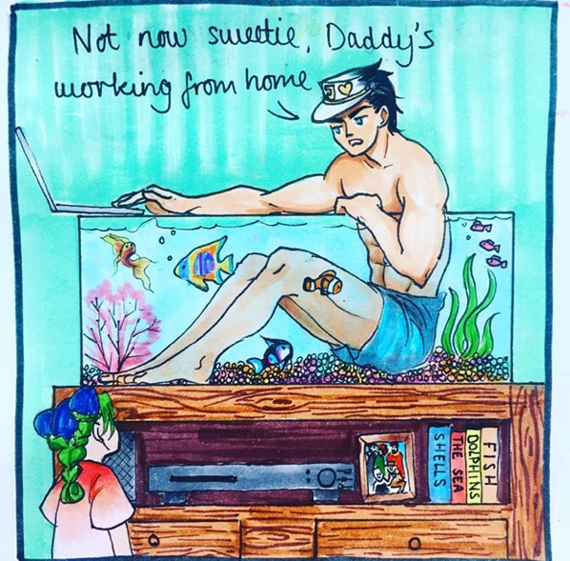

*(5th of April 2020, Instagram, @BRUNO_BEST_BOY_)*