Get Access to the New Kansas Sentencing App (KSApp) for JE submission

First, send an email request with your full name, title, county(ies), office phone number, and office email address to Jason Lamprecht and John Grube at the Kansas Sentencing Commission (Jason.Lamprecht@KS.gov, John.Grube@KS.gov).
Example:
To: | From:
Jason.Lamprecht@KS.gov | (Your name)
John.Grube@KS.gov | (Your office/County)
 | City
 | Phone number
 | Email

They will then add you as a Domo user. Domo is the digital platform on which the Kansas Sentencing App has been created and is accessible. Once you have been added to Domo, you will receive an email notification similar to this one…
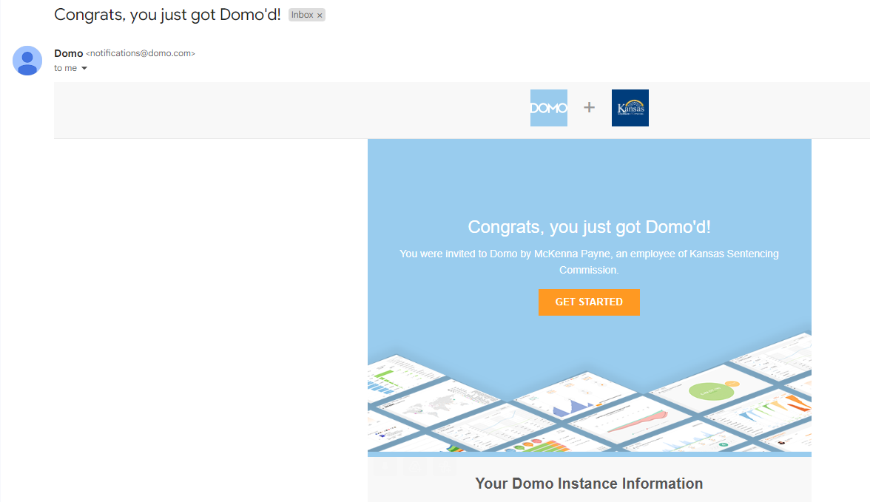
Click the orange Get Started button to set up a user account and profile in Domo, by following the Domo instructions.
If you think you did not receive the ‘Congrats, you just got Domo’d!’ email, check your spam/junk folder. We have reports from CSOs that notifications were landing in spam. If you still cannot find the email in your Inbox or in your spam/junk folder, contact Jason or John at the KSSC office for help.
Once you have a Domo profile created, take a snap shot of your profile screen and send it via email to Jason & John in the KSSC office to let them know you are a new Domo attorney, and that you need access to the Kansas Sentencing App. They will then ‘share the Kansas Sentencing App with you’ via email, where you can ‘view in Domo’ with the orange button.

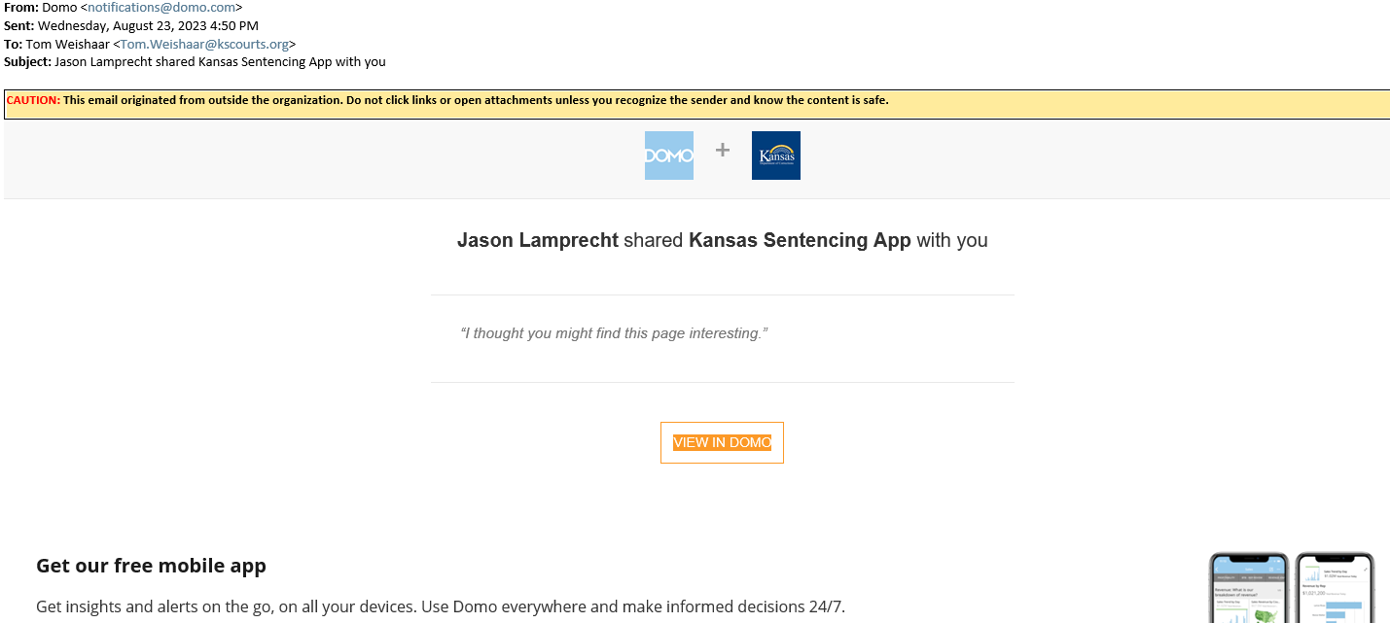

After you reach the Kansas Sentencing App introduction screen, you will notice the Kansas Sentencing App choice on the left side of your screen. You may have to click the menu button that looks like this…  You can now always choose that button to return to the Introduction screen of the App.

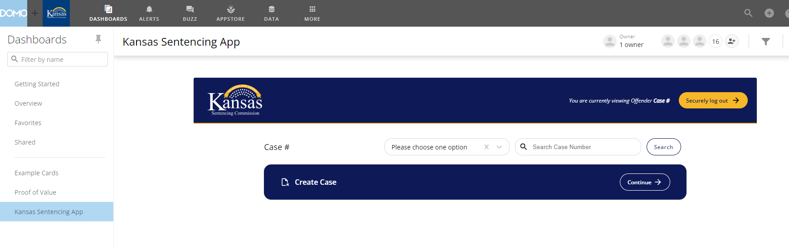

You are now ready to go with the Kansas Sentencing App (KSApp)!

