District 5M-2 Cabinet Meeting Minutes

**May 15, 2022**

**Revival on Main, Montgomery, MN**

**Call to Order**: DG Glenn Kaufmann called the meeting to order at 5:20 p.m.

**Pledge of Allegiance:** Led by DGE Kathleen Bleckeberg

**Invocation:** 1st VDGE Christy Trutnau gave the invocation.

**Establish Protocol:** DG Kaufmann established Protocol.

**Roll Call:** Taken by Lion Cindy Walters, showing 26 in attendance, 21 absent, 3 guests.

**Introduction of Guests:** DG Glenn Kaufman recognized two of the three guests: Lion Evelyn Grimm and Lion Darlene Breamer…missed Lion Lisa Kaufmann. Oops that would be a fine.

**Adoption of the Agenda:** One change under old business adding MD5M Convention Report.Motion to approve agenda with addition 1st VDGE Christy Trutnau; seconded by PDG Joan Blank; **MC**.

**Secretary’s Report**: Motion to approve the Cabinet Meeting minutes of February 11, 2022 with the correction of spelling PDG Anna Wickenhauser’s name correctly. Motion to approve meeting made by Lion Rose Thies; seconded by Lion Hilary Wickenhauser; **MC.**

**Treasurer’s Report:** Lion Sue Vos sent her report. Motion to accept the Treasurer’s Report by PDG Marvin Grimm, seconded by 2nd VDG Gerald Ziskovsky; **MC**. Copy is attached at the end of this report.

**Council of Governor’s Report:** DG Glenn Kaufmann – The multiple district has a zoom account now and DG Glenn will get info on how to use it from PDG Steve Wasserman.

* Letter from IP Douglas Alexander for LCI Due Increase Proposal – July 1 2023 - $3; 2024 - $2; 2025 - $2 will be voted on at the International Convention. Technology upgrades is the biggest driver for this increase.

**Communications:** None.

**Old Business:**

**1IVP Brian’s Board Meeting Gift Request:** DGE Kathleen Bleckeberg – PID Debra Wasserman and DGE Kathleen Bleckeberg have been working on this. This will not happen with the Faribault Woolen Mills as PID Debra was hoping. DGE Kathleen is looking into Waconia Chocolate and a company in Albert Lea. Looking for a motion for $750 dollars to build a budget for this year. It is for the October Board meeting and we need 150 items; $3-$5/per item. PDG Joan Blank made a motion to put in the 2022-23 budget $750 for these items; seconded by Lion Pam Koehnen. MC.

**MD5M Multiple Convention**: IPDG Anna Wickenhauser – We had 308 attendees: Friday-250; Saturday Brkfst-240; Sat Lunch-290; Banquet-245; Brunch-228.

A good time was had by all. We are still waiting for all the bills to come in. Our Convention pins are still being held hostage in airport storage in China.

Congratulations to PDG Marv Grimm for being Awarded the Hall of Fame and to PID Debra Wasserman on being awarded the Al Jensen Award.

We had excellent seminars, fantastic entertainment and an unbelievable Speaker on Sunday.

I also want to give a shout out to Ruth Klossner-she did an excellent job of capturing the weekend. The pictures have been shared to our District Facebook. I have recently gotten the video, but I have not uploaded it to Facebook/You Tube because it will take about 9 hours to upload the 4ish hours of video.

This was a Huge undertaking in a short amount of planning-I want to acknowledge the IPDG’s and DG Glenn and DG Sue Winner from 5M10, 1VDGE Christy Trutnau, Executive Secretary Cindy Walters, Sue Vos, Don and Hilary Wickenhauser and a special shoutout to Alden’s Ebenezer Howe. He was a permanent fixture at the registration table.

Thanks to 5M2 for having the most members at the convention-You are Fantastic!

**New Business:**

**Mid-Winter Convention Conversation:** Lion Lisa Kaufmann discussed the changes they had made this year in the convention plans. Newsletter in March has a complete write up of the convention. Lion Lisa Kaufmann suggested creating a rainy day fund with the money that PDG Anna Wickenhauser made a motion motion to create a rainy day fund for the Mid-Winter Convention; DGE Kathleen Bleckeberg seconded. PCC Brian Thies asked where that money would be located in the budget. It would be a separate line item in the money fund account. A lot of money was saved this year due to grants with the convention center, etc. This may not be the case in the future. MC.

Lion Lisa Kaufmann then talked about updating the Policy Manual and what the changes she is recommending. First how should 5M2 be indicated? 5M2 or 5M-2. It says that the policy manual is supposed to be printed. She would change it to delivered electronically. There are many other housekeeping items that need updating in relation to the Convention. Make sure the Parade of Green list is accurate. Suggestion that the 1st and 2nd VDGs sit on the committee as well to allow more consistency moving forward. Take out the Lioness section is housekeeping. PCC Brian said that anyone on the cabinet can bring this forward to a future meeting. Lion Lisa Kaufmann will work on this and bring it forward to the next meeting.

**Zone Reports:** DGE Kathleen Bleckeberg

**Zone 1: Lion Emmy Koch –**Spring Zone meeting was held on 4-20-22 hosted by the Plato Lions Club. We had 36 members attend. 6 out of the 9 clubs were there and a couple people from the different Lions Foundations. Thank you, Plato Lion members for everything you did to make the meeting a success.

**Zone 2: Lion Dave Lura –** No report.

**Zone 3: Lion Rose Thies** – Current membership stands at 251 members, which is up 4 from the previous year.

Our spring zone meeting was held on Tuesday, May 3rd in Winthrop, Minnesota with 41 Lions present representing 7 of the 8 clubs in our zone. Each club present gave a brief summary of what they were most proud of this past year. After a delicious meal was served and cabinet chairs gave their updates, we combined a service activity with a brief lesson on different types of members and their roles in a club project.

Each person was asked to bring 5 food shelf items. If they didn’t have any items they were able to purchase items with a donation to CCE Glenn’s favorite charity. After we split into teams, they were told to be creative. That was the only instruction. Each team had to work through what they were going to do and how they were going to accomplish it. You had members that took leadership roles, members who had good ideas but never got to use them, and then you had those that were followers once they knew the plan.

The end result was that we had fun learning and the Sibley County Food Shelf was gifted with 166 pounds of food and the St. Peter Food Shelf received 88 pounds.

I would like to thank CCE Glenn and IPDG Anna for the opportunity to serve the Lions of Zone 3 as their zone chair. It has been a learning experience with the first year being zoom meetings and COVID playing a role during my term. It has challenged not only me but all Lions to think outside of the box and roll with the punches.

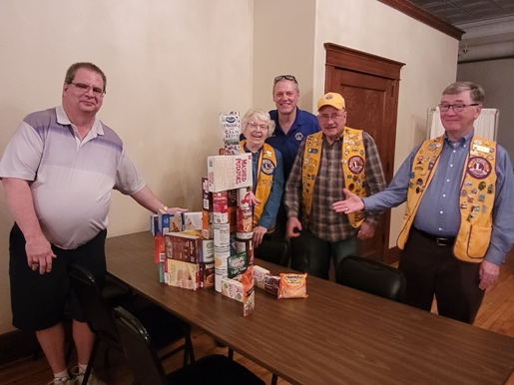 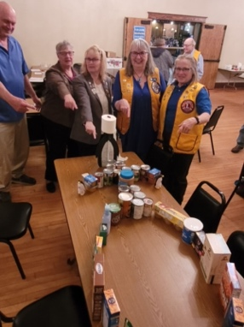 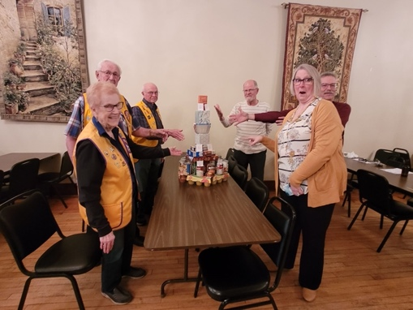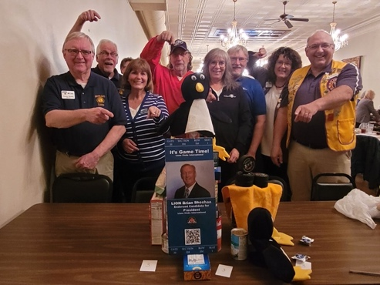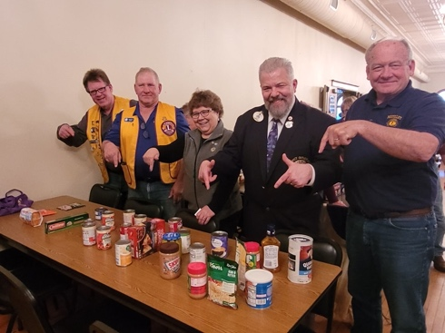

**Zone 4: Lion Todd Schansberg** –Zone 4 has 8 clubs with 382 members as of 4/30/22; up 17 members from the start of the year (38 added and 21 dropped) and five since the last meeting.

* Belle Plaine: 19 members, no change
* Carver: 59 members, +9
* Chaska: 44 members, +5
* Hamburg: 33 members, +4
* Jordan: 42 members, +2
* Jordaness: 46 members, no change
* Shakopee: 114 members, -5
* Shakopee Valley: 25 members, +2

Visited with five other clubs in my Zone so far this year, plus my own. Have visits scheduled with the Hamburg Lions on June 20 and the Shakopee Valley Lions on June 22. Clubs are active with their fund raisers, donations, and service projects.

Attended both the mid-Winter Convention in February and the recently completed MD5M Convention.

Held the Spring Zone 4 Meeting on Monday, March 28. Seven of the eight clubs had members at the meeting plus a good number of trustees from the various foundations. Sent a summary of the Zone meeting to the cabinet and the presidents and secretaries of each club.

**Zone 5: Lion Denise Wondra** – Zone 5 currently has lost 18 members and gained 18. Making us break even for the year thus far.

Clubs are busy with fundraising such as meat raffles, bingo and breakfasts, which are coming to end for the summer months. They are also busy collecting eyeglasses, cell phones and hearing aids. They also collected food for food drives and food shelfs. Clubs did Easter bunny drive-up and visits. A few clubs are doing the Trex benches for the community. Also, many clubs have been handing out scholarships and also handing out trees for arbor day.

I have gone to a few clubs for visits. We also had our spring zone meeting with an attendance from every club.

**Zone 6: Lion Bill VanderSluis** – No report.

**Zone 7: Lion Don Novack** – No report.

**Zone 8: Lion Shermayne Cross** – Clubs have been busy during the winter months. Many Pancake breakfasts have seen large participation. Other activities include: scholarships to high schools or community colleges, Foster parent participation, Radio Days, Burger Nights with American Legion, 5th Monday Membership Night, Pie Sale, and Blood Drive to name a few. Future endeavors include: Ice Cream Socials, Fishing Contest, Car Shows, Concert in the Park, and Volunteering at local fairs. She has visited 7 of the 8 clubs and total membership for Zone 8 is 233 with a net growth of 6.

**Cabinet Reports**: 1st VDGE Christy Trutnau facilitated.

**Can Do Canines:** Lion Rick Wagner – He has 2 programs scheduled with Chaska and Henderson this month. Can Do has trained it's 800th team. We reached a 95% club participation for the Parade of Green. Can Do Canines has an open house on the 21st. All are invited.

Lion Ruth Ann Marsh – Zones 5-8; Attended meetings in zones 5, 6 and 8 and presented to clubs in Montgomery and Faribault.

**Constitution & By-Laws:** IPCC Brian Thies – No report at this time.

**District Activities:** PDG Eunice Rucks thanked CCE Glenn Kaufmann for allowing her to again do the Service of Remembrance this past year. It is always an honor and privilege to do this service for our departed Lions.

She continues to encourage club members to forward to her at [king70@frontiernet.net](mailto:king70@frontiernet.net) any departed Lions information for the 2023 Service of Remembrance.

**Environmental:** Lion Pam Koenen – The avian influenza outbreak is affecting domestic and wild birds. The U of M Raptor Center is estimating that 43% of the bald eagles being admitted are testing positive. Song birds are being affected at a higher rate than usual. Many area DNR offices are strongly encouraging people to not feed birds, including humming birds until after May 31 to reduce the spread.

**GLT:** IPDG Anna Wickenhauser – DG Glenn just put on a Lions 101. It was an excellent presentation, and it has been emailed out to all of you to use it as you see fit.

This week is our Officer Training on Tuesday night in Waseca and Thursday night in Cologne. We are trying something outside of the box and hopefully the club officers that are attending think it was worthy of their time. RSVP’S are still being taken…

We had 5 members attend the Faculty Development Institute this past March -3 of which will be doing the training for the Upcoming Officer Training. Lisa Kaufman will be doing Club President. DGE Kathleen Bleckeberg will be doing Club Secretary and 1VDGE Christy Trutnau will be doing the Club Treasurer. 2VDGE Gerald will be attending both Trainings to help better prepare himself for his upcoming DG role.

Also, we have another opportunity for Training. Regional Lions Leadership Institute is coming back October 13-16, 2022 at the Hilton Doubletree Hotel Roseville MN. The forms are in the Newsletter, on our District Website and on our District Facebook page.

I would also like to thank DG Glenn for asking me to serve on his cabinet this past Lions year. I will be passing the GLT role onto DG Glenn and transitioning to a new opportunity as LCIF Chair. I have rather large shoes to fill and will do well with PID Debra’s mentoring.

**GMT:** IPCC Brian Thies, 2nd VDG Kathleen Bleckeberg – Our membership is currently up 81 due in a large part to the Waconia Dandy Lions. Please check out their social media accounts such as Facebook and Instagram to see how they effectively use it for recruiting and publicizing their activities. We are doing a good job of retention and recruitment with 80% of clubs having positive membership growth. Let’s keep up the good work and finish strong for CCE Glenn.

**GST:** Lion Dar Mondor and PDG Mary Spille – As the calendar year comes to an end, we notice that many clubs are back into a swing of activities similar to pre-COVID days.

Our personal activity has focused on the promoting to the Diabetes Kits Project based on a model presented at a GST seminar in St. Cloud in spring, 2019. Attended by Lion Dar. The project is now implemented in the Norwood Young America school district with the assistance of the district nursing staff. We have presented the project in the district newsletter. We were honored to be asked by DG Glenn to present at Midwinter Convention. We also provided a display at Midwinter.

These contacts generated much interest. Since that time we presented the same to the spring quarterly meeting of the MN Lions Diabetes Foundation in St. Cloud. Well received and were given the idea to expand the same to area Fire Departments. We have been told that a similar project will be used as an activity at IPE Brian Sheehan’s first conference in Minneapolis this fall.

We have also shared information with the clubs of Prior Lake, Henderson, and Waconia. We are still scheduled to visit Brownton and Lake Crystal. Unfortunately missed the Victoria request. Proud to state that the Henderson club has already cleared the project with the LeSueur-Henderson district and will be beginning there in the fall. Via help of Lion Loretta Klenke, contact has also been accepted by some Prior Lake parochial centers.

On another avenue, along with GST Multiple Leader Lion Gary Stevens, we visited Feed My Starving Children’s Development Advisor in Chanhassen. Ground work was laid for a district wide event for all three FMSC centers in fall, 2022. Hoping new GST leader will follow through on this – perfect service plus great marketing of Lionism.

We do participate in the NAMI Zoom meetings held every third Wednesday. Meetings are recently led by PDG Joan Blank and include zone chairs.

It has been an honor to serve 5M2 over the past years.

**Global Membership Approach Champion (NAMI):** PDG Joan Blank –The GMA Team has continued to meet by Zoom monthly. A report from GLT, GMT and GST respectively have been sent individually.

In review of this past Lion’s year, the feedback I have received from those who attended the monthly Zoom meetings is that the Zone chairs find the meetings helpful and a source of guidance and resources. It is a great platform to share ideas and ask questions. I have greatly appreciated the Zone chairs that have tried to attend and participate in most of the meetings.

The District Governor Team has been a great resource not only for the Zone chairs, but also to me as the GMA Champion. I would like to thank DG Glenn for allowing me to fulfill this position and to do my best to make the district function effectively. I believe it has been a very good year for district 5M2 and the Lion members!

**Historian:** PDG Sue Bowman – Clubs are encouraged to go to 5M2Lions.org to check for any missing information regarded sponsoring clubs and charter dates. PDG Marvin Grimm is the 2021-2022 Hall of Fame recipient.

**Journey for Service:** PDG Mike Vos – The 2022 Journey for Service was carried out on May 4, 5, and 6th.

District Governor Glenn and team, Lion Lisa, Lion Sue and PDG Mike, traveled 760 miles throughout 5M2 meeting with representatives from 65 Lion clubs and three Leo clubs collecting donations for approved district projects. Total money collected was $13,335 less Expenses $284.00 for a net of $13,051.

Special thanks to Lion Sue Vos for handling the money and providing the report.

**LCIF:** PID Debra Wasserman – Campaign 100 will officially end during the upcoming International Convention in Montreal. Lions are on track to meet our $300 million goal set when the campaign began. We in 5M2 have done our part. Clubs and individuals have donated over $237,407, over the course of the campaign. During this Lions year 5M2 is credited with $57,766.50. There is still over a month to send a donation to be credited in this Lions year so this amount will definitely go up. All but one club has made a donation to LCIF this year. I have contacted the club and hope to see a donation to be credited to them. I believe 5M2 can again be a 100% District. Congratulations to the Prior Lake Lions. They have been recognized as a Campaign 100 Model club. They have or are submitting paperwork to attain an additional Model club level.

A highlight of 2021-2022: Beginning at the Midwinter Convention, 3 MJF square boards were filled resulting in $3,000 being raised for the newly established Refugee and Displaced Persons Fund. 3 Lions will have the opportunity to receive or name a Melvin Jones Fellow out of this fundraising opportunity. Thank you to everyone who donated for a square or squares.

I also want to express my appreciation to the clubs that invited me to give LCIF presentations at meetings. The pandemic certainly impacted that option, but we did what we could given the circumstances we all had to deal with. And yes, I always visited the DQ after a presentation.

**Leader Dogs for the Blind:** Co-Chairs Lions Loretta Klenke and Emmy Koch – Thanks to all the clubs who donated for Parade of Green. Clubs who qualified for an award were notified. Leader Dog no long keeps a tally of donations for clubs for year to year. Only the current year donations qualify for an award.

1st VDG are scheduled to visit Leader Dog for the Blind this August. So far, Leader Dog remains open unless Covid returns in a resurgence.

Leader Dog placed its 20,000 dog in December 2021. The dog, a Labrador Retriever is assisting a young man on his journey.

**LEO Clubs:** Lion Hilary Wickenhauser – The Watertown Leos participated in the Polar Plunge for Special Olympics this past March with 3 Leos who took the plunge in Buffalo. They recently made and donated tie blankets to Crossroads Animal Shelter and Cat Tales Rescue. They will also be participating in the D-Feet Hearing loss walk and will be volunteering for that as well.

The Colone Leos have also been busy this spring. In January they brought fleece blankets to the Ridgeview medical center to donate to patients undergoing chemotherapy and radiation. They drop off around 20 blankets each month for this project. The Leos also supported students at the Cologne Academy elementary school, and donated Valentine’s cards and treats for 10 students that would otherwise have had nothing to hand out. Around Valentine's Day the Leos also donated treat bags to the food shelf and made a monetary donation as well to support people in the community facing food scarcity and need. In April the Leos partnered with the Cologne Fire Department, as well as the Old National Bank and Cologne Lions to host the second annual “Bunny Trail” event at the Lions Park on the Saturday before easter. The event had games, easter eggs, cookies and juice boxes, and the Fire Department gave fire truck rides to the kiddos. Leo Rebecca was the star of the event, dressed in an easter bunny costume, she posed for photos with the children at the end of the Bunny Trail. Upcoming, the Cologne Leos will be running the bounce house on May 18th when Fox 9 brings their town ball tour to Cologne. They will also be volunteering at the D-Feet Hearing Loss walk in June, alongside the Watertown Leos.

No updates or information available on the Sibley East or Northfield Leos. If you have a viable contact with either of these Leo clubs, please reach out to me with that information so I can make contact with them.

**Liberty Day:** Lion Denny Hewitt and Lion Dave Sebesta – no report.

**Lions Quest:** Lions Janet Knakmuhs and Janet Hall – No report.

**Long Range Planning:** PDG Harry Klenke – Long range planning is important especially since we are coming out of the pandemic. Maybe during these trying times we have come up with some great new ideas. But don’t forget the many good things we have done in the past.

**Mid-Winter Convention:** Lion Don Novack and Lion Troy Wetzel – Lion Lisa Kaufman put the following information into the March Newsletter as the Final Convention Report.

**MN Lions Childhood Cancer Foundation, Inc.:** Lion Gerald Ziskovsky and Lion Chuck Toltzman – At the Mid-Winter Convention we both attended the cabinet meeting, convention, and had a table at the convention. We both were at the 5M Multiple convention and worked a shift at our Foundation’s table. Lion Chuck attended the Spring Zone 1, 3, and 6 meetings and Lion Gerald attended the Zone 2, 4, 5, and 8 meetings. Lion Gerald attended the Foundation meeting in St, Cloud and Lion Chuck has been on a couple of the Zoom budget meetings for the foundation, Lion Chuck delivered 2 – $500 matching grant checks to families with a child with cancer, very hard to do, especially when one of the recipients has lost his battle to this terrible disease. The foundation recently approved another $500 matching grant to a family in the multiple, that makes 6 total matching grants. Lion Gerald was able to give a presentation at the Jordan Lions Club Meeting recently, and the foundation just sent a $100,000 donation to the M Health Fairview Masonic Children's Hospital. The Hospital sent notification that the MN Lions Childhood Cancer Foundation name will be added to the digital roster board located in the lobby.

**MN Lions Diabetes Foundation:** Lion Brian Rykhus and Lion Bobby Paulson – Trustees Rykhus and Paulson participated in District Governor Elect training on Wednesday, March 2. This was a great opportunity for the Foundation to inform our incoming District Governors of the fundraising MLDF does and the research projects MLDF supports. We are grateful for this opportunity to provide some in-depth information about our Foundation.

The Foundation held its Board meeting on March 19 at the Rivers Edge Conference Center in St. Cloud. Lions Rykhus and Paulson were in attendance. Foundation Officers were elected. Lion Brian Rykhus was elected to serve as Chairperson of the Foundation for the 2022-2023 year. This will be his sixth and final year as a 5M2 Trustee.

The Foundation also held their annual Research Update, for which there were nearly 50 attendees. This was the first live Update since 2019. Scientists from each of the core four research projects provided status reports of their research. The Foundation presented each of these four research projects a Dream Catcher Award.

MLDF recently completed its STRIDES event, the Foundation’s major 2022 fundraiser. A goal was set to raise $22,000. Nearly $30,000 was raised. 5M2 had two Club sponsors participate in the event. Three individual Lions contributed. The Down With Diabetes Alliance also contributed to the STRIDES fundraiser. Many thanks to all who participated.

MLDF hopes to continue participation in events such as Cub Foods Diabetes Awareness Days and Special Olympics. MLDF is participating in the State Fair booth with the Vision and Hearing foundations. Friday, August 26 is 5M2 day to man the booth. SignUp Genius is all set up so please grab your spot as soon as possible. You do not have to sign up for that day – you can fill in wherever it is convenient for you. Last year we had numerous empty time slots throughout the Fair due to covid. The Fair Board was very lenient about that last year. This may not be the case for 2022. Let’s do our best to fill every slot and have the booth manned for the entire Fair.

Next Trustee meeting is scheduled for Saturday, July 16 in Roseville. New Trustee orientation and training will be provided immediately prior to the Board meeting. The Foundation is working with UMN in hopes of having a site tour of at least one of the diabetes research laboratories on Friday, July 15. The evening of July 15 we are again planning a joint banquet with the Hearing and Vision Foundations, at which each foundation will have one of their research scientists present recent results of their work.

**MN Lions Hearing Foundation:** Lion Vern Breamer and PDG Marvin Grimm – The D-Feet Hearing Loss Walk is planned for June 4, 2022 at the Minnesota Landscape Arboretum in Chanhassen, MN. Plans are also being made for a second walk on the same day to be held at the Diamond Point Park in Bemidji, MN. We hope this gives more people the opportunity to participate in the Walk without having to travel so far. If you or your club cannot participate at either site, you can take a walk at your park, jump on a treadmill, or ride your bike. Send your donations to PDG Mike Vos, Treasurer, Minnesota Lions Hearing Foundation, 20472 371st Avenue, Green Isle, MN 55338-2171. Mark your check D-Feet Walk.

The 5M2 Foundation Trustees, Marvin and Evelyn Grimm, Vern & Darlene Breamer along with the Foundation Treasurers Mike and Sue Vos and some of the trustees from the other districts in MD5M toured the Starkey hearing aid production facility in Eden Prairie. We got to see how hearing aid orders come into the facility and are processed through the manufacturing process and new sets of hearing aids are sent out in 4 days or less. We also got to see the room where they refurbish and repair the hearing aids collected by the Lions and other sources. They refurbish or repair what they can. Any hearing aids they can’t fix and/or repair is used for parts to fix others. Mr. Austin takes these used hearing aids on mission trips to other countries and gives them to people who need them.

You still have time to call Lion Marvin Grimm or Lion Vern Breamer for a club visit. We have gone to visit some clubs and also the Zone meetings. The Minnesota Hearing Foundation will have a booth in the Education Building at the Minnesota State Fair. We will share the booth with the Vision Foundation and the Hearing Foundation.

Thank you to all the clubs and members that support the 5M2 Foundations.

**MD5M Lions KidSight Foundation:** PDG Harry Klenke and Lion Margie Jacobson - Lions need to contact the places they did before the pandemic and see if they are willing to have us do screenings again. Some places have forgotten that we are willing to come and do the screenings. Community events are a good place to do a screening if you can get a good place to do them. If you need help getting back doing them, you can contact Lion Margie Jacobson or Lion Harry Klenke. Lion Margie can be reached at [lionmargie11@gmail.com](mailto:lionmargie11@gmail.com) or 507-649-1034. Lion Harry at [lm.klenke@outlook.com](mailto:lm.klenke@outlook.com) or 952-445-0289 or cell phone 952-913-8134. Lion Margie has a camera for southern areas and PDG Harry has cameras for northern areas.

**STATE FAIR KIDSIGHT VOLUNTEERS NEEDED.**

We do need volunteers to be successful. Please consider assisting in this Lion’s Project. We are in the Health Care Building at the Minnesota State Fair. You will receive FREE State Fair entrance tickets for volunteering, State Fair Tickets entrance tickets are going up in price this year! Please use the website below to sign up. We need 2 screeners, 2 greeters and 2 escorts for each 2-hour shifts. YOU DO NOT NEED TO KNOW HOW TO OPERATE KIDSIGHT CAMERAS. 5M2 day is Thursday Sept. 1st. If you are having trouble signing up to volunteer on the sight below, PLEASE contact PDG Harry Klenke. Thank You.

https://www.signupgenius.com/go/5080D45ADAC2FA7F58-state2

The KidSight Foundation has voted to purchase a tent that works for doing KidSight screenings at outdoor settings. This will help with Lions Clubs who want to offer screenings at Community Events. When we will receive them is still unknown, hopefully early summer. We will only have one tent in our district so you can contact a Director to reserve the tent.

**MN Lions Vision Foundation:** Lion Wendy Goldsmith and 2nd VDG Christy Trutnau –

**MLVF Financial Report by Lion Mary McNellis**: Recent Financial reports show assets are up, profits look good on LGS P and L and donations are improving.  Our audit for FY 2020-2021 show good internal controls and good review with our new Accounting firm.  We discussed discontinuation of directed donations.  They suggested we stop with designations.  Starting in March 2022 we are not doing designated donations and we need to communicate to Cabinet’s in our Districts, our clubs, and our District Governor. Our mission is to support all of LGS and all clinics.   We discussed and approved the FY Budget for 2022-2023.  We are almost caught up with our pledge to Surgery Center and our total pledge was $4000000.  Our budget does show a slight decrease in investments secondary to market but overall has performed well over long haul.

**Dr. Erik van Kuijk, U of M department of OVNS,Chair**: He reported that we have a grant from NIH for electrophysiology of the retina and brain. We have sent five grants and four have been accepted and typically it is 1 in 5 and we are 4 and 5.  He has been spending a day a week in the Senate office building with Phil Griffith and the Chair has been reluctant to hear the bill and it may be stalled for another year.

**Dr. Hou, Medical Director at LGS:** He was not present but got terrific new in between board meetings that he received the career Development Award that will free up 50% of his time.

**LGS Executive Director, Sean Poppoff**: He reported that the Eye Bank revenue is up. He also reported that Life Source has an interim CEO that says they will maintain the course of the corp. and they had three people from Life Source visit the Eye Bank for a tour. They are looking for a better relationship with us. He had a visit with Bemidji club and talked with the club about Legislative effort. We lost the Bemidji Hospital previously, so they met with senior leaders and there is an opportunity to return to that hospital for donations.

**LGS Jennifer Marshall Communications Manager**: She reported that Governor Elect Training had a tour of LGS and saw it from the other side. In the report she stated EBAA ranking 8th of transplants and 3rd in research distribution of tissue.  She has completed the virtual tour of LGS for all of us to use on our club visits.  She let us know that April is National Donate Month and we raised awareness about donation and raised a flag at LGS.

**Community Relations and Legislative** **Liaison Lion Lyle Goff:** Two bills are in committee, and we need to get more on our site to do send to legislatures. Message that we are sending out needs to get out in a better way to Lion’s members, ie club visits, Facebook, newsletters, etc so we can get to more legislatures. Why are we doing this?  not because it is an antibusiness, antitrust but we are not doing this because we this as an ethics issue. Bills are probably going to die in committee. It is our 4th year, and most bills take over 5 years to pass.

**MVLF Fundraising** **Consultant Dave Moen**: LCIF Grant is being worked on and hopes to have more information at our next board meeting.

**MVLF Legal Consultant Jeff Fenske**: Unable to report on this portion of the meeting due to loss of connection.  I will update on this portion of report after I receive minutes of meeting from Secretary.

**Helen Keller** **Awards Nancy Mathwig and Jack Krage**: Unable to report on this portion of the meeting due to loss of connection. I will update on this portion of report after I receive minutes of meeting from Secretary.

**Misc. Items:**

-Brian Sheehan Board Meeting for Spouses will be a Luncheon/LGS Tour/ Project

-MLVF will donate a basket for silent Auction Campaign up to $350

-Gift Bags for international guest will be donating a lens cloth and need 200

-We have a train car that was already approved previously

-We will also be doing a page in the Program book and approved up to $1000

-Board Dinner on the evening of 10/3/2022 and all the directors are invited but will have to wait on the spouses to see what space is available

**Committee meetings of four divisions-**

**Finance:** Estates and wills deferred to Legal.  Directive donations deferred to PR and Legal.  Suggested that we add $25000 to budget for Lobbyist for legislative effort.  The proceeds of the Eye Bank Vehicle that will be sold will be retained for LGS purchases.

**Legal:** Donor Acknowledgement letter voted and put in policy manual and discussed how to handle wills and estates.

**Public Relations**: They discussed that one message is not being used a whole lot and they would like us to send emails with ideas.  They also would like fundraising ideas.  We discussed our large donor and what we should do for appreciation. The Committee thought that we should do two plaques, one appreciation plaque and one Helen Keller plaque before the July 9th Memorial.

**Long-Range Planning Deb Bialke:** Discussion in committee meeting and we will be moving forward with TGFV and the Eyeball this year.

**Other Business:** Multiple Convention Update MLVF Annual Meeting 7:50 a.m. April 30th Third Foundation to do meeting

Next Year’s meeting dates Nancy Mathwig

April 30th MLVF Annual Meeting Mankato 7:50am

July 15th and 16th Training/LGS Roseville

Oct. 3rd LCI President Brian Sheehan Board Spouse tour and  Luncheon

Oct. 3rd LCI President Brian Sheehan Board Reception Dinner

Sept. 24th 2nd Quarter MLVF Board Meeting

Feb. 11th 3rd Quarter MLVF Board Meeting

April 1st 4th Quarter MLVF Board Meeting

State Fair Update Christy Trutnau/Wendy Goldsmith:  Will be sending out Sign up genius for all the directors and forward to other foundations to start getting volunteers.  Going to set up meeting with other foundations to discuss booth set up and tear down and will update board in July at training and board meeting.

Used Eyeglasses LERC Steve Linder:

New Director/Replacement Keep a look out for new Directors and give recommendations to DG

**Newsletter Editor:** Lion Cindy Walters reported that the newsletter has been out on time each month and has been filled with information. Social Media has been active promoting events also. Keep the information coming. Looking for ideas to encourage folks to read the newsletter as it sent to all Lions members in the District. The contact is: [5m2newslettereditor@gmail.com](mailto:5m2newslettereditor@gmail.com). Special thank you to DG Glenn and DGE Kathleen for sending the newsletter out each month. That is very helpful.

**Project New Hope:** Chair Lion Darlene Wondra - We are getting ready for our retreat June 10-12 at Osprey Wilds in Sandstone. We are setting up a retreat for our committee members in August so we get to know Project New Hope better. We are looking into family day retreats, some in the form of picnics. We also will be having a treat for Caregivers and their families. We have interest in Wisconsin, Arizona, North Dakota and South Dakota in forming Project New Hope in their states. We are always looking for Veterans and their families to attend our retreats.

**Protocol:** PDG Sue Bowman – As a reminder as we go into our new Lion year and finish our current year:

When the District Governor visits, the DG should be introduced twice. At the beginning of the meeting, introduce the DG and companion. Before the DG's presentation, a formal introduction should be given. When the DG stands to speak, all members should stand and applaud. When the DG has finished, all members rise and applause.

Check 5M2 Lions.org website for information regarding common protocol questions.

**Public Relations:** PDG Sue Bowman and Lion Troy Feltmann – The north kit got used a few times the last few months. The zipper on one of the south retractors broke. He had an extra case laying around the shop which he gave to DG Glenn to bring to the cabinet meeting.

Clubs are encouraged to use the PR kit for fund raising, service projects and other community activities.

The kits share with the community the services and awareness of lions projects in the community and worldwide. The kit has two pull up display receipting the activities and programs of Lions. The district has two kits available, please contact Lion Troy Feltmann at 320-282-6250 or Lion Sue Bowman

507-256-4669.

**Social Media:** Lion Dave Williams – Overall viewing is down. I encourage clubs to post their events and activities. Let people know the great work that they are doing and the significant events in the clubs.

I’m always willing to help clubs set up their Facebook pages and post their information on our 5M2 Facebook site. He can be reached at davidmichaelwilliams@aol.com or 952-500-2378 or through his Facebook page at <https://www.facebook.com/dave.williams.9693/> He will gladly help clubs set up.

(Full stats located at the end of the minutes.)

**Special Olympics:** New program chair needed. No report.

**Technology:** IPDG Anna Wickenhauser – No report.

**Write Off:** Lion Deb Koehnen – She will continue to serve as Write-Off Chair person for 5M2 under DG Elect Kathleen. We had 3 zones with essayists last year. Information will be sent to 5M2 club presidents and 5M2 Zone chairs in August. Information will include judging criteria, the topic of the essay, and information that can be used when approaching the schools to get their participation. The topic will most likely follow the mottos of the Lions International President for the upcoming Lions year.

**Youth Exchange/Youth Camp:** Lion Jim Walters – Plans are moving forward for this year’s program. We have 24 confirmed attendees at this point and continue to look for host families. If you have an interest in being a host family this year, please contact him 952-239-2559 or golfwithjim@gmail.com.

**Youth Outreach, LCI Essay Contest:** PID Debra Wasserman – No report at the present time.

**Youth Outreach/Peace Poster:** PDG Diana Kroells – I sent out letters to 12 clubs (will be sending more soon) that did not participate in the Peace Poster contest the last 2 years, hoping to get at least 6 new clubs to participate this year. Last year I had 21 posters turned in for judging from 16 clubs. I am hoping that having all of the posters displayed at the convention inspired more clubs to participate.

The theme for 2022 is Lead with Compassion. This year was an exciting year for 5M2 as Maelynn’s poster (sponsored by the Arlington Lions) also went on to win the MD5M contest.

I am been writing articles for the newsletters highlighting the rules so that we don’t have any disqualified posters.

Thank you to DG/CCE Glenn for allowing me to serve on the cabinet in the Peace Poster position and I look forward to serving another year on DGE Kathleen’s cabinet.

**Comments:**

* 2nd VDGE Gerald Ziskovsky
* 1st VDGE Christy Trutnau
* DGE Kathleen Bleckeberg
* DG/CCE Glenn Kaufmann

**Adjournment:** Motion to adjourn by PDG Anna Wickenhauser, seconded by DGE Kathleen Bleckeberg. **MC.** Meeting adjourned at 6:30 p.m.

Respectfully Submitted – Lion Cindy Walters

Upcoming Cabinet Meetings:

* That’s all she wrote!!!!!
* Sunday, July 31st will probably be the first of DGE Kathleen Bleckeberg’s cabinet meetings.

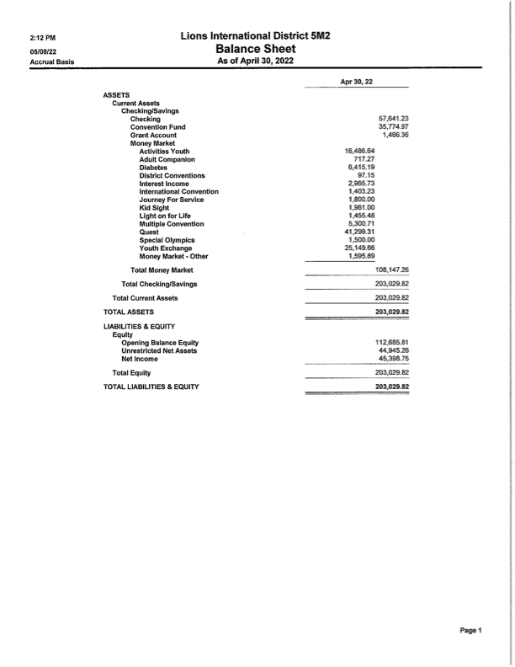

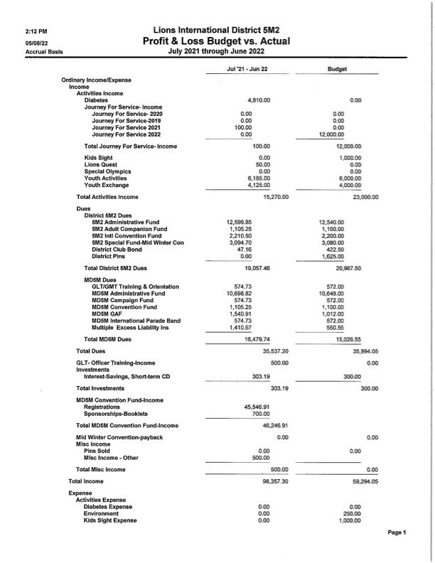

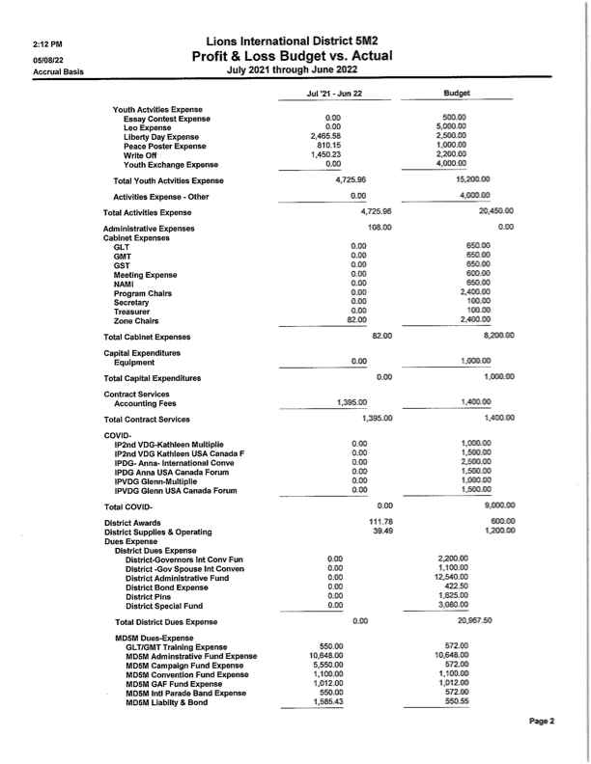

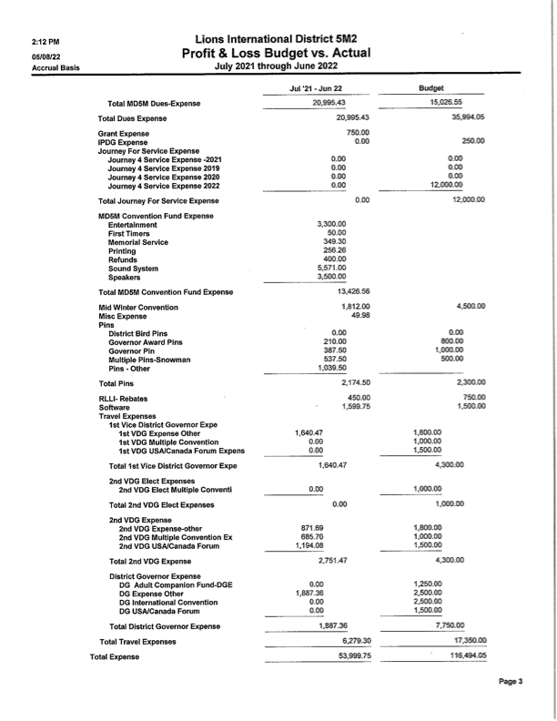

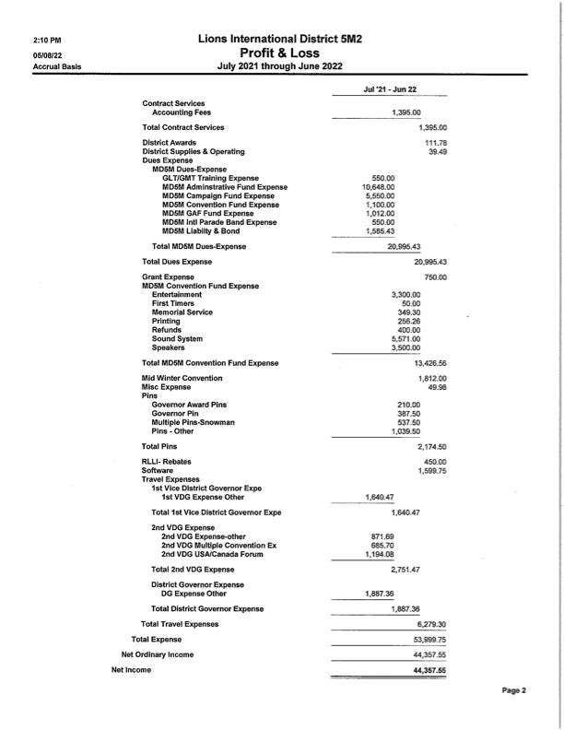

APRIL 2022 SOCIAL MEDIA REPORT

Overall viewing is down. I encourage clubs to post their events and activities. Let people know the great work that they are doing and the significant events in the clubs.

I’m always willing to help clubs set up their Facebook pages and post their information on our 5M2 Facebook site.

I can be reached at davidmichaelwilliams@ aol.com or 952-500-2378. Or through my Facebook page at <https://www.facebook.com/dave.williams.9693/> I will gladly help clubs set up.

**Summary of March 24-April 20, 2022**

*46 Views, down 36% from last 30 days

*3 New likes, down 75% from last 30 days

*Posts reach 2,135, down 7.8% from last 30 days

*Post engagements 699, down 19 % from last month

-April 16 had 105 engagements (Be Seen Promotions and MD5M post)

-April 20 had 99 engagements (Watertown, Owatonna and NYA Posts)

*New Page Followers is 4, down 67 % from previous 30 days. 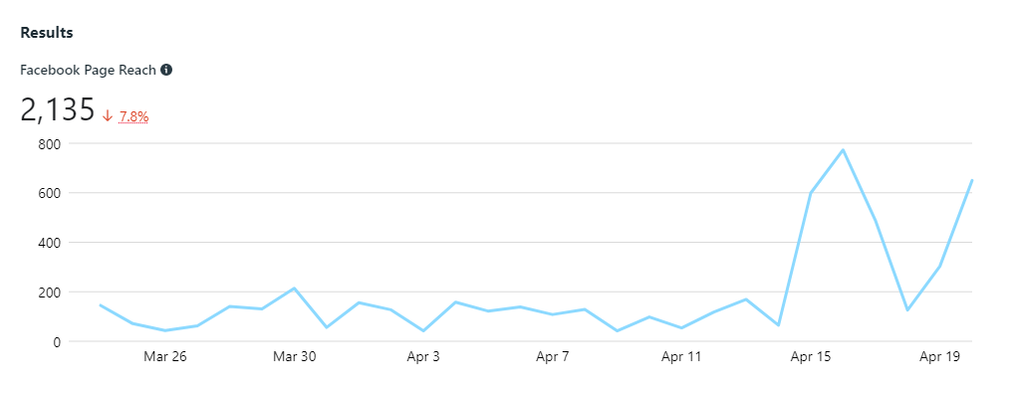

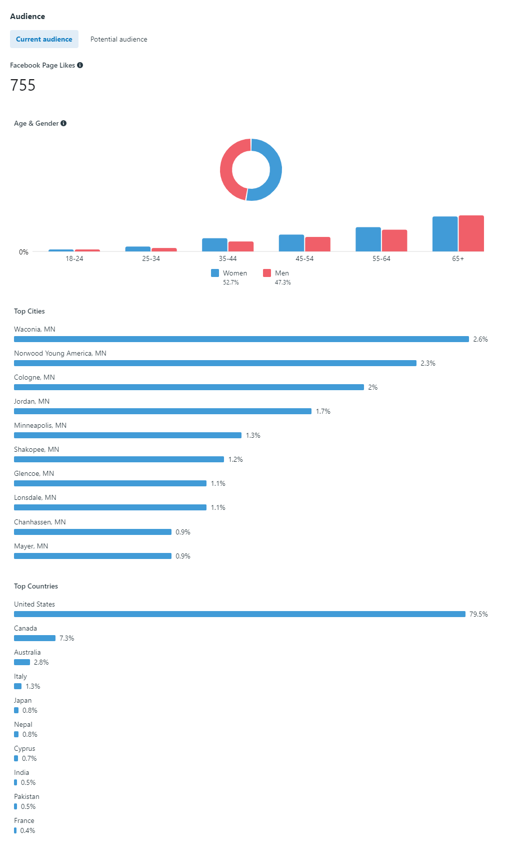

| **Published** | **Post** | **Reach** | **Engagement** |
| --- | --- | --- | --- |
| 04/20/2022  4:55 PM |  | 138 | 7  9 |
| 04/20/2022  3:45 PM |  | 75 | 0  2 |
| 04/20/2022  3:21 PM |  | 44 | 0  0 |
| 04/20/2022  12:08 PM |  | 198 | 12  12 |
| 04/20/2022  7:44 AM |  | 78 | 1  3 |
| 04/19/2022  9:20 PM | Congratulations and thanks for serving | 179 | 3  10 |
| 04/19/2022  8:43 PM |  | 132 | 2  5 |
| 04/19/2022  8:33 PM | Congratulations to Hamburg Lions for 40 years of service and fun! Great job | 243 | 22  28 |
| 04/19/2022  1:56 PM | Another Lions Out N About....Guess where this is? | 220 | 7  5 |
| 04/17/2022  8:56 AM | Happy Easter from 5M2 Lions | 321 | 4  22 |
| 04/16/2022  9:33 PM | Maybe Lion Ruth Klossner will sign autographs 🤩 | 244 | 34  13 |
| 04/16/2022  3:53 PM | As Lions "We Serve" is a familiar phrase to us. This year at the MD5M Convention we will have a seminar on "Homeless Youth". We will hear from some of these youth and they will share their perspective to what homelessness means. Our Service Project will happen after the Seminar and we ask that even if you are not able to attend the convention itself that you consider making a tax deductible donation. "Alone we can do so little; together we can do so much". Helen Keller | 181 | 4  8 |
| 04/16/2022  3:22 PM | Did you HEAR!!!! Bee Seen Promotions are coming to MD5M Convention. They have EVERYTHING you need to accessorize yourself into a well styled Lion. They will be there from Friday April 29, 2022-Saturday April 30, 2022 from 7:00 a.m. -4:00 p.m. | 1.1K | 21  47 |
| 04/15/2022  7:09 PM | Drumroll Please....Here is your 2022 MD5M Convention Schedule!! Remember registrations need to be in BY April 20th, 2022. Let's everybody give a Woo Hoo!!! It's going to be Fantabulous!!! | 1.1K | 96  44 |
| 04/15/2022  8:23 AM |  | 106 | 4  2 |
| 04/13/2022  6:14 PM |  | 116 | 0  4 |
| 04/13/2022  12:13 PM |  | 106 | 0  4 |
| 04/13/2022  9:16 AM |  | 96 | 1  2 |
| 04/13/2022  5:14 AM | Six 5M2 communities represented here...Play Ball! | 129 | 7  17 |
| 04/12/2022  8:18 PM |  | 154 | 6  7 |
| 04/12/2022  5:22 PM |  | 123 | 1  10 |
| 04/10/2022  9:26 PM | Cologne Leo's Easter Bunny Event | 75 | 0  1 |
| 04/10/2022  6:43 AM |  | 101 | 0  5 |
| 04/08/2022  6:39 AM |  | 146 | 2  4 |
| 04/07/2022  4:02 PM |  | 86 | 1  5 |
| 04/07/2022  1:56 PM |  | 106 | 0  6 |
| 04/06/2022  3:44 PM |  | 121 | 0  3 |
| 04/05/2022  8:58 PM | DG Glenn and Lion Lisa spent time with the Owatonna Lions today. Inducted a new Lion and awarded a Chevron. Hell of a day...*ding goes the swear jar*! | 172 | 13  21 |
| 04/04/2022  1:50 PM | Have you "herd" about our very own Lafayette Lion Ruth Klossner... | 198 | 18  10 |
| 04/02/2022  1:43 PM |  | 105 | 0  4 |
| 04/02/2022  11:46 AM |  | 119 | 0  4 |
| 04/01/2022  5:38 PM |  | 81 | 1  0 |
| 04/01/2022  1:58 PM | Spring has Sprung-Click on the link to find out what's happening in 5M2! https://conta.cc/3wWPlNz | 82 | 4  2 |
| 04/01/2022  9:14 AM |  | 190 | 5  7 |
| 03/30/2022  1:35 PM | Welcome to the Pride Courtney. We are glad to have you with Lions | 169 | 2  8 |
| 03/30/2022  11:41 AM |  | 115 | 0  3 |
| 03/30/2022  9:13 AM |  | 169 | 5  8 |
| 03/30/2022  7:31 AM | Due to the WX, tonight's Zone 7 Spring meeting has been postponed. A new invite will be sent once details have been determined. | 176 | 3  2 |
| 03/28/2022  9:30 PM |  | 243 | 21  25 |
| 03/28/2022  12:18 PM | Jordaness Lions Ham/Turkey Bingo | 87 | 1  3 |
| 03/27/2022  7:08 PM | Well….not to brag. This is how MD5M likes to roll 😂 I”ll show myself out…. | 67 | 2  4 |
| 03/24/2022  6:13 PM | This is very good ! | 82 | 5  1 |
| 03/24/2022  5:15 PM | Need a refresher on how to load next year's club officers into MyLion? VOILA!!! You asked for it, you got it! | 89 | 4  6 |
| 03/24/2022  8:59 AM |  | 55 | 0  1 |
| 03/23/2022  1:34 PM | Hop on over to Cologne.... | 181 | 3  4 |

See More