The Magic of San Miguel de Allende
Feb 20- 27, 2024
www.toursbysierra.com
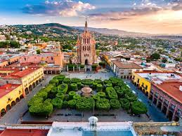
A Unesco World Heritage Site, this small city is famous for its culture, artistic lifestyle & architectural 16 century Baroque style masterpieces.
Experience: Majestic Parroquia de San Miguel Arcangel that towers above the city, Music & Events in the Jardin, the local zócalo, Benito Juarez Park, Local Markets, Bellas Artes Gallery, Fabrica La Aurora, an upscale art & design center, Biblioteca, (public library) the second largest bi-lingual library in Mexico & the center of cultural events, Instituto Allende, arts & language school built in the 1700's.

Arrive at Queretaro (keˈretaro) for a one night stay before heading to San Miguel. A university town known as one of the best Ex-Pat destinations in Mexico, it is also one of the safest places in Mexico. Also a Unesco Site & one of the most well-preserved historical cities with modern facilities. Our walking tour leads us to the wealth of beautiful, mostly baroque-style buildings and what I love most....the many pedestrian streets lined with restaurants & lovely parks.
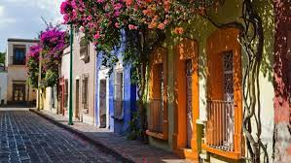

Wed. Feb 21: Depart after lunch for an hour drive to San Miguel de Allende for five nights. It's an artist's delight for the abundant artisan's galleries & shops as well as streets filled with musicians.
San Miguel food tour will delight as San Miguel is also known as a Culinary Mecca asit is a blend of Aztec, Mayan, Toltec, Spanish & French. Experience the regional flavors while learning about the architecture, history & culture.
Day Trips:
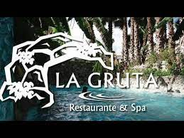 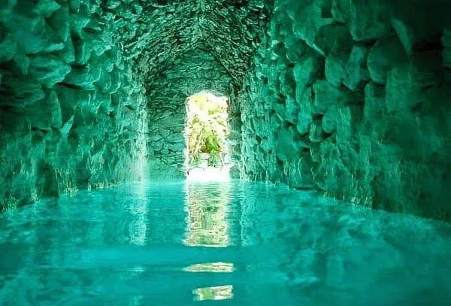 Guanajuato, the state capital, once a thriving colonial silver mining capital will remind you of the hill country of northern Italy. Underground tunnels & elaborate Moorish style architecture, International University. We will tour the birth place of Diego Rivera, now a museum.
La Gruta Hot Springs & Spa, 20 min drive, located in the highlands. A stop at the Unesco site of Santuario de Atotonilco with its beautiful Frescoes, (known as the Sistine Chapel of Mexico).
A half day tour to a local winery while exploring the hills of San Miguel.
Late afternoon on 26th, return to airport hotel in Queretaro for easy shuttle to the airport.
Hotel Quinta Loreto, www.quintaloreto.com.mx, located within a few blocks from the Center is our San Miguel lodging for our stay, with gardens & restaurant.

Details

Cost: Double occupancy per person: $885 Single: of $1195 Deposit: $200
Balance due Dec. 1, 2023. No refund as past that date.
Trip Insurance, see my website page on drop down menu. 9 people max.

Includes: 7 nights lodging, 5 tours with transportation, transportation to & from Queretaro,
departing airport shuttle
Airfare not included. I can assist with research on airfare: Tucson to Queretaro.

Payment methods: Checks to Tours by Sierra, P.O. Box 912, Green Valley, AZ 85622; Zelle deposit; Credit Cards (add 3%).
Joyce Sierra 520-404-2254
backroadsjoy@gmail.com www.toursbysierra.com
an easy flight, averaging around $550.

