**Friends of Wilson Ponds’ Five Rustic Campsites**

Last year, for the first time in my 16 years coming to Lower Wilson Pond, I visited FoWPA’s five campsites. My first visit was to drop off our kids and grandkids for “wilderness” camping experience. Staying at camp, even though off the grid, was too cushy to claim as a true camping experience.

Alexandra, Ted, Nellie and Emma camped at site #1, known as Birch Point. It is easily recognizable by the unusual 5-trunked tree (actually a Cedar) that is visible from across the pond. They had a blast!

My second visit was part of an effort to inspect and clean the camps and determine the need for new picnic tables. Ralph Johnson, my wife Dee, and I set out with camera, tape measure and chain saws.

**Birch Point** – Campsite 1 is likely the largest site at approximately 1600 square feet of clear area (40’ by 40’). It has views of Scammon Ridge and Teasdale Island. There is plenty of room for tents.

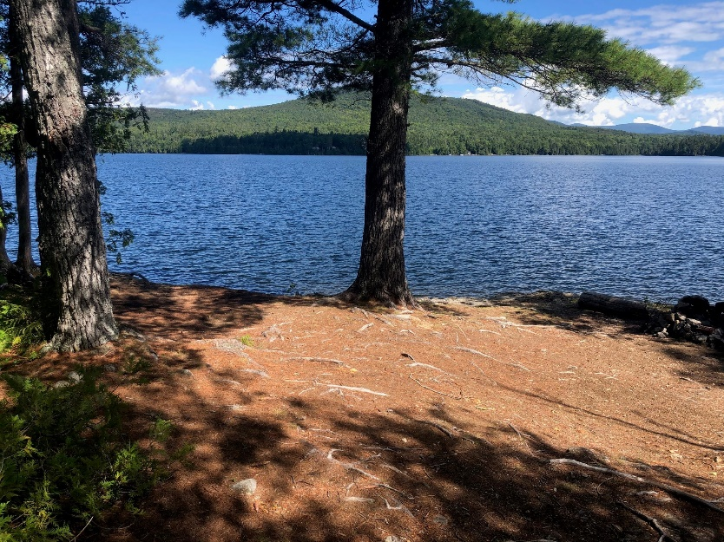 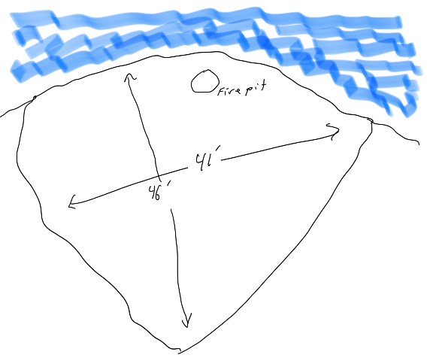

## Access - Birch Point can be accessed by pulling up to a rock ledge immediately in front of the site, or by pulling up to the beach to the West of the campsite and walking eastward, up a footpath. Geo coordinates for the campsite: 45.481165, -69.510251

## Gravel Bluff – Formerly campsite 2, is slightly smaller than Birch Point, and enjoys a more Westerly view, with terrific sunsets. There is ample space for tents.

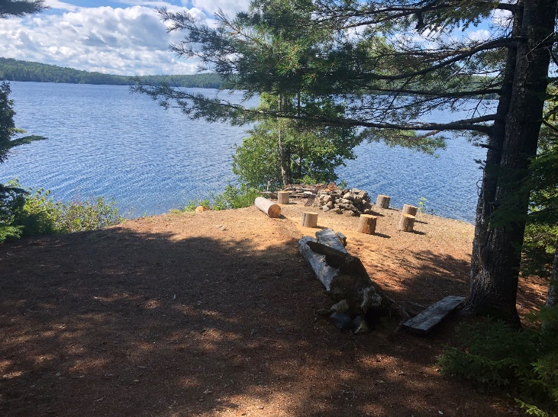 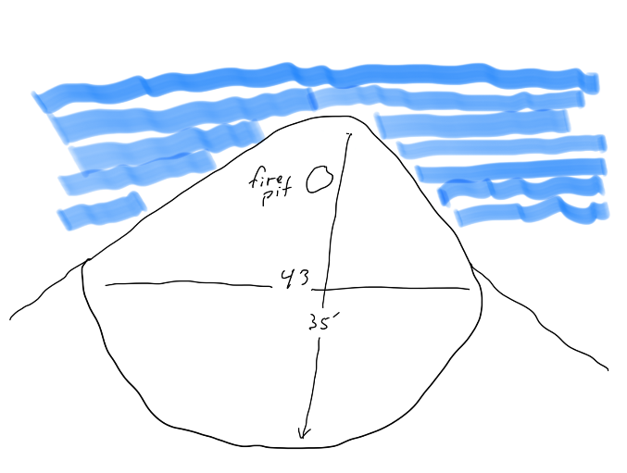

## Access – Gravel Bluff is accessible from the same path as Birch Point. Pull boats up on the beach (45.480579, -69.511345) and head up the path. Geo coordinates for the campsite: 45.480709, -69.511085

**Blueberry Island** – Campsite 3 is further West along the Rum Mountain shoreline. Blueberry Island is perhaps the smallest of the campsites. It does have the unique distinction of being an island. Views are somewhat constrained from the camping area, as the island is quite close to the shore of the mainland.

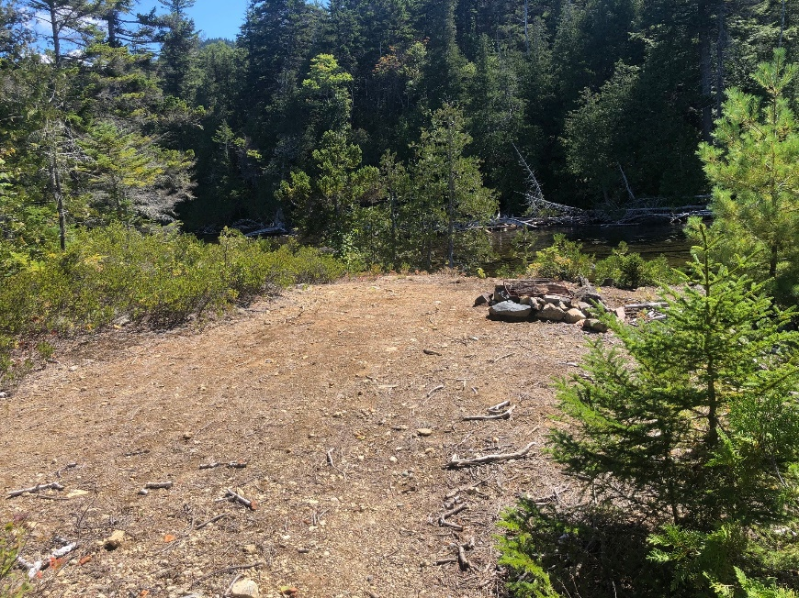 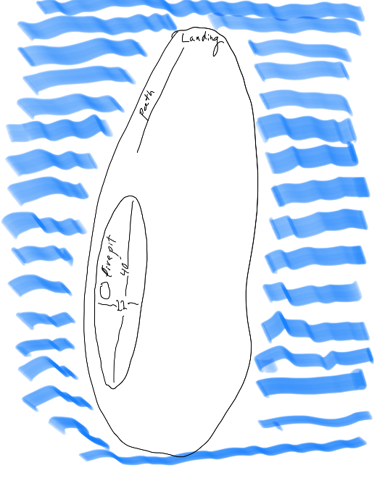

Access: Blueberry Island is best reached from the northernmost tip of the island. There is a rock shelf which can be rough on a boat’s hull during a storm. Follow the short path to Geo coordinates: 45.479353, -69.515639

**The Cliffs (locally known as Acapulco)** – Campsite 4 is a sprawling site, with relatively narrow open areas. The main attraction is the “cliff” that is a popular jumping platform (hence the Acapulco reference). There are rocks, so please be careful.

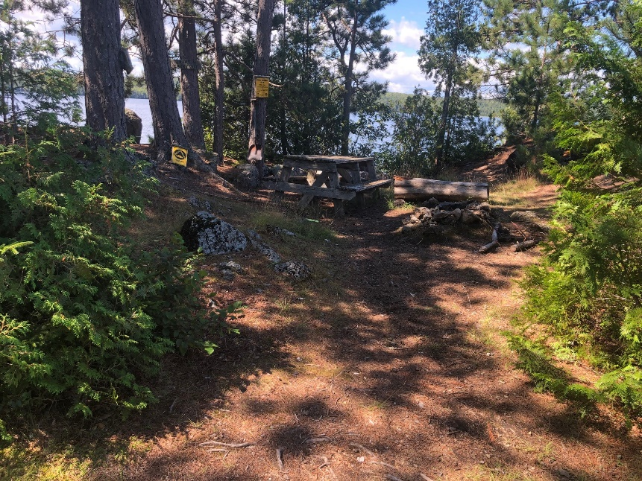 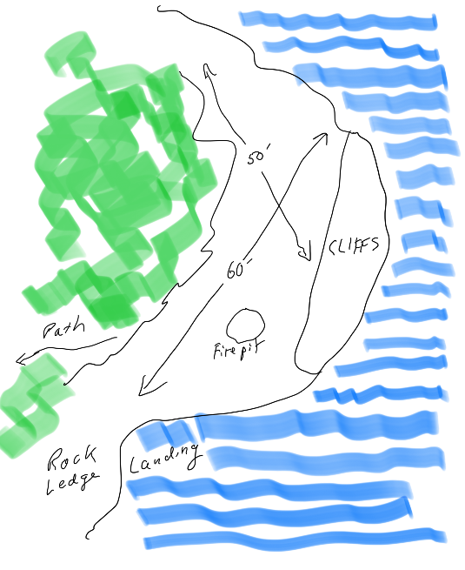

## Access – navigation is a bit tricky – there is a “reef” off the point, so approach the campsite from the East, and pull boats up on the rock ledge just East of the campsite. Campsite coordinates are: 45.481321, -69.520984

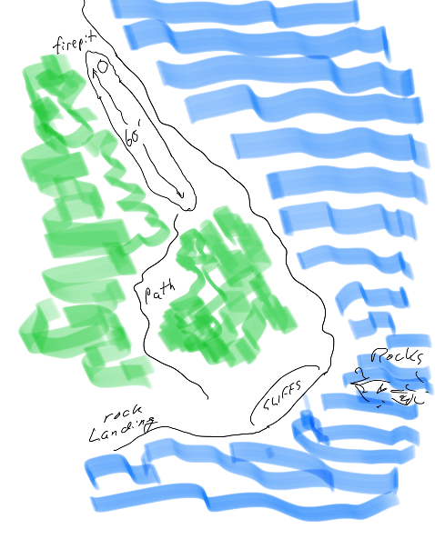**Rum Cove** – Campsite 5 is an attractive, wooded site with a narrow open space along the shore of Rum Cove. The area is largely shaded, so perfect for hot days. The long, narrow clearing has a firepit at the end.

The terrain is flat enough for tents, and the campsite has a nice, westerly view.

## Access – The Rum Cove site is accessed from the same landing as The Cliffs. Follow the path through the woods until you see a narrow clearing and Rum Cove. Geo coordinates: 45.480794, -69.521197

**Welcome**

All the campsites are Carry In-Carry Out and feature primitive, outdoor toilet seats (use of Wag-bags is required), fire pits, picnic tables and information boxes. A **Fire Permit is required** if a recreational fire has flames greater than 3 feet high and is greater than 3 feet in diameter.

*In Maine, you can get a campfire permit for a "permit" site by contacting the local forest ranger or the MFS Regional Headquarters:*

*\*MFS Regional Headquarters*

*You can call the MFS Regional Headquarters Monday through Friday between 8 AM and 4 PM*

*Augusta: (207) 624-3700  Old Town: 207-827-1800 Ashland: 207-435-7963*

Please sign in when you visit the sites and leave them as clean (or cleaner) than when you arrive. Your support with maintenance is greatly appreciated. Although there is no fee for the campsites, donations are greatly appreciated. You may donate online at [www.fowpa.org](http://www.fowpa.org) or send a check to Friends of Wilson Ponds, PO Box 454, Greenville, ME 04441. You are cordially invited to become a member of Friends of Wilson Ponds on our website. As a member you will receive newsletters twice a year and monthly updates of our activities.

The campsites are available throughout the year on a first-come basis. Campsites are accessible only by water or on the ice. There is a public boat launch on the west side of the pond.