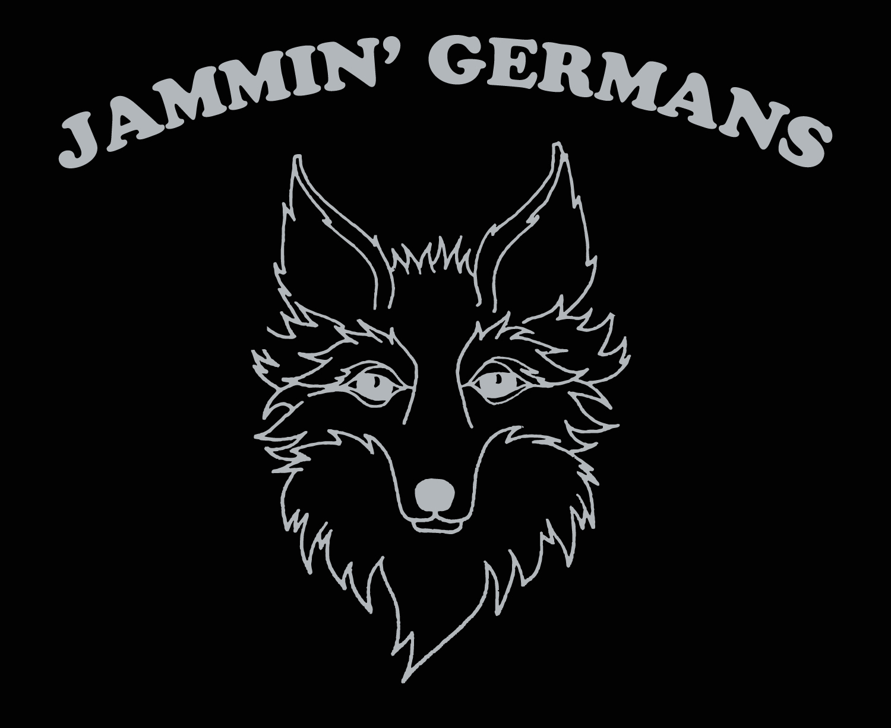
Contact: Jay Fox

Phone: 260-483-6071

Email: jayfoxband@msn.com

Facebook: fb.me/jammingermans

Web: www.jayfoxband.com

2024 PUBLIC DANCE SCHEDULE VOL. #4

JULY
Fri. 5 HOFBRAU HAUS, 200 E. 3rd St., Newport, KY 6-9
Sat. 6 HOFBRAU HAUS, 200 E. 3rd St., Newport, KY 3-10:30
Sun.7 HOFBRAU HAUS, 200 E. 3rd St., Newport, KY 12-3
Sat. 13 GOAT BIERGARTEN, 820 Catawba Ave., Put In Bay, OH 2-5
Sat. 20 FREUNDENFEST, Pearl & Water St., Oldenburg, IN 12-2:30
Fri. 26 SWISS VILLIAGE, 1350 W. Main St., Berne, IN 10-11 a.m.
Fri. 26 SWISS DAYS, 158 W. Franklin St., Berne, IN 3:30-6:30
w/performances by Fort Wayne Tanzer 1:30-2, 2:30-3
Sat. 27 GOAT BIERGARTEN, 820 Catawba Ave., Put In Bay, OH 2-5

AUGUST
Sat. 3 LIEDERKRANTZ PICNIC, GERMAN PARK, 8602 S. Meridian, Indy, IN 6-10
Fri. 9 GERMANFEST, 1377 S. Hart St.., Vincennes, IN 6:30-10:30
Sat. 10 GERMANFEST, 1377 S. Hart St., Vicennes, IN 6:30-10:30
Sat. 17 HOFBRAU HAUS, 200 E. 3rd St., Newport, KY 7-10:30
Sun.18 HOFBRAU HAUS, 200 E. 3rd St., Newport, KY 12-7
Fri. 23, GERMAN AMERICAN FEST, 3624 Seaman Rd. Oregon, OH 6-12
Sat. 24, GERMAN AMERICAN FEST, 3624 Seaman Rd. Oregon, OH 7-12
Sun. 25, GERMAN AMERICAN FEST, 3624 Seaman Rd. Oregon, OH 4-8

SEPTEMBER
Fri. 6 OKTOBERFEST, GERMAN PARK, 8602 S. Meridian, Indy, IN 5-11
Sat. 7 OKTOBERFEST, GERMAN PARK, 8602 S. Meridian, Indy, IN 5-11
Thr. 12 OKTOBERFEST, 402 N. Main St., Delphos, OH 6:30-9:30
w/performance by Fort Wayne Tanzer 7:30 & 8:30
Fri. 20 OKTOBERFEST, FAIRGROUNDS, 3901 S. US Hwy. 41, Terre Haute, IN 5-11
Sat. 21 OKTOBERFEST, FAIRGROUNDS, 3091 S. US Hwy. 41, Terre Haute, IN 5-11
Fri. 27 HOPTOBERFEST, 5000 Monroe St., Coldwater, MI 5:30-9:30
w/performances by Fort Wayne Tänzer 6:30 & 7:30 p.m
Sat. 28 BARKTOBERFEST, CONSTITUTIONAL PLAZA, Main St.Monticello, IN 4-8
w/performances by Fort Wayne Tänzer 5& 6 p.m.

OCTOBER
Fri. 4 OKTOBERFEST, Main & Lexington St., Harrodsburg, KY 5-7
Sat. 5 OKTOBERFEST, Main & Lexington St., Harrodsburg, KY 5-7
Sat. 19 OKTOBERFEST, URBAN APPLES, 18326 Spring Mill Rd., Westfield, IN 7-10
w/performances by Fort Wayne Tänzer 6:30 & 8
Fri. 25 OKTOBERFEST, K of C, 1631 Foxfire Ln., Kokomo, IN 6:30-9:30
w/performances by Fort Wayne Tänzer 7:30 & 8:30
Sat. 26 OKTOBERFEST, URBAN APPLES, 18326 Spring Mill Rd., Westfield, IN 7-10
w/performances by Fort Wayne Tänzer 6:30 & 8

NOVEMBER
Sat. 2 SCHWABENFEST, 7920 Jackson Rd. Ann Arbor, MI 6:30-10:30
w/performances by Fort Wayne Tanzer 7:30 & 8:30
Sat. 23 CHRISTKINDLEMARKT, 10 Carter Green, Carmel, IN 12:30-2:30
Sat. 30 CHRISTKINDLEMARKT, 10 Carter Green, Carmel, IN 1:30-3:30
w/performance by Fort Wayne Tänzer at 12:30-1:30

DECEMBER
Fri. 6 COOKIE DANCE, GERM. AMER. KLUB, 8602 S. Meridian, Indy, IN 7-10:30
Sat.7 CHRISTKINDLEMARKT, 10 Carter Green, Carmel, IN 3:30-5:30
w/performance by Fort Wayne Tänzer at 2-3

