
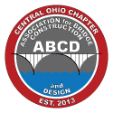
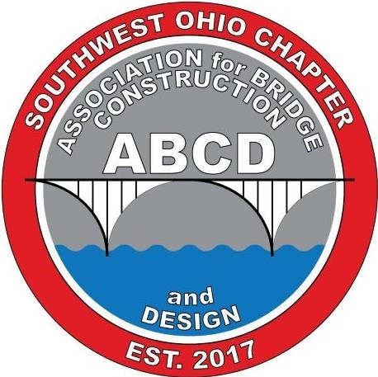
2024-2025 ABCD Scholarship Instructions
One-time scholarships will be awarded to students currently pursuing a degree in Civil Engineering and interested in focusing on Bridge Engineering. Two $1,000 scholarships and three $500 scholarships will be awarded. One of the $1,000 scholarships is named in honor of Mike Lenett, PE.
Mike Lenett was a professional engineer in Ohio and Kentucky. He was a member of several engineering societies including The American Society of Civil Engineers (ASCE) and the Association of Bridge Construction and Design where he was instrumental in helping start the Southwest Chapter. Mike was frequently invited to speak at engineering conferences around the country. Mike was a man of deep and resounding dedication. In both his professional and personal life, he was committed to living beyond himself. Mike passed away in September 2020 and this scholarship is in memory of Mike and all he provided to the bridge industry.
Qualifications
- Must be currently enrolled in an ABET-accredited Ohio university pursuing a 4-year undergraduate degree in Civil Engineering
- Must have attained sophomore status at time of application
Criteria for Selection
- Candidates must exhibit community and school involvement
- Work experience, volunteer experience, and leadership will be considered in the selection process
- College grade point average
Application Process
Applicants shall submit the following:
- ABCD Scholarship Application
- College transcript (an unofficial transcript may be included with the application; however, an official transcript must be provided prior to award of scholarship)
- A list of at least three references, including names, addresses and telephone numbers. References must be non-relatives, and at least one reference must be personal, and one must be collegiate.
- Personal Statement/Essay – in 500 words or less, explain your interest in a bridge engineering career, and how you believe you can make a contribution to the transportation field. Relate your participation in extracurricular activities, including community and school involvement and work/volunteer experience.
Scholarship Recipient
- Recipient will be notified by December 21, 2021.
- Recipient should plan on attending one of the ABCD Chapter meetings after the scholarship award.
Return these items by February 21, 2025 to:
ABCD Ohio Chapters
c/o Pete Anamasi OR Email*: pete.anamasi@rina.org
RINA North America
3961 St. Theresa Blvd
Avon, OH 44011
* Emailed applications are preferred. Emailed applications must be in pdf format and under 10 MB file size.
For questions, please contact Pete Anamasi at 410-952-3742 or email: pete.anamasi@rina.org.

