OPSTrax
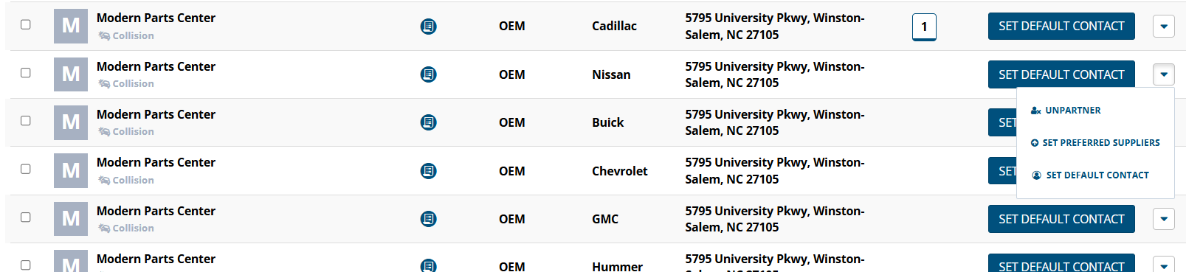
Click on TraxPartners, find the Modern Parts Center, click the drop down on the right hand side and select

Click add in the new window then Confirm
