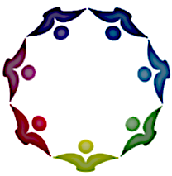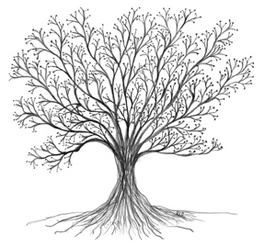

Therapist Process Training Group Experience

A Unique Opportunity for Growth and Connection
Are you a psychotherapist or other mental health professional seeking a supportive environment to engage in personal and professional growth? In response to several requests and in conjunction with the Toronto Institute of Group Studies, Shari Baron and Allan Sheps are offering a Therapist Process Training Group Experience.

This program presents a unique opportunity to connect with fellow professionals, share experiences, and deepen your understanding of group dynamics. This group is ideal for people interested in learning more about process groups and group dynamics, and who desire professional and personal growth.

At the end of each meeting, we will have a brief discussion of our group process. This is a training group, not a therapy group. Our focus as facilitators will be on the here & now unless members bring in historical material. The group will be limited to a maximum of 10 members.

Why Should You Join?
- Build Connections: Engage with a community of like-minded professionals who understand the challenges and rewards of therapeutic work.
- Enhance Self-Awareness: Explore personal patterns and dynamics to better understand yourself and your work.
- Develop Skills: Gain valuable insights into group therapy techniques and improve your overall practice.
- Receive Support: Experience the healing power of shared experiences in a nurturing and non-judgmental space.

Group Details
- Who: licensed therapists and mental health professionals
- Where: Zoom platform
- When: Tuesdays, September to June, 3:00 pm to 4:30 pm Eastern Time
- Cost: CDN$80 or US$60 per scheduled session Pre-group Interview Fee: $225 CDN/ $160 US

How to Join
Spaces are limited! To secure your spot, contact us at shariyb@aol.com (Shari Baron) or allan.sheps@gmail.com (Allan Sheps) and include therapist group in the subject line.

About Us
Shari and Allan are experienced group facilitators and trainers. Both have taken the American Group Psychotherapy Association Institute Designate training program, have led numerous experiential training groups and have both been recognized as Fellows of the American Group Psychotherapy Association (AGPA-F). In addition, both Allan and Shari have achieved the Certified Group Psychotherapist (CGP) designation from the International Board for the Certification of Group Psychotherapists.
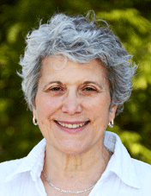
Shari Baron, MSN, CNS, CGP maintains a private practice in Media, Pennsylvania, where she works with individuals, couples and groups in-person and online. She is a faculty member of the Toronto Institute of Group Studies. She is a past president of the American Psychiatric Nurses Association – Pennsylvania Chapter and has been a Board Member of The American Group Psychotherapy Association (AGPA) and the Philadelphia Area Group Psychotherapy Society (PAGPS).
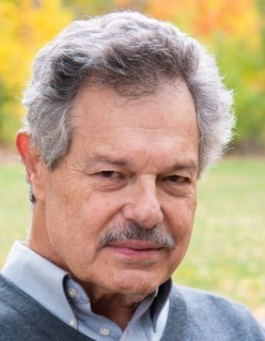
Allan Sheps, MSW, RSW, CGP practices online from Toronto. He is a Founder, Co- Director and Faculty member of the Toronto Institute of Group Studies (www.tigs.co). He is a past president and Fellow of the Canadian Group Psychotherapy Association. In his private practice he worked with individuals and couples, has a specialty in addressing anger management issues, and has served as consultant to social agency group programs.

Join us and take the next step in your professional journey. We look forward to welcoming you to our process training group!

