Fall/Winter Reading List 2022-2023

This season’s list highlights articles, texts and other creative and thoughtful offerings which address inner resourcing

The Cambridge dictionary definition of resource includes,
“a useful or valuable possession or quality that a person or organization has…”

In these times that continue to challenge all our collective experiences, as well as our own nervous systems, we felt that a reference list supporting our own inner resources might be a welcome offering for the seasons ahead.

Saint Francis and the Sow by Galway Kinnell

The bud
stands for all things,
even for those things that don’t flower,
for everything flowers, from within, of self-blessing;
though sometimes it is necessary
to reteach a thing its loveliness,
to put a hand on the brow
of the flower
and retell it in words and in touch
it is lovely
until it flowers again from within, of self-blessing;
as Saint Francis
put his hand on the creased forehead
of the sow, and told her in words and in touch
blessings of the earth on the sow, and the sow
began remembering all down her thick length,
from the earthen snout all the way
through the fodder and slops to the spiritual curl of the tail,
from the hard spininess spiked out from the spine
down through the great broken heart
to the sheer blue milken dreaminess spurting and shuddering
from the fourteen teats into the fourteen mouths sucking and blowing beneath them:
the long, perfect loveliness of sow.

Group Related:

The following two articles explore the reparative processing, that when activated in group therapy, potentiates the healing power of group:

Susan P. Gantt (2021) Systems-Centered Theory (SCT) into Group
Therapy: Beyond Surviving Ruptures to Repairing and Thriving, International Journal of Group Psychotherapy, 71:2, 224-252, DOI: 10.1080/00207284.2020.1772073
To link to this article: https://doi.org/10.1080/00207284.2020.1772073

The process of repairing relational ruptures in group is examined using the systems-centered therapy practice of functional subgrouping to repair in the here-and-now and integrate differences.

Marty Livingston & Christopher A. Scott (2017) Sustained Empathic
Focus and the Creation of a “We Space” Revisited in the Light of Recent Findings
in Neurobiology, International Journal of Group Psychotherapy, 67:4, 479-499, DOI:
10.1080/00207284.2016.1278173
To link to this article: https://doi.org/10.1080/00207284.2016.1278173

This article explores the ‘we-space’ in group from a neurobiological lens and the conditions that foster the development of inner resources and scaffolding necessary for healing in group.

Rupture and Repair in Psychotherapy: A Critical process for Change (2022).
Eubanks, C.F., Wallner Samstag, L., and Muran, C Editors. APA Publications: Washington, DC.
https://www.apa.org/pubs/books/rupture-repair-psychotherapy?tab=2

The title of the introduction to this text intrigued us: Rupture in a Wicked and Wonderful World. And notably, the text includes a chapter, Alliance Rupture and Repair in Group Psychotherapy, by Giorgio A. Tasca and Cheri Marmarosh, two of our respected invited faculty.

For those wanting to delve further into repairing ruptures, The International Journal of Group Psychotherapy offered a special issue exploring rupture and repair:
International Journal of Group Psychotherapy, Vol. 71, 2021: Issue 2-Special Issue: Rupture and Repair in Group Therapy; 205-392.
In her preface to this special issue, Cheri Marmarosh “begins by linking the process of rupture and repair to theoretical models of group work. Bateman et al. describe how rupture and repair are critical components in mentalization-based group treatment. Segalla describes how self-psychologists understand ruptures and repairs in groups. Gantt reviews Systems-Centered theory and how ruptures influence group process. The special issue also focuses on training group leaders to be aware of ruptures and repair. Rutan reviews the different ways that therapists can trigger ruptures in group therapy. Eubanks, Warren, and Muran explore how ruptures occur within supervision groups, and they apply their coding system historically used in individual therapy. Burlingame et al. describe the use of the Group Questionnaire (GQ) after sessions to detect ruptures and address them in group.” (IJGP 71 (2) p. 206). Most importantly the authors highlight strategies for noticing, acknowledging, and addressing ruptures and the consequences of not doing so.
~

In our previous newsletter, we referenced the Japanese art of Kintsugi ‘golden repair’ as a magnificent example of how creativity is used to heal and repair. The art of repairing broken pottery with gold is guided by the Japanese philosophy that views the breakage and repair of an object as part of its history rather than something that needs to be thrown away or hidden. As a result, the cracks of a broken pottery bowl are filled with gold, transforming it into another beautiful piece of art. Guided by this metaphor, we noted that the cracks that this pandemic has created or highlighted, need to be filled with the ‘gold’ of connection, compassion, and a commitment to transforming our world into a more equitable, just and kind place. Similarly, the cracks we experience as caregivers can be filled with self-love, self-care and compassion for ourselves as well as for our clients.

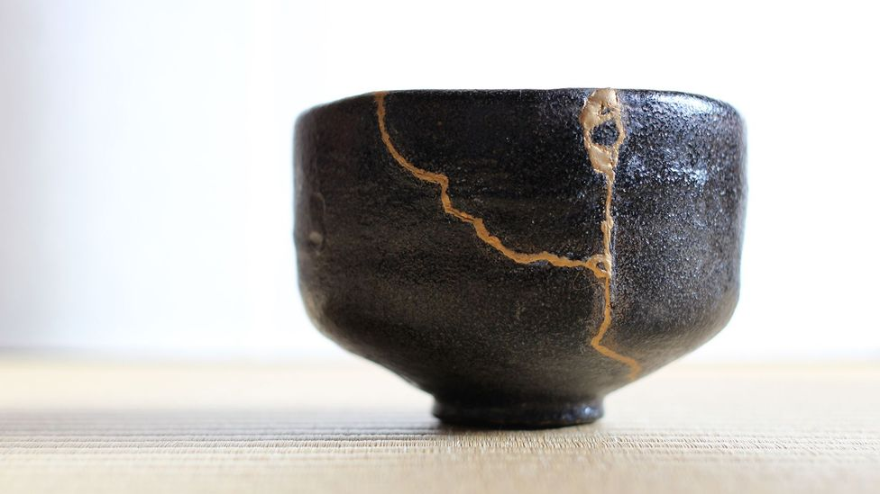

With this image in mind, we were delighted to note that the Art Gallery Of Ontario (AGO) is presenting an exhibition of the work of Leonard Cohen, Canadian poet, novelist, and singer-songwriter (1934-2016), titled Leonard Cohen: Everybody Knows, beginning December 7, 2022.
https://ago.ca/exhibitions/leonard-cohen-everybody-knows?utm_source=whatson&utm_medium=email&utm_campaign=whatson&utm_content=cohen&utm_source=AGO+email+communications&utm_campaign=43232f474b-whatson_Nov+3&utm_medium=email&utm_term=0_d4ab708299-43232f474b-246083481

Fittingly, the words to Cohen’s famous anthem resonate with our theme above:

“Ring the bells that still can ring
Forget your perfect offering
There is a crack in everything
That’s how the light gets in.”

A haunting recording of his anthem performed live in London can be found here:
https://www.youtube.com/watch?v=c8-BT6y_wYg

And currently, the Japanese Canadian Cultural Centre (JCCC) in Toronto is hosting a heritage exhibition by Annie Sumi and Brian Kobayakawa, titled Kintsugi, described as “an anti-racist, interactive, multi-disciplinary, art installation”, on now until March 2023.
https://jccc.on.ca/event/2022/10/kintsugi

“Exploring the Japanese practice of kintsugi - honouring and embellishing brokenness - this installation takes the fragmented pieces of self, story and culture, and brings attention to the greater wholeness. ‘Kintsugi’ intends to create space for others to reflect upon their own relationship to ancestry and share about how those stories take shape in their present lives.” (JCCC Website)

Practice Related:

The following YouTube video offers a conversation between Stephen Porges and Gabor Mate during a gathering about The Wisdom of Trauma offered by Zaya and Maurizio Benazzo:
https://www.youtube.com/watch?v=4bisa3dYf7U
During the conversation, Dr. Porges explains how “our underlying physiological state shifts our perspective of the world”, and that we ‘broadcast’ our feelings in our voices and through our facial expressions, as much as through our words.

The Myth of Normal by Gabor Mate with his son, Daniel Mate, 2022.
“Over four decades of clinical experience, Maté has come to recognize the prevailing understanding of “normal” as false, neglecting the roles that trauma and stress, and the pressures of modern-day living, exert on our bodies and our minds at the expense of good health. For all our expertise and technological sophistication, Western medicine often fails to treat the whole person, ignoring how the toxicity of today’s culture stresses the body, burdens the immune system, and undermines emotional balance.” drgabormate.com

Heavy Rotation by Gord Downie, from Coke Machine Glow, 2001.

The moon’s so beautiful
when you show it to me.
That’s the song playing
on my inner stereo
Around the clock.

Of Interest:

The Twelve Monotasks: Do One Thing at a Time to Do Everything Better by Thatcher Wine (2021). Little Brown Spark: New York.
“Drawing on research in psychology, neuroscience, and mindfulness, The Twelve Monotasks provides a clear and accessible plan for life in the twenty-first century. Practice resisting distractions and building focus by doing the things you already do—like reading, sleeping, eating, and listening—with renewed attention.“ (Goodreads.com)

Inner Mastery, Outer Impact by Hitendra Wadhwa (2022). Hachette Books: New York.
“Hitendra Wadhwa has created a transformative guide in this masterful tapestry weaving biographical insights from wise leaders in our world with self-disclosing inner explorations of how to cultivate the equanimity and access to a ‘core self’ that can liberate us to create skillful outer action. This wonderful book is filled with ‘aha’ moments of intellectual surprise, compelling narrative suspense, and deep emotional and spiritual insights that have been a joy to receive and an inspiration to live a fuller and freer life in these challenging times.” (Dan Siegel, Hitendra Wadhwa website.)

The Earth Prescription: Discover the Healing Power of Nature with Grounding Practices for every Season by Laura Koniver (2020). Reveal Press: Oakland, CA.
“… many of us spend the majority of our days indoors, trapped in our own heads, addicted to our screens and online connections, and feeling more and more disconnected to our own bodies — and the planet — than ever before. Intuitively, we know that even a five-minute walk outdoors can calm us and awaken our senses, but we tell ourselves we don’t have time, or we can’t seem to make the time. In The Earth Prescription, holistic physician Laura Koniver, MD, offers the ideal antidote to the toxicity of a life isolated from nature — grounding… With this practical and uplifting guide, you’ll learn how to incorporate the practice of grounding anytime, anywhere…” (Cover).

No Cure for Being Human (And Other Truths I Need to Hear) by Kate Bowler (2022). Random House: New York.

“In facing down cancer, Kate… searches for hope without cheap optimism, and truth with room for mystery. We are as fragile as the day we were born, and we will need each other if we’re going to tell the truth: Life is beautiful and terrible, full of hope and despair and everything in between, but there’s no cure for being human.” (Cover)

We’d like to end this season’s list of recommendations with Jonathan McReynold’s illuminating song, People:
https://www.youtube.com/watch?v=WDtw1fGuCbY

