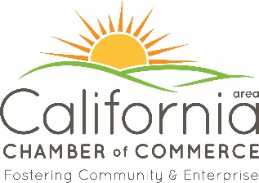 **34th OZARK HAM & TURKEY FESTIVAL**

**Saturday, September 21, 2024**

VENDOR BOOTH APPLICATION

Name of Vendor: ________________________________________________________

Name of Contact: _______________________________________________________________

Mailing Address: _______________________________________________________________

Phone: _______________________ Email Address: _____________________________

**PLEASE CHOOSE ONE:**

_____ Nonprofit Organization (Church or Civic Organization) Fee is negotiable

_____ Craft Vendor- (Items MUST be homemade) $50 for each 10’x10’ space

_____ Commercial Vendor- (purchased items for resale) $75 for each 10’x10’ space

_____ Food Vendor- $100 for each 10’x10’ space

**ELECTRICITY FOR ANY VENDOR IS AN ADDITIONAL $20.00. Please indicate electrical needs.**

Will you need electricity? No____ Yes______ Please specify: 110___ 220___ Other_______________

Requests or Special Accommodations: _____________________________________________________

_______________________________________________________________________________

What products will you be selling? Be specific: _________________________________________

________________________________________________________________________________

Is your organization tax exempt? (If yes, provide a copy of tax-exempt form) Yes___ No___

**Set up Saturday, September 21st at 6:00 am. Must be ready to vend by 9 am. Tear down NO SOONER THAN 4:00 pm. This is a one day event. All concessions are responsible for leaving their booth spaces clean!**

Submit this form & payment by check or cash to: Ozark Ham & Turkey Festival at 500 S. Oak St., Ste. A, California, Mo. 65018.

Contact: Rita Rippee, Executive Secretary, 573-796-3040 or email [chamber@calmo.com](mailto:chamber@calmo.com)

OFFICE USE ONLY: Paid ___/___/___ Check #_______ $_______ Cash $_________

Booth Space 2023 __________ Booth Space 2024_________