

San Francisco Soil and Water Conservation District

REQUEST FOR PROPOSALS (RFP)

Apache Creek Revetment Fence Construction

RFP # 2023-09-01

RFP Release Date: October 14, 2022

Proposal Due Date: November 11, 2022

Table of Contents
I. INTRODUCTION 1
A. PURPOSE OF THIS REQUEST FOR PROPOSALS 1
B. BACKGROUND INFORMATION 1
C. SCOPE OF PROCUREMENT 1
D. PROCUREMENT MANAGER 1
E. PROPOSAL DELIVERY 2
F. DEFINITION OF TERMINOLOGY 2
G. PROCUREMENT LIBRARY 5
II. CONDITIONS GOVERNING THE PROCUREMENT 6
A. SEQUENCE OF EVENTS 6
B. EXPLANATION OF EVENTS 6
1. Issue RFP 6
2. Acknowledgement of Receipt Form 6
3. Deadline to Submit Written Questions 7
4. Response to Written Questions 7
5. Submission of Proposal 7
6. Proposal Evaluation 7
7. Selection of Finalists 8
8. Best and Final Offers 8
9. Finalize Contractual Agreements 8
10. Contract Awards 8
11. Protest Deadline 8
C. GENERAL REQUIREMENTS 9
1. Acceptance of Conditions Governing the Procurement 9
2. Incurring Cost 9
3. Prime Contractor Responsibility 9
4. Subcontractors/Consent 9
5. Amended Proposals 9
6. Offeror’s Rights to Withdraw Proposal 9
7. Proposal Offer Firm 10
8. Disclosure of Proposal Contents 10
9. No Obligation 10
10. Termination 10
11. Sufficient Appropriation 11
12. Legal Review 11
13. Governing Law 11
14. Basis for Proposal 11
15. Contract Terms and Conditions 11
16. Offeror’s Terms and Conditions 12
17. Contract Deviations 12
18. Offeror Qualifications 12
19. Right to Waive Minor Irregularities 12
20. Change in Contractor Representatives 12
21. Notice of Penalties 12
22. Agency Rights 13
23. Right to Publish 13
24. Ownership of Proposals 13
25. Confidentiality 13
26. Electronic mail address required 13
27. Use of Electronic Versions of this RFP 13
28. New Mexico Employees Health Coverage 14
29. Campaign Contribution Disclosure Form 14
30. Letter of Transmittal 14
31. New Mexico/Native American Resident Preferences 15
III. RESPONSE FORMAT AND ORGANIZATION 16
A. NUMBER OF RESPONSES 16
B. NUMBER OF COPIES 16
1. Hard Copy Responses 16
C. PROPOSAL FORMAT 17
1. Proposal Content and Organization 17
IV. SPECIFICATIONS 18
A. DETAILED SCOPE OF WORK 18
B. TECHNICAL SPECIFICATIONS 18
1. Organizational Experience 18
2. Organizational References 18
3. Mandatory Specification 19
C. BUSINESS SPECIFICATIONS 19
1. Letter of Transmittal Form 19
2. Campaign Contribution Disclosure Form 19
3. Cost 20
V. EVALUATION 21
A. EVALUATION POINT SUMMARY 21
B. EVALUATION FACTORS 21
1. B.1 Organizational Experience (See Table 1) 21
2. B.2 Organizational References (See Table 1) 21
3. B.4 Mandatory Specifications 22
6. C.3 Letter of Transmittal (See Table 1) 22
7. C.4 Campaign Contribution Disclosure Form (See Table 1) 22
8. C.6 Cost (See Table 1) 22
C. EVALUATION PROCESS 22
APPENDIX A 24
ACKNOWLEDGEMENT OF RECEIPT FORM 24
APPENDIX B 26
CAMPAIGN CONTRIBUTION DISCLOSURE FORM 26
APPENDIX C 29
DRAFT CONTRACT 29
APPENDIX D 50
COST RESPONSE FORM 50
APPENDIX E 51
LETTER OF TRANSMITTAL FORM 51

I. INTRODUCTION

PURPOSE OF THIS REQUEST FOR PROPOSALS

The purpose of the Request for Proposal (RFP) is to solicit sealed proposals to establish a contract through competitive negotiations for the procurement of work to construct a flood revetment fence on property located on Apache Creek per the plans attached in Appendix F prepared by the Natural Resource Conservation Service (NRCS)

BACKGROUND INFORMATION

A flood on Apache Creek in July of 2021 deposited debris and threatened persons, home and outbuildings located adjacent to the creek. Catron County made a declaration of emergency that was followed by an emergency declaration by Governor Grisham. The San Francisco Soil and Water Conservation District sponsored an NRCS Emergency Watershed Protection project to protect persons, home and outbuildings.
The NRCS engineers then did an evaluation and prepared plans to protect the persons, home and outbuildings at the property.

SCOPE OF PROCUREMENT

The project requires construction of a 405-foot flood revetment fence based on the NRCS plans in Exhibit A using equipment and personnel necessary to complete the construction before February 27, 2023 unless that deadline is extended by NRCS.

This RFP will be a single award.

This procurement will result in a contractual agreement between two parties; the procurement may ONLY be used by those two parties exclusively.

PROCUREMENT MANAGER

The San Francisco Soil and Water Conservation District has assigned a Procurement Manager who is responsible for the conduct of this procurement whose name, address, telephone number and e-mail address are listed below:

Name: Annie Simpson Procurement Manager
Telephone: (575) 313-1386
Email: sfswcd@gmail.com

- Any inquiries or requests regarding this procurement should be submitted, in writing, to the Procurement Manager. Offerors may contact ONLY the Procurement Manager regarding this procurement.

- Protests of the solicitation or award must be submitted in writing to the Protest Manager identified in Section II.B.13. As a Protest Manager has been named in this Request for Proposals, pursuant to §13-1-172, NMSA 1978 and 1.4.1.82 NMAC, ONLY protests delivered directly to the Protest Manager in writing and in a timely fashion will be considered to have been submitted properly and in accordance with statute, rule and this Request for Proposals. Protests submitted or delivered to the Procurement Manager will NOT be considered properly submitted.

PROPOSAL DELIVERY
All deliveries of proposals via express carrier, courier or hand delivery, must be addressed and submitted as follows:

Name: Annie Simpson
Reference RFP Name: Apache Creek Revetment Fence Construction #2023-09-01
Address: P.O. Box 119
Glenwood, NM 88039
Hand Delivery 5460 Highway 180 Call (575) 313-1386 to make arrangements for hand delivery.

DEFINITION OF TERMINOLOGY

This section contains definitions of terms used throughout this procurement document, including appropriate abbreviations:

- “Agency” means the San Francisco Soil and Water Conservation District sponsoring this Procurement.

- “Award” means the final execution of the contract document.

- “Business Hours” means weekdays (Monday – Friday) 8:00 AM thru 5:00 PM MST/MDT, whichever is in effect on the date given.

- “Close of Business” means weekdays (Monday – Friday) 5:00 PM MST/MDT, whichever is in effect on the date given.

- “Confidential” means confidential financial information concerning Offeror’s organization and data that qualifies as a trade secret in accordance with the Uniform Trade Secrets Act §§57-3-A-1 through 57-3A-7, NMSA 1978,. See also NMAC 1.4.1.45. The following items may not be labeled as confidential: Offeror’s submitted Cost response, Staff/Personnel Resumes/Bios (excluding personal information such as personal telephone numbers and/or home addresses), and other submitted data that is not confidential financial information or that qualifies under the Uniform Trade Secrets Act.

- “Contract” means any agreement for the procurement of items of tangible personal property, services or construction.

- “Contractor” means any business having a contract with a state agency or local public body.

- “Determination” means the written documentation of a decision of a procurement officer including findings of fact required to support a decision. A determination becomes part of the procurement file to which it pertains.

- “Desirable” – the terms ”may,” “can,” “should,” “preferably,” or “prefers” identify a desirable or discretionary item or factor.

- “Evaluation Committee” means a body appointed to perform the evaluation of Offerors’ proposals.

- “Evaluation Committee Report” means a report prepared by the Procurement Manager and the Evaluation Committee to support the Committee’s recommendation for contract award. It will contain scores and written evaluations of all responsive Offeror proposals.

- “Final Award” means, in the context of this Request for Proposals and all its attendant documents, that point at which the final required signature on the contract(s) resulting from the procurement has been affixed to the contract(s) thus making it fully executed.

- “Finalist” means an Offeror who meets all the mandatory specifications of this Request for Proposals and whose score on evaluation factors is sufficiently high to merit further consideration by the Evaluation Committee, as explained in Section II.B.8.

- “Hourly Rate” means the proposed fully loaded maximum hourly rates that include travel, per diem, fringe benefits and any overhead costs for contractor personnel, as well as subcontractor personnel if appropriate.

- “IT” means Information Technology.

- “Mandatory” – the terms ”must,” ”shall” ”will,” ”is required,” or ”are required,” identify a mandatory item or factor. Failure to meet a mandatory item or factor may result in the rejection of the Offeror’s proposal.

- “Minor Irregularities” means anything in the proposal that does not affect the price, quality and/or quantity, or any other mandatory requirement.

- “Offeror” is any person, corporation, or partnership who chooses to submit a proposal.

- “Procurement Manager” means any person or designee authorized by a state agency or local public body with the responsibility, authority, and resources to conduct the RFP procurement, make written determinations regarding the RFP procurement, and/or enter into or administer contracts as a result of the RFP procurement.

- “Procuring Agency" means all State of New Mexico agencies, commissions, institutions, political subdivisions and local public bodies allowed by law to procure items of tangible personal property, services or construction from the agreement(s) awarded as a result of this RFP.

- “Project” means a temporary process undertaken to solve a well-defined goal or objective with clearly defined start and end times, a set of clearly defined tasks, and a budget. The project terminates once the project scope is achieved and project acceptance is given by the project executive sponsor.

- “Redacted” means a version/copy of the Offeror’s proposal with the information considered proprietary or confidential (as defined by §§57-3A-1 to 57-3A-7 NMSA 1978 and NMAC 1.4.1.45 and summarized herein and outlined in Section II.C.8 of this RFP) blacked-out BUT NOT omitted or removed.

- “Request for Proposals (RFP)” means all documents, including those attached or incorporated by reference, used for soliciting proposals.

- “Responsible Offeror" means an Offeror who submits a responsive proposal and who has furnished, when required, information and data to prove that his financial resources, production or service facilities, personnel, service reputation and experience are adequate to make satisfactory delivery of the services, or items of tangible personal property described in the proposal.

- “Responsive Offer” or means an offer which conforms in all material respects to the requirements set forth in the request for proposals. Material respects of a request for proposals include, but are not limited to price, quality, quantity or delivery requirements.

- “Sealed” means, in terms of a non-electronic submission, that the proposal is enclosed in a package which is completely fastened in such a way that nothing can be added or removed. Open packages submitted will not be accepted except for packages that may have been damaged by the delivery service itself. The San Francisco Soil and Water Conservation District reserves the right, however, to accept or reject packages where there may have been damage done by the delivery service itself. Whether a package has been damaged by the delivery service or left unfastened and should or should not be accepted is a determination to be made by the Procurement Manager. By submitting a proposal, the Offeror agrees to and concurs with this process and accepts the determination of the Procurement Manager in such cases.

- “SPD” means State Purchasing Division of the New Mexico State General Services Department.

- “Staff” means any individual who is a full-time, part-time, or an independently contracted employee with the Offerors’ company.

- “State (the State)” means the State of New Mexico.

- “State Agency” means any department, commission, council, board, committee, institution, legislative body, agency, government corporation, educational institution or official of the executive, legislative or judicial branch of the government of this state. “State agency” includes the Purchasing Division of the General Services Department and the State Purchasing Agent but does not include local public bodies.

- “Statement of Concurrence” means an affirmative statement from the Offeror indicating its response to a required Section IV specification agreeing to comply and concur with the stated requirement(s). This statement shall be included in Offerors proposal, pursuant to Section III.C.1. (E.g. “We concur,” “Understands and Complies,” “Comply,” “Will Comply if Applicable,” etc.)

- “Unredacted” means a version/copy of the proposal containing all complete information; including any that the Offeror would otherwise consider confidential, such copy for use only for the purposes of evaluation.

- “Written” means typewritten on standard 8 ½ x 11 inch paper. Larger paper is permissible for charts, spreadsheets, etc.

PROCUREMENT LIBRARY
A procurement library has been established. Offerors are encouraged to review the material contained in the Procurement Library by selecting the link provided in this document through your own internet connection. The library contains information listed below:

RFP, Questions & Answers, RFP Amendments, etc. https://www.generalservices.state.nm.us/statepurchasing/active-procurements.aspx

Other relevant links:
https://sfswcd.org/meetings-records then select “Other Documents.”

II. CONDITIONS GOVERNING THE PROCUREMENT

This section of the RFP contains the schedule of events, the descriptions of each event, and the conditions governing this procurement.

SEQUENCE OF EVENTS

The Procurement Manager will make every effort to adhere to the following schedule:

Action | Responsible Party | Due Dates
1. Issue RFP | SFSWCD Supervisors | October 14, 2022
2. Acknowledgement of Receipt Form | Potential Offerors | October 24, 2022
4. Deadline to submit  Written Questions | Potential Offerors | October 26, 2022
5. Response to Written  Questions | Procurement Manager | October 28, 2022
6. Submission of Proposal | Potential Offerors | November 11. 2022
7.* Proposal Evaluation | SFSWCD Supervisors | November 14, 2022
8.* Selection of Finalists | SFSWCD Supervisors | November 14, 2022
10.* Best and Final Offers | Finalist Offerors | November 18, 2022
11.* Finalize Contractual Agreements | Agency/Finalist Offerors | December 1, 2022
12.* Contract Award | SFSWCD Supervisors/ Finalist Offerors | December 12, 2022
13.* Protest Deadline | SFSWCD Legal Council | December 27, 2022
*Dates indicated in Events 7 through 13 are estimates only, and may be subject to change without necessitating an amendment to the RFP.

EXPLANATION OF EVENTS

The following paragraphs describe the activities listed in the Sequence of Events shown in Section II.A. above.

Issue RFP
This RFP is being issued on behalf of the San Francisco Soil and Water Conservation District on the date indicated in Section II.A, Sequence of Events.

Acknowledgement of Receipt Form
Potential Offerors may e-mail the Acknowledgement of Receipt Form (APPENDIX A), to the Procurement Manager at sfswcd@gmail.com, to have their organization placed on the procurement Distribution List. The form must be returned to the SFSWCD by 3:00 pm MST on date indicated in Section II.A, Sequence of Events

The procurement distribution list will be used for the distribution of written responses to questions, and/or any amendments to the RFP. Failure to return the Acknowledgement of Receipt Form does not prohibit potential Offerors from submitting a response to this RFP. However, by not returning the Acknowledgement of Receipt Form, the potential Offeror’s representative shall not be included on the distribution list, and will be solely responsible for obtaining from the Procurement Library (Section I.G.) responses to written questions and any amendments to the RFP.

Deadline to Submit Written Questions
Potential Offerors may submit written questions to the Procurement Manager as to the intent or clarity of this RFP until 3:00 PM MDT as indicated in Section II.A, Sequence of Events. All written questions must be addressed to the Procurement Manager as declared in Section I.D. Questions shall be clearly labeled and shall cite the Section(s) in the RFP or other document which form the basis of the question.

Response to Written Questions
Written responses to the written questions will be provided via e-mail, on or before the date indicated in Section II.A, Sequence of Events, to all potential Offerors who timely submitted an Acknowledgement of Receipt Form (Section II.B.2 and APPENDIX A).

The Questions and Answers will be posted to: https://sfswcd.org/meetings-records then select “Other Documents.”

Submission of Proposal
ALL PROPOSALS MUST BE RECEIVED BY THE PROCUREMENT MANAGER OR DESIGNEE NO LATER THAN 3:00 PM MDT ON THE DATE INDICATED IN SECTION II.A, SEQUENCE OF EVENTS. NO LATE PROPOSAL CAN BE ACCEPTED. The date and time of receipt will be recorded on each proposal. Proposals will be time-stamped in the system when the Offeror clicks “OK” after “Review and Submit.” Such electronic submissions will be considered sealed in accordance with statute.

A log will be kept of the names of all Offeror organizations that submitted proposals. Pursuant to §13-1-116 NMSA 1978, the contents of proposals shall not be disclosed to competing potential Offerors during the negotiation process. The negotiation process is deemed to be in effect until the contract is awarded pursuant to this Request for Proposals. Awarded in this context means the final required state agency signature on the contract(s) resulting from the procurement has been obtained.

Proposal Evaluation
SFSWCD Supervisors will perform the evaluation of proposals. This process will take place as indicated in Section II.A, Sequence of Events, depending upon the number of proposals received. During this time, the Procurement Manager may initiate discussions with Offerors who submit responsive or potentially responsive proposals for the purpose of clarifying aspects of the proposals. However, proposals may be accepted and evaluated without such discussion. Discussions SHALL NOT be initiated by the Offerors.

Selection of Finalists
The Evaluation Committee will select and the Procurement Manager will notify the finalist Offerors as per schedule Section II.A, Sequence of Events or as soon as possible thereafter. A schedule for Oral Presentation, if any, will be determined at this time. Finalists will be comprised of up to five (5) Offerors receiving the highest cumulative scores in the following Sections: Section IV.B.1 Organizational Experience, Section IV.B.2 Organizational References, and Section IV.B.3 Mandatory Specifications.

Best and Final Offers
Finalist Offerors may be asked to submit revisions to their proposals for the purpose of obtaining best and final offers by as per schedule Section II. A., Sequence of Events or as soon as possible. Best and final offers may also be clarified and amended at finalist Offeror’s Oral Presentation.

Finalize Contractual Agreements
After approval of the Evaluation Committee Report, any contractual agreement(s) resulting from this RFP will be finalized with the most advantageous Offeror(s), taking into consideration the evaluation factors set forth in this RFP, as per Section II.A., Sequence of Events, or as soon as possible thereafter. The most advantageous proposal may or may not have received the most points. In the event mutually agreeable terms cannot be reached with the apparent most advantageous Offeror in the timeframe specified, the State reserves the right to finalize a contractual agreement with the next most advantageous Offeror(s) without undertaking a new procurement process.

Contract Awards
Upon receipt of the signed contractual agreement, the Agency Procurement office will award as per Section II.A., Sequence of Events, or as soon as possible thereafter.

Protest Deadline
Any protest by an Offeror must be timely submitted and in conformance with §13-1-172 NMSA 1978 and applicable procurement regulations. As a Protest Manager has been named in this Request for Proposals, pursuant to §13-1-172 NMSA 1978 and 1.4.1.82 NMAC, ONLY protests delivered directly to the Protest Manager in writing and in a timely fashion will be considered to have been submitted properly and in accordance with statute, rule and this Request for Proposals. The 15 calendar day protest period shall begin on the day following the notice of award of contract(s) and will end at 5:00 pm MST/MDT on the 15th day. Protests must be written and must include the name and address of the protestor and the request for proposal number. It must also contain a statement of the grounds for protest including appropriate supporting exhibits and it must specify the ruling requested from the party listed below. The protest must be directed to:

Protest Manager: Elizabeth Newlin Taylor
Protest Manager e-mail address: etaylor@taylormccaleb.com

Protests received after the deadline will not be accepted

GENERAL REQUIREMENTS

Acceptance of Conditions Governing the Procurement
Offerors must indicate their acceptance to be bound by the Conditions Governing the Procurement, Section II.C, and Evaluation, Section V, by completing and signing the Letter of Transmittal form, pursuant to the requirements in Section II.C.30, located in APPENDIX E.

Incurring Cost
Any cost incurred by the potential Offeror in preparation, transmittal, and/or presentation of any proposal or material submitted in response to this RFP shall be borne solely by the Offeror. Any cost incurred by the Offeror for set up and demonstration of the proposed equipment and/or system shall be borne solely by the Offeror.

Prime Contractor Responsibility
Any contractual agreement that may result from this RFP shall specify that the prime contractor is solely responsible for fulfillment of all requirements of the contractual agreement with a State Agency which may derive from this RFP. The State Agency entering into a contractual agreement with a vendor will make payments to only the prime contractor.

Subcontractors/Consent
The use of subcontractors is not allowed. The prime contractor shall be wholly responsible for the entire performance of the contractual agreement whether or not subcontractors are used. Additionally, the prime contractor must receive approval, in writing, from the agency awarding any resultant contract, before any subcontractor is used during the term of this agreement.

Amended Proposals
An Offeror may submit an amended proposal before the deadline for receipt of proposals. Such amended proposals must be complete replacements for a previously submitted proposal and must be clearly identified as such in the transmittal letter. Agency personnel will not merge, collate, or assemble proposal materials.

Offeror’s Rights to Withdraw Proposal
Offerors will be allowed to withdraw their proposals at any time prior to the deadline for receipt of proposals. The Offeror must submit a written withdrawal request addressed to the Procurement Manager and signed by the Offeror’s duly authorized representative.

The approval or denial of withdrawal requests received after the deadline for receipt of the proposals is governed by the applicable procurement regulations, 1.4.1.5 & 1.4.1.36 NMAC.

Proposal Offer Firm
Responses to this RFP, including proposal prices for services, will be considered firm for one-hundred twenty (120) days after the due date for receipt of proposals or ninety (90) days after the due date for the receipt of a best and final offer, if the Offeror is invited or required to submit one.

Disclosure of Proposal Contents
The contents of all submitted proposals will be kept confidential until the final award has been completed by the Agency. At that time, all proposals and documents pertaining to the proposals will be available for public inspection, except for proprietary or confidential material as follows:
- Proprietary and Confidential information is restricted to:
- confidential financial information concerning the Offeror’s organization; and
- information that qualifies as a trade secret in accordance with the Uniform Trade Secrets Act, §§57-3A-1 through 57-3A-7 NMSA 1978.
- An additional but separate redacted version of Offeror’s proposal, as outlined and identified in Section III.B.1.a, shall be submitted containing the blacked-out proprietary or confidential information, in order to facilitate eventual public inspection of the non-confidential version of Offeror’s proposal.

IMPORTANT: The price of products offered or the cost of services proposed SHALL NOT be designated as proprietary or confidential information.

If a request is received for disclosure of proprietary or confidential materials, the Agency shall examine the request and make a written determination that specifies which portions of the proposal should be disclosed. Unless the Offeror takes legal action to prevent the disclosure, the proposal will be so disclosed. The proposal shall be open to public inspection subject to any continuing prohibition on the disclosure of proprietary or confidential information.

No Obligation
This RFP in no manner obligates the State of New Mexico or any of its Agencies to the use of any Offeror’s services until a valid written contract is awarded and approved by appropriate authorities.

Termination
This RFP may be canceled at any time and any and all proposals may be rejected in whole or in part when the Agency determines such action to be in the best interest of the State of New Mexico.

Sufficient Appropriation
Any contract awarded as a result of this RFP process may be terminated if sufficient appropriations or authorizations do not exist. Such terminations will be affected by sending written notice to the contractor. The Agency’s decision as to whether sufficient appropriations and authorizations are available will be accepted by the contractor as final.

Legal Review
The Agency requires that all Offerors agree to be bound by the General Requirements contained in this RFP. Any Offeror’s concerns must be promptly submitted in writing to the attention of the Procurement Manager.

Governing Law
This RFP and any agreement with an Offeror which may result from this procurement shall be governed by the laws of the State of New Mexico.

Basis for Proposal
Only information supplied in writing by the Procurement Manager or contained in this RFP shall be used as the basis for the preparation of Offeror proposals.

Contract Terms and Conditions
The contract between an agency and a contractor will follow the format specified by the Agency and contain the terms and conditions set forth in the Draft Contract Appendix C. However, the contracting agency reserves the right to negotiate provisions in addition to those contained in this RFP (Draft Contract) with any Offeror. The contents of this RFP, as revised and/or supplemented, and the successful Offeror’s proposal will be incorporated into and become part of any resultant contract.

The Agency discourages exceptions from the contract terms and conditions as set forth in the RFP Draft Contract. Such exceptions may cause a proposal to be rejected as nonresponsive when, in the sole judgment of the Agency (and its evaluation team), the proposal appears to be conditioned on the exception, or correction of what is deemed to be a deficiency, or an unacceptable exception is proposed which would require a substantial proposal rewrite to correct.

Should an Offeror object to any of the terms and conditions as set forth in the RFP Draft Contract (APPENDIX C) strongly enough to propose alternate terms and conditions in spite of the above, the Offeror must propose specific alternative language. The Agency may or may not accept the alternative language. General references to the Offeror’s terms and conditions or attempts at complete substitutions of the Draft Contract are not acceptable to the Agency and will result in disqualification of the Offeror’s proposal.

Offerors must provide a brief discussion of the purpose and impact, if any, of each proposed change followed by the specific proposed alternate wording.

If an Offeror fails to propose any alternate terms and conditions during the procurement process (the RFP process prior to selection as successful Offeror), no proposed alternate terms and conditions will be considered later during the negotiation process. Failure to propose alternate terms and conditions during the procurement process (the RFP process prior to selection as successful Offeror) is an explicit agreement by the Offeror that the contractual terms and conditions contained herein are accepted by the Offeror.

Offeror’s Terms and Conditions
Offerors must submit with the proposal a complete set of any additional terms and conditions they expect to have included in a contract negotiated with the Agency. See Section II.C.15 for requirements.

Contract Deviations
Any additional terms and conditions, which may be the subject of negotiation (such terms and conditions having been proposed during the procurement process, that is, the RFP process prior to selection as successful Offeror), will be discussed only between the Agency and the Offeror selected and shall not be deemed an opportunity to amend the Offeror’s proposal.

Offeror Qualifications
The Evaluation Committee may make such investigations as necessary to determine the ability of the potential Offeror to adhere to the requirements specified within this RFP. The Evaluation Committee will reject the proposal of any potential Offeror who is not a Responsible Offeror or fails to submit a Responsive Offer as defined in §13-1-83 and §13-1-85, NMSA 1978.

Right to Waive Minor Irregularities
The Evaluation Committee reserves the right to waive minor irregularities, as defined in Section I.F.19. The Evaluation Committee also reserves the right to waive mandatory requirements, provided that all of the otherwise responsive proposals failed to meet the same mandatory requirements and the failure to do so does not otherwise materially affect the procurement. This right is at the sole discretion of the Evaluation Committee.

Change in Contractor Representatives
The Agency reserves the right to require a change in contractor representatives if the assigned representative(s) is (are) not, in the opinion of the Agency, adequately meeting the needs of the Agency.

Notice of Penalties
The Procurement Code, §§13-1-28 through 13-1-199, NMSA 1978, imposes civil, and misdemeanor and felony criminal penalties for its violation. In addition, the New Mexico criminal statutes impose felony penalties for bribes, gratuities and kickbacks.

Agency Rights
The Agency in agreement with the Evaluation Committee reserves the right to accept all or a portion of a potential Offeror’s proposal.

Right to Publish
Throughout the duration of this procurement process and contract term, Offerors and contractors must secure from the agency written approval prior to the release of any information that pertains to the potential work or activities covered by this procurement and/or agency contracts deriving from this procurement. Failure to adhere to this requirement may result in disqualification of the Offeror’s proposal or removal from the contract.

Ownership of Proposals
All documents submitted in response to the RFP shall become property of the San Francisco Soil and Water Conservation District. If the RFP is cancelled, all responses received shall be destroyed by the Agency unless the Offeror either picks up, or arranges for pick-up, the materials within three (3) business days of notification of the cancellation. Offeror is responsible for all costs involved in return mailing/shipping of proposals.

Confidentiality
Any confidential information provided to, or developed by, the contractor in the performance of the contract resulting from this RFP shall be kept confidential and shall not be made available to any individual or organization by the contractor without the prior written approval of the Agency.

The Contractor(s) agrees to protect the confidentiality of all confidential information and not to publish or disclose such information to any third party without the procuring Agency's written permission.

Electronic mail address required
A large part of the communication regarding this procurement will be conducted by electronic mail (e-mail). Offeror must have a valid e-mail address to receive this correspondence. (See also Section II.B.5, Response to Written Questions).

Use of Electronic Versions of this RFP
In addition to printed versions this RFP is being made available by electronic means. In the event of conflict between a version of the RFP in the Offeror’s possession and the version maintained by the agency, the Offeror acknowledges that the version maintained by the agency shall govern. An Offeror may obtain a printed version by calling the procurement officer at 575-313-1386 or via email at sfswcd@gmail.com or online via https://sfswcd.org/meetings-records then select “RFP # 2023-09-01” under “Other Documents.”

New Mexico Employees Health Coverage
- If the Offeror has, or grows to, six (6) or more employees who work, or who are expected to work, an average of at least 20 hours per week over a six (6) month period during the term of the contract, Offeror must agree to have in place, and agree to maintain for the term of the contract, health insurance for those employees if the expected annual value in the aggregate of any and all contracts between Contractor and the State exceed $250,000 dollars.

- Offeror must agree to maintain a record of the number of employees who have (a) accepted health insurance; (b) decline health insurance due to other health insurance coverage already in place; or (c) decline health insurance for other reasons. These records are subject to review and audit by a representative of the state.

- Offeror must agree to advise all employees of the availability of State publicly financed health care coverage programs by providing each employee with, as a minimum, the following web site link to additional information https://bewellnm.com.

- For Indefinite Quantity, Indefinite Delivery contracts (price agreements without specific limitations on quantity and providing for an indeterminate number of orders to be placed against it); these requirements shall apply the first day of the second month after the Offeror reports combined sales (from state and, if applicable, from local public bodies if from a state price agreement) of $250,000.

Campaign Contribution Disclosure Form
Offeror must complete, sign, and return the Campaign Contribution Disclosure Form (APPENDIX B) as a part of their proposal. This requirement applies regardless whether a covered contribution was made or not made for the positions of Governor and Lieutenant Governor or other identified official. Failure to complete and return the signed, unaltered form will result in Offeror’s disqualification.

Letter of Transmittal
Offeror’s proposal must be accompanied by a Letter of Transmittal Form (APPENDIX E), which must be signed by the individual authorized to contractually obligate the company, identified in #2 below.

Provide the following information:

- Identify the submitting business entity; Name, Mailing Address, Phone Number, Federal Tax ID Number (TIN), and New Mexico Business Tax ID Number(BTIN, formerly CRS);
- Identify the Name, Title, Telephone, and E-mail address of the person authorized by the Offeror’s organization to (A) contractually obligate the business entity providing the Offer, (B) negotiate a contract on behalf of the organization; and/or (C) provide clarifications or answer questions regarding the Offeror’s proposal content (A response to B and/or C is only necessary if the responses differs from the individual identified in A);
- Identify any subcontractor/s that may be utilized in the performance of any resultant contract award;
- Identify any other entity/-ies (such as State Agency, reseller, etc., that is not a sub-contractor identified in #3) that may be used in the performance of this awarded contract; and
- The individual identified in #2 above, must sign and date the form, attesting to the veracity of the information provided, and acknowledging (a) the organization’s acceptance of the Conditions Governing the Procurement stated in Section II.C.1, (b) the organizations acceptance of the Section V Evaluation Factors, and (c) receipt of any and all amendments to the RFP.

Failure to submit a signed Letter of Transmittal Form (Appendix E) will result in Offeror’s disqualification.

New Mexico/Native American Resident Preferences
The New Mexico/Native American Resident Preferences shall not apply because the expenditures for this RFP includes federal funds.

III. RESPONSE FORMAT AND ORGANIZATION

NUMBER OF RESPONSES

Offerors shall submit only one proposal in response to this RFP.

NUMBER OF COPIES

Hard Copy Responses

Offeror’s proposals must be clearly labeled and numbered and indexed as outlined in Section III.C. Proposal Format. Proposals must be submitted in the manner outlined below, and sealed according to the definition provided in Section I.F.30. Each ORIGINAL binder (Technical and Cost) shall be clearly marked as “ORIGINAL” on the front of the binder. The additional HARD COPIES (if any) must each be submitted in separate binders, and must be clearly identified as “COPY” on the front cover.

Technical and Cost portions of Offerors proposal must be submitted in separate binders as indicated below in this section, and must be prominently identified as “Technical Binder,” or “Cost Binder,” on each front cover. Envelopes, packages or boxes containing the original and the copies must be clearly labeled and submitted in a sealed envelope, package or box according to the information provided in Section I.E. It is not necessary to segregate Technical Binders from Cost Binders, if they are submitted within the same sealed envelope, package or box, as long as the Technical Binders and Cost Binders are each submitted in separate binders. DO NOT submit ANY cost in the Technical Binder.

Offerors must deliver:

- Technical Proposals – One (1) ORIGINAL of the proposal containing ONLY the Technical Proposal; ORIGINAL of the Technical Proposal shall be in separate labeled binder.

- Confidential Information: If Offeror’s proposal contains confidential information, as defined in Section I.F.5 and detailed in Section II.C.8, Offeror must submit:
- all of the requisite proposals identified in Section III.B.1.a above as unredacted (def. Section 1.F.38) versions for evaluation purposes; AND
- ONE (1) additional redacted (def. Section 1.F.26) HARD COPY version and ONE (1) additional redacted electronic version for the public file, in order to facilitate eventual public inspection of the non-confidential version of Offeror’s proposal. Redacted versions must be clearly marked as “REDACTED” or “CONFIDENTIAL” on the front cover of the hard-copy binder and on the first page of the electronic file.;

- Cost Proposals – One (1) ORIGINAL of the proposal containing ONLY the Cost Proposal; ORIGINAL of the Cost Proposal shall be in separate labeled binders from the Technical Proposals.

Any proposal that does not adhere to the requirements of this Section and Section III.C.1 Proposal Content and Organization, may be deemed non-responsive and rejected on that basis.

PROPOSAL FORMAT

All proposals must be submitted as follows:
Hard copies must be typewritten on standard 8 ½ x 11 inch paper (larger paper is permissible for charts, spreadsheets, etc.) and placed within binders with tabs delineating each section.

Organization of folders/envelopes for hard copy proposals and electronic copy proposal:

Proposal Content and Organization

All proposals must be submitted as follows:

Direct reference to pre-prepared may be used if referenced and clearly marked. Within each section of the proposal, Offerors must organize and address the RFP requirements in the order indicated below. All forms provided in this RFP must be thoroughly completed and included in the appropriate section of Offeror’s proposal. Any and all discussion of proposed costs, rates or expenses must occur ONLY in the Cost Proposal.

Technical Proposal – DO NOT INCLUDE ANY COST INFORMATION IN THE TECHNICAL PROPOSAL.
  - Signed Letter of Transmittal
  - Signed Campaign Contribution Form
  - Table of Contents
  - Response to Contract Terms and Conditions (from Section II.C.15)
  - Offeror’s Additional Terms and Conditions (from Section II.C.16 )
  - Response to Specifications (except Cost information which shall be included ONLY in Cost Proposal)
    - Organizational Experience
    - Organizational References
    - Mandatory Specification

Cost Proposal:
- Completed Cost Response Form (APPENDIX D)

IV. SPECIFICATIONS

DETAILED SCOPE OF WORK
Construct a 405 foot flood revetment fence using the materials, design and specifications contained in the attached Harrold_revetment Sheet 2, Harrold_revetment Sheet 3, Harrold_revetment Sheet 4, Harrold_revetment Sheet 5 and Harrold_revetment Sheet 6 location depictions and plans as detailed in the Appendix C Draft Contract. Offeror may substitute suitable five (5) inch ten (10) foot steel pipe that exceed the schedule 40 pipe requirement.

TECHNICAL SPECIFICATIONS
The Offeror will construct the flood revetment fence to the technical specifications contained in the attached documents Harrold_revetment Sheet 2, Harrold_revetment Sheet 3, Harrold_revetment Sheet 4, Harrold_revetment Sheet 5 and Harrold_revetment Sheet 6. Offeror may substitute suitable five (5) inch ten (10) foot steel pipe that exceed the schedule 40 pipe requirement.

Organizational Experience
Offeror should:

- provide a brief description of relevant corporate experience with state government and private sector. The experience of all proposed subcontractors must be described. The narrative must thoroughly describe how the Offeror has supplied expertise for similar contracts and must include the extent of their experience, expertise and knowledge as a provider of fence construction All experience in providing fence construction and flood protection provided to private sector will also be considered;

- provide a brief resume of all key personnel Offeror proposes to use in performance of the resulting contract, should Offeror be awarded. Key personnel is identified as persons directly involved in fence construction and flood protection. Offeror must include key personnel education, work experience, and relevant certifications/licenses.

- describe at least two project successes and failures of a fence or flood protection device engagement. Include how each experience improved the Offeror’s services.

Organizational References

Offeror should provide a list of a minimum of three (3) external reference from similar projects/programs performed for private, state or large local government clients within the last three (3) years.

Offeror should include the following Business Reference information as part of its proposals:

    - Client name;
    - Project description;
    - Project dates (starting and ending);
    - Staff assigned to reference engagement that will be designated for work per this RFP; and
    - Client project manager name, telephone number, fax number and e-mail address.

Offeror is required to submit APPENDIX F, Organizational Reference Questionnaire (“Questionnaire”), to the business references it lists. The business references must submit the Questionnaire directly to the designee identified in APPENDIX F. The business references must not return the completed Questionnaire to the Offeror. It is the Offeror’s responsibility to ensure the completed forms are submitted on or before the date indicated in Section II.A, Sequence of Events, for inclusion in the evaluation process.

Organizational References that are not received or are not complete, may adversely affect the Offeror’s score in the evaluation process. Offerors are encouraged to specifically request that their Organizational References provide detailed comments.

Mandatory Specification

Construct a 405 foot flood revetment fence using the materials, design and specifications contained in the attached Harrold_revetment Sheet 2, Harrold_revetment Sheet 3, Harrold_revetment Sheet 4, Harrold_revetment Sheet 5 and Harrold_revetment Sheet 6 location depictions and plans. Offeror may substitute suitable five (5) inch ten (10) foot steel pipe that exceed the schedule 40 pipe requirement. Detailed specifications are contained in the Draft Contract in Appendix C under Scope of Work.

BUSINESS SPECIFICATIONS

Letter of Transmittal Form

The Offeror’s proposal must be accompanied by the Letter of Transmittal Form located in APPENDIX E. The form must be completed and must be signed by the person authorized to obligate the company. Failure to submit a signed form will result in Offeror’s disqualification.

Campaign Contribution Disclosure Form

The Offeror must complete an unaltered Campaign Contribution Disclosure Form and submit a signed copy with the Offeror’s proposal. This must be accomplished whether or not an applicable contribution has been made. (See APPENDIX B). Failure to complete and return the signed, unaltered form will result in Offeror’s disqualification.

Cost
Offerors must complete the Cost Response Form in APPENDIX D. Cost will be measured by current market prices for materials, labor requirements and equipment operation. All charges listed on APPENDIX D must be justified and evidence of need documented in the proposal.

V. EVALUATION

EVALUATION POINT SUMMARY

The following is a summary of evaluation factors with point values assigned to each. These weighted factors will be used in the evaluation of individual potential Offeror proposals by sub-category.

Evaluation Factors  (Correspond to Sections IV.B and IV.C) | Points Available
- Technical Specifications (700 Total Points)
B. 1. Organizational Experience | 300
B. 2. Organizational References | 100
B. 3. Mandatory Specification | 300
- Business Specifications (300 Total Points)
C.3. Letter Of Transmittal | Pass/Fail
C.4. Campaign Contribution Disclosure Form | Pass/Fail
C.6. Cost | 300
TOTAL POINTS AVAILABLE | 1,000
Table 1: Evaluation Point Summary

EVALUATION FACTORS

B.1 Organizational Experience (See Table 1)
Points will be awarded based on the thoroughness and clarity of Offeror’s response in this Section. The Evaluation Committee will also weigh the relevancy and extent of Offeror’s experience, expertise and knowledge; and of personnel education, experience and certifications/licenses. In addition, points will be awarded based on Offeror’s candid and well-thought-out response to successes and failures, as well as the ability of the Offeror to learn from its failures and grow from its successes.

B.2 Organizational References (See Table 1)

Points will be awarded based upon an evaluation of the responses to a series of questions on the Organizational Reference Questionnaire (Appendix F). Offeror will be evaluated on references that show positive service history, successful execution of services and evidence of satisfaction by each reference. References indicating significantly similar services/scopes of work and comments provided by a submitted reference will add weight and value to a recommendation during the evaluation process. Points will be awarded for each individual response up to 1/3 of the total points for this category. Lack of a response will receive zero (0) points.

The Evaluation Committee may contact any or all business references for validation of information submitted. If this step is taken, the Procurement Manager and the Evaluation Committee must all be together on a conference call with the submitted reference so that the Procurement Manager and all members of the Evaluation Committee receive the same information. Additionally, the Agency reserves the right to consider any and all information available to it (outside of the Organizational Reference information required herein), in its evaluation of Offeror responsibility per Section II.C.18.

B.4 Mandatory Specifications
The evaluation criteria is based on Attachment A and includes that Offeror can:
- Supply materials listed 1/5 of total points;
- Provide construction required by the specific designs displayed in Exhibit A 1/5 of total points;
- Supply proper equipment and experienced operators 1/5 of total points;
- Complete the project to a positive final inspection 1/5 of total points;
- Completed the project before February 27, 2023 unless that deadline is extended by NRCS 1/5 of total points.

C.3 Letter of Transmittal (See Table 1)
Pass/Fail only. No points assigned.

C.4 Campaign Contribution Disclosure Form (See Table 1)
Pass/Fail only. No points assigned.

C.6 Cost (See Table 1)

The evaluation of each Offeror’s cost proposal will be conducted using the following formula:

Lowest Responsive Offeror’s Total Cost
------------------------------------------------------- X Available Award Points
Each Offeror’s Cost

EVALUATION PROCESS

1. All Offeror proposals will be reviewed for compliance with the requirements and specifications stated within the RFP. Proposals deemed non-responsive will be eliminated from further consideration.

2. The Procurement Manager may contact the Offeror for clarification of the response as specified in Section II. B.7.

3. Responsive proposals will be evaluated on the factors in Section IV, which have been assigned a point value in Section V. The responsible Offerors with the highest scores may be selected as finalist Offerors, based upon the proposals submitted. In accordance with §13-1-117 NMSA 1978, the responsible Offerors whose proposals are most advantageous to the State taking into consideration the Evaluation Factors in Section V will be recommended for award (as specified in Section II.B.12). Please note, however, that a serious deficiency in the response to any one factor may be grounds for rejection regardless of overall score.

APPENDIX A

ACKNOWLEDGEMENT OF RECEIPT FORM
APPENDIX A

REQUEST FOR PROPOSAL

Apache Creek Revetment Fence Construction
RFP # 2023-09-01

ACKNOWLEDGEMENT OF RECEIPT FORM

This optional Acknowledgement of Receipt Form establishes a distribution list to be used for the distribution of written responses to questions, and/or any amendments to the RFP. Failure to return the Acknowledgement of Receipt Form does not prohibit potential Offerors from submitting a response to this RFP. However, by not returning the Acknowledgement of Receipt Form, the potential Offeror’s representative shall not be included on the distribution list, and will be solely responsible for obtaining from the Procurement Library (Section I.G.) responses to written questions and any amendments to the RFP.

The information below will be used for all correspondence related to the Request for Proposal. Only one contact per Offeror is permitted.

ORGANIZATION: _______________________________________________________________

CONTACT NAME: ______________________________________________________________

TITLE: ________________________________ PHONE NO.: ____________________

E-MAIL: __________________________________________

ADDRESS: _____________________________________________________________

CITY: __________________________ STATE: ________ ZIP CODE: _____________

Submit Acknowledgement of Receipt Form to:
To: Annie Simpson
E-mail: sfswcd@gmail.com
Subject Line: Apache Creek Revetment Fence Construction RFP # 2023-09-01

APPENDIX B

CAMPAIGN CONTRIBUTION DISCLOSURE FORM

Pursuant to the Procurement Code, Sections 13-1-28, et seq., NMSA 1978 and NMSA 1978, § 13-1-191.1 (2006), as amended by Laws of 2007, Chapter 234, a prospective contractor subject to this section shall disclose all campaign contributions given by the prospective contractor or a family member or representative of the prospective contractor to an applicable public official of the state or a local public body during the two years prior to the date on which a proposal is submitted or, in the case of a sole source or small purchase contract, the two years prior to the date on which the contractor signs the contract, if the aggregate total of contributions given by the prospective contractor or a family member or representative of the prospective contractor to the public official exceeds two hundred fifty dollars ($250) over the two-year period. A prospective contractor submitting a disclosure statement pursuant to this section who has not contributed to an applicable public official, whose family members have not contributed to an applicable public official or whose representatives have not contributed to an applicable public official shall make a statement that no contribution was made.

A prospective contractor or a family member or representative of the prospective contractor shall not give a campaign contribution or other thing of value to an applicable public official or the applicable public official's employees during the pendency of the procurement process or during the pendency of negotiations for a sole source or small purchase contract.

Furthermore, a solicitation or proposed award for a proposed contract may be canceled pursuant to Section 13-1-181 NMSA 1978 or a contract that is executed may be ratified or terminated pursuant to Section 13-1-182 NMSA 1978 if a prospective contractor fails to submit a fully completed disclosure statement pursuant to this section; or a prospective contractor or family member or representative of the prospective contractor gives a campaign contribution or other thing of value to an applicable public official or the applicable public official's employees during the pendency of the procurement process.

The state agency or local public body that procures the services or items of tangible personal property shall indicate on the form the name or names of every applicable public official, if any, for which disclosure is required by a prospective contractor.

THIS FORM MUST BE INCLUDED IN THE REQUEST FOR PROPOSALS AND MUST BE FILED BY ANY PROSPECTIVE CONTRACTOR WHETHER OR NOT THEY, THEIR FAMILY MEMBER, OR THEIR REPRESENTATIVE HAS MADE ANY CONTRIBUTIONS SUBJECT TO DISCLOSURE.

The following definitions apply:

“Applicable public official” means a person elected to an office or a person appointed to complete a term of an elected office, who has the authority to award or influence the award of the contract for which the prospective contractor is submitting a competitive sealed proposal or who has the authority to negotiate a sole source or small purchase contract that may be awarded without submission of a sealed competitive proposal.

“Campaign Contribution” means a gift, subscription, loan, advance or deposit of money
or other thing of value, including the estimated value of an in-kind contribution, that is made to or received by an applicable public official or any person authorized to raise, collect or expend contributions on that official’s behalf for the purpose of electing the official to statewide or local office. “Campaign Contribution” includes the payment of a debt incurred in an election campaign, but does not include the value of services provided without compensation or unreimbursed travel or other personal expenses of individuals who volunteer a portion or all of their time on behalf of a candidate or political committee, nor does it include the administrative or solicitation expenses of a political committee that are paid by an organization that sponsors the committee.

“Family member” means a spouse, father, mother, child, father-in-law, mother-in-law, daughter-in-law or son-in-law of (a) a prospective contractor, if the prospective contractor is a natural person; or (b) an owner of a prospective contractor;

“Pendency of the procurement process” means the time period commencing with the public notice of the request for proposals and ending with the award of the contract or the cancellation of the request for proposals.

“Prospective contractor” means a person or business that is subject to the competitive sealed proposal process set forth in the Procurement Code [Sections 13-1-28 through 13-1-199 NMSA 1978] or is not required to submit a competitive sealed proposal because that person or business qualifies for a sole source or small purchase contract.

“Representative of a prospective contractor” means an officer or director of a corporation, a member or manager of a limited liability corporation, a partner of a partnership or a trustee of a trust of the prospective contractor.

Names of Applicable SFSWCD District Supervisors: Howard Hutchinson, Carolyn Nelson, Jan Porter Carrejo, Brent Laney, William Powell

DISCLOSURE OF CONTRIBUTIONS BY PROSPECTIVE CONTRACTOR:

Contribution Made By: __________________________________________

Relation to Prospective Contractor: __________________________________________

Date Contribution(s) Made: __________________________________________
__________________________________________

Amount(s) of Contribution(s) __________________________________________
__________________________________________

Nature of Contribution(s) __________________________________________
__________________________________________

Purpose of Contribution(s) __________________________________________
__________________________________________

(Attach extra pages if necessary)

___________________________ _______________________
Signature Date

___________________________
Title (position)

--OR—

NO CONTRIBUTIONS IN THE AGGREGATE TOTAL OVER TWO HUNDRED FIFTY DOLLARS ($250) WERE MADE to an applicable public official by me, a family member or representative.

______________________________ _______________________
Signature Date

______________________________
Title (Position)

APPENDIX C

DRAFT CONTRACT

The Agreement included in this Appendix C represents the contract the Agency intends to use to make an award. The State of New Mexico and the Agency reserve the right to modify the Agreement prior to, or during, the award process, as necessary.

San Francisco Soil and Water Conservation District
Agreement Cover Page

RFP # 2023-09-01

Awarded Vendor:  Email:  Telephone No.: |  | Agreement Number:  Payment Terms: Net 30  F.O.B.: Destination  Delivery:
Ship To: |  | Procurement Specialist:  Telephone No.: 505-827-  Email: @state.nm.us
Invoice:

For questions regarding this agreement please contact:

Title:

Term:

The attached Agreement is made subject to the “terms and conditions” as indicated.

San Francisco Soil & Water Conservation District

Agreement No.________________

THIS Agreement (“Agreement”) is made by and between the San Francisco Soil and Water Conservation District hereinafter referred to as the “Procuring Agency” and [Insert Contractor Name], hereinafter referred to as the “Contractor” and collectively referred to as the “Parties”.

WHEREAS, pursuant to the Procurement Code, NMSA 1978 13-1-28 et. seq. and Procurement Code Regulations, NMAC 1.4.1 et. seq. the Contractor has held itself out as an entity with the ability to provide the required services to implement the Scope of Work as contained herein and the Procuring Agency has selected the Contractor as the offeror most advantageous to the State of New Mexico; and

WHEREAS, all terms and conditions of the RFP and the Contractor’s response to such document(s) are incorporated herein by reference;

NOW, THEREFORE, THE FOLLOWING TERMS AND CONDITIONS ARE MUTUALLY AGREED BETWEEN THE PARTIES:

1. Definitions.

- "Business Hours" means 8:00 a.m. to 5:00 p.m. Mountain Time.
- "Price Agreement" means a definite quantity contract or indefinite quantity contract which requires the Contractor to furnish items of tangible personal property or service to the Procuring Agency which issues a purchase order, if the purchase order is within the quantity limitations of the contract, if any. [Remove this language if this is a not a Price Agreement but is an Agreement between the Contractor and a single Procuring Agency or entity.]
- "Procuring Agency" means any state agency or local public body that enters into an Agreement to procure products or services.
- “Products and Services schedule” refers to the complete list of products and services offered under this Agreement and the price for each. Product and service descriptions may be amended only through a written amendment signed by all required signatories and with the prior approval of the Agreement Administrator, if any. New products and services beyond those in the original procurement (whether RFP or ITB) shall not be added to the Products and Services Schedule.
- “RFP” means Request for Proposals as defined in statute and rule.
- “We,” “us” or “our” refers to the State of New Mexico, agencies, commissions, institutions, political sub-divisions and local public bodies allowed by law to participate in the Agreement and whose accounts are created under this Agreement.
- “You” and “your” refers to (Contractor Name).

2. Scope of Work.

The Contractor shall perform the work at the location, with the materials listed and specific designs, displayed in Exhibit A, attached hereto and incorporated herein by reference, supply proper equipment, experienced operators and complete the project pursuant to final approval achieved as a result of a positive final inspection. Construction is to be completed before February 27, 2023 unless that deadline is extended by NRCS.

3. Compensation.

- Compensation Schedule.
The Procuring Agency shall pay to the Contractor based upon invoiced amounts for the following deliverables:
- Materials purchased to complete project;
- Delivery of materials and setup of equipment needed for completion of the project;
- Successful completion of project per final inspection.
- Payment.
The total compensation under this Agreement shall not exceed [$60,000] including New Mexico gross receipts tax. This amount is a maximum and not a guarantee that the work assigned to be performed by Contractor under this Agreement shall equal the amount stated herein. The Parties do not intend for the Contractor to continue to provide Services without compensation when the total compensation amount is reached. Contractor is responsible for notifying the Procuring Agency when the Services provided under this Agreement reach the total compensation amount. In no event will the Contractor be paid for Services provided in excess of the total compensation amount without this Agreement being amended in writing prior to services, in excess of the total compensation amount being provided.
Payment shall be made upon Acceptance of each Deliverable and upon the receipt and Acceptance of a detailed, certified Payment Invoice. Payment will be made to the Contractor's designated mailing address. In accordance with Section 13-1-158 NMSA 1978, payment shall be tendered to the Contractor within thirty (30) days of the date of written certification of Acceptance. All Payment Invoices MUST BE received by the Procuring Agency no later than fifteen (15) days after the termination of this Agreement. Payment Invoices received after such date WILL NOT BE PAID.
- Taxes.
The Contractor shall be reimbursed by the Procuring Agency for applicable New Mexico gross receipts taxes, excluding interest or penalties assessed on the Contractor by any authority. PLEASE NOTE NO PROPERTY TAX WILL BE PAID TO THE CONTRACTOR BY THE STATE. The payment of taxes for any money received under this Agreement shall be the Contractor's sole responsibility and should be reported under the Contractor's Federal and State tax identification number(s).
Contractor and any and all subcontractors shall pay all Federal, state and local taxes
applicable to its operation and any persons employed by the Contractor. Contractor shall require all subcontractors to hold the Procuring Agency harmless from any responsibility for taxes, damages and interest, if applicable, contributions required under Federal and/or state and local laws and regulations and any other costs, including transaction privilege taxes, unemployment compensation insurance, Social Security and Worker’s Compensation.
- Retainage.
Not Applicable – The Parties agree there is no retainage.
- Performance Bond.
Not Applicable. The Parties agree there is no Performance Bond.

4. Term.

THIS AGREEMENT SHALL NOT BECOME EFFECTIVE UNTIL APPROVED BY THE FINAL REQUIRED SIGNATORY. This Agreement shall begin on the date approved by the Final Required Signatory and shall end on (DATE) unless terminated pursuant to this Agreement’s Termination Clause or Appropriations Clause. The Procuring Agency reserves the right to renew the Agreement through a written amendment signed by all required signatories and in accordance with the term of the request for proposals, if this contract was based on a request for proposals.

5. Termination

A. Grounds. The Procuring Agency may terminate this Agreement for convenience or cause. The Contractor may only terminate this Agreement based upon the Procuring Agency’s uncured, material breach of this Agreement.
B. Notice; Procuring Agency Opportunity to Cure.
1. Except as otherwise provided in sub-paragraph A of this Clause and the Appropriations Clause of this Agreement, the Procuring Agency shall give Contractor written notice of termination at least thirty (30) days prior to the intended date of termination.
2. Contractor shall give Procuring Agency written notice of termination at least thirty (30) days prior to the intended date of termination, which notice shall (i) identify all the Procuring Agency’s material breaches of this Agreement upon which the termination is based and (ii) state what the Procuring Agency must do to cure such material breaches. Contractor’s notice of termination shall only be effective (i) if the Procuring Agency does not cure all material breaches within the thirty (30) day notice period or (ii) in the case of material breaches that cannot be cured within thirty (30) days, the Procuring Agency does not, within the thirty (30) day notice period, notify the Contractor of its intent to cure and begin with due diligence to cure the material breach.
3. Notwithstanding the foregoing, this Agreement may be terminated immediately upon written notice to the Contractor (i) if the Contractor becomes unable to perform the services contracted for, as determined by the Procuring Agency; (ii) if, during the term of this Agreement, the Contractor is suspended or debarred by the State Purchasing Agent.
C. Liability. Except as otherwise expressly allowed or provided under this Agreement, the Procuring Agency’s sole liability upon termination shall be to pay for acceptable work performed prior to the Contractor’s receipt or issuance of a notice of termination; provided, however, that a notice of termination shall not nullify or otherwise affect either party’s liability for pre-termination defaults under or breaches of this Agreement. The Contractor shall submit an invoice for such work within thirty (30) days of receiving or sending the notice of termination. THIS PROVISION IS NOT EXCLUSIVE AND DOES NOT WAIVE THE PROCURING AGENCY’S OTHER LEGAL RIGHTS AND REMEDIES CAUSED BY THE CONTRACTOR'S DEFAULT/BREACH OF THIS AGREEMENT.

6. Status of Contractor.

The Contractor and its agents and employees are independent contractors performing professional or general services for the Procuring Agency and are not employees of the State of New Mexico. The Contractor and its agents and employees shall not accrue leave, retirement, insurance, bonding, use of state vehicles, or any other benefits afforded to employees of the State of New Mexico as a result of this Agreement. The Contractor acknowledges that all sums received hereunder are reportable by the Contractor for tax purposes, including without limitation, self-employment and business income tax. The Contractor agrees not to purport to bind the State of New Mexico unless the Contractor has express written authority to do so, and then only within the strict limits of that authority.

7. Conflict of Interest; Governmental Conduct Act.

A. The Contractor represents and warrants that it presently has no interest and, during the term of this Agreement, shall not acquire any interest, direct or indirect, which would conflict in any manner or degree with the performance or services required under the Agreement.

B. The Contractor further represents and warrants that it has complied with, and, during the term of this Agreement, will continue to comply with, and that this Agreement complies with all applicable provisions of the Governmental Conduct Act, Chapter 10, Article 16 NMSA 1978. Without in any way limiting the generality of the foregoing, the Contractor specifically represents and warrants that:
1) in accordance with NMSA 1978, § 10-16-4.3, the Contractor does not employ, has not employed, and will not employ during the term of this Agreement any Procuring Agency employee while such employee was or is employed by the Procuring Agency and participating directly or indirectly in the Procuring Agency’s contracting process;
2) this Agreement complies with NMSA 1978, § 10-16-7(A) because (i) the Contractor is not a public officer or employee of the State; (ii) the Contractor is not a member of the family of a public officer or employee of the State; (iii) the Contractor is not a business in which a public officer or employee or the family of a public officer or employee has a substantial interest; or (iv) if the Contractor is a public officer or employee of the State, a member of the family of a public officer or employee of the State, or a business in which a public officer or employee of the State or the family of a public officer or employee of the State has a substantial interest, public notice was given as required by NMSA 1978, § 10-16-7(A) and this Agreement was awarded pursuant to a competitive process;
3) in accordance with NMSA 1978, § 10-16-8(A), (i) the Contractor is not, and has not been represented by, a person who has been a public officer or employee of the State within the preceding year and whose official act directly resulted in this Agreement and (ii) the Contractor is not, and has not been assisted in any way regarding this transaction by, a former public officer or employee of the State whose official act, while in State employment, directly resulted in the Procuring Agency's making this Agreement;
4) this Agreement complies with NMSA 1978, § 10-16-9(A)because (i) the Contractor is not a legislator; (ii) the Contractor is not a member of a legislator's family; (iii) the Contractor is not a business in which a legislator or a legislator's family has a substantial interest; or (iv) if the Contractor is a legislator, a member of a legislator’s family, or a business in which a legislator or a legislator's family has a substantial interest, disclosure has been made as required by NMSA 1978, § 10-16-7(A), this Agreement is not a sole source or small purchase contract, and this Agreement was awarded in accordance with the provisions of the Procurement Code;
5) in accordance with NMSA 1978, § 10-16-13, the Contractor has not directly participated in the preparation of specifications, qualifications or evaluation criteria for this Agreement or any procurement related to this Agreement; and
6) in accordance with NMSA 1978, § 10-16-3 and § 10-16-13.3, the Contractor has not contributed, and during the term of this Agreement shall not contribute, anything of value to a public officer or employee of the Procuring Agency.

C. Contractor’s representations and warranties in paragraphs A and B of this Clause are material representations of fact upon which the Procuring Agency relied when this Agreement was entered into by the parties. Contractor shall provide immediate written notice to the Procuring Agency if, at any time during the term of this Agreement, Contractor learns that Contractor’s representations and warranties in paragraphs A and B of this Clause were erroneous on the effective date of this Agreement or have become erroneous by reason of new or changed circumstances. If it is later determined that Contractor’s representations and warranties in paragraphs A and B of this Clause were erroneous on the effective date of this Agreement or have become erroneous by reason of new or changed circumstances, in addition to other remedies available to the Procuring Agency and notwithstanding anything in the Agreement to the contrary, the Procuring Agency may immediately terminate the Agreement.

D. All terms defined in the Governmental Conduct Act have the same meaning in this Agreement.

8. Amendment.

A. This Agreement shall not be altered, changed or amended except by instrument in writing executed by the parties hereto and all other required signatories.

B. If the Procuring Agency proposes an amendment to the Agreement to unilaterally reduce funding due to budget or other considerations, the Contractor shall, within thirty (30) days of receipt of the proposed Amendment, have the option to terminate the Agreement, pursuant to the termination provisions as set forth in the Terminations Clause of this Agreement, or to agree to the reduced funding.

9. Merger.

This Agreement incorporates all the Agreements, covenants and understandings between the parties hereto concerning the subject matter hereof, and all such covenants, Agreements and understandings have been merged into this written Agreement. No prior Agreement or understanding, oral or otherwise, of the parties or their agents shall be valid or enforceable unless embodied in this Agreement.

10. Penalties for violation of law.

The Procurement Code, NMSA 1978 §§ 13-1-28 through 13-1-199, imposes civil and criminal penalties for violation of the statute. In addition, the New Mexico criminal statutes impose felony penalties for illegal acts, including bribes, gratuities and kickbacks.

11. Equal Opportunity Compliance.

The Contractor agrees to abide by all federal and state laws and rules and regulations, and executive orders of the Governor of the State of New Mexico, pertaining to equal employment opportunity. In accordance with all such laws of the State of New Mexico, the Contractor assures that no person in the United States shall, on the grounds of race, religion, color, national origin, ancestry, sex, age, physical or mental handicap, or serious medical condition, spousal affiliation, sexual orientation or gender identity, be excluded from employment with or participation in, be denied the benefits of, or be otherwise subjected to discrimination under any program or activity performed under this Agreement. If Contractor is found not to be in compliance with these requirements during the life of this Agreement, Contractor agrees to take appropriate steps to correct these deficiencies.

12. Workers Compensation.

The Contractor agrees to comply with state laws and rules applicable to workers compensation benefits for its employees. If the Contractor fails to comply with the Workers Compensation Act and applicable rules when required to do so, this Agreement may be terminated by the Procuring Agency.

13. Applicable Law.

The laws of the State of New Mexico shall govern this Agreement, without giving effect to its choice of law provisions. Venue shall be proper only in a New Mexico court of competent jurisdiction in accordance with NMSA 1978, § 38-3-1 (G). By execution of this Agreement, Contractor acknowledges and agrees to the jurisdiction of the courts of the State of New Mexico over any and all lawsuits arising under or out of any term of this Agreement.

14. Invalid Term or Condition.

If any term or condition of this Agreement shall be held invalid or unenforceable, the remainder of this Agreement shall not be affected and shall be valid and enforceable.

15. Enforcement of Agreement

A party's failure to require strict performance of any provision of this Agreement shall not waive or diminish that party's right thereafter to demand strict compliance with that or any other provision. No waiver by a party of any of its rights under this Agreement shall be effective unless express and in writing, and no effective waiver by a party of any of its rights shall be effective to waive any other rights.

16. Non-Collusion

In signing this Agreement, the Contractor certifies the Contractor has not, either directly or indirectly, entered into action in restraint of free competitive bidding in connection with this offer submitted to the State Purchasing Agent or agency or entity.

17. Notices.
Any notice required to be given to either party by this Agreement shall be in writing and shall be delivered in person, by courier service or by U.S. mail, either first class or certified, return receipt requested, postage prepaid, as follows:

To the Procuring Agency:
Annie Simpson
P.O. Box 119
Glenwood, NM 88039
sfswcd@gmail.com

To the Contractor:
[insert name, address and email].

18. Succession

This Agreement shall extend to and be binding upon the successors and assigns of the parties.

19. Headings

Any and all headings herein are inserted only for convenience and ease of reference and
are not to be considered in the construction or interpretation of any provision of this Agreement. Numbered or lettered provisions, sections and subsections contained herein, refer only to provisions, sections and subsections of this Agreement unless otherwise expressly stated.

20. Default/Breach.

In case of Default and/or Breach by the Contractor, for any reason whatsoever, the Procuring Agency and the State of New Mexico may procure the goods or Services from another source and hold the Contractor responsible for any resulting excess costs and/or damages, including but not limited to, direct damages, indirect damages, consequential damages, special damages and the Procuring Agency and the State of New Mexico may also seek all other remedies under the terms of this Agreement and under law or equity.

21. Equitable Remedies.

Contractor acknowledges that its failure to comply with any provision of this Agreement will cause the Procuring Agency irrevocable harm and that a remedy at law for such a failure would be an inadequate remedy for the Procuring Agency, and the Contractor consents to the Procuring Agency’s obtaining from a court of competent jurisdiction, specific performance, or injunction, or any other equitable relief in order to enforce such compliance. Procuring Agency’s rights to obtain equitable relief pursuant to this Agreement shall be in addition to, and not in lieu of, any other remedy that Procuring Agency may have under applicable law, including, but not limited to, monetary damages.

22. New Mexico Employees Health Coverage.

A. If Contractor has, or grows to, six (6) or more employees who work, or who are expected to work, an average of at least 20 hours per week over a six (6) month period during the term of this Agreement, Contractor certifies, by signing this agreement, to have in place, and agree to maintain for the term of the Agreement, health insurance for those employees and offer that health insurance to those employees if the expected annual value in the aggregate of any and all contracts between Contractor and the State exceed $250,000 dollars.

B. Contractor agrees to maintain a record of the number of employees who have (a) accepted health insurance; (b) declined health insurance due to other health insurance coverage already in place; or (c) declined health insurance for other reasons. These records are subject to review and audit by a representative of the state.

C. Contractor agrees to advise all employees of the availability of State publicly financed health care coverage programs by providing each employee with, as a minimum, the following web site link to additional information: https://bewellnm.com.

23. Indemnification.

The Contractor shall defend, indemnify and hold harmless the Procuring Agency and the State of New Mexico from all actions, proceeding, claims, demands, costs, damages, attorneys’ fees and all other liabilities and expenses of any kind from any source which may arise out of the performance of this Agreement, caused by the negligent act or failure to act of the Contractor, its officers, employees, servants, subcontractors or agents, resulting in injury or damage to persons or property during the time when the Contractor or any officer, agent, employee, servant or subcontractor thereof has or is performing services pursuant to this Agreement. In the event that any action, suit or proceeding related to the services performed by the Contractor or any officer, agent, employee, servant or subcontractor under this Agreement is brought against the Contractor, the Contractor shall, as soon as practicable but no later than two (2) days after it receives notice thereof, notify the legal counsel of the Procuring.

24. Default and Force Majeure.

The Procuring Agency reserves the right to cancel all or any part of any orders placed under this Agreement without cost to the Procuring Agency, if the Contractor fails to meet the provisions of this Agreement and, except as otherwise provided herein, to hold the Contractor liable for any excess cost occasioned by the Procuring Agency due to the Contractor's default. The Contractor shall not be liable for any excess costs if failure to perform the order arises out of causes beyond the control and without the fault or negligence of the Contractor; such causes include, but are not restricted to, acts of God or the public enemy, acts of the State or Federal Government, fires, floods, epidemics, quarantine restrictions, strikes, freight embargoes, unusually severe weather and defaults of subcontractors due to any of the above, unless the State shall determine that the supplies or services to be furnished by the subcontractor were obtainable from other sources in sufficient time to permit the Contractor to meet the required delivery scheduled. The rights and remedies of the State provided in this Clause shall not be exclusive and are in addition to any other rights now being provided by law or under this Agreement.

25. Assignment.

The Contractor shall not assign or transfer any interest in this Agreement or assign any claims for money due or to become due under this Agreement without the prior written approval of the Procuring Agency.

26. Subcontracting.

The Contractor shall not subcontract any portion of the services to be performed under this Agreement without the prior written approval of the Procuring Agency. No such subcontract shall relieve the primary Contractor from its obligations and liabilities under this Agreement, nor shall any subcontract obligate direct payment from the Procuring Agency.

27. Inspection of Plant.

The State Purchasing Agent or agency or entity that is a party to this Agreement may inspect, at any reasonable time during Contractor’s regular business hours and upon prior written notice, the Contractor’s plant or place of business, or any subcontractor’s plant or place of business, which is related to the performance of this Agreement.

28. Commercial Warranty.

The Contractor agrees that the tangible personal property or services furnished under this Agreement shall be covered by the most favorable commercial warranties the Contractor gives to any customer for such tangible personal property or services, and that the rights and remedies provided herein shall extend to the State and are in addition to and do not limit any rights afforded to the State by any other Clause of this Agreement or order. Contractor agrees not to disclaim warranties of fitness for a particular purpose or merchantability.

29. Condition of Proposed Items.

Where tangible personal property is a part of this Agreement, all proposed items are to be NEW and of most current production, unless otherwise specified.

30. Release.

Final payment of the amounts due under this Agreement shall operate as a release of the Procuring Agency, its officers and employees, and the State of New Mexico from all liabilities, claims and obligations whatsoever arising from or under this Agreement.

31. Confidentiality.

Any Confidential Information provided to the Contractor by the Procuring Agency or, developed by the Contractor based on information provided by the Procuring Agency in the performance of this Agreement shall be kept confidential and shall not be made available to any individual or organization by the Contractor without the prior written approval of the Procuring Agency. Upon termination of this Agreement, Contractor shall deliver all Confidential Information in its possession to the Procuring Agency within thirty (30) Business Days of such termination. Contractor acknowledges that failure to deliver such Confidential Information to the Procuring Agency will result in direct, special and incidental damages.

32. Contractor Personnel.

A. Key Personnel. Contractor’s key personnel shall not be diverted from this Agreement without the prior written approval of the Procuring Agency. Key personnel are those individuals considered by the Procuring Agency to be mandatory to the work to be performed under this Agreement. Key personnel shall be:
[Insert Contractor Staff Name(s)]

B. Personnel Changes. Replacement of any personnel shall be made with personnel of equal ability, experience, and qualification and shall be approved by the Procuring Agency. For all personnel, the Procuring Agency reserves the right to require submission of their resumes prior to approval. If the number of Contractor’s personnel assigned to the Project is reduced for any reason, Contractor shall, within ten (10) Business Days of the reduction, replace with the same or greater number of personnel with equal ability, experience, and qualifications, subject to Procuring Agency approval. The Procuring Agency, in its sole discretion, may approve additional time beyond the ten (10) Business Days for replacement of personnel. The Contractor shall include status reports of its efforts and progress in finding replacements and the effect of the absence of the personnel on the progress of the Project. The Contractor shall also make interim arrangements to assure that the Project progress is not affected by the loss of personnel. The Procuring Agency reserves the right to require a change in Contractor’s personnel if the assigned personnel are not, in the sole opinion of the Procuring Agency, meeting the Procuring Agency’s expectations.

33. Incorporation by Reference and Precedence.

If this Agreement has been procured pursuant to a request for proposals, this Agreement is derived from (1) the request for proposal, (including any written clarifications to the request for proposals and any agency response to questions); (2) the Contractor’s best and final offer; and (3) the Contractor’s response to the request for proposals.

In the event of a dispute under this Agreement, applicable documents will be referred to for the purpose of clarification or for additional detail in the following order of precedence: (1) amendments to the Agreement in reverse chronological order; (2) the Agreement, including the scope of work and all terms and conditions thereof; (3) the request for proposals, including attachments thereto and written responses to questions and written clarifications; (4) the Contractor’s best and final offer if such has been made and accepted by the SPA or Procuring Agency or entity; and (5) the Contractor’s response to the request for proposals.

IN WITNESS WHEREOF, the Parties hereby execute this Agreement, which will take effect on the last signature date of the required approval authorities below. Each of the signatories, below, may execute this Agreement by hard copy original, facsimile, digital or electronic signature, any of which shall be deemed to be a true and original signature hereunder.

By: / | Date:
Howard Hutchinson Chairman
San Francisco Soil and Water Conservation District

By: / | Date:
[Insert Contractor Name, Title]
[Company Name]

Approved for legal sufficiency:

By: | Date:
Elizabeth Taylor Legal Counsel
San Francisco Soil and Water Conservation District

The records of the Taxation and Revenue Department reflect that the Contractor is registered with the Taxation and Revenue Department of the State to pay gross receipts and compensating taxes:

CRS ID Number: ___________________________

NOTE: Taxation and Revenue is only verifying the registration and will not confirm or deny taxability statements contained in this contract.

By: | Date:
Taxation & Revenue Department
Exhibit A
- Location
- Materials Quantities
- Plan View
- Revetment Fence Detail
- Typical End of Fence
- Cable Attachment Details
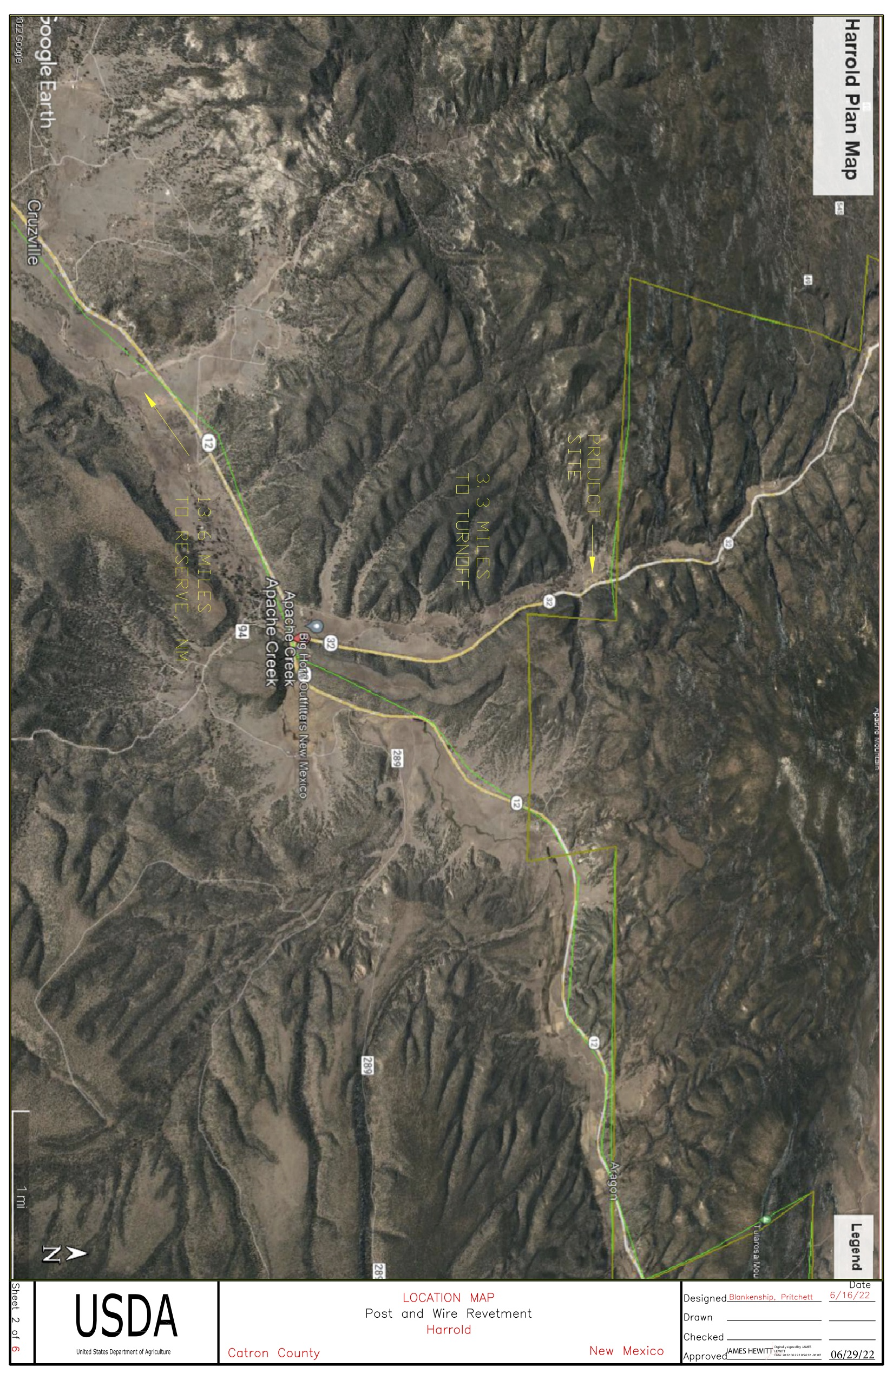
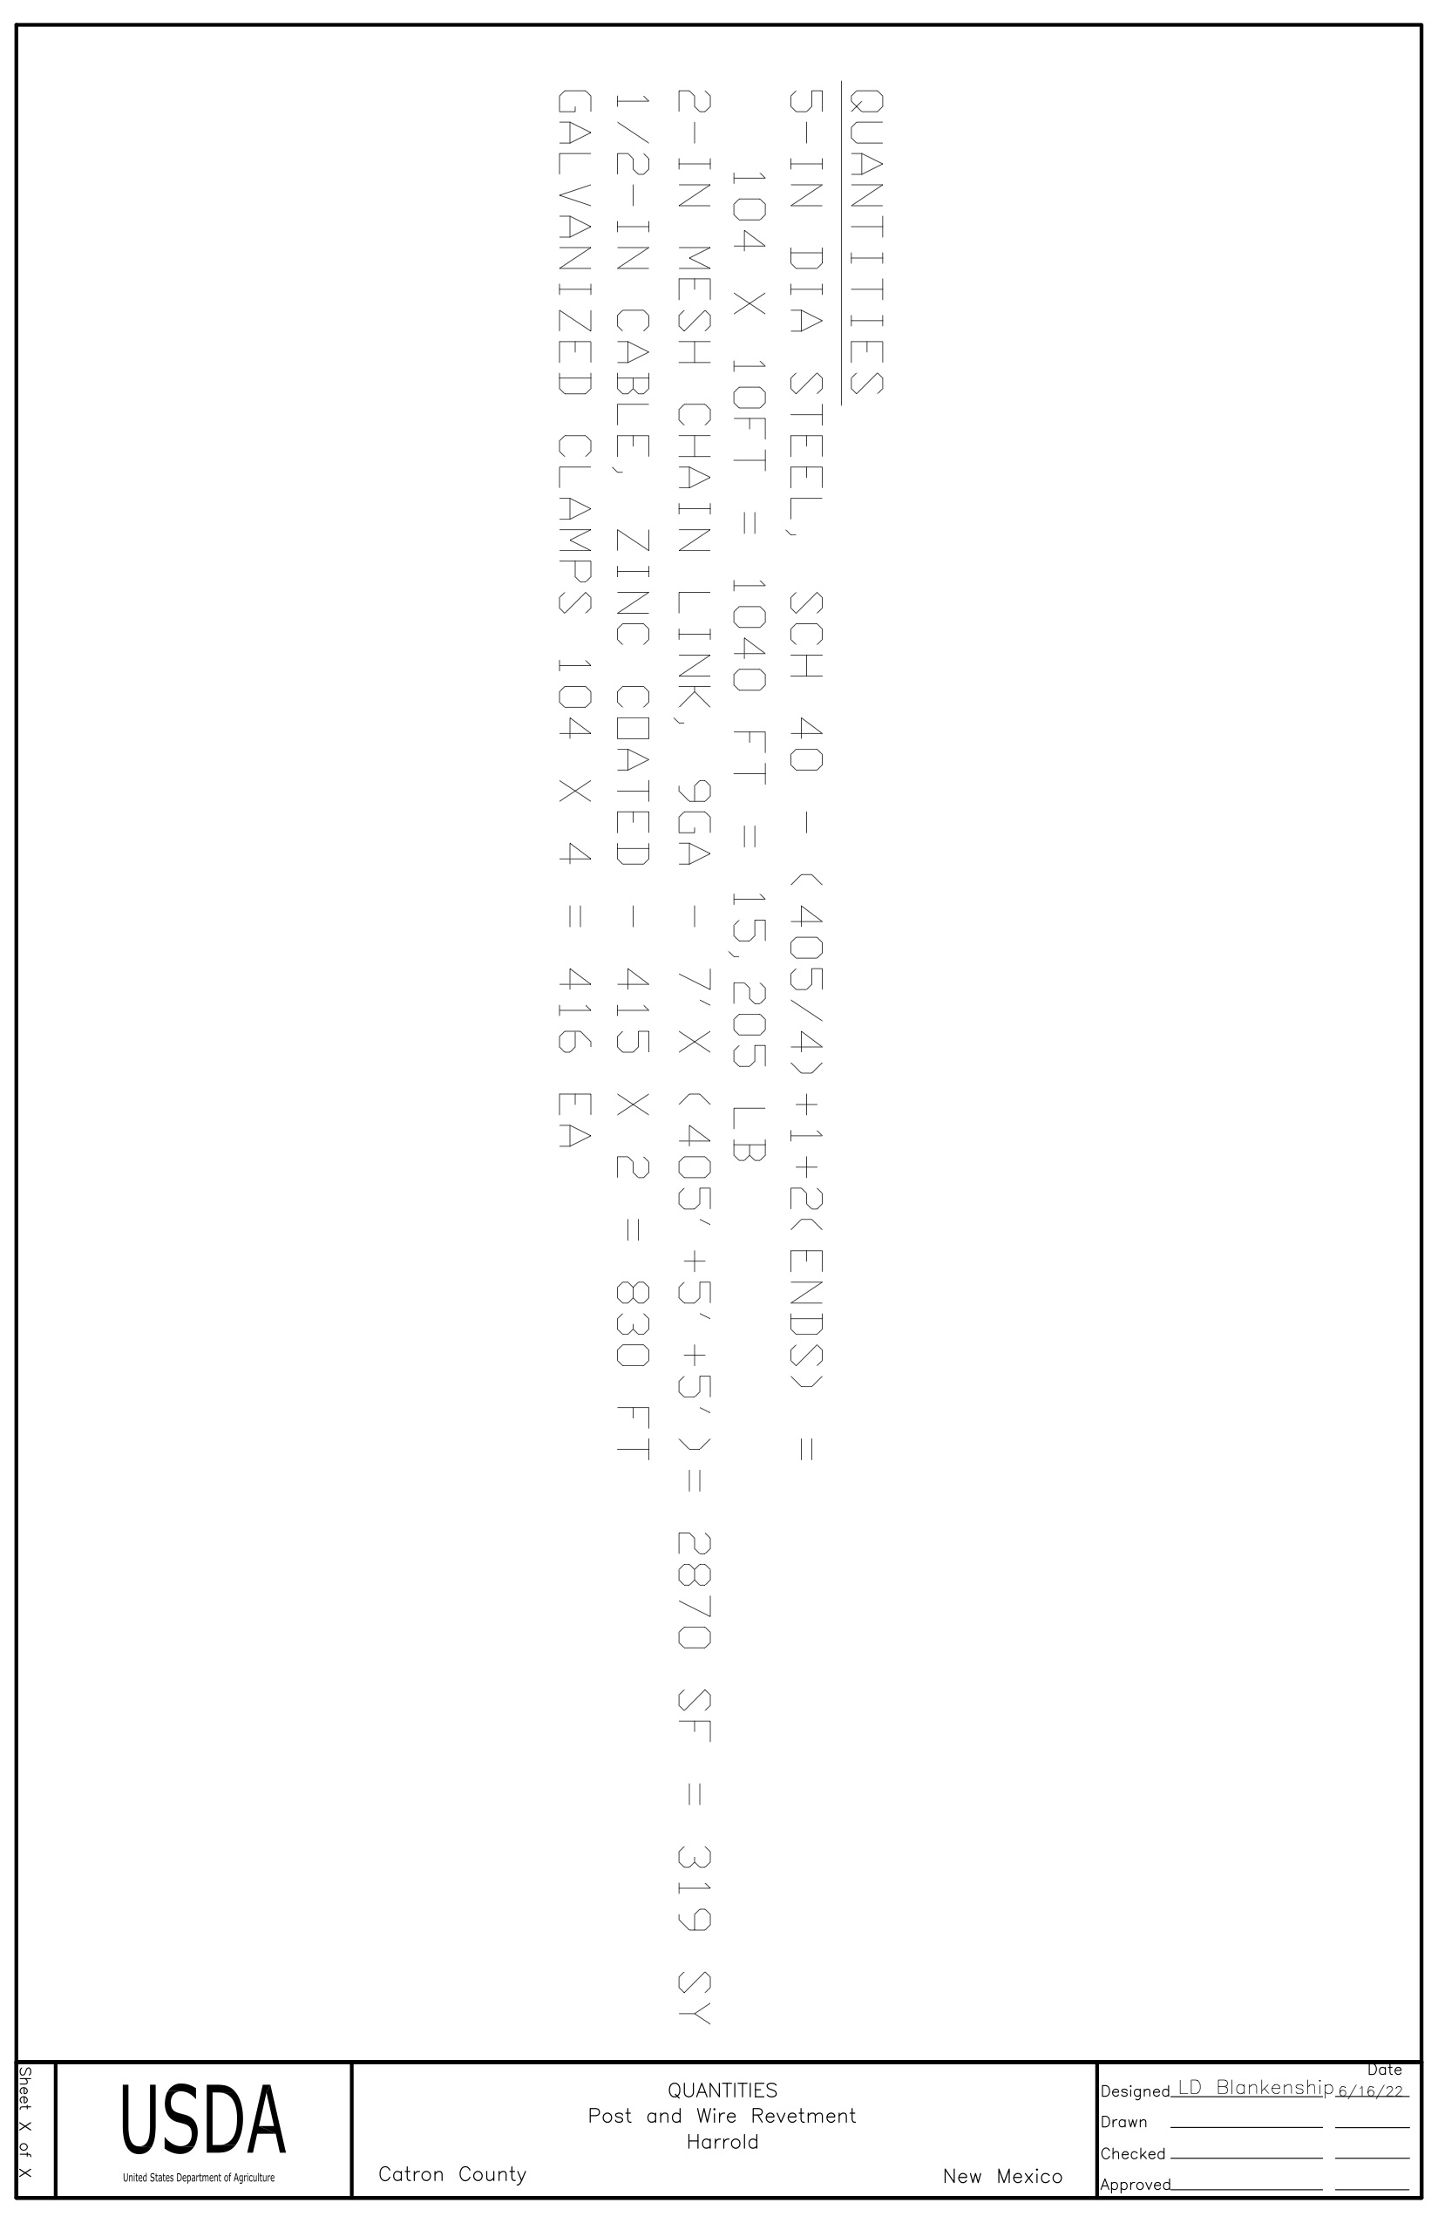
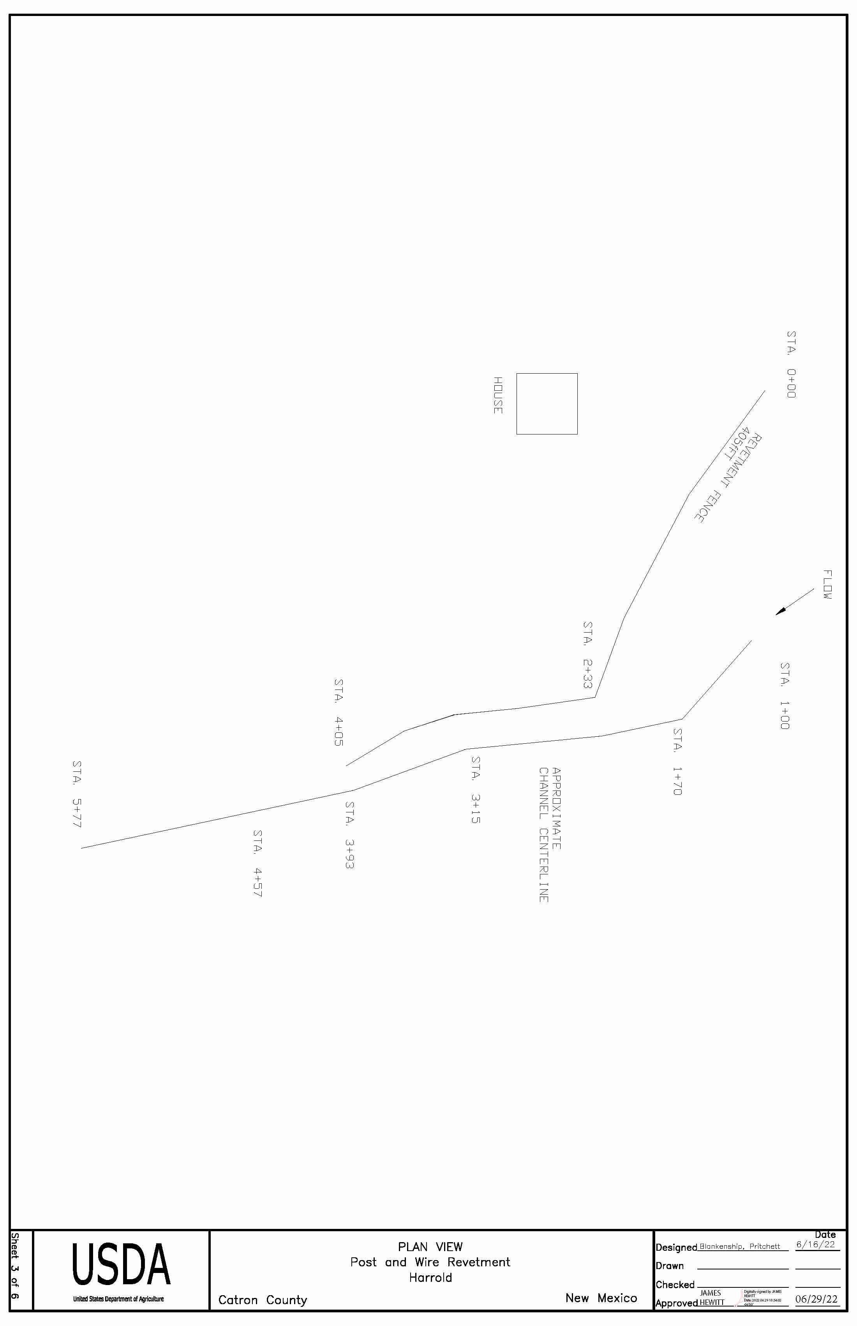
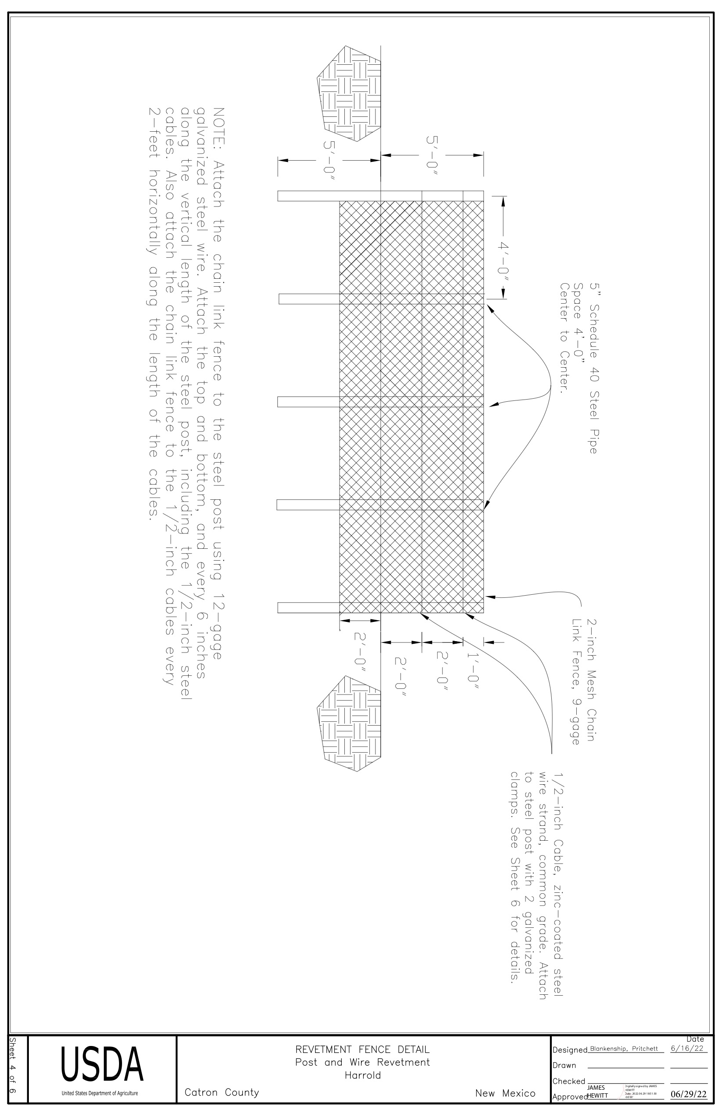

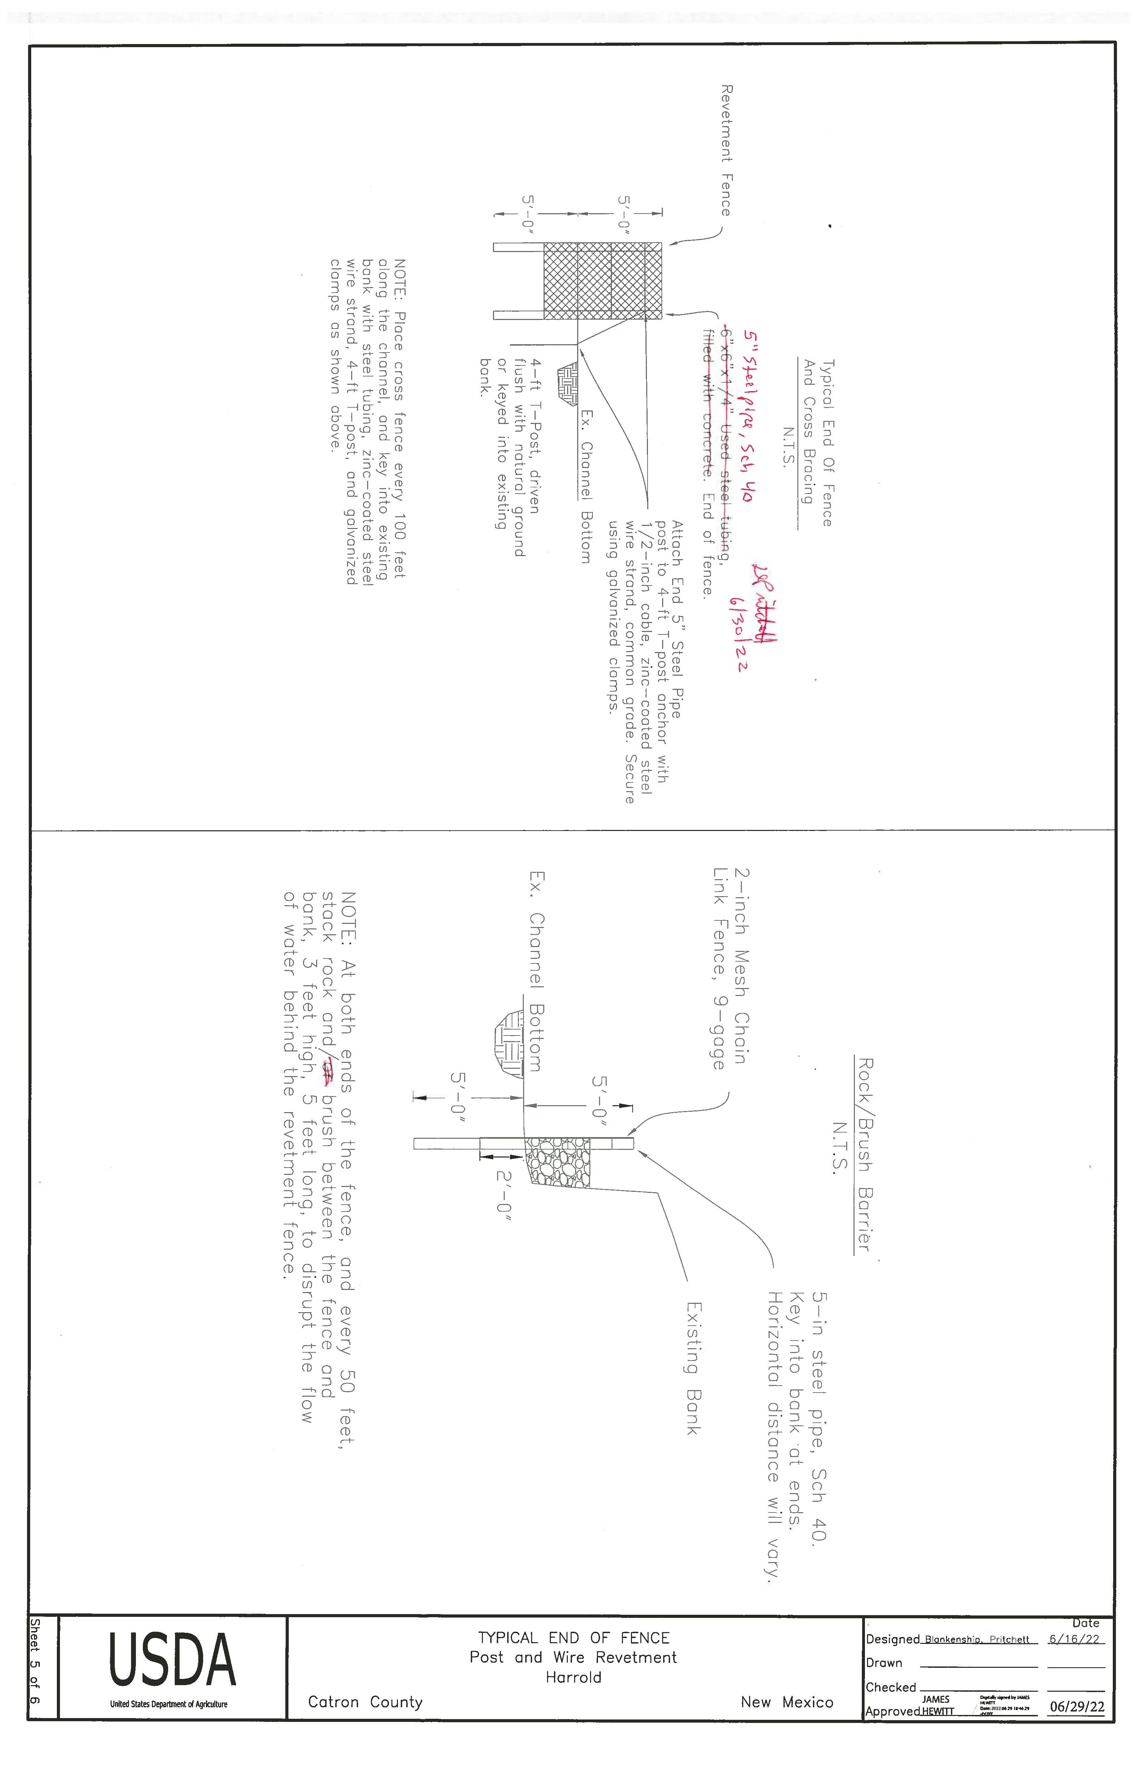

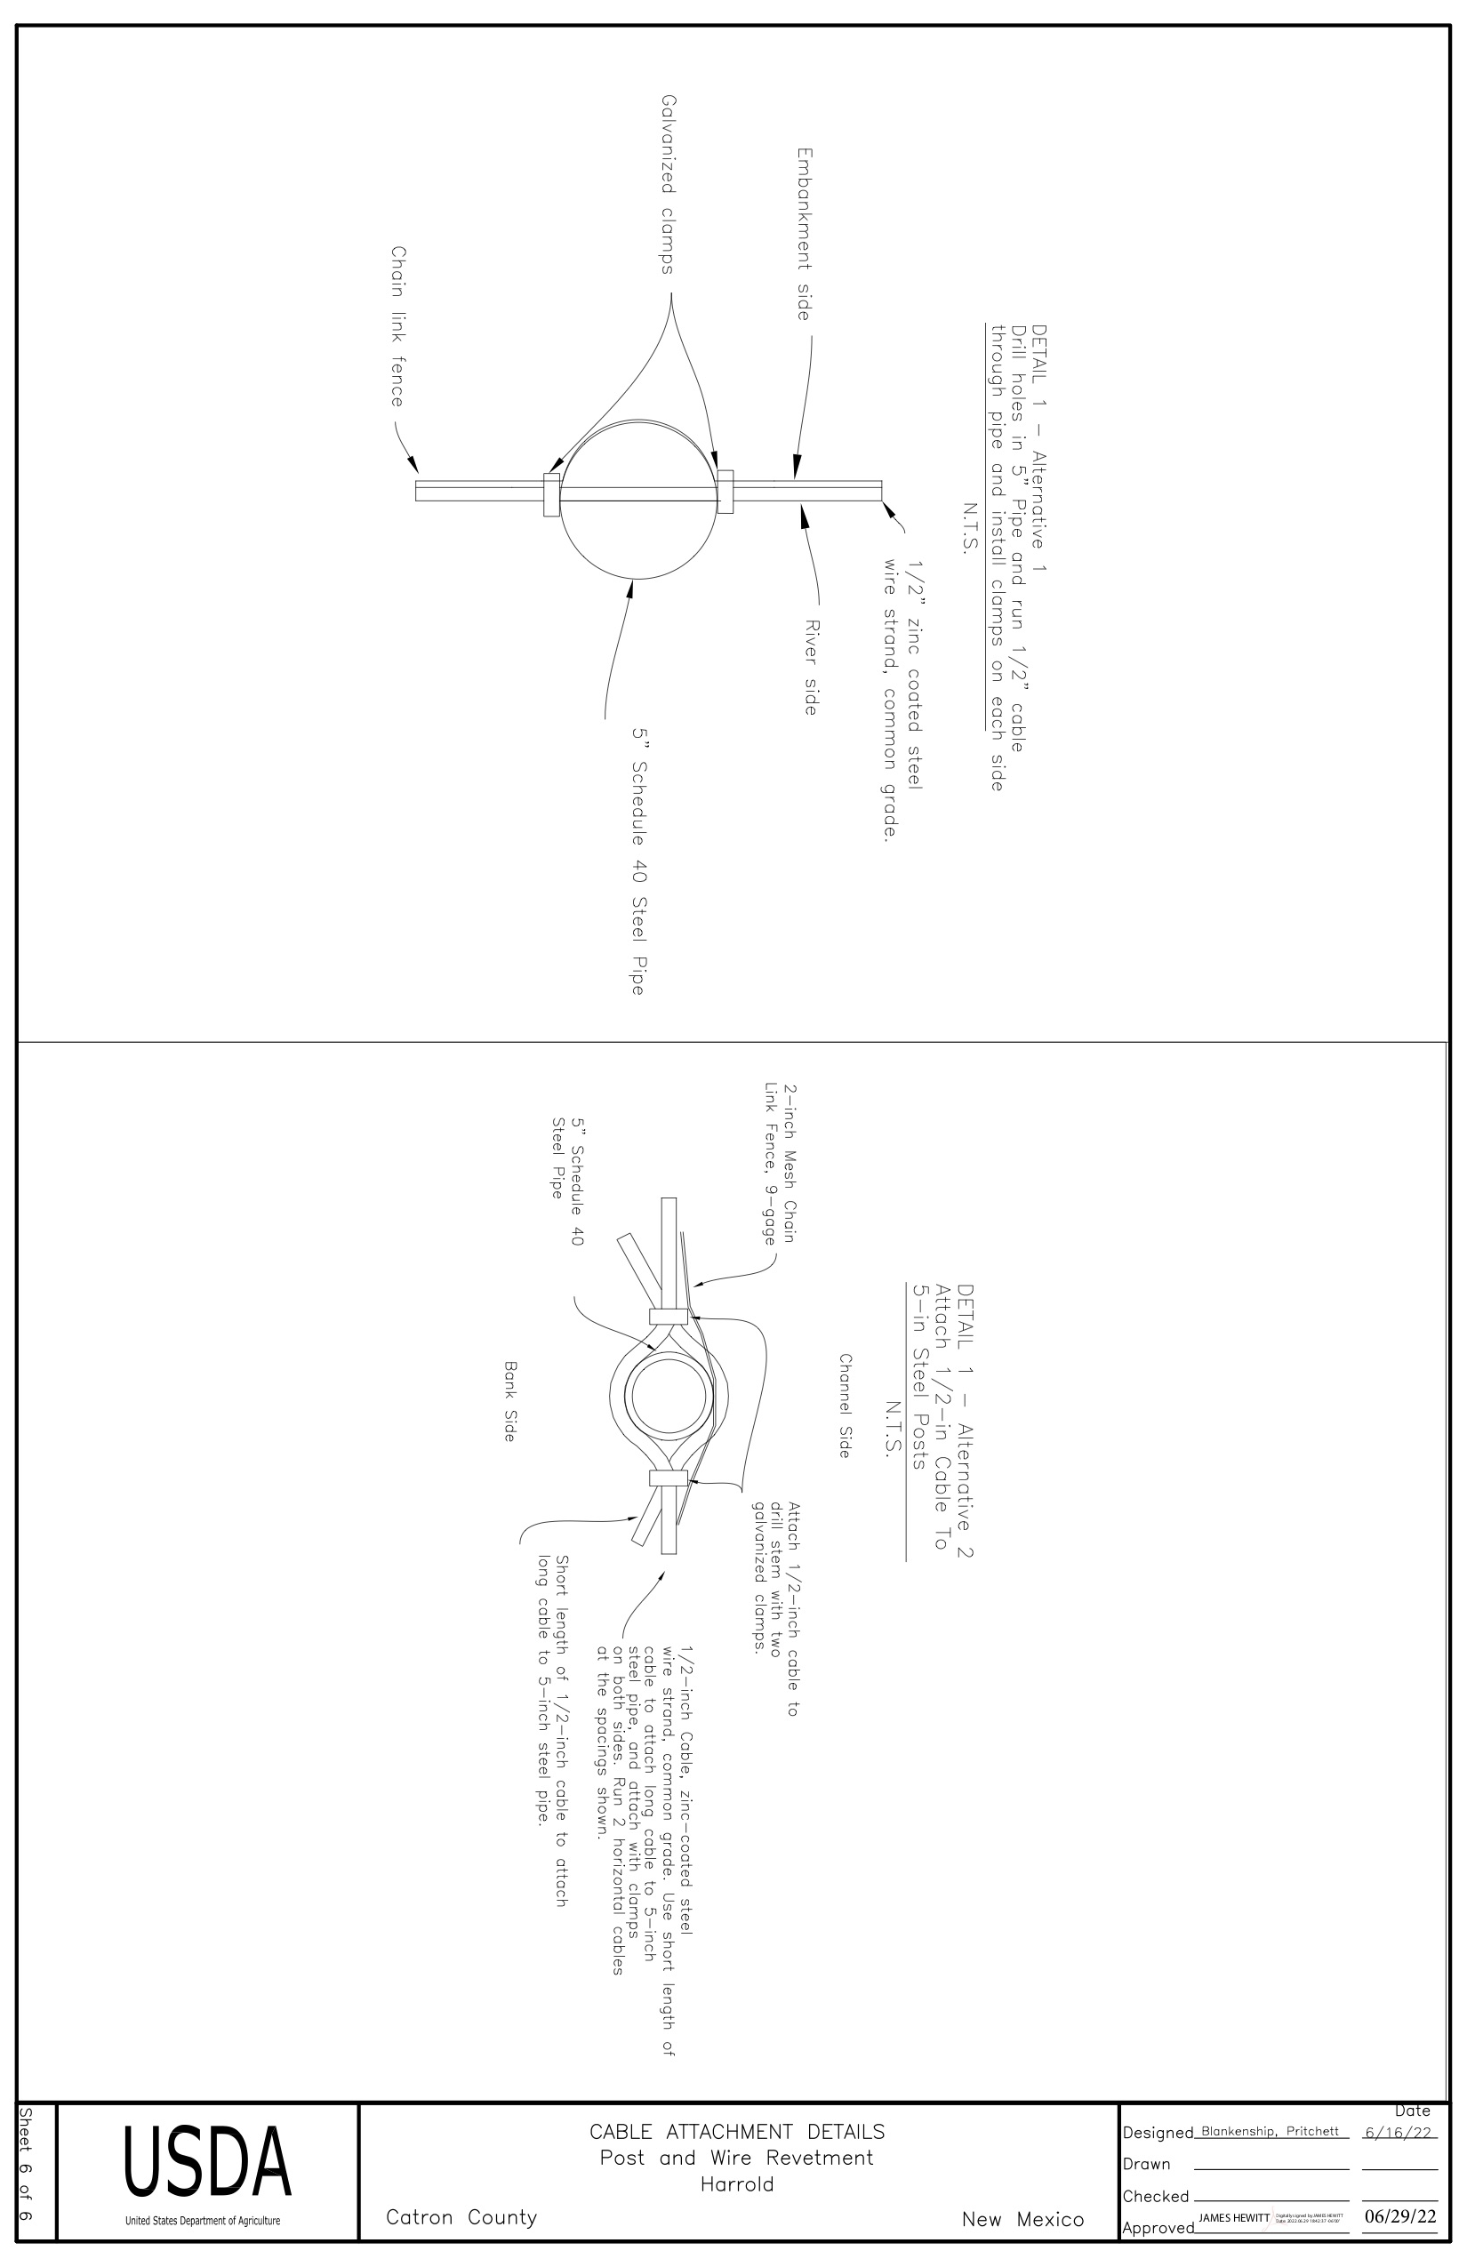

APPENDIX D

COST RESPONSE FORM
Deliverable Item | Cost
Purchase Revetment Fence Materials | $
Materials and Equipment Delivery & Set Up | $
Complete Construction of All Project Components | $
Total

- Cost Response Form Guidance:

    - Offeror must provide costs for each and every line item included in the budget table provided.
    - All costs provided by the Offeror must include all labor materials, equipment, travel, training, transportation, configuration, installation and profit.
    - The Offeror shall not add categories or line items to the budget table provided. It must be completed as-is.

- Offeror should base their cost calculation based on construction is to be completed before February 27, 2023 unless that deadline is extended by NRCS.

- Cost evaluation is based on the Cost Evaluation Factor formula in Section V.

APPENDIX E

LETTER OF TRANSMITTAL FORM
APPENDIX E
Letter of Transmittal Form

Please complete this form in its entirety. Failure to sign and/or submit this form will result in the disqualification of Offeror’s proposal.

RFP#:2023-09-01

1. Identify the following information for the submitting organization:
Offeror Name
Mailing Address
Telephone
FED TIN#
NM BTIN#

2. Identify the individual(s) authorized by the organization to (A) contractually obligate, (B) negotiate, and/or (C) clarify/respond to queries on behalf of this Offeror:

 | A  Contractually Obligate | B  Negotiate* | C  Clarify/Respond to Queries*
Name
Title
E-mail
Telephone
* If the individual identified in Column A also performs the functions identified in Columns B & C, then no response is required for those Columns. If separate individuals perform the functions in Columns B and/or C, they must be identified.

3. Will any subcontractor/s be used in the performance of any resultant contract? (Select one):
____ No.
____ Yes. Identify subcontractor/s: _______________________________________________

4. Will any other entity/-ies (such as a State Agency, reseller, etc., that is not a subcontractor identified in #3 above) be used in the performance of any resultant contract? (Select one)
____ No.
____ Yes. Identify entity/-ies: ___________________________________________________

By signing the form below, the Authorized Signatory attests to the accuracy and veracity of the information provided on this form, and explicitly acknowledges the following:
- On behalf of the submitting-organization identified in item #1, above, I accept the Conditions Governing the Procurement, as required in Section II.C.1. of this RFP;
- I concur that submission of our proposal constitutes acceptance of the Evaluation Factors contained in Section V of this RFP; and
- I acknowledge receipt of any and all amendments to this RFP, if any.

Sign: ________________________________________________ Date: _____________________
(Must be signed by the individual identified in item #2.A, above.)

