Lynette McSpadden, Herman J. Lyons Memorial Scholarship $2500

Lynette has been a very active PWC member since 1995. She has been on the Regional Board of Directors for multiple terms serving 2 regions, served as President from 2007-2009, and is presently serving as co-lead of the PWC National Mentor Program which she has been involved with since 2006. Currently, Lynette is working on her third act at Lenoir-Rhyne University, Lutheran Theological Southern Seminary as a student in their Master of Arts in Christian Ministry Program. She plans to use this degree to become a Deacon or an Associate Minister at a church as her transition into the private sector after her retirement from the FAA in 8 years. For this program she takes 2-3 online classes per semester as well as conducts field assignments at local churches, volunteers at hospital and hospice facilities, and prepares worship service all while still working full-time as an Air Traffic Safety Inspector (Aeronautical Information Standards) in Air Traffic Safety Oversight. In addition, Lynette also volunteers at and serves as President of her church council at Good Shepherd Lutheran Church.
Lynette’s letters of recommendation boasted her as hardworking, a leader, a good person who always wants to help others, and she has a great big heart. The Herman J Lyons Memorial Scholarship is awarded to a candidate that stands out above the rest for their service to their community, excellence in academics, and dedication to the advancement of aviation education and design. The scholarship committee found Lynette to fit this description perfectly.

Maaliyah Bowden, Jacqueline Smith Burdette Career in Aviation Scholarship $2500
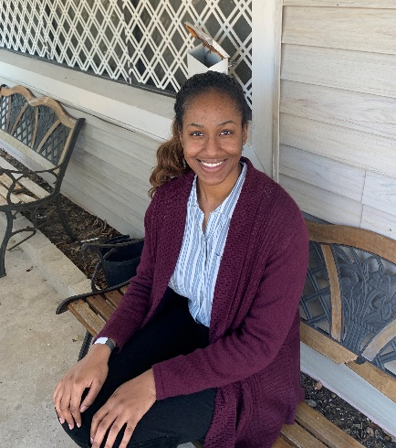
Throughout high school, Maaliyah was involved in her school’s Marine Corps. Junior Reserve Officer Training Corps. During this time, she became a strong leader, increased her confidence in public speaking, and got her involved with her community. Maaliyah earned the US Air Force’s Order of the Daedalians in her junior year and graduated high school as a Cadet Master Gunnery Sergeant. Also, during high school, Maaliyah was also involved with Advancement Via Individual Development (AVID) program at her school and she also attended the American Legion Auxiliary’s Florida Girls State in 2019. Currently Maaliyah is in her first year at Embry-Riddle Aeronautical Universities’ Daytona Beach campus double majoring in Air Traffic Management and Human Factors Psychology. After completion of these bachelor’s degrees, she plans to continue at ERAU in their Accelerated Master’s Program in the Science in Human Factors. In addition, Maaliyah also volunteers with outreach programs and is very involved with her church.
Maaliyah’s letters of recommendation described her as self-motivated (which is clear in her aforementioned achievements and goals), strong leader, passionate, and a remarkable young woman. After reviewing her scholarship application, the scholarship committee thought she would be a great candidate for the Jacqueline Smith Burdette Scholarship because her goals and determination will set her up for greatness in not only air traffic, but beyond as well. We all look forward to working with her someday!

Jocelyn Gaydos, PWC Recruitment Scholarship $1500

Jocelyn is currently a sophomore at Western Michigan University where she is pursuing a bachelor’s degree in Aviation Management and Operations. As a long-term goal, Jocelyn wants to become an Air Traffic Controller because she has always been interested in it and she has been surrounded by aviation all her life since her father is a private pilot. A short-term goal of hers is to get involved in an extracurricular club related to her major and to interact with her aviation peers, since this has been difficult to do thus far with the pandemic. Jocelyn has made the Dean’s list 2 out of the 3 semesters she has been in college, she was accepted into the Lee’s Honors College, and she was just recently invited to join the Honors Fraternity at Western Michigan.
Jocelyn’s letters of recommendation highly recommended her and described her as hard-working, dedicated, passionate about aviation, and having a solid work ethic. The scholarship committee enjoyed reviewing her application and we look forward to helping her in any way we can to join the ATC ranks.

Lauren Enders, PWC Recruitment Scholarship $1500

Lauren is a high school senior at Lyman High School in Longwood, FL and has been accepted for admission to Embry-Riddle Aeronautical University Daytona Beach Campus. She will also be a student athlete at ERAU as a coxswain on the women’s rowing team. In her essay, Lauren pointed out the similarities of the attributes of a coxswain to those of air traffic controllers: “natural leaders who are decisive, driven, and know what has to be done and how to take control of a boat or situation to get the desired end result”. Lauren has taken honors classes throughout her 4 years in high school maintaining a 3.8 GPA and participates in the National Honors Society. She is also very involved in her community participating on cheer team and crew team as captain, as well as volunteering at her high school, girl scouts, and with her church.
Lauren’s letters of recommendation describe her as a natural leader, dedicated, a good team member, having a solid work ethic, and kind. The scholarship committee thought that it was very astute of her to make the connection between the similarities of a coxswain and an air traffic controller. We look forward to having Lauren in the ATC ranks with us someday and are more than happy to help her along the way.

