***Carissa Benson  
Mary McBurney Memorial Scholarship, $1500***

Carissa somewhat stumbled into a career in ATC when her Air Force Recruiter called her to ask her if she wanted to take someone’s place in basic training (due to an injury) and become an air traffic controller. It wasn’t until she completed basic training and began classroom instruction in Biloxi, MS when she realized what she had gotten herself into. She studied day and night to learn all she could about our wonderful world of aviation. She spent four years in South Carolina working fighter jets, one year in South Korea in a leadership role, then she ended her Air Force career working heavies in Minot, ND. In 2016, she made her transition to the FAA at Toledo ATCT where, due to fantastic mentorship and coaching, she is currently an Operational Supervisor. During her career with the FAA she used her GI Bill benefits to complete a Bachelor degree in Human Resources. Continuing her education would be her responsibility – which is a huge time and monetary commitment especially to a single mom. Currently Carissa is enrolled in the University of Toledo Graduate School continuing her Human Resource studies. She is currently applying for locations and positions outside of her current position with the ultimate goal of becoming an Air Traffic Manager or potentially beyond someday. She believes it is critically important that we become the type of role model that we needed when we were young in our careers (especially as women) – and she plans to use this scholarship to be the best version of herself to set that example.

***Karen Combe*  
*PWC Family Scholarship, $1500*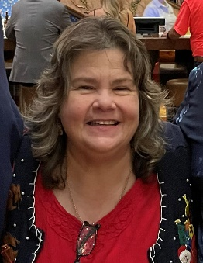**

Karen is the wife of PWC Alumnus Member, Michael Combe. She worked as a probation officer for the adult and juvenile system in Texas for approximately 14 years. While working full-time as a probation officer, she attended college part-time eventually earning a Bachelor Degree in Psychology. After receiving this degree, she was hired by the Montgomery County Juvenile Probation Department, beginning her career in helping others. Nearly 23 years after she graduated from Sam Houston University, she has returned to college to achieve a master’s degree in Clinical Mental Health at New Orleans Baptist Theological Seminary to continue her path of helping others. Karen’s short-term goals include balancing a full-time class schedule while keeping up her GPA and maintaining a full-time job. After completing her practicum and internship program hours, she was hired by the Jefferson Parish Diversion Program, but is only paid at a student rate until she graduates and gets her Provisional License for Professional Counselors (PLPC) certification.

Karen has done VAST amounts of volunteer work and stays very involved in the communities that she has lived. She has provided assistance for those affected by Hurricane Ida through the Disaster Relief Program at the First Baptist Church of Slidell, she has packed backpacks for homeless individuals, she has prepared many meals for various church events and for people in need, and she has even led Sunday school and children’s Bible studies at one of the churches she has belonged to. The driving force behind Karen’s desire to help others stems from her own personal experience as a teenager. She never wants to lose sight of what she went through and what individuals may be going through. As she likes to say, “Be careful and kind, you don’t know their story.”

***Casandra Hurd  
Sue Townsend Scholarship, $1500***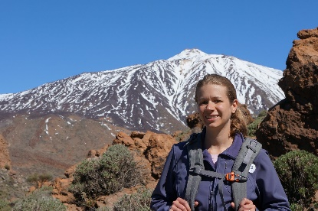

Casandra is an ATCS at ABQ ATCT/TRACON. She is a very active NATCA member including being the LSC Lead at her facility. She already has a BS in Aeronautics from UND and has her PPL. This past year she realized she was settling and was destined to do more, so she began exploring different parts of the aviation industry. She began a certificate program in Unmanned Aircraft Systems at her local community college, Central New Mexico Community College, where she earned her Remote Pilot, sUAS (Part 107) license and is set to graduate in April 2023. She also began a graduate degree program in Unmanned Systems at ERAU Worldwide earlier this year. Her initial career goal was to transfer to the ATCSCC in a role with the Central Altitude Reservation Function (CARF). Now she wants to help maintain operational integrity throughout the NAS while accommodating various applications of UAS and Space Operations, so she intends to transition to a role in airspace design that safely integrates Advanced and Urban Air Mobility and/or Space Operations. She is doing her best to find a balance between her ambitious dreams and goals work, school, and her children.

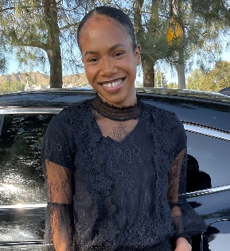

***Tonian Tomlinson  
Jaqueline Smith Burdette Career in Aviation, $1500***

Tonian has already earned a Commercial Flight AS Degree from Mt San Antonio College and is currently enrolled in Southern Illinois University’s Aviation Management BS off-campus program located at Mt SAC. In addition to her school work, Tonian is also a member of Mt SAC’s Flight Training Association where she has approximately 100 flight hours and is preparing for her Private Pilot check ride. Her goal is to continue her flight training by pursuing her Instrument Rating and Commercial Pilot Certificate working toward her long-term goal of becoming a pilot for a major airline. If she isn’t in the cockpit or on campus attending classes, Tonian can be found at Mt SAC’s flight school behind the dispatcher desk where she holds the position of Lead Dispatcher. Her responsibilities include prioritizing students’ safety and ensuring that the flight school and its aircraft are running smoothly. Being a part of these institutions has allowed her to be an active member of organizations such as Women in Aviation and the San Gabriel Valley Ninety-Nines, where she volunteers at air shows, conferences, and other outreach events. Tonian also volunteers her time at the House of Ruth, a domestic violence shelter providing food items and other necessities to those undergoing hard times, as well as the No Drugs America Association to advocate against the use of drugs within the youth community. As an immigrant and first-generation college student, pursuing higher education is of the utmost importance to Tonian and this scholarship will help her to focus on her academics and goals without financial stress.