THE
ENDOWMENT
FUND

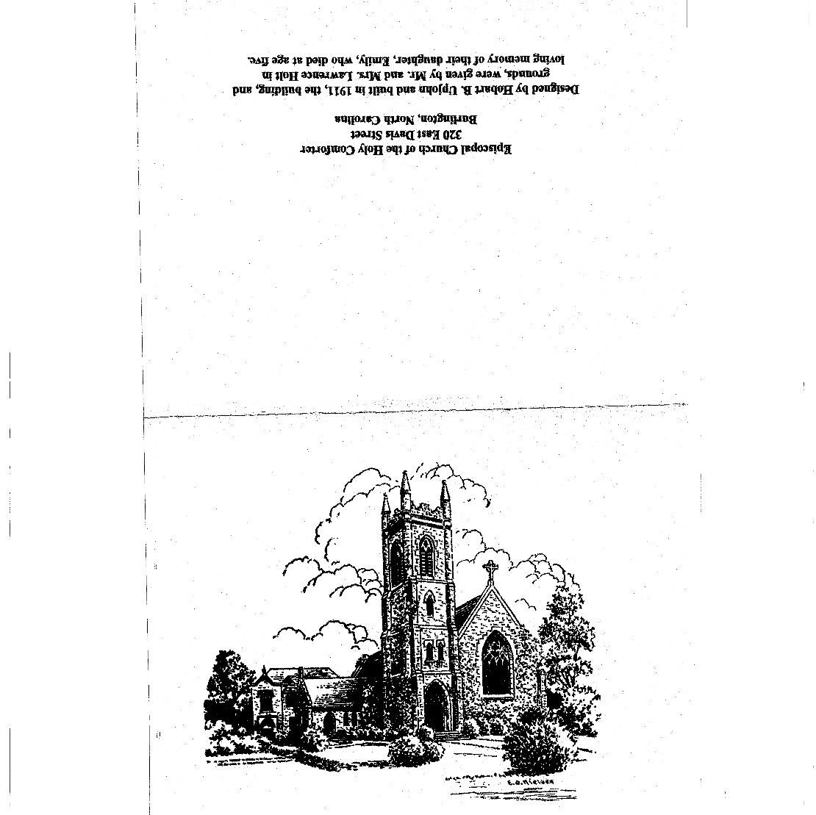

The Episcopal Church of the Holy Comforter
320 E Davis St. (PO Box 1336) Burlington, North Carolina 27216
Endowment

Christian stewardship involves the faithful management of all the gifts God has given humankind - time, talents, the created world, and money. The Episcopal Church of the Holy Comforter Endowment Fund became a permanent fund of the Church on December 20, 2004, when the Vestry approved the Plan of Operation for the Endowment Program. The Vestry approved an updated and revised plan in the Endowment Fund Policies and Guidelines on May 8, 2023. A copy of the plan may be obtained from the parish administrator.

Gifts from anyone, at any time, and in any amount are always welcomed, including cash gifts and memorial contributions. Endowment Funds also come from planned gifts in the form of bequests in a will or provisions made in a trust, as well as designations in insurance policies, annuities, retirement accounts, and real estate.

The Fund's assets are invested with the dual objectives of current income and long-term growth. Every effort is made to maintain a prudent balance of assets, with an eye towards managing volatility and maintaining an appropriate risk exposure. The Plan of Operation stipulates that the Fund be allowed to grow in perpetuity as a true endowment to benefit future generations within the Church and throughout the community.

Endowment Policy Statement

We recognize that Christian stewardship involves faithful management of all the abundant gifts God has given us. The Endowment Fund of the Episcopal Church of the Holy Comforter exists to encourage and receive gifts in a faithful manner and in accord with policies of the Episcopal Church, the Diocese of North Carolina, and this parish. The Endowment Fund enables our parish, within specific guidelines, to better fulfill its mission in response to Jesus’ continuing call to minister to others.

Each parishioner is a prospective donor to the Endowment Fund. Contributions are a faithful way to show love and respect, and to express your commitment to our Church and all it stands for.

If you are considering a gift, have questions about the Holy Comforter Endowment Fund, or would like to review the governing documents of the Endowment Fund, the Rector or the Endowment Board Chairperson would be happy to speak with you. They can also help you identify possible giving strategies to explore with your advisor.

How are Endowment Funds Used?

Having an endowment fund is like standing strong with one foot in the present and one in the future, bringing a sense of permanence to our church programs and stewardship. The gifts endowed today will not be used up but will be available to help those who come after us to move forward with ministries beyond what may be possible through annual operating funds. As we leave a legacy of faith, we also share our faith through an economic legacy of endowment.

The assets distributed from the general endowment fund are restricted to:

- mission and outreach,
- specific capital needs,
- and other purposes that support the mission and goals of the church.

A separate and designated sub-fund within the general endowment fund may be established for gifts in the amount of $25,000 or more. In such a case, the donor may tailor the purpose of the gift to benefit a particular area of interest.

How are Endowment Funds Managed?

The Endowment Board, with Vestry approval, is entrusted with the administration of the Endowment Fund subject to all relevant public laws, Diocesan canons, and the policies set forth in the Plan of Operation. The Board consists of five parishioners appointed by the Vestry. Additionally, the Rector and the Senior Warden serve as ex-officio members.

Contributions intended for the Endowment Fund may be received by the Rector, the Parish Treasurer, or any Board member. Gifts of cash, certain personal property, and marketable securities will be accepted. Gifts such as real estate, personal property valued in excess of $1,000, or any encumbered gift should be reviewed by the Endowment Board and the Vestry prior to acceptance for the Fund.

All gifts are placed in the Endowment Fund under the management of professional money managers selected by the Vestry. The Church Finance Commission monitors the performance of the Fund. A copy of the most current performance report can be obtained from the Parish Treasurer or the Finance Commission Chairperson.

The Vestry established that distributions from the fund would begin when the market value exceeded $500,000; this level was reached in 2022. The Endowment Board is approved to distribute funds and will periodically consider, prioritize, and approve requests for distribution. Because the goal of the Board is to grow, or at least maintain, the purchasing power of the Fund, the distribution will be no more than five percent (5%). The distribution amount will depend on prevailing economic and market performance as well as inflationary effects. Details on the Endowment and the application for funds are available on the church’s Endowment website or from the parish administrator.

What is Planned Giving?

“Your Kingdom is an everlasting kingdom, and your dominion endures through all generations.” Psalm 145:13

If you would like to perpetuate and secure the works of Holy Comforter and our buildings and grounds because they matter deeply to you, you may want to consider planning a gift.
Everyone can take advantage of the benefits of planned giving. Planned giving is essentially mapping out how you want your personal resources to ultimately be distributed. A planned gift is timed to help you minimize tax liability as a donor or to be able to make a gift that might not be possible during your lifetime.
Common methods of planned giving include:

- Bequests – For many people, a bequest is the means to the most generous financial gift they will make. Using this method, Holy Comforter would be bequeathed a gift in a donor’s will or living trust. The gift may be a percentage of the donor’s estate, a specific dollar amount or description of property.
- Life insurance and retirement accounts – Holy Comforter can be named as a beneficiary of a life insurance policy or retirement account.
- Charitable trusts or gift annuities – Trusts and annuities provide the donor with several financial benefits: provides life income for the donor and others, reduces capital gains taxes, qualifies for a charitable income gift deduction, reduces or eliminates probate expenses and estate taxes.

How to Make a Bequest to Holy Comforter?

Throughout its history, Holy Comforter has benefited greatly from bequests. Making a provision for the Church in your will or trust is a wonderful way to leave your legacy and to also ensure the legacy of Holy Comforter will continue long into the future. Anyone seeking to include Holy Comforter in their will should be certain of their intention and the designation they have in mind is clearly worded within their bequest. (The Leave a Legacy® organization www.leavealegacy.org offers helpful guidance regarding different kinds of bequests.) Samples of general bequest language are provided below.
Holy Comforter’s Financial Administrator can also provide direction to interested donors. This guide is not intended to provide specific advice about estate planning or to recommend a specific course of action. It is important to discuss your gift strategy with your attorney or tax advisor to ensure that your philanthropic goals are met.
General bequest language:
“I give, devise, and bequeath to the Episcopal Church of the Holy Comforter in Burlington, North Carolina, the sum of $________, [or _____% / all the rest, residue, and remainder of my estate] to be used for the purposes of the endowment of the Episcopal Church of the Holy Comforter.”
Or, to make an unrestricted non-endowment bequest to the Church:
“I give, devise, and bequeath to the Episcopal Church of the Holy Comforter in Burlington, North Carolina, the sum of $________, [or _____% / all the rest, residue, and remainder of my estate] for the benefit of the Episcopal Church of the Holy Comforter and its general purposes.”
Contingency bequest language:
“I devise and bequeath the residue of the property, real and personal and wherever situated, owned by me at my death, to {name of beneficiary}, if {she/he} survives me. If {name of beneficiary} does not survive me, I devise and bequeath my residuary estate to the Episcopal Church of the Holy Comforter in Burlington, North Carolina, for its endowment.”
Or, to make an unrestricted non-endowment contingency bequest to the Church:
“I devise and bequeath the residue of the property, real and personal and wherever situated, owned by me at my death, to {name of beneficiary}, if {she/he} survives me. If {name of beneficiary} does not survive me, I devise and bequeath my residuary estate to the Episcopal Church of the Holy Comforter in Burlington, North Carolina, for its general purposes.”

How to Create a Designated Endowment?

A Designated Endowment may be established for the Church with an outright or planned gift of $25,000 or more. In such a case, the donor may tailor the purpose of the gift to benefit a particular area of interest. Sample bequest language follows:
“I give, devise, and bequeath to the Endowment Fund of the Episcopal Church of the Holy Comforter in Burlington, North Carolina, the sum of {insert amount of at least $25,000} for the benefit of the Episcopal Church of the Holy Comforter to be used for the following purpose: {state the purpose; examples: for the music program; for youth Christian Formation program support; for landscape upkeep}. If at any time in the judgment of the Vestry of the Episcopal Church of the Holy Comforter it is impossible or impracticable to carry out exactly the designated purpose, they shall determine an alternative purpose closest to the designated purpose.”

How can I get more Information about the Endowment Fund?
If you have questions about the Holy Comforter Endowment Fund or Endowment Fund Board or would like to review the governing documents of the Endowment Fund, please call the Church office and you will be directed to a member of the Endowment Fund Board.

To contact the Rector, Endowment Board Chairperson, Parish Treasurer, Investment Committee Chairperson, or Parish Administrator please call 336-227-4251

Parish Members of the Endowment Board
- Pete Glidewell - At Large - Secretary - thru 2026
- Pat House - At Large - thru 2024
- Steven House - At Large - Chair - thru 2025
- Tom McLean - Vestry thru 2023
- Chappy Moser - At Large - thru 2023
- Mark Thomas - Sr. Warden - Ex Officio
- Rector - Ex Officio

