*Friends of Colvin Run Mill* is an IRS 501(c)(3) non-profit organization established with the goal of strengthening community ties through the development of new exhibits and programs. Our aim is to increase the public’s understanding of the role that Colvin Run Mill played in the evolution of 19th and 20th century technology and community. An integral part of that goal is the construction of a new visitor’s center and the restoration of the Miller’s House.

Situated near the Leesburg Turnpike in Great Falls, Virginia, Colvin Run Mill stands on what was once a major transportation artery from the rich farming valley of the Shenandoah to the busy maritime port of Alexandria. The millers bought farmer’s grain and sold the processed flour to both domestic and foreign markets.

Built between 1802 and 1811, the mill was closely modeled on the principles developed by Oliver Evans (1755-1819) which revolutionized milling in late 18th and early 19th century America.

The grounds of the mill, restored in the late 60’s and early 70’s, are open every day, dawn to dusk, for nature walks and picnics. The mill, miller’s house, and general store are open every day except Tuesday. Tours of the mill are normally available on the hour from 11 AM to 3 PM every day except Tuesday.

***Friends of***

***Colvin Run Mill***

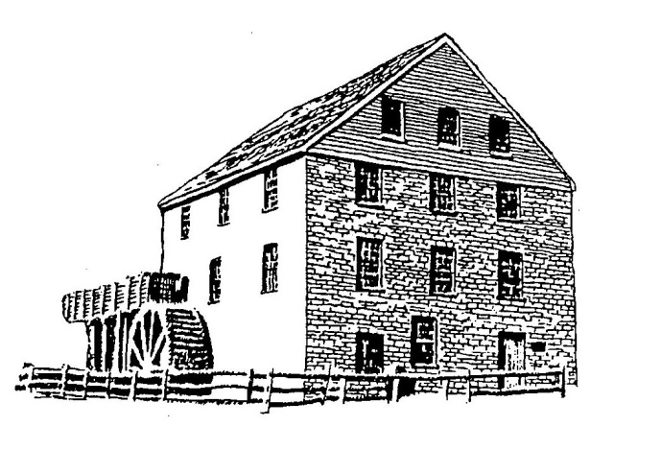

*Friends of Colvin Run Mill* is dedicated to preserving the heritage of Northern Virginia for future generations. The restored Colvin Run Mill, a working example of 19th century water powered grist milling technology, serves as a focal point for educating visitors, children and families about early life in our community. We invite you to participate in keeping this heritage alive. By becoming a *Friend of Colvin Run Mill* your tax deductible membership contributions will be used to support its educational programs, as well as the continued restoration and preservation of the site.

*Friends of Colvin Run Mill*

*Membership Form*

Yes….I want to be a Friend of Colvin Run Mill. Please enroll me at the annual membership of:

_____ Individual ………………..$35

_____ Family …………………...$55

_____ Business ………………..$100

_____ * Donation of ______________

Total submitted _____________

* (FOCRM is an IRS 501(c)(3) non-profit Organization.) Rounding up your membership to $50 or $60 or more would help.

**____________________________________**

Name

____________________________________

Address

____________________________________

City

____________________________________

State Zip

____________________________________

Phone

____________________________________

E-Mail

Pay by check payable to ***Friends of Colvin Run Mill*** or go to ***focrm.org/be-a-friend*** to donate through PayPal or debit/credit card.

I am interested in participating in the activities of *Friends of Colvin Run Mill.* Specify any special area(s) you would like to help with.

__________________________________

___________________________________

___________________________________

Mail this portion, along with payment to:

**Friends of Colvin Run Mill**

**10017 Colvin Run Road**

**Great Falls, VA 22066-1834**

focrm.eps

***Thank you for joining***

***Friends of Colvin Run Mill***

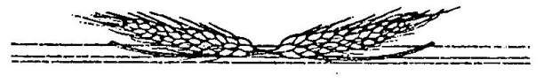

Check No. _______ Date: ______

Amount: ____________

For more information, contact us at:

Friends of Colvin Run Mill

10017 Colvin Run Road

Great Falls, Virginia 22066

Phone: 703-759-2771

***Membership Benefits:***

* Tax-deductible dues
* Quarterly (or more) newsletters
* Special tours of the mill during the year
* Samples grain packets at some events

***(Keep this portion for your records)***

(Revised 4/21)